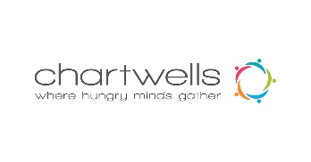
Catering/Event Request Form

Organizer Name: First Name - Last Name -
Contact Information: Phone - Email -
Group/Club/Department Hosting Event:
Proposed Date of Event: Event Hours: Start Time: End Time:
Preferred Venue for Event:
- TwelvEighty Restaurant Dining Room
- The Grind Café Area
- Event Space
Expected Number of Guests: Proposed Budget:
Event/Catering Type:
- Social Reception
- Buffet
- Night Event
- Pick Up Order
- Other (Please Specify):
Food Requested (ie. Themed meal, platters, etc.):
Known Dietary Considerations (Allergies, vegan/vegetarian, cultural):
Bar Service Requested:
- Alcoholic
- Non-alcoholic
- Both
- Not Required
Audiovisual Equipment Required (Please Specify):
Preferred Payment Method:
- Credit/Debit
- Cheque
- Purchase Order
- Internal Account (Please Specify Chartfield Account
ROOM RENTAL RATE: $150/Hour

Please Confirm Guest Attendance 5 Days Prior to Event to Avoid Charges

HST (13%) and Service Charges (15%) Will Be Applied to the Final Invoice

