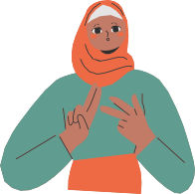

OUR COMMUNITY MORE ABOUT US

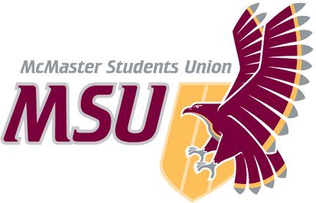Our services are available for any McMaster student who experiences (or identifies as) any of the following:
WELCOME TO MSU
MACCESS
Maccess is a peer support, advocacy, and community centre for students who experience disability, chronic illness, mental health concerns, or inaccessibility.
PEER SUPPORT
Talk to peer support volunteers about anything on your mind! Find us on Discord from our Linktree, and in-person at MUSC, Room B111.
ADVOCACY

Check out our socials to join us for events such as Disability & Mad Pride Week.
COMMUNITY
Stay tuned for weekly community groups based on identity & shared experiences.
Linktree: https://linktr.ee/maccess
maccess@msu.mcmaster.ca
Instagram: msu_maccess Facebook: msumaccess
disability/disabled
chronic illness or health conditions
madness, mental health concerns, or mental illness neurodivergence/neurodiversity
learning disability
d/Deaf or hard of hearing sensory impairment
navigating inaccessibility or accessing accommodations other experiences/identities that are part of the larger Disability Justice movement

Maccess aims to build and maintain a campus that celebrates, advocates, and ensures inclusiveness in the area of disability. We provide programming and events in an effort to establish a sense of community for those that self-identify as having disabilities or as disabled. In addition, Maccess strives to advocate on behalf of students in a proactive and affirmative fashion, and provide educational programming on and opportunities to learn about critical disability studies.

