REPORT
From the office of the…

Spark Director
TO: | Members of the Executive Board
FROM: | Mitchell German (He/Him)
SUBJECT: | Spark Report #1
DATE: | July 8th, 2021

Year Plan Update
- At this point, there are no additional updates on Spark’s Year Plan; everything has been going as planned thus far!

Events, Projects, & Activities

General Service Usage
- We have not begun any programming within Spark as of yet or any outreach to the McMaster population other than for hiring. However, I will be able to provide a more in-depth update regarding this once we begin our Summer programming (July 16th).

Projects & Events

Project 1: Team Leader Hiring
Project Status: On-Going
General Information:
- The Spark Team is currently in the process of hiring Team Leaders (TLs) for the 2021/22 year.
- The initial written application was in the form of a Microsoft Form and applicants were required to answer four (4) application questions that were approved by Victoria/Christina in advance
- TL JD was altered, then sent to EB and approved (thank-you!). Applicants will be notified of any changes prior to accepting their position. However, the changes were minor, and I don’t foresee this being an issue.
- Spark received 172 applications for the position of Team Leader, and we offered 103 interviews.
- Interviews were 1-hour long as opposed to 3-hours as they have been in the past. This was done to enhance accessibility for both the applicants and the Spark Executives.
- Interviews consisted of 5 stations (4 were individual, 1 was a group station).
- We are planning to hire approximately thirty-four (34) TLs and are currently wrapping up interviews at this point in time.
- Offers will be sent out once the Executive Team has made all their final decisions.
- Applicants will be tiered based on their past experiences to ensure that we have a diverse group of Team Leaders who can support the greatest proportion of first years possible.
- My goal is to hire at least one (1) person from each program at McMaster to enhance the diversity of our TL team!
- We have been collecting feedback from applicants on the interview process to improve for future years. This has been reviewed on a rolling basis to ensure we are making interviews as accessible as we possibly can. I have inserted the feedback below under ‘Miscellaneous’.
- Disclosure forms have been sent out to applicants with their rejections or acceptances. This is a new initiative that has been implemented this year to provide transparency to applicants and highlight the strategies Spark uses in its hiring practices to minimize biases.

Project 2: Summer Programming
Project Status: Upcoming
- With MSU Horizons being rescinded, Spark has taken on the responsibility of providing first years with programming throughout the Summer. This has primarily been the responsibility of our Events Coordinators (Myra, Darshana, Ester).
- They have done a FANTASTIC job in their transition into the role and consulted past members of the Horizons Team to learn the logistics of running Summer programming.
- The format will consist of approximately four (4) Webinars that will be open for all incoming McMaster first years to register for. They will take place throughout July (16,17,18) and August (TBD).
- The themes will include: Student Life, Faculty Fest x Spark (x2), and How to Get Involved. Current collaborating partners include Maroons, FYC, Macademics, Archway, and faculty planners.
- All registration will be through Eventbrite and graphics are currently being made by the Underground.
- They will take place via Zoom and we can accommodate upwards of 280 participants.
- All Webinars will be recorded and posted to YouTube for first years to reference if they were unable to attend. With this, we will ask all attendees to ensure they are muted, and their cameras are off as this video will be posted on a public platform.
- Currently we are seeking out sponsorship from the Campus Store to donate three (3) $25 gift cards that will be awarded to one (1) attendee of the Webinars. If we cannot secure this, we will go through Alumni Association, or pull from our Events budget line if necessary.
- Spark Sessions pre-registration will be open when these Webinars run to allow Spark to take advantage of this first contact with incoming first years.

Project 3: Spark Mini-Scholarship
Project Status: Upcoming
- The Outreach & Engagement Coordinators (Abithiny and Sofia) have been taking on this new initiative that Spark is VERY excited about.
- Hoping to be valued at approximately $250 and awarded to one (1) first year registered in Spark who demonstrates growth of their leadership skills throughout the year and who helps to promote a safe(r) space on McMaster campus.
- Eligibility currently includes having attended either four (4) Sessions in both the Fall and Winter terms (total of 8 Sessions), or alternatively, 6 Sessions in the Winter term to accommodate for first years who registered for Spark later in the year.
- Currently in communication with VP Finance to determine where we can pull funding from (last resort is from Spark’s budget). We are currently considering the Special Projects Fund and other sources.
- There will be an application process for first years to apply for the Spark Mini Scholarship that will allow them to reflect on their growth within the Service. The O&E Coordinators are currently in the process of developing this. All applications will be verified by one of the first year’s TLs.
- This year, the Spark Mini-Scholarship will run as a pilot initiative as a way to help increase retention into the Winter term. However, if this initiative is successful and we feel it should be implemented yearly by the Spark Director, the Operating Policy will be altered accordingly.
- Planning to speak with VP Finance about potentially including a budget line in Spark that is dedicated to the Spark Mini-Scholarship in future years so the Service can receive consistent funding for this initiative.

Project 4: Mac 101 Student Services Fair (SSC)
Project Status: Upcoming
- The Student Success Centre has invited Spark to take part in their Mac 101 Student Services Fair at the end of July
- The Outreach & Engagement Coordinators (Sofia and Abithiny) are currently in the process of designing our booth and we are reaching out to other Executives to see if they can be present at the event.
- Spark is SUPER excited to be able to collaborate with SSC and I am planning on continuing this relationship throughout the year.
- We will ensure we have pre-registration open by that time so we can benefit from this opportunity!

Project 5: Spark Discord Community
Project Status: Upcoming
- The Promotions & Publications Coordinators (Josephine and Irene) are planning to help us create a Spark Discord Community that will be open to first years registered in Spark Sessions.
- This will create an online community where first years can connect with other first years outside their program and Session time
- We will use this Discord page as an opportunity to promote upcoming Spark Sessions, events, and opportunities directly to our first years (they will be promoted on our Instagram as well).
- This Discord community will take the strain off individual Team Leaders to answer all questions from their first years. This will allow first years to connect with other Team Leaders who do not lead their Sessions, but who have experience in that specific topic (i.e., program, specialities, EC experiences, etc.)

Project 6: Campus Tour Video
Project Status: Upcoming
- This was an absolutely FANTASTIC idea brought forward by the Sessions Coordinators (Kyobin, Ryan, Vithuyan).
- Planning to create an approximately 5-minute campus tour video that will be posted on our Instagram and used in Spark Sessions as an activity for first years to engage in.
- Video will feature prominent buildings on McMaster’s campus and provide pertinent information on these buildings (i.e., BSB, MUSC, Mills, etc.)
- Recognizing that some first years and second years may have never physically been on McMaster’s campus due to the COVID-19 pandemic, this will act as a resource for them to familiarize themselves with what the campus has to offer before we are inevitably back in-person.
- Video will be filmed by the Spark Executives. The script and effects will be planned by the Promotions & Publications Coordinators, and the video will be made in collaboration with Betta (from Comms Team).
- We are still in the VERY early planning stages of this and are open to suggestions!

Outreach & Promotions

Summary
Currently, our primary form of outreach has been through the use of promotions to advertise the hiring of Executive and Team Leader positions (which we received many applications for and was very effective!). Therefore, we have been reaching out to only upper-year students at McMaster. However, now that our hiring process is on the verge of being complete, we have shifted our focus and begun to follow first years at McMaster on Instagram to ensure our promotions are making it onto the feeds of our target population! We will continue to do this as we ramp up for Summer programming and registration for Spark Sessions. The Promotions & Publications Coordinators (Irene & Josephine) and the Outreach & Engagement Coordinators (Sofia & Abithiny) have been doing an absolutely AMAZING job in their roles. They are all extremely talented individuals who I have no doubt will be able to promote Spark’s programming to first years and garner support from McMaster partners/stakeholders.

Promotional Materials

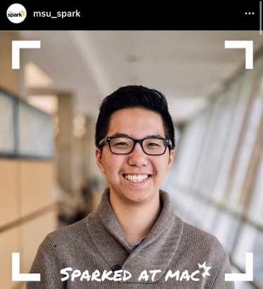
Sparked at Mac Campaign (TL Hiring Promo):
Likes: 121
Sends: 1
Saves: 0
Reach: 2,598
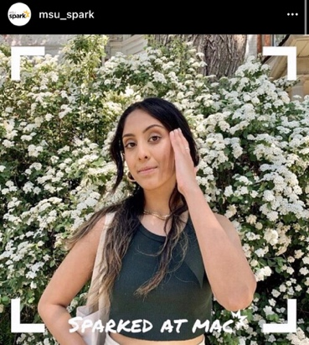
Likes: 163
Sends: 3
Saves: 6
Reach: 3,072

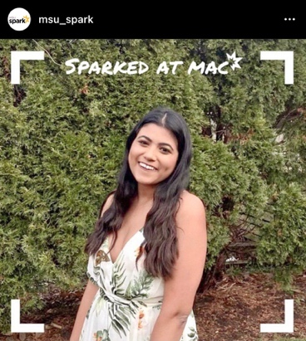
Likes: 146
Sends: 3
Saves: 4
Reach: 3,010
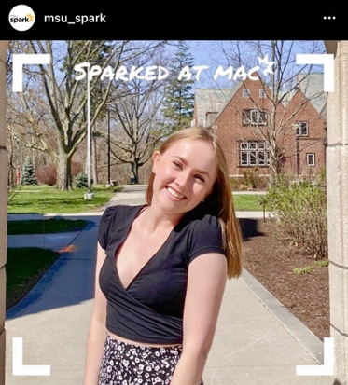
Likes: 251
Sends: 6
Saves: 4
Reach: 3,289

Team Leader Hiring Graphic (TL Hiring Campaign):
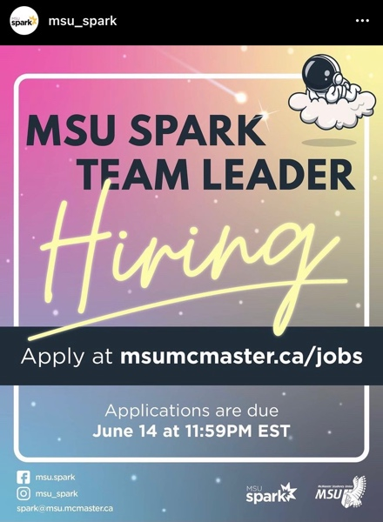
Likes: 172
Sends: 216
Saves: 84
Reach: 3,840

Team Leader Hiring Video (TL Hiring Campaign):
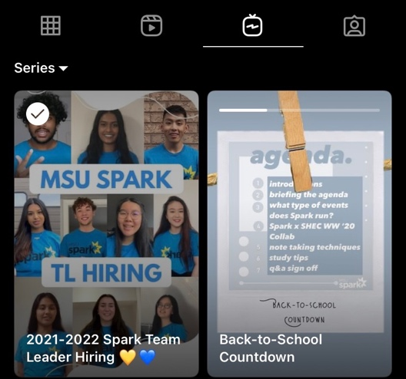
Views: 3,014
Likes: 182
Sends: 60
Saves: 27
Reach: 3,108

Social Media Engagement

Instagram (Last 30 Days)
Table 1: Instagram Engagement Insights
Insights | Start Values | Last Report Values | Current Values | Report Change (%) | Total Change (%)
Followers | 4532 | 4532 | 4532 | 0 | 0
Impressions | 46,090 | 46,090 | 46,090 | 0 | 0
Profile Visits | 2,951 | 2,951 | 2,951 | 0 | 0
Website Visits | 229 | 229 | 229 | 0 | 0
Reach | 5,290 | 5,290 | 5,290 | 0 | 0

Twitter (Previous Month)
Table 2: Twitter Engagement Insights
Insights | Start Values | Last Report Values | Current Values | Report Change (%) | Total Change (%)
Followers | 600 | 600 | 600 | 0 | 0
Mentions |  |  |  | #DIV/0! | #DIV/0!
Likes |  |  |  | #DIV/0! | #DIV/0!
Impressions |  |  |  | #DIV/0! | #DIV/0!
Engagement |  |  |  | #DIV/0! | #DIV/0!

** I apologize, but I am unsure how to collect Twitter insights other than through third party applications! I consulted the AD and P&P Coordinators and they were unsure as well.

Facebook (Last 28 Days)
Table 3: Facebook Engagement Insights
Insights | Start Values | Last Report Values | Current Values | Report Change (%) | Total Change (%)
Likes | 2,678 | 2,678 | 2,678 | 0 | 0
Reach | 920 | 920 | 920 | 0 | 0
Views | 108 | 108 | 108 | 0 | 0
Engagement | 129 | 129 | 129 | 0 | 0
Followers | 2,817 | 2,817 | 2,817 | 0 | 0

Finances
- Currently working on my budget plan and will have that submitted by the proposed due date (July 9th).
- Only spending thus far has been for TL hiring graphics ($125) and I have set up a standing order with the Underground (UG) for $1500.00.
- Would like to point out to the EB that Spark has taken on the additional responsibility of conducting Summer programming (due to Horizons being rescinded) and as a result, we have technically become a full-year Service. However, we received the same Advertising and Promotions budget as last year ($2600) despite having to promote additional programming.
- Would like to advise that Spark is working on developing strategies with the UG and Comms Team to help us stay within budget, but I do feel this could be a barrier for us nearing the end of the year. As a result, I may have to ask to overspend above the $2600 in the future or may have to ask for permission to not execute parts of Spark’s Operating Policy.
- The additional expenses that are required from a promotional standpoint to execute this Summer programming that Horizons previously had done is likely around $300.
- I just wanted to make the EB aware of this, but I am fully committed to trying to stay within budget. However, I jwanted to highlight this as a potential issue that may arise.

Budget Summary
Table 4: Budget Tracker
Account Code | Item | Cost | Description | Date of Purchase
5003-0125 | SPARK - OFFICE SUPPLIES | $ 100 -
 | Total Spent in Line | $ -
 | Remaining in Line | $ 100 -
6103-0125 | SPARK - ANNUAL CAMPAIGNS | $ 3,000 -
 | Total Spent in Line | $ -
 | Remaining in Line | $ 3,000 -
6501-0125 | SPARK - ADVERTISING & PROMOTIONS | $ 2,600 -
 | Total Spent in Line | $ 1,625 - | TL Hiring Graphics and Standing Order w/ UG
 | Remaining in Line | $ 975 -
6494-0125 | SPARK - VOLUNTEER APPRECIATION | $ 750 -
 | Total Spent in Line | $ -
 | Remaining in Line | $ 750 -
6802-0125 | SPARK - LEADER TRAINING | $ 500 -
 | Total Spent in Line | $ -
 | Remaining in Line | $ 500 -

Executives and Volunteers
- My Executive Team is filled with absolutely AMAZING human beings who are truly passionate about first year success. I couldn’t ask for a better team and don’t know how I got so lucky. They are all so talented and I am continuously impressed by the work they do for the Service.
- Hired two new Executives due to a Sessions Coordinator stepping down from their position, and additional support required for the Promotions and Publications Coordinator role.
- At this point in the year, there has been a lot of planning taking place for programming throughout the year and the Summer -- their morale is definitely high, and they have been working hard!
- Team Leaders (TLs) are currently in the process of being hired. We are wrapping up interviews at this point in time but will have an entire TL team hired by the next EB report from Spark is presented.
- TL hiring has been a tiring process for the Executives, but we tried our best to cut down the length of interviews this year to accommodate for this strain and to prevent burn-out! From a logistical standpoint, it has worked extremely well.
- The Assistant Director and I have been regularly checking-in with the Execs individually or in their coships. We are currently having weekly Executive Meetings.
- Team Leaders will be provided a Team Leader Guidebook as a substitute for the transition reports the Executives typically receive.

Successes

So far, the Spark Team has had many successes that I am extremely proud of! They are as follows:
- Executive Hiring: Together, the Assistant Director and I have hired a team of absolutely AMAZING Executives. While it was definitely a tiring hiring process that was prolonged with an individual stepping down from their position, it was extremely rewarding, nonetheless. The Executives consistently impress me, have been such a helpful support system, and are truly passionate about the Service and supporting first years. Each and every Executive brings unique talents to the team, and I cannot wait to see all of their work thus far come to life. Being able to spend this year learning with them is an absolute privilege and I could not ask for a better Executive Team. They truly help to make McMaster ‘Shine Brighter’.
- Team Leader Hiring: Team Leader hiring is always a stressful, time-consuming task in Spark. With the additional responsibility this year to host Summer programming, the AD and I decided to push Team Leader hiring forward to ensure it does not overlap with the upcoming Spark Webinars. Not only does this reduce the strain on the Events Coordinators, but we also have extra people power to help out during the Summer! This year, we received 172 applications, interviewed approximately 103 applicants, and will select 34 Team Leaders. Despite the ambitious timelines we set, everybody involved was beyond supportive in helping Spark meet these goals. All of the Executives completed every step by the proposed due date and worked diligently to ensure it was a hiring process we were all proud of. So far, we have been receiving phenomenal feedback from applicants. Despite their busy schedules, all Executives have been extremely accommodating to ensure we can hire our Team Leaders by the proposed deadlines. We are all so excited to be able to welcome the new Team Leaders to our Spark family!
- Team Dynamic: One slight fear I had prior to hiring the Executives for the Sessions Coordinator and Events Coordinator positions was having a trio for the first time in Spark. This dynamic can at times be hit or miss, with one individual being excluded. However, thus far, after checking in with all of the Executives both individually and in their coships, everything has been working out very well! Aside from that, the dynamic amongst the Executives as a whole has been phenomenal. They were very welcoming to the new Executives that were hired, and we have a very fun dynamic. The Executive Team, AD, and I have been able to establish a mix of personal and professional relationships with every individual. Overall, this has made the experience VERY enjoyable for everybody involved. For future Spark Directors, I think that taking the time to host an Incoming/Outgoing Executive Event and an Executive Retreat was extremely helpful in establishing these bonds early on. We have also set out clear expectations within the team that allows us to work respectfully and efficiently with each other. Ultimately, this has helped to set the Spark team up for future success!

Challenges

Spark has experienced the following challenges thus far:

- Scheduling: Spark has increased the size of its Executive Team significantly this year to ten (10) individuals as opposed to the previous six (6). With that being said, scheduling a time when each Executive is available has definitely been difficult. We have established a weekly Executive Meeting time which in and of itself was a HUGE success, but finding time for additional meetings is definitely difficult. We have become very avid users of When2Meet, and it has been super helpful thus far! Scheduling for larger tasks, like TL hiring for example, makes it even more difficult to find a time when everybody is available. With that being said, we are trying our absolute best to accommodate to each Executive’s scheduling needs, and all has worked out thus far (however, this does not discount the fact that it is still tough to do so!). The AD (Vivien) is also extremely helpful in handling many of the logistics with regards to scheduling. I am beyond grateful for all of her help!
- Communication: While attempting to tackle TL hiring and plan for the Summer Webinars simultaneously, I found that I dedicated the majority of my time towards the hiring process. Looking back, I should have divided my time a little bit more equally between hiring and the Summer programming to ensure that the Events Coordinators were on the right track in the planning process. While they were able to provide weekly updates to the AD and I during our Executive Meetings, this communication was minimal. We ran into a slight problem in the planning process with the Events Coordinators causing us to have to go back and revisit some of the logistics and our personal expectations for these Webinars. While earlier and more regular communication between myself, the AD, and the Events Coordinators would have been beneficial, they have still been able to plan very engaging and useful Summer programming that I am certain will be a huge support system for first years. I cannot wait to see their ideas and months of hard work on this Webinar series come to life in the upcoming days! Recognizing this slight mishap, moving forward, I am going to ensure that I check in with the Executives on their upcoming initiatives more frequently to mitigate the likelihood of this happening again.
- Supporting Executives: With the increased size of the Spark Executive Team (10) and the responsibility to now conduct Summer programming, this has made myself and the AD very busy in all aspects of our role. One of my priorities that I established before starting this position as Director was to ensure that I was adequately supporting my Executive Team. While I do feel that they are adequately supported by myself and the AD, I would like to be able to spend more time checking in with them than we have previously done. Moving forward, I am going to prioritize conducting more frequent 1-on-1s with the Executives, especially throughout the year. This ensures that I am checking in on them outside of the Executive Meetings so they know that I am here to support them every step of the journey in their role! With this being said, I am going to rely more on my AD to help support me in this endeavour.

Miscellaneous
The new Promotions and Publications Coordinator, Irene, will be attending Communications Training with MSU SHEC. I have checked in with Michael Wooder and Anika Anand regarding this and have been given the go ahead!

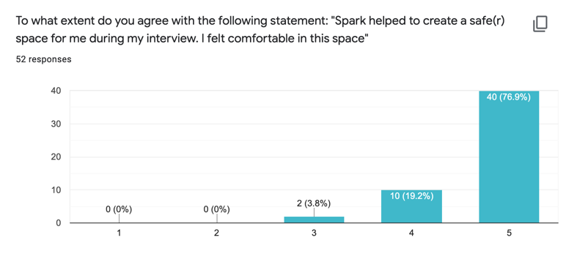
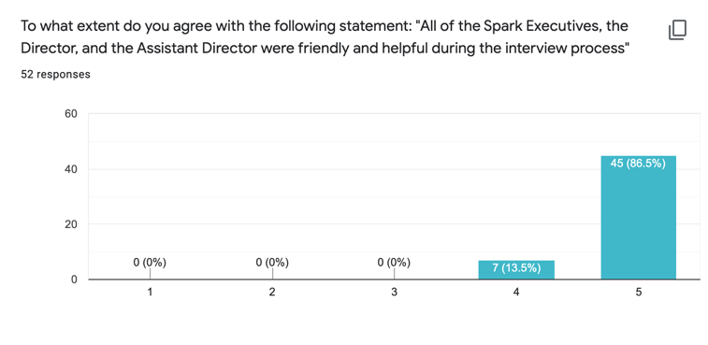
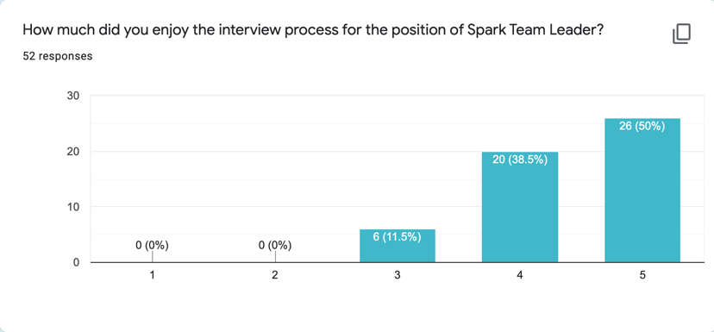
We have been collecting feedback on the TL hiring process from applicants and I wanted to share it as a proud moment for the Spark team!
