REPORT
From the office of the…

Maccess Director (Emunah Woolf)
Maccess Assistant Director (Susan Attaei)
TO: | Members of the Executive Board
FROM: | Emunah Woolf and Susan Attaei
SUBJECT: | Maccess Report 1
DATE: | June 24, 2021

Year Plan Update
May was spent developing the year plan. We also met with the Directors of other services to align our values and possible events. A draft of the year plan has been submitted to the VP Admin. We intend to incorporate feedback and event ideas from the executive team as changes to the year plan before the final version is due.

Events, Projects, & Activities

General Service Usage
The space is not open over the summer but we are planning to host a summer drop-in group over July and August. However, Maccess had a peer support request through Instagram and Emunah was able to meet this need by holding a 1:1 peer support conversation over Discord.

Projects & Events

Project 1:
Project Status: In progress
General Information: Executive Team hiring and onboarding
We have just hired the eight members of our executive team. We collected applications, reviewed them, offered interviews, and gave offers to join the team. We have had our first executive team and are midway through conducting 1:1 meetings with each executive member to determine strengths, interests, and access needs. We are also meeting with both members of any roles where two executives are hired (Social and Political Advocacy, Training and Development). We have begun developing executive team training to be delivered in July. Looking at our team, we excited to begin community building and planning for the year ahead!

Project 2:
Project Status: In progress
Building relationships with other services
Emunah has spent time building relationships with the Directors of the other peer support services (PCC, SHEC, WGEN, Diversity Services). This enables the services to collectivize concerns and utilize our strengths across services. It also enables us to align our goals and visions with one another and sets us up well to host collaborative events throughout the year. This has gone well with the services meeting three times thusfar and beginning a conversation thread where we offer each other support, assistance, training opportunities, and resources.

Project 3:
Project Status: Upcoming
Summer drop-in group
The Maccess community is experiencing increased levels of isolation over the summer given the continuity of COVID-19 and the lack of disability community that is available during the year. We have heard multiple students express that this isolation has been difficult lately. We hope to run a weekly 1-2 hour drop-in group to help community members cope with isolation, running through July and August. We introduced this idea to the executive team and will be getting advertising material from the Underground and coordinating logistics in the upcoming weeks.

Outreach & Promotions

Summary
We have advertised for executive team positions, leading to many applications coming in. We have also received engagement on Instagram story posts throughout the month. Now that we have a promotions executive, we hope to better utilize our social media accounts.

Promotional Materials

Social Media Engagement

Instagram (Last 30 Days)
Table 1: Instagram Engagement Insights
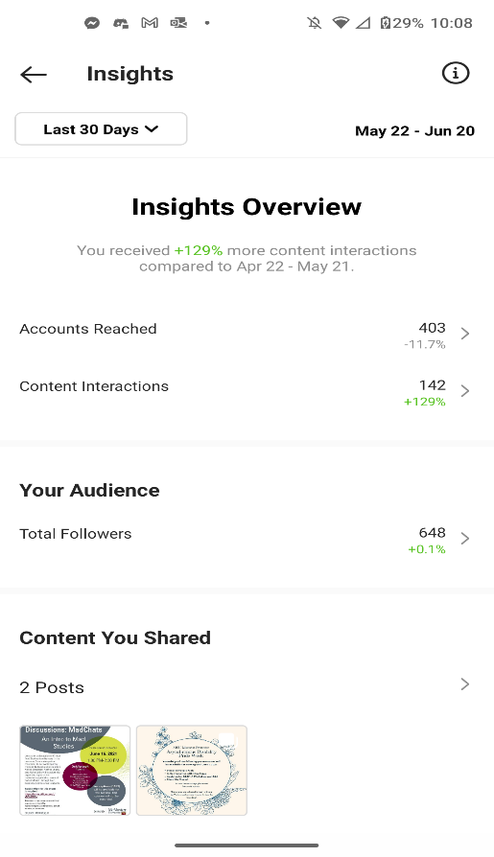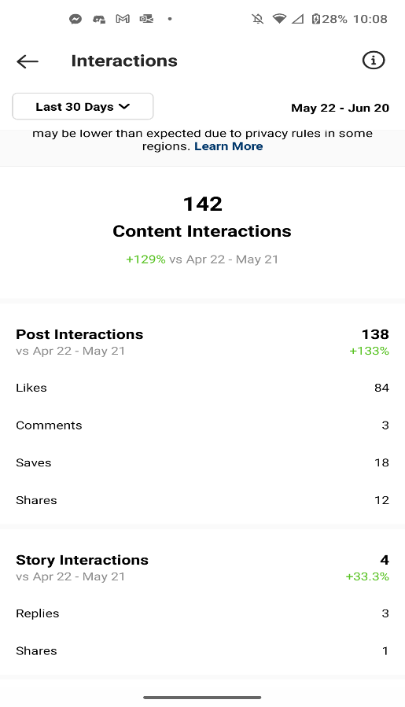

Twitter (Previous Month)
Table 2: Twitter Engagement Insights
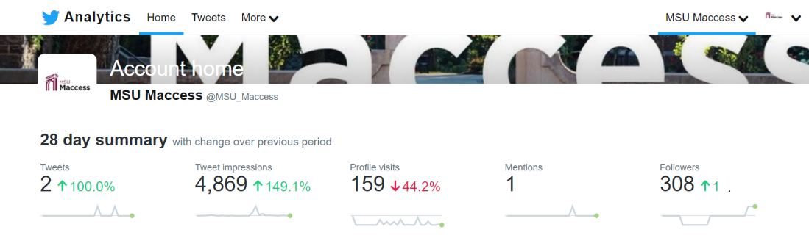

Facebook (Last 28 Days)
Table 3: Facebook Engagement Insights
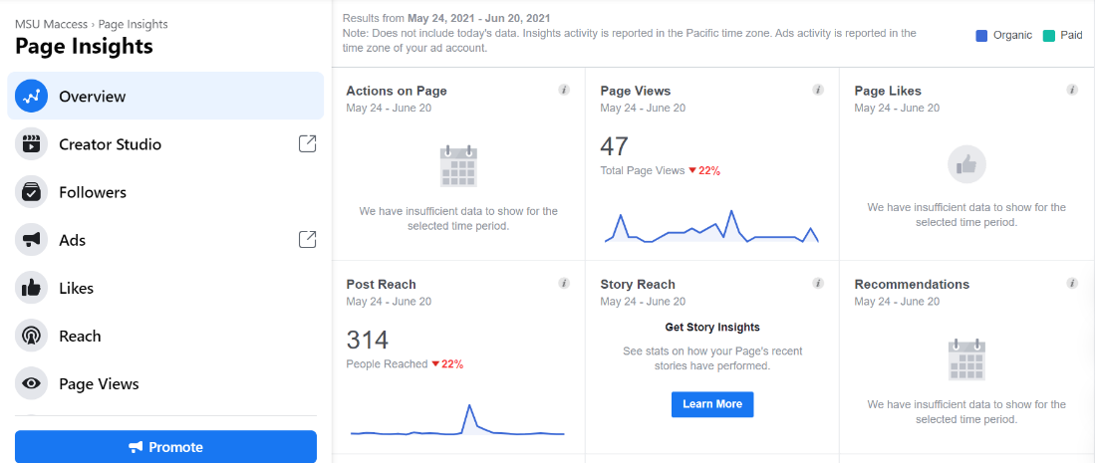

Finances
As of yet, we have not spent any money from this years’ budget, although we did have to deal with a few remaining purchase orders from the last Director’s budget. We have spent time on finance training and are mid-way through creating a budget plan for the year.

Budget Summary
We have not yet finished our budget plan and have not yet spent any money.

Executives and Volunteers
We have just hired our executive team and held our first team meeting. The execs seemed excited to meet each other and get started working together. We are meeting with each team member individually and folks seem glad to be part of Maccess.

Successes
We are so pleased with our executive team – we feel that we hired people into roles that fit their talents and interests and who will work well with one another.

Challenges
It has taken some time to settle into a working dynamic amongst the Director and Assistant Director, although we have set up a weekly check-in to ensure we are on the same page and have things to be working on. We also struggled in creating the year plan as we are unsure of the ability to operate in person over the schoolyear.

