REPORT
From the office of the…

Food Collective Centre Director
TO: | Members of the Executive Board
FROM: | Morghen Jael
SUBJECT: | FCC Report 1
DATE: | June 24, 2021

Year Plan Update
I submitted my year plan on June 16, and I have yet to receive any updates/feedback on it. I plan to share the year plan with my Assistant Director soon (and with the rest of our execs once we hire them), and I will edit the plan according to feedback or any new ideas.

Events, Projects, & Activities

General Service Usage
The FCC in-person food bank space is currently not being utilized due to pandemic closures. I have been in contact with McMaster Hospitality Services to discuss accessing the space in the short-term/during the school year; I hope for clarity on this issue soon. Lockers of Love is currently on hiatus – we are waiting to see whether the FCC AD will be approved for employment starting before August 1, since Lockers of Love is typically overseen by the AD – but we have sending emergency financial aid to students in need of food support who have contacted us in the interim, in the form of electronic gift cards. Funds for this have come from last year’s leftover FCC budget (though I am unsure on details; I am still waiting to hear back from Kevin O’Mara about this), or from McMaster’s Meal Exchange Student Ambassador, who luckily has a sum of Meal Exchange funds available this summer for supporting food insecure individuals. When we have engaged with the latter funding source, I have had the Student Ambassador issue the electronic gift cards directly on their end, so that the FCC budget does not become impacted. Both of these funding avenues are intended to be exceptional and temporary; as soon as we have clarity on the AD’s hiring status, we will move forward with running Lockers of Love more officially. I hope to consult with VP Admin soon about whether the temporary funding from Meal Exchange needs to be logged into my Budget Tracker, or whether we will treat these situations as merely an FCC referral to the McMaster Meal Exchange Student Ambassador.

Folks continue to engage with the FCC on social media (particularly with our recent promotions surrounding Exec hiring).

I continue to be engaged with planning for SUSTAIN 2SS3 (Project: Advocating for a Community Fridge) as a Community Project Champion, affiliated officially with the FCC. The FCC will be an official supporter of the Community Fridge project, should it materialize successfully, though we will not contribute financially at this point.

Projects & Events

Hiring Executive Team:
Project Status: Ongoing
General Information:
Applications for Good Food Coordinator, Promotions Coordinator, Community Kitchen Coordinator, and Social & Political Advocacy Coordinator(s) closed on June 14, and the hiring panel (consisting of myself and the incoming AD) is currently reviewing the resumes and selecting candidates to be interviewed. We plan to conduct interviews synchronously and virtually over the course of the next week and a half.
Hiring the rest of our Executive Team will kick-start year planning! I am excited to establish team relationships and to get input from Exec members on my plans for the year.

FCC involvement with SUSTAIN 2SS3:
Project Status: Upcoming/ongoing
SUSTAIN 2SS3 is a 2021 Summer session course, so it officially begins this week. I am working with my co-Community Project Champion, a Health Promoter from the SWC, to brainstorm how to best guide and support students in the Community Fridge working group. We have been gathering resources, learning about the logistics community fridge implementation, and considering the long-term possibilities for the project (e.g., can FCC volunteers help to conduct routine check-ins on the fridge?).

Cultivating Change: A Food Collective Centre Web-series:
Project Status: Upcoming
I am in the planning stages of this year-long advocacy project (financed with Special Project Funding from the McMaster Okanagan Committee); recent action items have included composing a project description for the MOC to use in their promotions of our project, working with VP Finance to determine where and how the funding can be transferred to us, and sifting through old FCC files to pull out logos and photos that can be used for Cultivating Change promotion. Once we hire our Social & Political Advocacy Coordinators, we will determine one SPAC to take on this project for the year; planning (including contacting community partners who may be able to host workshops) can really begin at this point.

Outreach & Promotions

Summary
We not yet hired our Promotions Coordinator, nor have I or the AD received Communications training, so our social media presence has been minimal so far this summer. Exec hiring was promoted on Instagram, Facebook, and Twitter; I am temporarily logged into these accounts to make posts and answer any questions sent to us by dm.
Because we have not yet received Comms training or been very active on social media, statistics shared under “Social Media Engagement” below are more rudimentary than they perhaps will be in future EB reports. However, you will notice that we have healthily increased our followers on Instagram in the last month; this is probably related to the buzz surrounding Exec hiring.

Promotional Materials
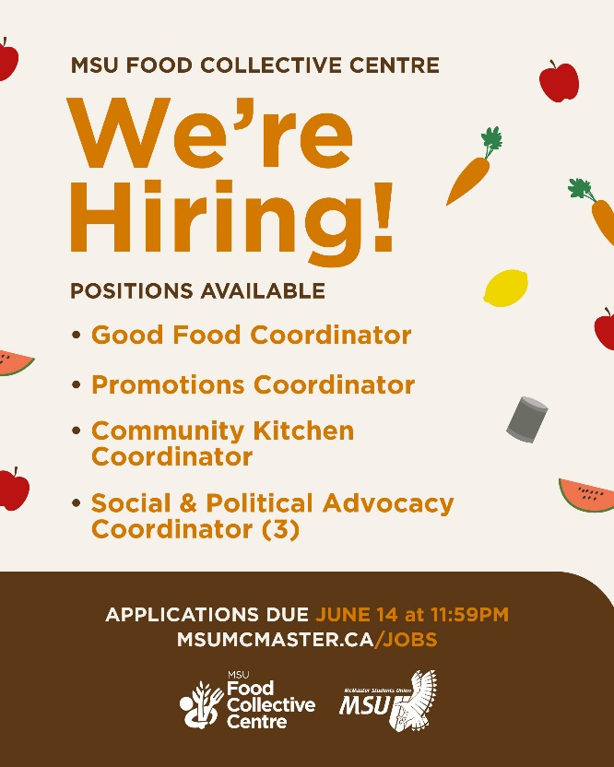
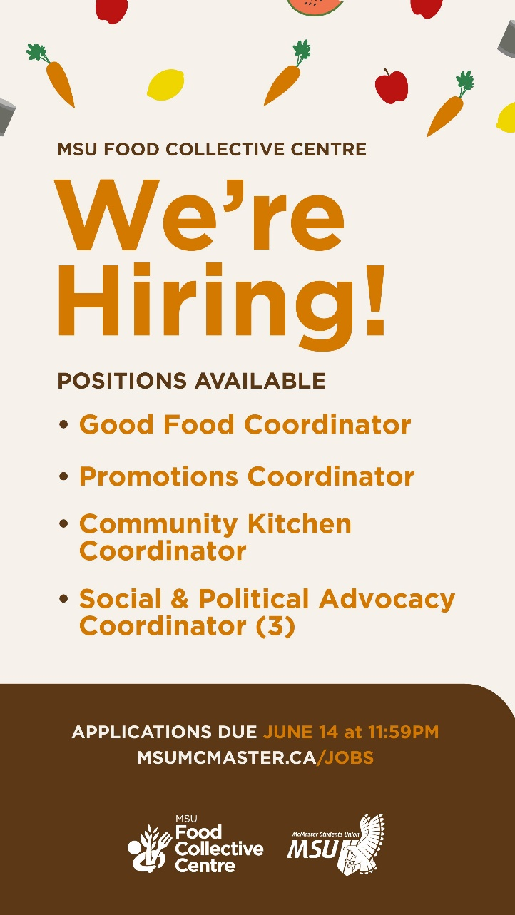

Social Media Engagement

Instagram (Last 30 Days)
Table 1: Instagram Engagement Insights
Insights | Start Values | Last Report Values | Current Values | Report Change (%) | Total Change (%)
Followers | 781 |  | 802 | #DIV/0! | #DIV/0!
Impressions |  |  | 2022 | #DIV/0! | #DIV/0!
Profile Visits |  |  | 178 | #DIV/0! | #DIV/0!
Website Visits |  |  | 24 | #DIV/0! | #DIV/0!
Reach |  |  | 551 | #DIV/0! | #DIV/0!

Twitter (Previous Month)
Table 2: Twitter Engagement Insights
Insights | Start Values | Last Report Values | Current Values | Report Change (%) | Total Change (%)
Followers | 663 |  | 658 | #DIV/0! | #DIV/0!
Mentions |  |  | 1 | #DIV/0! | #DIV/0!
Likes |  |  | 0 (but 3 retweets) | #DIV/0! | #DIV/0!
Impressions |  |  | 1400 | #DIV/0! | #DIV/0!
Engagement |  |  | 16 | #DIV/0! | #DIV/0!

Facebook (Last 28 Days)
Table 3: Facebook Engagement Insights
Insights | Start Values | Last Report Values | Current Values | Report Change (%) | Total Change (%)
Likes | 1495 |  | 1497 | #DIV/0! | #DIV/0!
Reach | 134 |  | 509 | #DIV/0! | #DIV/0!
Views |  |  | 40 | #DIV/0! | #DIV/0!
Engagement |  |  | 14 | #DIV/0! | #DIV/0!
Followers |  |  | N/A | #DIV/0! | #DIV/0!

Finances
My budget plan is due July 9, so I will have more details to report after that point. I recently did the Finances/Budget training provided by VP Finance, which was very helpful in my learning. I am struggling to figure out how much freedom and leeway I have in my allocation of funds; it is hard to know how detailed my budget plans should be, when the state of our service’s programming is still uncertain for the coming year (e.g., online vs in-person events)!
I will update my budget tracker/plan once I receive confirmation that the McMaster Okanagan Committee has sent our grant for Cultivating Change to the MSU; it will belong under “Sponsorship/Donation Revenue”.

Budget Summary
Table 4: Budget Tracker
Account Code | Item | Cost | Description | Date of Purchase
5003--0318 | FCC - OFFICE SUPPLIES | $ 100 -
 | Total Spent in Line | $ 0 -
 | Remaining in Line | $ 100 -
6102-0318 | FCC - ANNUAL CAMPAIGNS | $ 2300 -
 | Total Spent in Line | $ 0 -
 | Remaining in Line | $ 2300 -
6494-0318 | FCC - VOLUNTEER RECOGNITION | $ 750 -
 | Total Spent in Line | $ 0 -
 | Remaining in Line | $ 0 -
6501-0318 | FCC - ADVERTISING & PROMOTIONS | $ 2300 -
 | Total Spent in Line | $ 0 -
 | Remaining in Line | $ 2300 -
6603-0318 | FCC - RESERVE | $ 1000 -
 | Total Spent in Line | $ 0 -
 | Remaining in Line | $ 1000 -

Executives and Volunteers

We have not yet hired volunteers for the year (this process begins in August), and we are currently reviewing resumes for the remaining Executive positions, but the Assistant Director and I have been in regular contact and I believe her transition is progressing well. We have already established a very open and friendly working relationship!

Successes
The recent news that our application for MOC funding for Cultivating Change: A Food Collective Centre Web-series was successful is a major success for our service! This will be an exciting opportunity to do a large-scale advocacy project.

Challenges
Uncertainty surrounding campus facilities closures/reopening (this summer, and the coming school year) has been a challenge; it has been difficult to make year plans when it is unclear to what extent the food bank space will be accessible or whether in-person workshops will be possible during the Fall.

Miscellaneous
I submitted two memos to EB in an email to VP Admin on June 16; they are both regarding the FCC Assistant Director’s employment contract. I am happy to re-send or further explain these memos in an EB meeting if need be!

