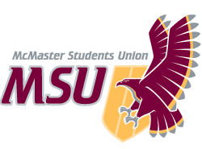 | REPORT  From the office of the…  Macademics Coordinator
TO: | Members of the Executive Board
FROM: | Taya Linton
SUBJECT: | Macademics Report #1
DATE: | June 11th, 2021

Year Plan Update
The Year Plan for Macademics has not yet been fully finalized; it is still being edited and revised before being submitted to the VP Administration, Christina, on June 16th.

This month, the service is focusing on hiring and onboarding our executive team.

Events, Projects, & Activities

General Service Usage
Since we are heading into the summer months, there are not any campaigns currently running. Service usage during this time is limited to interactions with the official Macademics social media and past blog posts.

Projects & Events

Project 1: Executive Team Hiring
Project Status: Ongoing
General Information:
Executive team applications are currently open and are being promoted through the service’s social media accounts. After the applications close on June 14th and have been reviewed, interview requests will be sent out. Currently, interviews will be conducted with the help of the outgoing Macademics Coordinator and are scheduled to take place during the week of June 21st. If this is the case, job offers will likely be sent to successful candidates the week of June 28th.

Project 2: Executive Team Onboarding
Project Status: Upcoming
General Information:
Once the executive team has been selected, the initial team meeting will be held. During this meeting, I will review the service’s philosophy, as well as its role within the MSU. In addition to this, I will also be discussing the responsibilities and expectations associated with each of their roles, the goals I’ve set out for the service this year, and how they can go about creating the Year Plan for their subcommittee.

A separate team meeting will also be held to allow the executive team to bond with each other. This will hopefully aid in building a strong team dynamic, which will be beneficial for the service as a whole.

Additionally, the Promotions Coordinator and I will be meeting with the Director of Marketing and Communications, Michael, to complete communications training in July. As more information is released, Executive Team members will also attend MSU-wide trainings.

Outreach & Promotions

Summary
All promotions are currently advertising the available executive team positions. Throughout the promotional period (May 31st to June 14th), the attached graphics have been posted and shared through the service’s Instagram and Facebook accounts.

Promotional Materials
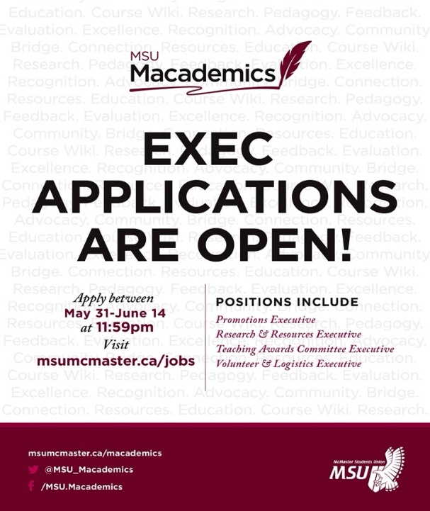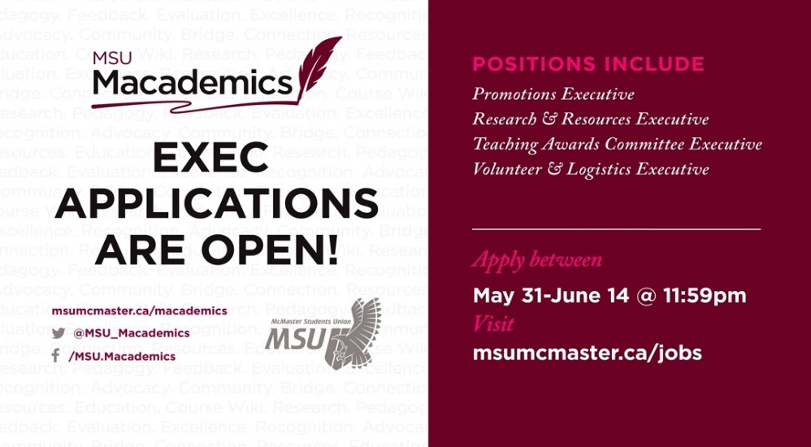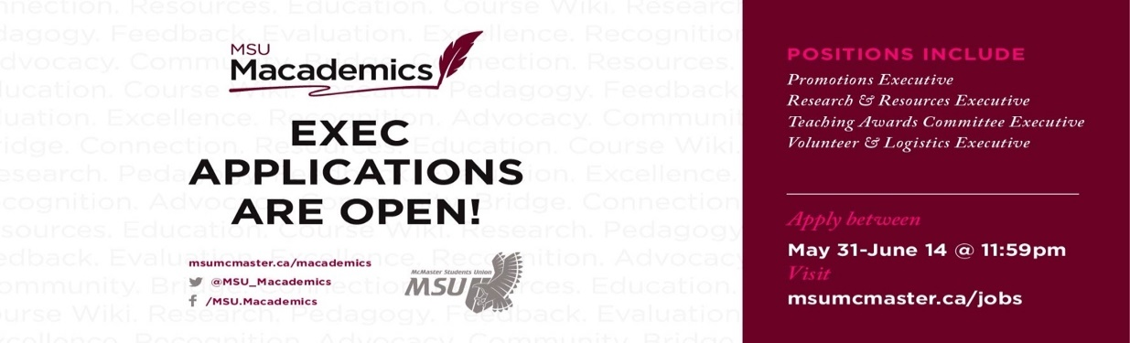

Social Media Engagement

Instagram (Last 30 Days)
Table 1: Instagram Engagement Insights
Insights | Start Values | Last Report Values | Current Values | Report Change (%) | Total Change (%)
Followers | 381 |  | 381 | 100% | 100%
Impressions | 854 |  | 854 | 100% | 100%
Profile Visits | 148 |  | 148 | 100% | 100%
Website Visits | 22 |  | 22 | 100% | 100%
Reach | 321 |  | 321 | 100% | 100%

Facebook (Last 28 Days)
Table 3: Facebook Engagement Insights
Insights | Start Values | Last Report Values | Current Values | Report Change (%) | Total Change (%)
Likes | 2 |  | 5 | 250% | 250%
Reach | 671 |  | 858 | 128% | 128%
Views | 65 |  | 54 | -83% | -83%
Engagement | 7 |  | 4 | -57% | -57%
Followers | 2 |  | 5 | 250% | 250%

Finances
The budget is in the process of being completed, but will be finished by the given deadline, July 9th. Nothing has been taken out against the budget thus far.

Executives and Volunteers
As previously mentioned, executive team applications are currently open, and the executive team is scheduled to be hired by the beginning of July. Once the executive team is hired, I will meet with the Volunteer and Logistics Coordinator to plan volunteer hiring for the upcoming year, which will most likely occur in September. The format of volunteer hiring and the size of the volunteer team will heavily depend on McMaster’s plan for the Fall 2021 term.

Successes
Promotion for the executive positions is going well and I’m looking forward to finalizing the executive team!

Challenges
As of right now, the biggest challenge is creating a Year Plan and setting goals for the service that I am confident can be executed this upcoming year. Since it is currently unclear how much access students will have to the campus, it is difficult to decide on the best approach for aiding students this year. With that being said, I feel that the best way to overcome this challenge is to focus on projects that could potentially be executed using a number of delivery methods.

