MSU Occupational Health And Safety Policy

- PURPOSE

To ensure that health and safety concerns in the MSU workplace are identified and addressed.

- Joint Health & Safety Committee

The Joint Health & Safety Committee of the McMaster Students Union shall act as an advisory body. The Committee will act in accordance with the Occupational Health & Safety Act (herein after referred to as the Act) and shall;

  - hold regular meetings and conduct regular inspections as specified in the Act;
  - ensure that all health and safety issues encountered during inspections are addressed to the satisfaction of the committee, employee and the employer;
  - help stimulate awareness of health and safety issues in the workplace;
  - recognize and deal with workplace risks;
  - maintain adequate records of inspections, and minutes of meetings and ensure that
the information is accessible to employees and the employer;
  - ensure that a copy of the Act is posted in an accessible area of all MSU buildings

- OPERATING PARAMETERS

  - The Joint Health & Safety Committee will meet at least every three months or as required.
  - The JHSC will draft or revise a written MSU occupational health and safety policy and ensure that it is adopted and implemented on an annual basis by the MSU Board of Directors.

- Committee Members

  - Committee Members shall serve on the JHSC for a period of at least one year.
  - There will be at least four committee members with at least half of the members being worker representatives.
  - There will be at least two certified members of the Committee at all times; one member representing Management, and one member representing Workers.
  - The committee shall elect from within its membership, two Committee Co-Chairs who will alternate as the chair of meetings
  - The committee shall elect from within its membership, two Committee Co-Secretaries, who will alternate as the secretary of meetings.

- Occupational Health & Safety Policy Statement

The management of the McMaster Students Union Inc. is vitally interested in the health and safety of its employees. Protection of employees from injury or occupational disease is a major continuing objective. The McMaster Students Union will make every effort to provide a safe, health work environment. All supervisors and workers must be dedicated to the continuing objective of reducing risk of injury.

The MSU, as employer, is ultimately responsible for worker health and safety. The MSU Board of Directors hereby commits that every reasonable precaution will be taken for the protection of workers.

Supervisors will be held accountable for the health and safety of workers under their supervision. Supervisors are responsible to ensure that machinery and equipment are safe and that workers work in compliance with established safe work practices and procedures. Workers must receive adequate training in their specific work tasks to protect their health and safety.

Every worker must protect his or her own health and safety by working in compliance with the law and with safe work practices and procedures established by the company.

It is in the best interest of all parties to consider health and safety in every activity. Commitment to health and safety must form an integral part of this organization.

Date: June 15, 2021

Approved by:

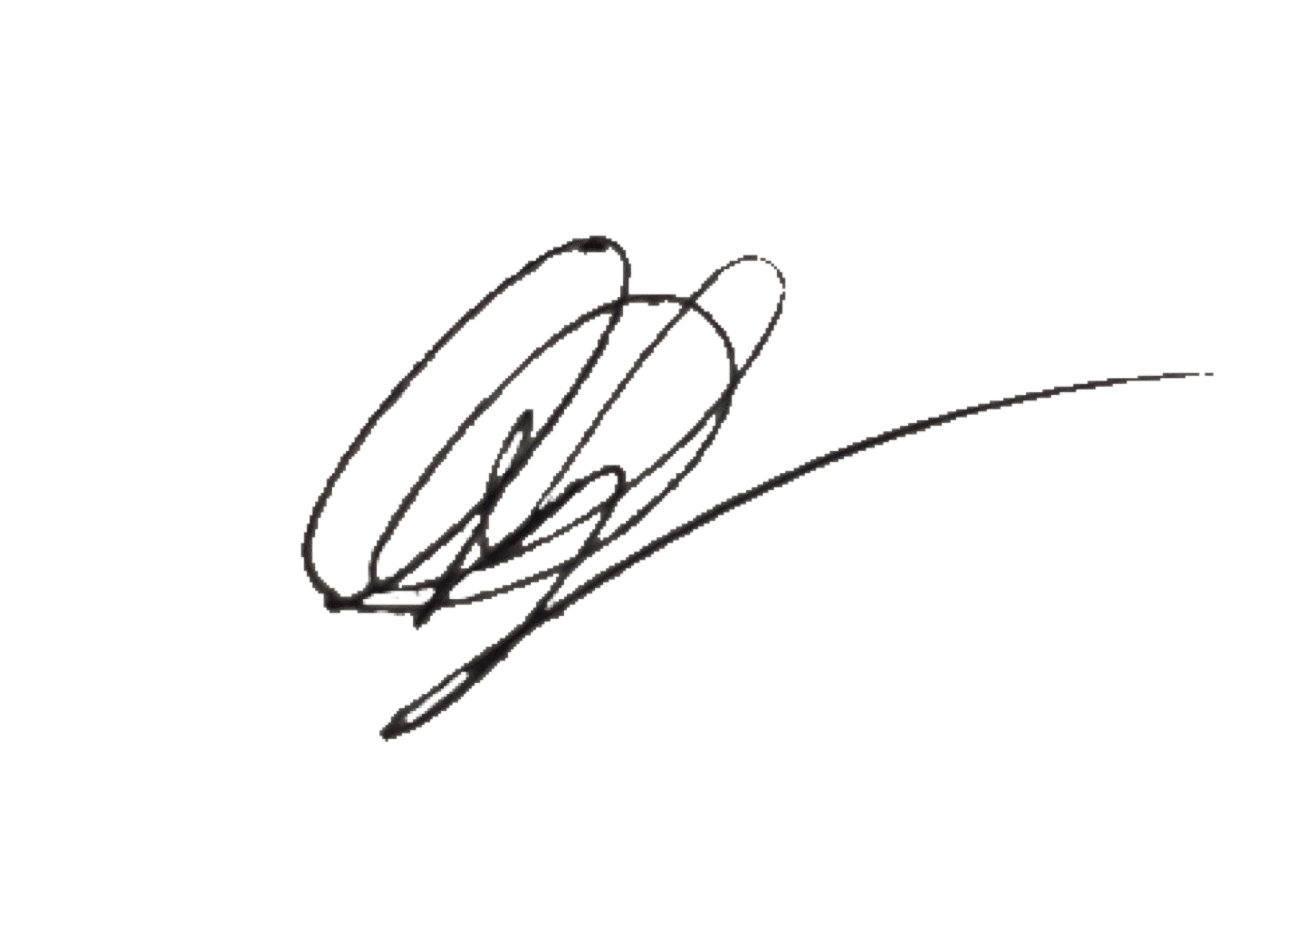
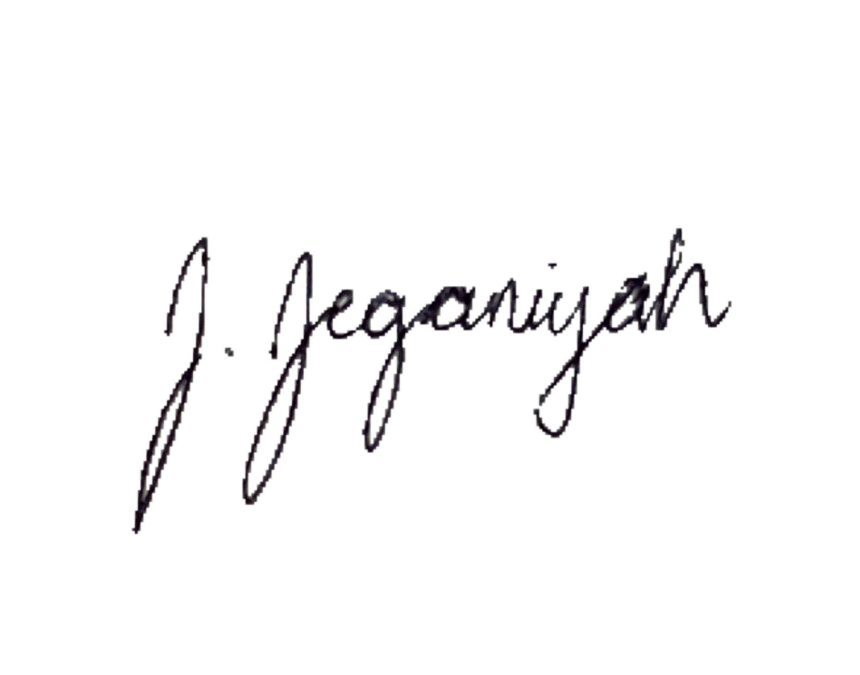

Denver Della-Vedova Jeganiyah Jayachandran
MSU President MSU Vice-President (Finance)

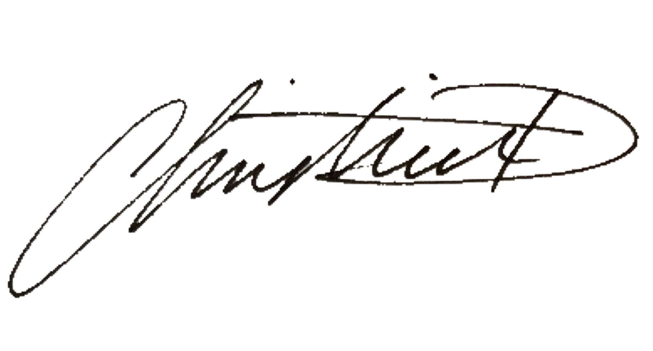
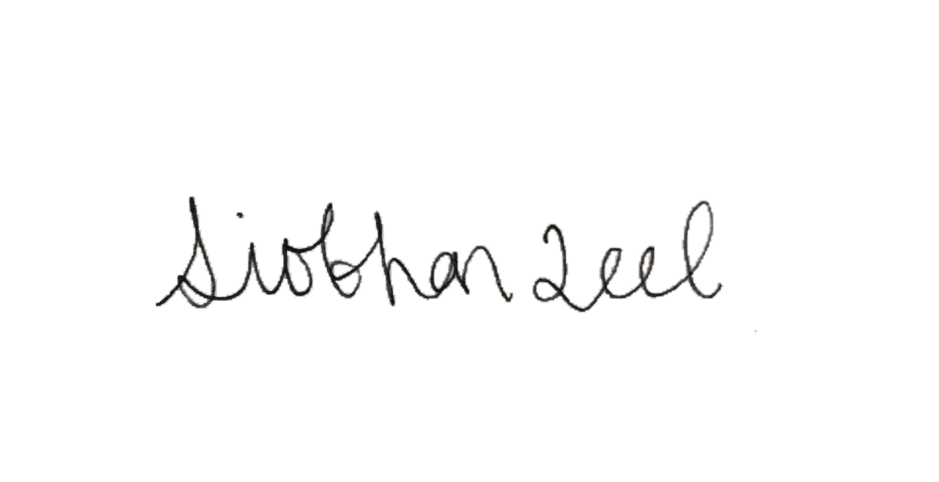

Christina Devarapalli Siobhan Teel
MSU Vice-President (Administration) MSU Vice-President (Education)

