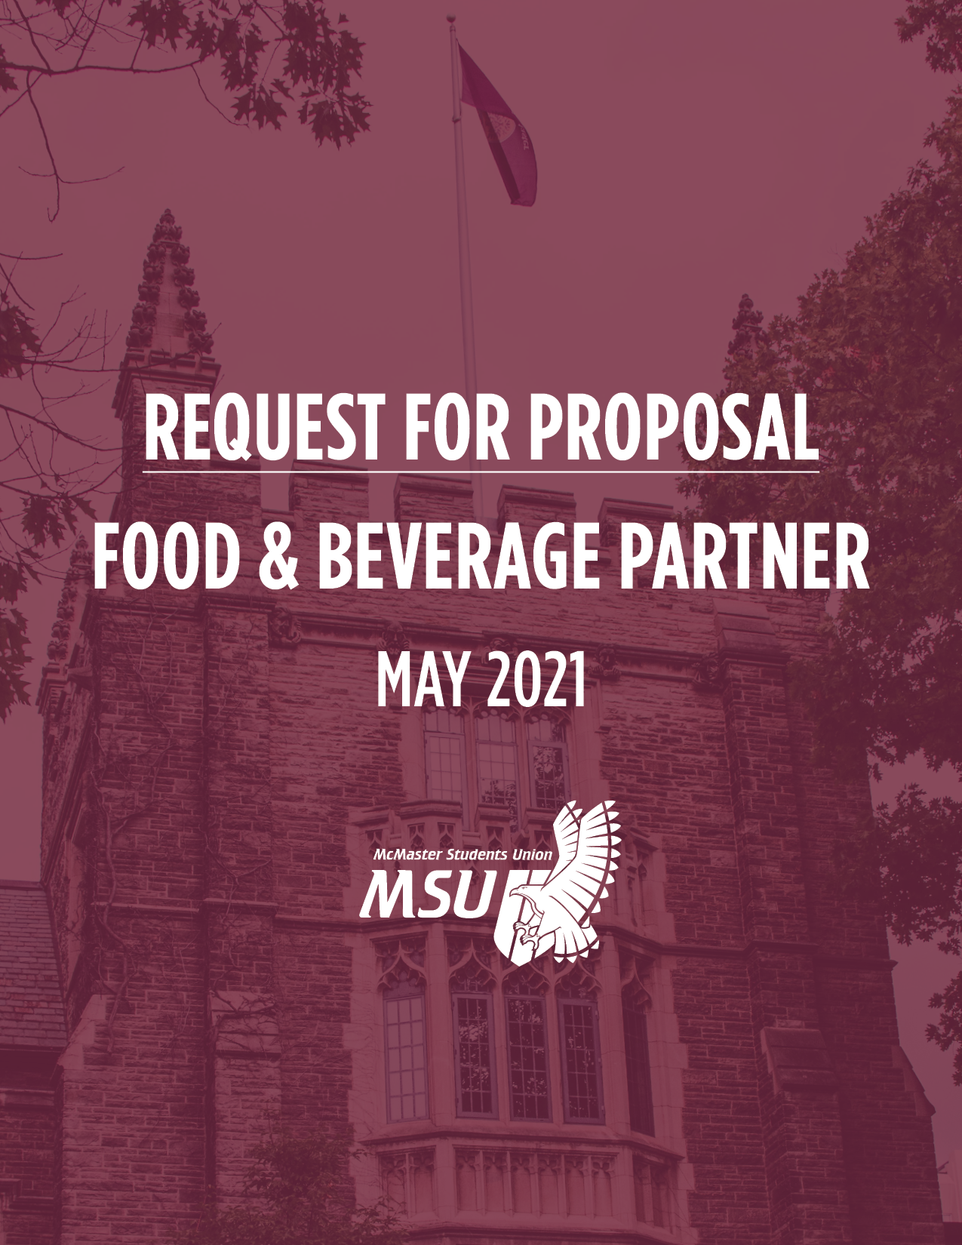

McMaster Students Union Inc.
Request for Proposal

Who We Are
The McMaster Students Union (MSU) is a not-for-profit student association at McMaster University, representing all full-time undergraduate students. The MSU serves students in two main areas: political representation and the enhancement of student life. The MSU is managed by a student Board of Directors, who are elected annually, and supported predominately by a General Manager.
The purpose of the MSU is to draw into a true society all students at McMaster University. In pursuit of this, it fosters activities and events which seek to enhance the University experience of its members and contribute to the operations of the University as a whole. Further, it will seek to facilitate communication between the student body, the University, and other organizations and will organize and regulate student self-government.

The MSU provides services to over 26,000 full-time undergraduate students. Some of these services include its campus restaurant (TwelvEighty), convenience store (Union Market), Emergency First Response Team (EFRT), large-scale event planners (Campus Events & AvTek), and the MSU Child Care Centre.

Over the past decade, the MSU has evolved and grown substantially, currently operating 11 student-led peers support / student life services, three business units, 300+ clubs, and an additional five revenue neutral services. Additionally, the MSU administers a student Health and Dental plan, a Hamilton Street Railway (HSR) bus pass, and is currently overseeing the construction of a 40,000 sq. ft. student centre. To support its day-to-day functions, the MSU typically employees 44 full-time staff, 100+ part-time staff, and over 400 volunteers.

For additional information about the MSU, including a full list of managed and funded departments and services, please visit www.msumcmaster.ca.

Purpose of RFP

The MSU is exploring the opportunity to partner with a leader in the food and beverage industry to meet the needs of the organization and broader campus community. The MSU is seeking proposals from firms and/or consultants who have extensive knowledge and experience in this industry. The partner must provide a clear vision on how to support the student needs in future years. Bidders shall have the opportunity to provide a proposal to partner on any, all, or a combination of the opportunities listed:

TwelvEighty/The Grind
TwelvEighty is the MSU-run bar and grill providing a great selection of delicious food at an affordable price. They offer daily lunch and dinner specials, a wide variety of alcoholic beverage options, an abundance of seating and Wi-Fi. In addition, TwelvEighty provides year-round entertainment, including comedy shows, karaoke, trivia, live music, and club nights.

Opened in 2018, The Grind is a café serving premium coffee and tea, featuring daily specials on scones and baked goods. In addition to its lineup of espresso, lattés and cappuccinos, The Grind has a great selection of both sweet and savory crêpes, made fresh to order. The location is integrated with USB connectivity for device charging. It has proven to be the MSU’s largest area of growth, as it has become a daily destination for many students.

These two operations share a space, located between Togo Salmon Hall and the McMaster University Student Centre, with a licensed capacity of 720 patrons. The two operations share a kitchen and washroom facilities.

Union Market
Union Market is McMaster’s student-run convenience store and coffee shop, offering snacks and affordable, fresh lunch options seven days a week. Union Market is a one-stop-shop for everything a student needs to get through your day. Hot and cold beverages, fresh fruit, sandwiches, and more are all available on a grab-and-go basis.

The HUB Grocery Market
The HUB Grocery Market is projected to open in March 2022. The concept for this operation is to provide fresh groceries, along with grab-and-go and ancillary item that support a healthy lifestyle. The market, like all MSU food and beverage operations, will be open to both students and greater McMaster community.

RFP Terms

- Cost of Proposal – The potential partner shall prepare and submit the proposal at their own expense.
- Opening of Bids – The MSU may review bids and contact partners prior to the close of the RFP for the purpose of expediency.
- Terms of Accepting a Proposal – By accepting a proposal, the MSU does not intend to bind itself legally in any form. The MSU solely intends to begin negotiating a contract on the subject matter of the proposal. Unless the MSU states otherwise in writing at the time, oral or written communications between any potential partners and the MSU on the subject matter of the proposal are to be considered as subject to the execution of a formal written agreement. The MSU reserves the right to not move forward with any proposals submitted.
- Explanation of Decision – The MSU is not bound to explain its decision regarding submitted proposals.

Contents of Proposal

Submitted proposals shall include the following information:
Part I: Your commitment
Please include the following in your proposal:
- Specific location(s) the bid encompasses
- Proposed rent and revenue sharing model
- Vision for location(s)
- Explanation of the positive contribution to the student experience
- Commitment to student and staff employment
- Value commitment
- Marketing and promotion commitment
Part II: Organization overview and experience

Please provide an overview of your organization and experience, such as:
- What services do you provide?
- What are your values?
- What makes your organization unique?
Selection Criteria

The following areas outline the MSU’s priorities and are critical factors in determining the best direction for the MSU.

Student Experience – Your involvement with leading the food and beverage operations will provide an improved experience to the food, beverage, and overall programming within the current portfolio of experiences on campus. Tell us how you have done this in the past and will do so at McMaster.

Financial Viability - The proposal must provide a guaranteed revenue stream to the MSU in addition to any revenue sharing concepts the partner wishes to explore.

Pricing – The MSU prides itself on providing great value to students. Our prices have always been below those of competitors and, therefore, the MSU strives to continue to provide affordable food and beverage options for students.

Staff – A minimum number of jobs shall be guaranteed for full-time undergraduate students or they shall be given the first right of refusal. Additionally, job opportunities would be, ideally, provided to current team members.

Marketing & Promotion – The partner must commit to being a true enthusiast of campus life. This includes a clear marketing budget to support other MSU-related operations through annual marketing and promotions. An overview of all the MSU’s services can be found at www.msumcmaster.ca and please feel free to elaborate on any marketing ideas.

MSU Representative/Contact
Please direct any questions to:
Food & Beverage Operations Working Group
C/O John McGowan, General Manager or MSU Vice President (Finance)
McMaster Students Union Inc.
1280 Main St. W. MUSC #201
Hamilton, Ontario L8S 4S4
Email: gm@msu.mcmaster.ca or vpfinance@msu.mcmaster.ca

PROPOSAL SUBMISSION INSTRUCTIONS and TERMS AND CONDITIONS
Bidders must acquaint themselves with the terms and conditions and clearly identify, by clause, any exceptions. Failure to do so will be deemed that all terms and conditions have been accepted by your organization.

Proposal Submission Instructions:

Please submit your final written proposal by email to:

John McGowan
gm@msu.mcmaster.ca

If your proposal cannot be sent electronically, please send it by mail to:

Food & Beverage Operations Working Group
C/O John McGowan, General Manager
McMaster Students Union Inc.
1280 Main St. W. MUSC #201
Hamilton, Ontario L8S 4S4

Please include blank copies of any formal contractual agreements that you typically use in relation to your services with your proposal.

PLEASE NOTE:
Proposals shall be submitted by 5pm (EDT) on July 5th, 2021.

Proposal Submission Deadline:
Proposal Due Date: July 5th, 2021 at 5pm (EDT)
Announcement of Decision: July 2021

Terms and Conditions

- Proposals received after the closing time and date will not be opened. Proposals will be accepted by delivery to the addressors email. However, the MSU takes no responsibility for the availability or completeness of any electronic transmission.
- All communications regarding this RFP must be directed to John McGowan via e-mail.

- All questions and answers during the bid period will be communicated by email by gm@msu.mcmaster.ca or designate to potential bidder’s primary contacts.
- No amendments or changes to proposals will be accepted after the closing date and time.
- If information within this proposal is proprietary or confidential, the MSU will sign a non-disclosure agreement if required.
- Proposals must be prepared in accordance with the conditions outlined in this and any associated documents. Failure to comply may result in the disqualification of the proposal.
- The MSU is not responsible for any expenses incurred by a bidder in preparing and submitting a response to this RFP.
- The complete proposal document and any attachments shall become part of any contract entered between the successful bidder and the MSU.
- Proposal pricing shall be irrevocable for one hundred and twenty (120) days following the closing date of the RFP.
- The MSU intends to award a Purchase Order to the bidder whose proposal offers the best value to the MSU. However, the MSU is not under any obligation to award a contract and reserves the right to terminate the Request for Proposal process at any time and to withdraw from discussions with any or all bidders who have responded.
- The conditions listed on the MSU’s purchase order shall form part of the contract.
- All proposals must be signed by an authorized company representative.
- Any terms or conditions that cannot be fulfilled should be clearly stated in the proposal.
- All bidders shall treat as confidential and safeguard all knowledge and information acquired during the course of this exercise.
- The successful bidder shall not assign or sub-contract for the provision of any services or products hereby tendered on without the written consent of the MSU.
- The terms of this proposal shall be governed and construed in accordance with the laws of the Province of Ontario.
- The MSU has the unqualified right to accept or reject any submission and to waive irregularities included in the submission documentation, as may be in the best interest of the MSU, without giving reason for such action.
- The successful bidder shall indemnify and hold harmless the MSU, its employees, servants and/or agents from all claims, demands, losses, costs, damages, actions, suits or proceedings initiated by third parties arising from the negligence or wrongful acts of the successful bidder, its employees, servants and/or agents.
- The MSU reserves the right in its sole discretion to request clarification and/or further information from one or more bidders after closing without becoming obliged to offer the same opportunity to all bidders.
- The MSU reserves the right in its sole discretion to request one or more bidders to present its/their proposals to the MSU after closing without becoming obliged to offer the same opportunity to all bidders.

ACKNOWLEDGEMENT

___________________________ ____________________________
Company Name Date

I/We ______ the undersigned HEREBY DECLARE AND ACKNOWLEDGE:

THAT I / WE have examined, and agree to, the terms and conditions contained in this RFP and standard term and conditions.

THAT I / WE have the authority to bind the company or individual above.

THAT full disclosure has been made of any conflict of interest or potential conflict of interest.

Contact Information:

Partner: _______________________________

Primary Contact: _______________________________

Phone and email: _______________________________

Signing Authority _______________________________

Signed: _______________________________

(I have the authority to bind the Partner to the terms enclosed)

