POLICY PAPER
Gender and Sexual Diversity

Prepared by:
Gachi Issa, Advocacy and Policy Research Assistant, 2019-2020
Sarah Homsi, SRA Nursing, 2019-2020
Damanjot Kaur, SRA Humanities, 2019-2020
Jessica Herscovitch, SRA Humanities, 2019-2020
Anna Naidenova, Provincial and Federal Affairs Committee, 2019-2020

Glossary

Cisnormativity: The assumption that all individuals are cis-gender, meaning that they identify with the gender that they were assigned at birth.

Gender: A fluid identity. It takes into account cultural implications, historical ascriptions, societal associations of masculinity and femininity, and how individuals understand their identities. It is also not limited to a female/male binary.

Gender Expression: The ways a person publicly communicates their gender. This can be based on societal factors such as gender norms and perceptions. Gender expression does not have to be static and can change frequently.

Heteronormativity: The assumption that all individuals are heterosexual. This assumption is based on the notion that everyone exists in the gender binary.

Homophobia: Hatred and intolerance of individuals based on their sexuality. Homophobia manifests itself in things such as state sanctioned discrimination, systemic oppression and bullying.

LGBTQ+: While the MSU understands that this acronym is not all-encompassing, we use this acronym throughout this policy to define individuals who identify as Lesbian, Gay, Bisexual, Transgender, Queer, Questioning, Intersex, Asexual, Pansexual, non-binary and other identities and sexualities that have been historically marginalized.

Sex: A social construction used by society to categorize people based on biological traits. Sex is usually assigned at birth whether it focuses on chromosomes, genitalia, or other physical attributions.

Sexual orientation: An individual’s pattern of emotional, romantic, or sexual attraction towards individuals based on their sex or gender.

Transgender: Someone who identifies with a gender other than the one they were assigned at birth.

Transphobia: Hatred and intolerance of individuals who identify as transgender or non-binary. Transphobia manifests itself in things such as state sanctioned discrimination, systemic oppression and bullying.

Two Spirit: “Two-Spirit” is a term used within Indigenous communities, encompassing cultural, spiritual, sexual and gender identity.Being “Two Spirit” does not mean that an individual is automatically LGBTQ+.

Introduction

According to McMaster’s Code of Student Rights and Responsibilities, all students have the right to “live and work in an environment free from discrimination, harassment, intimidation, sexual violence and violence.” While the university has made improvements to the campus climate, there are still significant changes that should be made to ensure that Two Spirit and LGBTQ+ students are indeed in an environment free from discrimination, harassment and violence.

Two Spirit and LGBTQ+ students face many barriers resulting from cisnormative and heteronormative ideologies, that are still prevalent today. In a 2017 study, it was found that more Two Spirit and LGBTQ+ students reported instances of discrimination and harassment compared to their cis-gender heterosexual peers. This increase in victimization has an impact on students' sense of belonging, directly impacts their academic performance, and has a significant impact on students' mental health. These negative health and wellbeing consequences are compounded with other intersecting identities, such as race, disability and class. Students at McMaster, as in all universities, should have the right to an education and student experience free from these barriers. Cisheteronormative and heteronormative ideologies are therefore important for the university to combat, as they pose a threat to the safety and wellbeing of students on campus.

This paper will offer the University and other stakeholders’ tangible solutions that can address student concerns. Recent research has shown that the development of policies and resources geared toward Two Spirit and LGBTQ+ students can increase rates of student success and can lower rates of on-campus discrimination. Thus, it is of the utmost importance that the university take the steps towards implementing these recommendations and mitigate the traumas that discrimination, harassment and alienation have inflicted upon students. While recognizing the vastness and diversity of the Two Spirit LGBTQ+ community, it is important that the following recommendations are understood using an intersectional lens. This lens acknowledges that students can possess many identities and can thus be subjected to discrimination based on either of those identities. It is critical that this concept of intersectionality is acknowledged while efforts are being made to create a more equitable environment for students.

Campus Climate
University Policy and Procedures
Principle: All students, regardless of their sex, sexual orientation, gender identity, gender expression or race should feel supported by McMaster’s policy and procedures.
Concern: When reporting an instance of harassment, there are significant gaps that fail to keep students safe throughout the process.
Concern: Many students have expressed feeling unsafe due to the newly established freedom of speech guidelines.
Concern: Students who face discrimination based on their gender and/or sexual orientation are unable to receive adequate university support.
Recommendation: The Equity and Inclusion office should improve awareness of the guidelines on reporting acts of discrimination/harassment as well as the overall investigation process.
Recommendation: McMaster University should amend the policies, procedures and guidelines of the Discrimination and Harassment Policy to require intake offices, as well as the final decision makers in the complaint/reporting process to draw on the equity, diversity and inclusion framework.
Recommendation: The Freedom of Speech Guidelines should be amended to include a clear condemnation of hate speech, and specify that discriminatory events exceed the bounds of freedom of speech. This must include a clear statement that discrimination targeted towards the 2SLGBTQ+ community, among other communities, is prohibited.
Recommendation: McMaster should establish standards and policies in Environment and Occupational Health Support Services (EOHSS) to protect the safety, inclusion, and psychological wellbeing of students, particularly in regards to marginalized gender and sexual identities.

The discrimination of Two-spirit and LGBTQ+ individuals is a constant reality that persists in the post-secondary sector. According to a recent McMaster report, although there are significant efforts made by schools to address this discrimination, students still feel largely uncomfortable on campus. The MSU believes that all students deserve to feel safe and comfortable at school, and all university policies and procedures should thoroughly reflect this.
The policies, procedures and guidelines for McMaster’s Discrimination and Harassment policy does not provide a fair and unbiased process for students. In the event that a student decides to file a report/complaint, their lived realities may not be taken into account. As all complaints or procedures must first be filed at an intake office, the directors of the offices make a decision on whether the complaint/report should be further investigated. The intake offices include the Equity and Inclusion Office, Student Support and Case Management office, Employee and Labour relations, and the Faculty of Health Sciences Professionalism Office. The policy does not include that the intake directors will make decisions that are unbiased and based on an equity, diversity and inclusion framework. Additionally, there is also no mention that the final decision makers, who come to a decision about if/how disciplinary actions will be applicable, should draw on an equity, diversity and inclusion framework.
In 2019, the Ministry of Colleges and Universities mandated all post-secondary institutions in the province to create a separate policy on Freedom of Speech. In the wake of this, research conducted by the Ontario Undergraduate Student Alliance (OUSA) reveals that two-spirit and LGBTQ+ students feel uncomfortable and worried about their wellbeing due to this mandate. Additionally, the Student Representative Assembly of the MSU unanimously passed a motion opposing this mandate from the government, reflecting the general student body’s stance. McMaster’s Freedom of Speech guidelines fail to reflect the bounds of freedom of speech, and do not explicitly name discriminatory behaviours towards individuals of marginalized communities as unacceptable. The university should adhere to their discrimination and harassment policy, and unequivocally condemn all speech and events that promote and/or justify discrimination and hatred towards the Two-Spirit and LGTBQ+ community, among others.

Campus Safety
Principle: All students should feel safe and respected on campus.
Concern: There have been multiple hate crimes directed towards Two-Spirit and LGBTQ+ students on campus, and a lack of information on the incidence of these crimes are not provided.
Concern: Many students feel uncomfortable in the presence of campus security services.
Recommendation: The Equity and Inclusion Office should create a procedure that describes the steps the university will take to address a hate crime in the McMaster community. This procedure should outline the university’s transparent communication strategy on the progress of investigations as well as the implementation of initiatives addressing the McMaster community.
Recommendation: The university should conduct a Two-Spirit and LGTBQ+ campus climate survey every 4 years and develop a strategic action plan in order to address student concerns.
Recommendation: McMaster should conduct a review of security services. With this information, the university should be proactive in reducing and mitigating the harm caused.

In 2018, the McMaster Pride crosswalk was vandalized twice. A McMaster investigation determined what was already known: these acts were purposefully targeting the Two-spirit and LGBTQ+ community on campus. In response to these acts, the university has failed to provide updates on the investigation and if it came to a close. Without consistent communication to the student body, little was known about the investigation, which may have significant impact on students’ perceived safety and comfort on campus. According to a 2019 report submitted to the Hamilton Police Services Board, there has been a significant increase in reported hate crimes at McMaster in the 2016-2018 period. McMaster Security Services reported hate crimes rising to 10 during the 2018 year, compared to an average of 3 hate crimes from the years 2014-2017. In response to these trends, the university should implement a hate crime response protocol in order to ensure that all marginalized students are protected and respected on campus. Although the university currently has intake protocols for harassment/discrimination, this procedure will help to address the impacts of the hate crime to the wider student body. This procedure must outline how the university will engage in transparent communication with the student body, and prioritize the implementation of initiatives aimed at addressing the climate on campus. Campus Response to Hate, a student organization based in the United States provides examples of such initiatives, including an open forum conducted by the university to hear the concerns and recommendations from the affected community.

Figure 1: Summary of criminal incidents at McMaster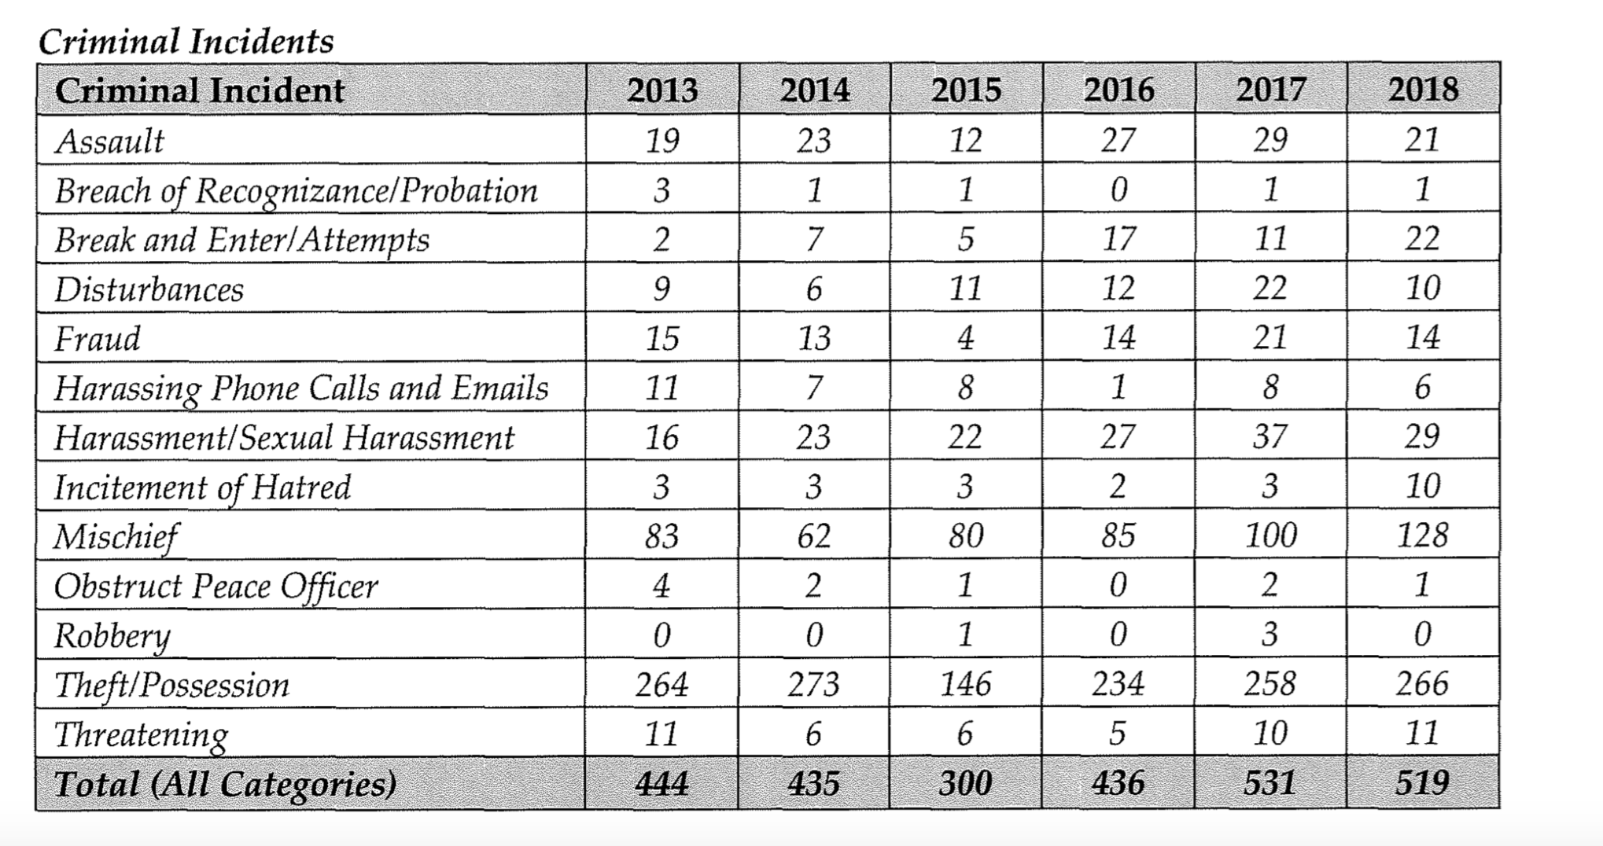
Furthermore, the university should conduct a Two-spirit and LGBTQ+ climate review and implement McMaster specific recommendations based on the results. A similar review is currently being done at Ryerson University regarding anti-Black racism, after multiple incidents of hatred and discrimination on campus. The MSU believes that this is an appropriate next step for the university, and underscores McMaster’s self-declared commitment to maintain a safe environment free from discrimination and hate on campus.

Although student reported hate crimes have increased significantly throughout the years, it is important to note that hate crimes are underreported and do not reflect the true statistics of hate crime on campus. A 2018 Hamilton Police Services report suggests that, among other things, this may be due to the fact that historical and present-day injustices committed by police impact individual’s decision to report these hate incidents. Students at McMaster have also expressed their discomfort with campus security services, with 62.9% of respondents of a MSU climate survey claiming that they are uncomfortable reporting their experiences with McMaster Security Services. It is the MSU’s stance that the university should also conduct an external review of Security Services, with the intention of making reporting any incidents of hate more accessible to Two-Spirit and LGTBQ+ students. This review should look at training, practises, hiring and it should be informed by student feedback. The MSU recognizes that the distrust of police, special constables, and security services is predicated upon years of historical and present-day injustices towards the Two-Spirit and LGBTQ+ community. Keeping this in mind, the MSU believes that there should still be an effort on the part of the university to make reporting mechanisms more available to students, seeing as Campus Security Services are considered an intake office for complaints.

Name and Pronoun Changes
Principle: Students have the right to be addressed by their appropriate name and pronouns.
Concern: Although there are structures available to change a student’s name and/or pronouns, students find them difficult to navigate.
Concern: The university does not effectively communicate how students can change their name and/or pronouns.
Recommendation: The university should normalize the use of name change processes and promote them widely, regardless of self-identification as an individual needing these supports.

According to the Ontario Human Rights Code, all individuals have the right to define their own gender, underscoring the importance of using an individual's appropriate pronoun and name. Individuals may decide to change their names and pronouns in accordance with their gender identity. Although McMaster’s Equity and Inclusion Office released a trans inclusion resource listing the specific procedure for name and pronoun changes in the school system, these procedures are not accessible to students as many are not aware of them. According to the Gender and Sexual Diversity Survey most respondents found that the process to change names and/or pronouns have been difficult to navigate. A recent OUSA report also indicated that a Trans student found the name-changing process to be difficult, and that not all documents included their proper names. Students at McMaster should thus be provided with widespread knowledge of these processes.

The MSU recommends that the university promote these resources widely at large university events such as Welcome Week, May at Mac, and in residences. According to the above-mentioned report, students voiced their concerns about knowledge only being available for students who identify as being a part of the 2S and LGTBQIA+ communities. Specifically, a student mentioned that “Either [students] must disclose their own identity and out themselves or they are seen as performative. I have always chosen to be labelled as performative rather than out myself.” McMaster should thus widely advertise pronoun change protocols to all students, regardless of self-identification and/or access to 2S and LGBTQIA+ resources on campus. Trans inclusion resources should be promoted widely, and on a yearly basis. Students, regardless of self-identification, deserve to know where these resources are.

Gender Neutral Washrooms
Principle: All students should feel safe in using a washroom that aligns with their gender identity, without fear of any physical and/or emotional violence.
Concern: The locations of gender-neutral washrooms are not widely known by students on campus.
Recommendation: The Equity and Inclusion Office should implement more campus wide campaigns that advertise gender neutral washrooms on campus, increasing its access to more students.
Recommendation: The provincial government should provide funding to universities for the retrofitting of facilities to include more gender-neutral washrooms

The Ontario Human Rights Code states that everyone has the right to access services without any instances of discrimination. This code includes the protections of those who are at risk of being discriminated against on the basis of their gender identity and/or expression. This right especially extends itself to the use of washrooms, where according to a report conducted in Toronto secondary schools, 43% of students felt unsafe using washrooms. This is further reflected in a survey conducted by OUSA, where 79% of non-cisgender participants preferred using gender neutral washrooms. The MSU believes that McMaster should respect this right to equal access, and make the knowledge of gender neutral washrooms widely known across campus. Although the MSU recognizes the initiatives that the university is currently undertaking in renovating washrooms to be accessible and gender neutral, there should be efforts dedicated towards the wide promotion and access of these washrooms. Maps and posters should be posted across campus specifying the location and existence of gender-neutral washrooms. This information should be widely known by all members of the McMaster community, ensuring that all individuals have access to these washrooms regardless if they identify publicly. The posters/promotional materials for gender neutral washrooms should be more strategically placed, so students can make an informed choice on what facilities they can use.

Additionally, the MSU believes that more efforts can be taken to build gender neutral washrooms around campus. Currently, there are gender neutral washrooms in 22 facilities at McMaster, however they should be included in all buildings on campus. The provincial government should thus provide funding to universities to ensure that existing spaces are updated to include gender neutral washrooms.

Training and Equity-Based Initiatives
Principle: Students should feel respected and comfortable during their lectures and tutorials.
Concern: Students are subjected to heteronormative materials in lecture that dismiss their identities.
Concern: Students do not feel comfortable in their classrooms, and many among them have had experiences of discrimination due to their identities.
Recommendation: Instructors, teaching assistants, all staff and faculty members, should be required to participate in mandatory paid training programs to broaden their understanding of Two-Spirit and LGBTQ+ identities and issues, as well as proper use of gender inclusive language.
Recommendation: The Equity and Inclusion Office should partner with each faculty on campus to establish an equity council. These faculty specific equity committees will focus on equity-based initiatives that address the diverse identities and needs of students.

According to the results from the MSU’s Gender and Sexual Diversity survey, 30% of the respondents have had at least some experiences of discrimination in the classroom. This is only further exemplified in OUSA’s LGBTQ+ student experience survey, where 63% of respondents have been made uncomfortable about their orientation or gender in class because of a professor’s language/assumptions. The MSU believes that mandatory training for instructors, teaching assistants and all staff members should be offered to help mitigate any harm that might be directed towards 2S and LGBTQ+ individuals.

A brief assessment of the training provided by McMaster for staff displays significant gaps in regard to Two Spirit and LGBTQ+ specific training. Although violence and harassment training is mandatory for staff every three years, there isn’t specific mention of discrimination and harassment faced by students based on their sexual orientation, gender expression and/or gender identity. Human rights and equity fundamentals training is available for all staff, however it is not listed as mandatory. Furthermore, positive space program training through the equity and inclusion office is offered to staff if interested. Upon completion of this program staff can put up positive space stickers or signs to indicate that they are attempting to hold space for 2S and LGBTQIA+ students. Great initiatives they may be, these non-mandatory trainings attract a population of staff who are already engaged and keen on learning, instead of ensuring that this a universal priority. A recent study suggests that including mandatory training grounded in social justice and equity in teacher’s colleges will systematically create an environment that nurtures and respects the gender expressions, identities and sexual orientation of students. Along the same vein, the Equity and Inclusion Office’s plans to strengthen and enhance staff training will be futile as there is no mention as to whether these training sessions will be mandatory. It is the MSU’s position that mandatory training that specifically broadens knowledge and understanding of 2S and LGBTQIA+ Identities, Issues, discrimination, and the importance of using appropriate language and pronouns. According to the Gender and Sexual Diversity survey conducted by the MSU, 91% of the respondents would feel more comfortable in classrooms in their instructors had mandatory training surrounding their 2S and LGBTQIA+ identities. This training should not be a burden to staff and should thus count towards normal weekly paid hours.

Training is also not the only route towards creating safe and respectful environments for 2S and LGBTQIA+ students. There are many faculty specific issues that many students experience, which often cannot be outlined in detail in the above mentioned mandatory training and are therefore difficult to implement across specific faculties. This is best exemplified in OUSA’s LGTBQ+ interview report, where students in STEM fields discussed how their classes are less likely to use inclusive language or condemn hate speech. As such, the MSU recommends that the university encourage the establishment of faculty specific equity committees. This type of program has precedent, and is already established at McGill university, where multiple programs and faculties have their own equity committees, including an equity ambassador initiative for the engineering program where faculty, staff, and students volunteer to receive equity, diversity and inclusion training and provide feedback to an already established equity committee. The University of Dalhousie has also followed suit, and established equity working groups in several faculties.

Course content:
Principle: Students should not be made to feel excluded or invisible in their classes. Students should also feel reflected in course material, when applicable.
Principle: Students should receive an education without the burden of enduring discriminatory speech and/or actions on campus.
Concern: Students have had experiences of discrimination and harassment in the classroom that often make them feel uncomfortable.
Recommendation: The university should amend the Undergraduate Course Management Policy to include a required statement in all course syllabi, which should outline the university's commitment to fostering a safe and equitable environment for all students regardless of their identities. This statement should also promote the avenues available for students to report incidences of discrimination.

Students deserve to have an equitable, comfortable and safe experience in the classroom where learning is prioritized. For Two-Spirit and LGTBQ+ students however, this is often not reflective of their reality. Multiple respondents of the OUSA campus health survey have reported feeling uncomfortable in their classes due to their gender expression, gender identity, and/or sexual orientation. The classroom environment is crucial to a student’s learning and health, however experiences of discrimination in a academic setting can impede the intellectual growth of students, and have negative impacts on their mental health.

Knowing this, the MSU believes that a mandatory statement reiterating the university's commitment to fostering a safe and equitable environment for all students regardless of Two- Spirit and LGTBQ+ identity should be integrated into all course syllabi. A list of intake offices should also be promoted in this statement, in case students need to report incidences of discrimination. This statement is especially necessary in courses in Social Sciences and Humanities, as they tend to deal with more identity-based issues. These topics can often be difficult for Two Spirit and LGBTQ+ students to navigate, as they relate directly to personal experiences. This statement can therefore set a standard for all students in the classroom and help to create a more inclusive climate.

This change can be done through the amendment of the Undergraduate Course Management Policy to include this mandatory statement using university approved language. This statement would operate similarly to the academic integrity policy, which is summarized in a pre-written statement by the university, and is required to be embedded in all course syllabi. Although this will not produce the necessary changes needed to shift the cis-heteronormative culture perpuated both on and off campus, it is the MSU’s hope that it will set precedence for students and staff to uphold and maintain an equitable classroom environment.

Space and support resources
Principle: Students should have the opportunity to foster community and experience a sense of belonging on campus.
Concern: Many students feel as if there is a lack of university specific resources, events and spaces directed specifically for Two-Spirit and LGTBQ+ students, staff, and faculty.
Recommendation: McMaster University should commit to investing $10,000 over the next three years for initiatives aimed at supporting Two-Spirit and LGTBQ+ individuals.

Students within the 2S and LGBTQIA+ community face consistent forms of institutional and social discrimination that stems from the colonial and cis-heteronormative structures that are embedded in society at large. In this reality, students belonging to this community are more likely to report feeling unsafe in schools, and experience verbal, physical and sexual violence. These factors can have direct impacts on students' mental health, and their sense of belonging to the greater university community. Although dismantling these violent and oppressive structures necessitates a reconstruction of society itself, it is important that students have dedicated space to heal, connect and build community amongst each other.

According to the MSU’s Gender and Sexual Diversity survey, many respondents expressed their frustrations at the lack of community and spaces available for students. Additionally, 96% of the respondents from the MSU’s Gender and Sexual diversity survey ‘somewhat agree’, ‘agree’ or ‘strongly agree’ that there should be an increase in funding for supports and resources for 2S and LGBTQIA+ individuals, as seen in figure 2. These supports and resources may include more dedicated events, workshops, seminars, and educational campaigns that foster a sense of community for students, staff and faculty.

Figure 2: “I believe there should be an increase in funding dedicated towards supports and resources of 2SLGBTQ+ students on campus”
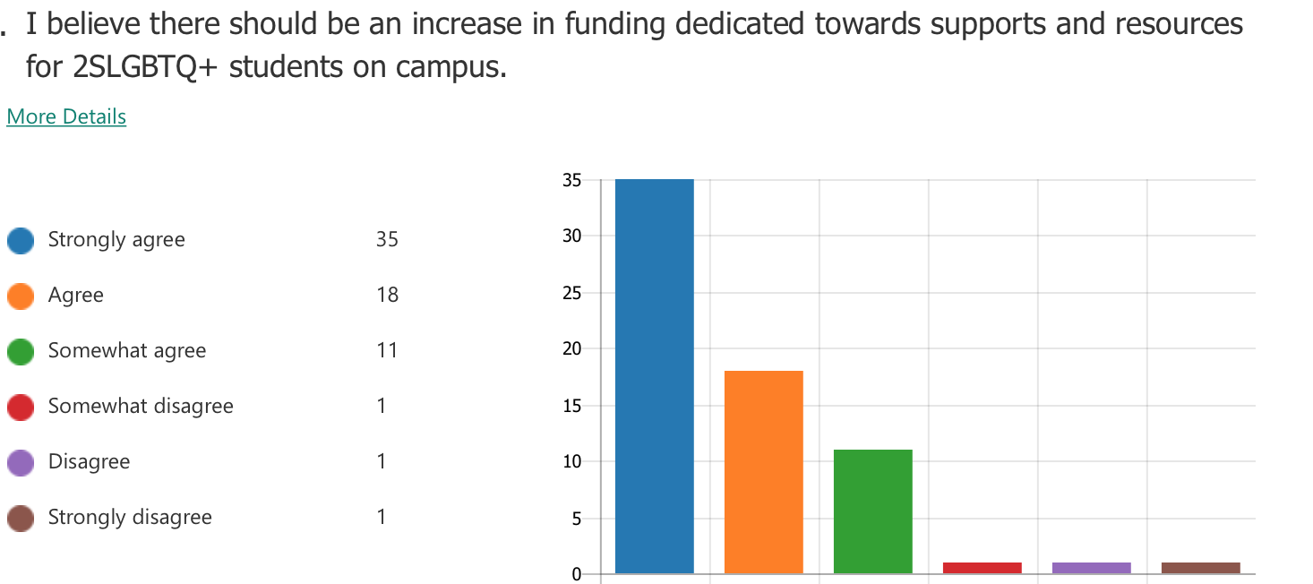

Although the Equity and Inclusion Office, SWELL, and the PACBIC gender and sexuality working group host events and workshops, it is important that the university attempt to make a rigorous effort to address campus climate and build safe environments for students. Although there are existing student services like the Pride Community Centre that provide peer support and a safe environment to exist openly, the nature of the service being run entirely by students poses a financial limitation on what they can do. The university should be able to allocate funding towards initiatives hosted by student groups in light of these limitations. In doing so, students are still able to maintain their autonomy, while still receiving support from the university as both parties work towards similar goals of campus inclusivity.

The university of Regina Pride Centre for Sexuality and Gender Diversity provide bursaries to students who wish to host an initiative that supports sexually or gender diverse communities in Regina. The fund’s total amount is $3,500 which is almost equivalent to the amount that is provided in our recommendation. McMaster should follow suit and commit to investing $10,000 over the course of three years to enhance the experiences of Two-Spirit and LGBTQ+ students on campus.

Health Services:
Principle: All students should have access to equitable and adequate health care regardless of gender identity, gender expression and/or sexual orientation.
Concern: Many students feel as if their health care is inadequate or not reflective of their needs related to their gender and/or sexual orientation, particularly in the areas of physical, mental, and sexual health.
Recommendation: The Student Wellness Lounge and McPherson Institute should partner and gather feedback from students regarding the Student Wellness Centre to implement and improve services for Two-Spirit and LGBTQ+ students.
Recommendation: The university should ensure that the Student Wellness Lounge has enough funding to compile, create, and distribute information relating to sexual and gender diversity. This can include relevant university policies, on and off campus resources, as well as general information.
Recommendation: All mental health personnel available to students should receive standardized training to support the needs of Two-Spirit and LGBTQ+ students.

The Student Wellness Centre provides students with various programming grounded in an equity lens for two-spirit and LGBTQ+ students. This programing includes non-discriminatory health, counselling and education services to trans people including: referral for hormone therapy, mental health support and connections to community. Although this is the case, 34% of students still feel uncomfortable accessing and reporting their experiences of discrimination at the Student Wellness Centre. In addition, the Student Wellness Centre website does not have a specific resource tab that consolidates programming and services available to 2S and LGBTQIA+ students. The MSU believes that The Student Wellness Lounge and McPherson Institute should partner to gather large scale feedback and run consultations with students to increase access and comfortability.

According to OUSA’s Two Spirit and LGBTQIA+ students policy brief, Good To Talk: Post-Secondary Student Helpline does not have standardized training that can support the needs of Two-Spirit and LGBTQ+ students. As such, the MSU believes that all training that is advertised to students must be grounded in an equity lens, allowing for equal access and adequate support for all.

Hamilton Community:
Principle: All residents of Hamilton, including McMaster students, should feel accepted openly existing as Two-Spirit and LGBTQ+ individuals in the broader community.
Principle: All residents of Hamilton should be comfortable openly existing without any threat of physical and/or emotional harm being inflicted upon them.
Concern: The City of Hamilton have not provided adequate support and resources towards the Two-Spirit and LGTBQ+ community in the face of discrimination.
Concern: Organized hate remains persistent in Hamilton without any significant efforts being established by the city to combat this.
Concern: Students do not feel safe existing openly in the broader Hamilton community.
Recommendation: The City of Hamilton should provide funding/grants for community-based resources for Two-Spirit and LGBTQ+ identifying individuals.
Recommendation: The City of Hamilton should create a task force addressing the systemic inequalities that make it difficult for a disproportionate amount of Two-Spirit and LGBTQ+ individuals to access adequate services such as housing.
Recommendation: The City of Hamilton should audit its policing practices, and how this disproportionately impacts the safety of Two-Spirit and LGBTQ+ Individuals.

McMaster students, as residents of Hamilton, should be able to exist freely and openly as 2S and LGBTQIA+ individuals. The city of Hamilton, being the site of many instances of organized hate, failed to stand up for the Two-Spirit and LGBTQ+ community. Hamilton has been designated the ‘Hate crime capital of Canada’ with the leading amount of police reported hate crimes across the country. This explains the blatantly discriminatory series of events following Hamilton Pride during the summer of 2019, where individuals who pushed back against homophobic and transphobic disruptors at pride were criminalized by the Police, and ridiculed by a sitting council member. The arrests of multiple individuals standing up boldly in the face of violent homophobic and transphobic rhetoric speaks to the historic injustices historically and presently committed by police against the 2S and LGBTQIA+ community. Notably, after sentiments were expressed in their speech about police violence and the discomfort that the community feels as it relates to police being at pride, a resident was arrested due to the fact that the speech “incit[ed] violence”. In light of this, the MSU believes that the city should conduct an audit of its policing practices, and the ways in which they disproportionately impact the safety of Two-Spirit and LGBTQ+ individuals.

This also is further exemplified in the 2019 McMaster report tilted “ Mapping the Void”, which states that more than 50% of LGBTQ+ have faced harassment, violence or hate crimes, and 93% of trans students feel unsafe. The report also highlights that members of the community increasingly feel like there is little to no infrastructure/ spaces available to foster and maintain a sense of community.

The MSU believes that the City of Hamilton should provide funding/grants for community-based resources for those in the Two-Spirit and LGBTQ+ community with the intent on enhancing or establishing permanent space to heal, grow, and frequent. A model for this recommendation can be seen in the City of Toronto’s allocation of funding towards a centre for LGBTQ+ identifying individuals that provides services, a meeting space, and leadership opportunities to grow. The MSU believes that the City of Hamilton should follow this lead, and designate financial resources towards community based initiatives. The City should also conduct a task force aimed at studying and addressing the systemic inequalities that make life difficult for Two-Spirit and LGBTQ+ residents.

Residence

Room Change Policies
Principle: Residences should be equally accessible to all students regardless of gender identity, gender expression and/or sexual orientation
Principle: Students should feel safe, welcomed and respected in their residences.
Concern: Many students experience financial and institutional barriers in the process of room change, even in instances when a student has encountered acts of discrimination.
Concern: Students who are in residence situations where they feel uncomfortable, often do
not know the available options to them and/or do not feel comfortable accessing them.
Recommendation: Residence room change application fees should not be enforced in cases where a student requires a room change as a result of their gender and/or sexual orientation. Students should also not have to pay any additional costs associated with their new residence prices.
Recommendation: Residence Life should ensure that there are specific resources/ accommodations available for students who are in the midst of requesting a room change due to acts of discrimination.
Recommendation: Residence life should amend the Housing and Conference Services Agreement/Contract to include protocols that describe what happens if students of marginalized communities face discrimination. This document should state that these students are exempt from the room change fee.

There are no procedures or special considerations for students who decide to apply for room change In light of experiences of discrimination on the part of their roommates. In addition, students are charged a 75$ fee to simply apply for a change of rooms. This poses as a systemic barrier, forcing students who are not able to pay this fee to remain in an undesirable situation. This barrier poses a specific challenge Two-Spirit and LGBTQ+ students, who endure experiences of harassment and discrimination on the part of a cis-heterormative societal values, and violent homophobic and transphobic structures. The MSU believes that it is the responsibility of the university to provide equitable options for students to safely remove themselves from discriminatory situations. In this way, the university is able to maintain their commitment to the creation of a safe and equitable campus. Thus, the university should amend the Housing and Conference Services agreement contract/services to include a protocols for students facing discrimination and/or discomfort from their roommates. This amendment should outline resources and support available for students in the midst of this experience.

Residence Programming
Principle: Students should have access to well-rounded programs that reflect and integrate all sexual orientations and gender identities of all students.
Concern: Residence life does not have equity-based programming in all of their LLC’s
Recommendation: Residence Life should incorporate an equity-based lens to all LLC programming, and advertise this to students widely.
Recommendation: The university should establish a separate intake form for Two-Spirit and LGBTQ+ students who wish to identify as a member of this community, without being revealed to parents/guardians.

First year students deserve to have intersectional and representational programming grounded in an equity-based framework. Although there are multiple ‘Living and Learning Communities’ that bring academic, leadership and/or personal opportunities to students, there are no specific communities and opportunities geared towards 2s and LGBTQIA+ students. A 2014 study found that the development of peer networks and involvement in LGBTQ+ communities have significant positive impacts on the wellbeing of students. As such, Residence life should ensure that all LLC programming should include an equity based lens, and provide opportunities for Two-Spirit and LGBTQ+ students.

Additionally, the university should establish a separate intake form for Two-Spirit and LGTBQ+ students who may wish to self-identify as a member of the community, but not be outed to their parents/ guardians. According to the results from the MSU’s Sexual and Gender Diversity survey, most students would feel safer during the application process if there was a separate intake form, as shown in figure 3. The Housing and Conference Services Portal intake form allows for students to be able to indicate their name and gender identity. Within this form, students can also choose their gender identity, where there is an option to identify as trans or other. As important as this option is, students may complete this form alongside parents/guardians and may choose to not identify, so as to not reveal their Two-Spirit and/or LGBTQ+ identities. The MSU recommends that the university should establish a separate intake form for Two-Spirit and LGBTQ+ students who wish to identify as a member of these communities.

Figure 3. “ A separate email/intake process for 2SLGBTQ+ students requesting residence accommodation would make me feel safe.”
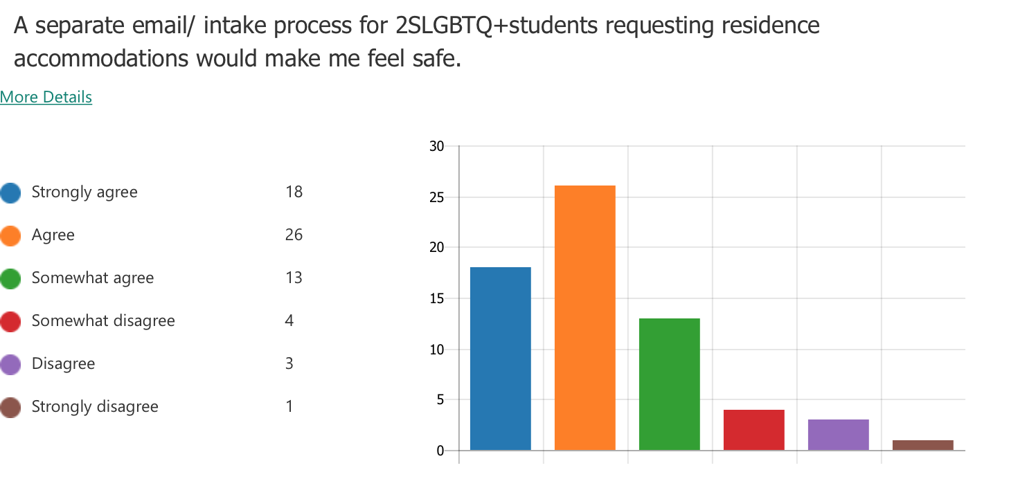

Policy statement

Whereas: All students, regardless of their sex, sexual orientation, gender identity, gender expression or race should feel supported by McMaster’s policy and procedures.

Whereas: All students should feel safe and respected on campus.

Whereas: Students have the right to be addressed by their appropriate name and pronouns.

Whereas: All students should feel safe in using a washroom that aligns with their gender identity, without fear of any physical and/or emotional violence.

Whereas: students should feel respected and comfortable during their lectures and tutorials.

Whereas: Students should not be made to feel excluded or invisible in their classes. Students should also feel reflected in course material, when applicable.

Whereas: Students should have the opportunity to foster community and experience a sense of belonging on campus.

Whereas: All students should have access to equitable and adequate health care regardless of gender identity, gender expression and/or sexual orientation.

Whereas: All residents of Hamilton, including McMaster students, should feel accepted openly existing as Two-Spirit and LGBTQ+ individuals in the broader community.

Whereas: Residences should be equally accessible to all students regardless of gender identity, gender expression and/or sexual orientation

Whereas: Students should have access to well-rounded programs that reflect and integrate all sexual orientations and gender identities of all students.

Be it Resolved that ( BIRT): The Equity and Inclusion office should improve awareness of the guidelines on reporting acts of discrimination/harrasment as well as the overall investigation process.

Be it Further Resolved That ( BIFRT): McMaster University should amend the policies, procedures and guidelines of the Discrimination and Harrasment Policy to require intake offices, as well as the final decision makers in the complaint/reporting process to draw on the equity, diversity and inclusion framework.

BIFRT: The Freedom of Speech Guidelines should be amended to include a clear condemnation of hate speech, and specify that discriminatory events exceed the bounds of freedom of speech. This must include a clear statement that discrimination targeted towards the 2SLGBTQ+ community, among other communities, is prohibited.

BIFRT: McMaster should establish standards and policies in Environment and
Occupational Health Support Services (EOHSS) to protect the safety, inclusion, and
psychological wellbeing of students, particularly in regards to marginalized gender and
sexual identities.

BIFRT: The Equity and Inclusion Office should create a procedure that describes the steps the university will take to address a hate crime in the McMaster community.This procedure should outline the university’s transparent communication strategy on the progress of investigations as well as the implementation of initiatives addressing the McMaster community.

BIFRT: The university should conduct a Two-Spirit and LGTBQ+ campus climate survey every 4 years and develop a strategic action plan in order to address student concerns.

BIFRT: McMaster should conduct a review of security services. With this information, the university should be proactive in reducing and mitigating the harm caused.

BIFRT: The university should normalize the use of name change processes and promote them widely, regardless of self-identification as an individual needing these supports.

BIFRT: The Equity and Inclusion Office should implement more campus wide campaigns that advertise gender neutral washrooms on campus, increasing its access to more students.

BIFRT: The provincial government should provide funding to universities for the retrofitting of facilities to include more gender neutral washrooms

BIFRT: Instructors, teaching assistants, all staff and faculty members, should be required to participate in mandatory paid training programs to broaden their understanding of Two-Spirit and LGBTQ+ identities and issues, as well as proper use of gender inclusive language.

BIFRT: The Equity and Inclusion Office should partner with each faculty on campus to establish an equity council. These faculty specific equity committees will focus on equity-based initiatives that address the diverse identities and needs of students.

BIFRT: The university should amend the Undergraduate Course Management Policy to include a required statement in all course syllabi, which should outline the university's commitment to fostering a safe and equitable environment for all students regardless of their identities. This statement should also promote the avenues available for students to report incidences of discrimination.

BIFRT: McMaster University should commit to investing $10,000 over the next three years for initiatives aimed at supporting Two-Spirit and LGTBQ+ individuals.

BIFRT: The Student Wellness Lounge and McPherson Institute should partner and gather feedback from students regarding the Student Wellness Centre to implement and improve services for Two-Spirit and LGBTQ+ students.

BIFRT: The university should ensure that the Student Wellness Lounge has enough funding to compile, create, and distribute information relating to sexual and gender diversity. This can include relevant university policies, on and off campus resources, as well as general information.

BIFRT: All mental health personnel available to students should receive standardized training to support the needs of Two-Spirit and LGBTQ+ students.

BIFRT: The City of Hamilton should provide funding/grants for community based resources for Two-Spirit and LGBTQ+ identifying individuals.

BIFRT: The City of Hamilton should create a task force addressing the systemic inequalities that make it difficult for a disproportionate amount of Two-Spirit and LGBTQ+ individuals to access adequate services such as housing.

BIFRT: The City of Hamilton should audit its policing practices, and how this disproportionately impacts the safety of Two-Spirit and LGBTQ+ Individuals.
BIFRT: Residence room change application fees should not be enforced in cases where a student requires a room change as a result of their gender and/or sexual orientation. Students should also not have to pay any additional costs associated with their new residence prices.
BIFRT: Residence Life should ensure that there are specific resources/ accommodations available for students who are in the midst of requesting a room change due to acts of discrimination.
BIFRT: Residence life should amend the Housing and Conference Services Agreement/Contract to include protocols that describe what happens if students of marginalized communities face discrimination. This document should state that these students are exempt from the room change fee.
BIFRT: Residence Life should incorporate an equity-based lens to all LLC programming, and advertise this to students widely.
BIFRT: The university should establish a separate intake form for Two-Spirit and LGBTQ+ students who wish to identify as a member of this community, without being revealed to parents/guardians.

This General Policy of the McMaster Students Union is licensed under a Creative Commons Attribution-NonCommercial-NoDerivatives 4.0 International License.

Trans Care BC. “Two Spirit” http://www.phsa.ca/transcarebc/trans-basics/two-spirit
“Code of Student Rights and Responsibilities”. http://www.mcmaster.ca/policy/Students- AcademicStudies/Code_of_Student_Rights_and_Responsibilities.pdf
Canadian Centre for Gender and Sexual Diversity “LGBTQ2 Health Policy:Addressing the Needs of LGBTQ2 Post Secondary Students” (House of Commons Standing Committee on Health Governance Canada, 2019)
Rachel Schenk Martin, T. Sasso, and M. G. González-Morales, “LGBTQ Students in Higher Education: an Evaluation of Website Data and Accessible, Ongoing Resources in Ontario Universities,” Psychology & Sexuality, 2019, pp. 1-13,
Suzanne Mills et al. “Mapping the Void: Two Spirit and LGBTIQ+ Experiences in Hamilton. https://labourstudies.mcmaster.ca/documents/mappingthevoid.pdf
Paola Lorrigio, “Ontario Post Secondary Schools Expected to Now Have Free-Speech Policies in Place” Global News, 2019. https://globalnews.ca/news/4823953/ontario-post-secondary-schools-free-speech-policies/
Linda Cabrall. “ Sexual and Gender Diversity in Post Secondary Education:LGBTQ+ Students Interview Report” OUSA, 2019.
Nicole O’Reilly. “ White paint spilled on rainbow crosswalk at McMaster entrance” The Hamilton Spectator, 2018.https://www.thespec.com/news-story/8932159-white-paint-spilled-on-rainbow-crosswalk-at-mcmaster-entrance/
“Rainbow crosswalk incident”, Daily News McMaster, 2019 https://dailynews.mcmaster.ca/worthmentioning/rainbow-crosswalk-incident/
Hamilton Police Services Board. 2019 https://pub-hamilton.escribemeetings.com/filestream.ashx?DocumentId=179055
Paul Corrigan. “2018 Hate/bias statistical report” Hamilton Police, 2018. https://hamiltonpolice.on.ca/sites/default/files/2018_annual_hate_bias_crime_report.pdf
Campus Response to Hate. “ Take a stand on your campus” https://www.niot.org/stop-hate-action-kits/campus-response-to-hate
Ibid, 13
Ryerson University. “Upcoming changes to Ryerson Community Safety and Security.” 2019.https://www.ryerson.ca/community-safety-security/news/2019/09/upcoming-changes-to-ryerson-community-safety-and-security/
“Discrimination and Harrasment Policy” https://secretariat.mcmaster.ca/app/uploads/Discrimination-and-Harassment-Policy.pdf
Ibid, 14
MSU Gender and Sexual Diversity survey.
Ibid, 17
“LGBTQ+ Student Experience Survey Report.” Ontario Undergraduate Student Alliance. https://d3n8a8pro7vhmx.cloudfront.net/ousa/pages/103/attachments/original/1473428414/2015-11_-_LGBTQ_Student_Experience_Survey_Report_document.pdf?1473428414
Ibid, 17
Ontario Human Rights Commission.”policy on preventing discrimination because of gender identitiy and gender expression.” http://www.ohrc.on.ca/en/policy-preventing-discrimination-because-gender-identity-and-gender-expression/6-ontario’s-human-rights-code
Jay Jaxen Jonah. “Trans Youth and the Right to Access Public Washrooms” https://www.issuelab.org/resources/33746/33746.pdf
Ibid, 19
Equity and Inclusion Office. “A Guide to All Gender Washrooms at McMaster University.” https://equity.mcmaster.ca/documents/washroomsbrochure17-2.pdf
Ibid 17
Ibid 19
Human Resource Services. “ Employment Equity Training” https://hr.mcmaster.ca/employees/employment-equity/ee-training-and-resources/
Ibid, 30
Equity and Inclusion Office. “ Equity Services Program” https://equity.mcmaster.ca/equity-services-program
Laura-Lee Kearns et al. “LGBTQ Awarness and Allies: Building Capacity in a Bachelor of Education Program. https://files.eric.ed.gov/fulltext/EJ1057937.pdf
Ibid,17
Ibid, 19
Mcgill. “ New Equity Program in Faculty of Eng” https://www.mcgill.ca/studentleaders/new-equity-program-faculty-eng
Dalhousie University. “ Progress on Report Recommendations” 2016. https://cdn.dal.ca/content/dam/dalhousie/pdf/cultureofrespect/PORR-Spring2016-June8.pdf
Laura Pin and Chris Martin. “Student Health: Bringing Healthy Change to Ontario’s Universities.” 2012. Ontario Undergraduate Student Alliance.
“Undergraduate Course Management Policies” https://secretariat.mcmaster.ca/app/uploads/2019/06/Undergraduate-Course-Management-Policy.pdf
Ibid, 38
UR Pride Centre For Sexuality and Gender Diversity. “Funding and Bursaries” https://www.urpride.ca/funding/
Student Wellness Centre. “ The Fluidity of Gender” https://wellness.mcmaster.ca/the-fluidity-of-gender/
“Policy Brief: Two Spirit and LGBTQ+ Students” Ontario Undergraduate Student Alliance. https://d3n8a8pro7vhmx.cloudfront.net/ousa/pages/1904/attachments/original/1576004364/Two_Spirit_and_LGBTQ__Students_Brief_v2_brief.pdf?1576004364
Samantha Craggs. “Mayor shuts down city council meeting after shouting from angry LGBTQ residents” 2019. https://www.cbc.ca/news/canada/hamilton/council-1.5191712
Samantha Craggs. “Cedar Hopperton will stay in jail following heated speech at Hamilton City Hall.” 2019. https://www.cbc.ca/news/canada/hamilton/hopperton-parole-1.5204482
https://labourstudies.mcmaster.ca/documents/mappingthevoid.pdf
The 519. “About the 519” https://www.the519.org/about
Darrel Higa et al., “Negative and Positive Factors Associated With the Well-Being of Lesbian, Gay, Bisexual, Transgender, Queer, and Questioning (LGBTQ) Youth,” Youth & Society46, no. 5 (2012): pp. 663-687, https://doi.org/10.1177/0044118x12449630)

