POLICY PAPER
Mental Health

Prepared by:

Hargun Kaur, Advocacy and Policy Research Assistant 2020-2021
Brittany Williams, AVP University Affairs 2020-2021
Bethel Samson, SRA Health Sciences 2020-2021
Zoe Tsai, SRA Health Sciences 2020-2021
Rebeena Subadar, University Affairs Committee Member 2020-2021
Gail Marie Del Castillo, SRA Sciences 2020-2021

Table of Contents
Introduction 3
Culture and Mental Health 5
Marginalized & Vulnerable Populations 11
Racialized Students and Mental Health 12
Indigenous Students and Mental Health 13
2SLGBTQIA+ Students and Mental Health Support 14
International Students and Mental Health Support 15
Male-Identifying Students 16
Academics, Accommodations, and Mental Health 18
Accessing Accommodations 18
Transparency and Awareness of Accommodations 21
Mental Health Awareness 24
Mental Health Literacy 24
Addressing Stigma and Discrimination 27
Faculty and Staff Training 31
Substance Use 34
Whole of Community Approach 39
Off-Campus Collaboration 39
Peer Support Referrals 40
Mental Health and Remote Learning 42
Geographic Limitations and McMaster Mental Health Support 42
Online Counselling 43
Online Booking System 43
Website Accessibility 45
Accessibility for Online Counselling 46
University Accountability 50
Progress Dashboard for Mental Health 50
Suicide Prevention, Transparency & Training 53
Policy Statement 60
COVID-19 & Mental Health Survey 72

Introduction
Mental health affects various areas of a student’s life. Poor mental health can reduce a student's quality of life, academic achievement, physical health, satisfaction with their university experience, and negatively impact their interpersonal relationships. Defined by the Government of Canada as “the state of your psychological and emotional well-being”, mental health is a necessary component of overall health. According to the World Health Organization, mental illness is the worldwide leading cause of disabilities. In Canadians aged 16 to 34 years, there has been an alarming increase from 6.2% in 2015 to 11.8% in 2019 in those rating their mental health as poor or fair. Not only are one in five Canadians living with a mental illness by the age of 25, but the majority of mental illness symptoms onset before the age of 18. Despite these alarming and devastating statistics, one-third of Canadians over the age of 15 report their need for mental health care as not being fully met.

University is a transitional period of instability and exploration, characterized by an elevated risk of mental distress as students are tasked with exploring careers, discovering themselves, and developing relationships and supports, all during an immense transition of leaving home and old social networks. In addition to this time of elevated stress, adolescents and young adults are particularly vulnerable populations during times of crisis. Many studies have shown that the COVID-19 pandemic poses an elevated risk of PTSD, depression, and anxiety symptoms in students caused by stress, intrafamily violence, uncertainty about the future, and inability to access traditional support systems, among other factors.,

The relationship of individual students with mental health and their help-seeking efficacy is significantly influenced by their identities, environments, and personal dispositions. The effect of intersectionality on heterogeneity in expression of and outcomes related to mental health and illness is an important consideration in developing policy recommendations and interventions for a diverse student population. Although significant progress has been made in the acceptance of and conversation around mental health, stigmatizing and discriminatory attitudes continue to persist which decreases a student’s ability to ask for help, as has been shown in previous literature, our survey, and student consultations. Lacking mental health literacy, staff and faculty can further perpetuate stigmatizing attitudes, further creating hostile and unsafe educational environments.

There also seems to be an intricate, bidirectional relationship between marginalization and mental health such that marginalized and vulnerable students face greater mental distress due to various structural and contextual factors resulting from historical and continued oppression and discrimination, while a diagnosis of mental distress and illness can also result in marginalization. Resulting Westernized approaches to mental health promotion, education, and support have failed to account for the diversity in the needs of the McMaster student body. In addition to the deterioration of student mental health, COVID-19 has exposed major gaps in our mental health care systems including the inability of international and out-of-province students to access care, the lack of certain remote learning accommodations, the inaccessibility of online counselling, and exacerbation of existing inequities in health and mental health care. A whole-of-community approach is needed to overcome these gaps and adequately meet the increased demands of student mental health care, with increased university accountability through continuous and transparent evaluation on the efficacy of ongoing and future interventions.

While this policy paper arose from the aforementioned call to action for interventions to mitigate the negative implications of the COVID-19 pandemic on student mental health, the recommendations of this policy paper extend beyond. In addition to being informed by literature, this policy paper was guided by consultations with Student Wellness Center, Women and Gender Equity Network, First Year Council, Diversity Services, Pride Community Center, Maccess, and Open Circles, identity-based focus groups with McMaster students, and a university-wide survey.

Culture and Mental Health
Principle: The inclusion of cultural lived experiences and cultural models is critical in facilitating the understanding of administration, staff, and students on the effects of culture on mental health and students' willingness to seek treatment.

Principle: Mental health practices should recognize and accommodate the non-material cultural ideas, beliefs, values, rules, norms, morals, social roles, ethics, traditions, organizations, and how individuals identify within their institution.

Principle: All students should have access to affordable, accessible, and timely mental health resources, support, and accommodation regardless of their cultural backgrounds.

Concern: McMaster students from cultural groups of non-Western societies have a high risk of compromised mental health because they may experience many cultural stressors.

Concern: McMaster students from non-Western cultural groups are more likely to delay seeking mental health treatment due to psychological and emotional trauma caused by systemic barriers.

Concern: The Student Wellness Centre offers McMaster students standardized accommodations, treatment, and mental health services irrespective of unique and distinct cultural perspectives.

Concern: There is insufficient data and transparency between McMaster University and its student population on how cultural stressors impact a student’s mental health and actionable steps being taken by the university.

Concern: There is a lack of non-Western cultural diversity within the training for front-facing staff to understand cultural stressors and develop approaches consistent with the student’s underlying cultural values.

Recommendation: McMaster University’s administration and services should collect a broader scope of data using focus groups, surveys, and content analysis as principal methodologies to discern how cultural stressors impact students’ mental health.

Recommendation: The Student Wellness Centre needs to partner with culturally diverse students to co-design support services inclusive of non-material cultural stressors.

Recommendation: In partnership with the McMaster Students Union and the Equity and Inclusion Office, McMaster University should develop diversity and cultural, mental health care training services for visible minorities and non-visible minorities that extend beyond providing counselling as a primary type of help.

Recommendation: The Student Wellness Center should integrate, expand, and promote synonymous use of accredited accommodations to mental health with holistic options as other mental health supports to provide care for a student’s physical, mental, spiritual, and social needs.

Culture has been defined across many sectors in societies to have different meanings and applications according to various groups, and as such, there is no limitation to how institutions can become more inclusive of cultural perspectives. Consultations with McMaster students have revealed demands of non-Western cultural perspectives in institutional approaches to mental health to recognize nonphysical ideas that students have about their culture. Such nonphysical ideas include beliefs, values, norms, morals, language, organizations, and institutions a student identifies with and feels a connection. Currently, McMaster University and associated university services that provide mental health support do not sufficiently recognize non-Western nonphysical ideas in its approaches.

The Western framework that provides mental health support lacks the space for students to insert their cultural lived experiences towards the type of treatment they would like to receive. For example, during a talk with Donna Alexander, MSW RSW and a social worker at CAMH (Centre for Addiction and Mental Health), Donna presented the difference between Afrocentric and Eurocentric approaches to mental health implications appealing to a dominant Western framework. Donna explains, an Afrocentric model involves mental health treatment being consistent with communal healing of trauma. As such, individuals who identify with such a collectivist model would need support and reassurance that the community is doing well to allow individuals to recover from their trauma. However, with the individualistic Western framework for mental health being the dominant form of healing in McMaster University, students do not have the opportunity to participate in communal healing. Even in the group programming offered by the Student Wellness Center, there is insufficient information on the website for students to determine the values and principles guiding the therapies and the acceptance of various cultural practices. The lack of cultural systems in the treatment of mental health can perpetuate the cycle of trauma for students whose cultural systems are not represented, and there is an expectation for students to comply with a healing system that could be incompatible with them.

There is a continuing supply of evidence that suggests there are various factors that increase the likelihood of an individual delaying mental health treatment and avoiding it in its entirety. For example, worldwide statistics reveal more than 70% of young people and adults with mental illness or enduring duress to their mental health do not receive nor seek mental health treatment. Some factors contributing to the treatment gap of mental health include the lack of knowledge to identify features of mental health concerns, less awareness of how to access treatment, and preconceived prejudices against those who openly confront their mental health issues. Similarly, a report by CAMH revealed that stigma prevents 40% of persons with anxiety and depression from reaching out for medical support. It seems that it would be a healthy idea to pursue the mental health approach to ensure that no particular group is privileged in their mental health treatment.

However, appealing to a universal mental health treatment model does not present opportunities for students to avidly process, confront, reflect, and heal how nonphysical cultural stressors impact their mental health and their willingness to seek treatment. For example, Guyana makes up 0.01% of the total world population, but it currently ranks as the third-highest in suicide rates. Though the issue of combating suicide is a separate area to address, and despite Guyana’s existence as a separate country from Canada, the example demonstrates how areas of mental health are intricately connected to the overall significance of avidly integrating cultural perspectives in our approaches to mental health to address and heal intergenerational trauma. Can we be confident that students living in Western society do not feel the strain on their mental health due to nonphysical cultural stressors? We cannot adamantly say that nonphysical cultural stressors do not affect students in Western society as students range from various backgrounds that tend to conflict with Western practices and institutions. For example, we cannot say that students that identify their ethnicity as Guyanese do not experience nonphysical cultural stressors in a Western society such as Canada. Hence, issues such as the pervasive stigma about mental illness, poverty, family dysfunction, insufficient mental health resources, interpersonal violence put a strain on a person’s mental health and are not stand-alone issues nor isolated experiences to one specific non-Western group, they are a result of generational years of trauma that is passed down to the very students studying under McMaster University.

The Western model of mental health is outdated in its approach to the inclusivity of cultural approaches to healing, and McMaster University has the power and platform to amend the gap in a way that creates a more inclusive and supportive environment for its students. For example, the Western model of mental health is inherently limited in its scope. It views mental health/illnesses as a foundation for institutionalization, an individual with mental health issues is rendered incapable of advocating for their treatment, and it is less of a priority for funding to be expended. Various examples of this were brought up in student consultations, such as limiting autonomy for students with disabilities in determining desirable accommodations and accessing their information through Student Accessibility Services. It is difficult for students to address and cope with nonphysical cultural stressors when the Western model perpetuates a cyclical procedure of paternalistic care. A body of authority decides the treatment a person receives without providing an opportunity for the other person to choose the treatment they prefer. Hence, a student’s autonomy must be respected and reinforced within McMaster University by having the option to select their form of mental health care rather than be prescribed standard treatments or therapies that are not of their choice.

The recommendations follow that McMaster University needs in its programming, in its therapeutic approaches, and in its shared learning resources, more data of how nonphysical cultural stressors impact communities and more inclusivity in its approaches that are produced in response to the data collected. For example, McMaster University can pursue both qualitative and quantitative data collection on nonphysical cultural stressors. Some initial points of consideration could include:
- What cultures are we analyzing?
- How are cultural groups determined?
- Should cultural groups be decided by looking at the categories of identification given to students for administrative documents?
- Can we identify and equate cultural groups by referring to ethnic groups?
- What are everyday nonphysical cultural stressors amongst groups?
- What implications do such stressors have on a student’s academic and non-academic performance?
- What non-Western cultural models of mental health exist?
- How can we test non-Western models against Western models of mental health?

Once data is collected, in partnership with culturally diverse student groups and populations, McMaster University should create and implement therapeutic supports, peer programs, resources, cultural diversity training, and additional methods for combating cultural and mental health barriers. McMaster University and the Student Wellness Center should create such options for implementing non-Western mental health models' research as support. McMaster University, the Student Wellness Centre, and the McMaster Students Union should assess the effectiveness of implementation ideas according to how well they address the significant nonphysical cultural stressors identified in McMaster students' data. McMaster University's goal is to ensure cultural safety for ethnic and minority groups that feel distressed due to nonphysical cultural stressors.

McMaster University cannot create cultural safety for students if the incentive is not present for staff and students to become culturally competent. Cultural competence involves our ability to work, listen, and accommodate people from different cultural backgrounds. In this sense, by fostering a culturally competent environment, McMaster University needs to take responsibility for the different ways culture is viewed and displayed by students. It promotes cultural backgrounds to effectively address the disparities and lack of resolution in amending the barrier of culture and mental health.

An effective way to foster a culturally safe and competent environment is by integrating accredited mental health accommodations and programs with holistic practices. Holistic practices combine traditional medicine with complementary and alternative medicine to improve the body, mind, and soul's health and wellness. A significant shortcoming of the holistic practices is that their effectiveness has not been widely proved by scientific means. However, with the increasing popularity and demand for holistic practices, it is worth it to test it out, and the option of researching to determine how effective it is to people remain an option for McMaster. For example, reiki healing is an alternative therapy of energy healing that emerged in Japan, aiming to help the flow of energy and remove blockages fueled by trauma. Pranic healing is an energy treatment that uses prana to balance, harmonize, and transform the body's energy processes to alleviate psychological and physical conditions by enhancing the body's capability to heal itself. Another example of integrating a culturally responsive practice for diverse nonphysical cultural groups is to voluntarily incorporate a safe space for Indigenous students to participate in traditional smudging ceremonies. It would reinforce Indigenous students' connection to the nonphysical aspects of their culture while also alleviating nonphysical cultural stressors' heaviness. Ceremonies should be informed and facilitated by practitioners of the culture who understand what a smudge is and why it is done. Regardless of the type of practice, implementing holistic practices should be culturally appropriate and in consonance with student and non-student groups who can attest, inform, and develop McMaster University's practices. Therefore, many holistic practices can help address the nonphysical cultural stressors students are enduring that present students with opportunities to control their situation and feel empowered to self-develop.

Marginalized & Vulnerable Populations
Principle: Effective campus wellness services must reflect the diverse nature of the student population.

Principle: All McMaster students should have access to affordable, accessible and timely mental health supports that adequately address their unique concerns and needs.

Principle: Students, faculty and staff should be knowledgeable on the intersectionality of identity and its impact on one’s experience with mental health.

Concern: Marginalized student populations are more likely to face disproportionate challenges and systemic barriers when accessing or using mental health services and support.

Concern: Students from marginalized populations are more likely to underutilize mental health services due to societal and cultural factors, and stigma.

Concern: Students in visible minority groups often face hostile conditions and systemic racism in the campus environment that can detract from their mental wellness.

Concern: Student health and counselling services are often not adequately equipped to address concerns specific to students from certain marginalized populations.

Recommendation: McMaster should ensure that its mental health policies include crisis management and suicide prevention strategies, that specifically address the needs of marginalized and vulnerable populations.

Recommendation: In their creation of shared health priorities, McMaster University should include an increased focus on vulnerable and/or marginalized groups of individuals, working with these populations to identify and evaluate health priorities.

Recommendation: The Student Wellness Centre should periodically engage in further outreach activities geared towards marginalized and vulnerable populations to raise awareness about available mental health resources and to reduce the stigma surrounding mental health and the use of mental health services within the McMaster Student Community.

Recommendation: The Student Wellness Centre should create and execute a plan to connect and collaborate with organizations and clubs on campus who are closely connected to marginalized and vulnerable student populations on campus.

Recommendation: McMaster University should conduct research into equity, diversity and inclusion issues present in their Student Wellness Centre and examine and adopt best practices for offering equitable physical and mental health services to all students.

Recommendation: McMaster should create an equity and diversity task force to review the current hiring practices of the Student Wellness Centre and to provide best practices for integrating diversity, equity and inclusion principles into their hiring practices.

Recommendation: McMaster should ensure that its mental health policies include crisis management and suicide prevention strategies, that specifically address the needs of marginalized and vulnerable populations.

Racialized Students and Mental Health
Principle: Racialized students at McMaster should be provided with mental health services and supports that adequately address and meet their mental health needs.

Principle: All students, faculty, and staff should have strong mental health literacy and access to high-quality education on how to support others.

Concern: Racialized students may be less likely to have conversations about mental health with other students, staff, and faculty - hesitations which are not addressed through traditional, Westernized mental health literacy and de-stigmatization campaigns.

Concern: Racialized students are more likely to struggle with managing mental health issues due to cultural and societal beliefs that stigmatize mental health.

Concern: Racialized students are disproportionately exposed to systemic racism, discriminatory experiences, racial trauma, and emotional turmoil, impacting their mental health.

Concern: Black, Indigenous, and People of Color disproportionately face worse physical and mental health outcomes and face systemic barriers to accessing resources.

Concern: Many racialized students do not use counselling services because they do not feel that counsellors can understand their lived experiences and provide adequate solutions to their problems.

Concern: The lack of BIPOC medical professionals in healthcare services further exacerbates the lack of understanding of the effects of systemic racism on BIPOC students.

Recommendation: The staff of the Student Wellness Centre should be equipped with cross-cultural training to ensure that they are able to effectively serve a diverse student body.

Recommendation: McMaster should allocate a certain portion of university mental health care funding to the hiring of more BIPOC staff who can better understand and address the unique perspective of racialized students.

Recommendation: McMaster University should co-create and design mental health resources in consultation with and informed by the lived experiences of racialized and Black-identifying students and identity-based community groups.

Recommendation: The Student Wellness Centre should offer additional supports and resources for Black-identified and racialized students at McMaster.

Indigenous Students and Mental Health
Principle: Indigenous students should be provided with mental health services and supports that adequately address and meet their mental health needs.

Principle: The continuing impact of colonialism and structural barriers on Indigenous student mental health and wellbeing must be acknowledged and actioned upon by the university leadership and front-facing staff.

Concern: Indigenous youth face significantly higher rates of mental health issues compared to the general population, which can have a severe impact on their quality of life and academic performance.

Concern: Feelings of tokenization and the extra pressure that comes with needing to represent all Indigenous students is taxing for students and their mental health.

Concern: There is a lack of mental health support services that acknowledge and incorporate the Indigenous way of knowing and wellbeing into their models of service.

Concern: Indigenous students are consistently exposed to discriminatory experiences, including during the process of trying to reach out for support, that negatively impact their mental health and discourage them from reaching out.

Concern: Many Indigenous students are unaware of Indigenous counselling services that are available through the Indigenous Student Services.

Concern: Indigenous students continue to face discrimination in the learning environment which impacts their mental health and ability to engage in the classroom.

Recommendation: McMaster University and associated services should promote and coordinate services with Indigenous specific resources offered by Indigenous Student Services and student groups.

Recommendation: McMaster University should include and adequately compensate, in a non-tokenistic manner, Indigenous students as an integral part of conversations on the student experience to understand unique barriers faced by these populations and how best to go beyond performative allyship.

Recommendation: Indigenous Student Services should introduce the option for students to anonymously report their experiences with discrimination and racism inside and outside the classroom.

Recommendation: Mandatory onboarding and professional development for McMaster staff and faculty should include information on Indigenous experience and the history of colonialism, delivered by Indigenous scholars and the Indigenous Student Services.

Recommendation: The Student Wellness Centre should produce physical and online mental health resources that cater to Indigenous Students at McMaster.

2SLGBTQIA+ Students and Mental Health Support
Principle: All students should have access to affordable, accessible and timely mental health services and supports that meet their needs.

Principle: 2SLGBTQIA+ students should have access to 2SLGBTQ - positive, inclusive and responsive mental healthcare professionals.

Principle: All McMaster services and spaces must strive to maintain inclusivity for all students, regardless of lived experience or identity.

Concerns: Many members of the 2SLGBTQIA+ community underutilize mental health support services because they feel that these services do not adequately address their needs.

Concerns: Members of the 2SLGBTQIA+ community face heightened stressors as they are at a higher risk of facing harassment and abuse, intentional and unintentional, based on sexual orientation or gender identity.

Concern: 2SLGBTQIA+ Students are more likely than their peers to experience mental illness, substance abuse, and self-harming behavior such as suicide.

Concern: Students who are members of the 2SLGBTQIA+ communities face additional stressors as they navigate social and educational environments.

Recommendation: All front-facing staff and student leaders should undergo standardized diversity and equity training to ensure that they are adequately equipped to support 2SLGBTQIA+ students.

Recommendation: The Student Wellness Centre should produce physical and online mental health resources that cater to 2SLGBTQIA+ Students at McMaster.

International Students and Mental Health Support
Principle: International students should have access to affordable, accessible and timely mental health services and support.

Principle: International students should be made aware of the range of mental health supports available to them as McMaster Students.

Concern: International students are more likely to underutilize mental health care supports available to them, than their domestic peers.

Concern: Many international students lack knowledge about the range of mental health and counselling supports available to them on and off-campus and when they can and should use these resources.

Concern: International students may not readily seek mental health support and services available to them due to language barriers, cultural barriers and stigma.

Concern: International students may feel that counsellors cannot adequately understand their problems and provide them with relevant mental health support due to perceived barriers.

Concern: International students may be afraid to utilize mental health services as they are afraid of the impact that a mental health diagnosis may have on their immigration status and their ability to remain in Canada.

Concern: International students face many challenges as they transition into a new cultural and academic environment that may negatively impact their mental health.

Concern: Many international students face significant stress and anxiety during their undergraduate studies due to the high costs of their studies, societal and familial pressure, a lack of social support and immigration uncertainties.

Concern: Many international students are not aware of the academic accommodations available to them through McMaster's Student Accessibility Services.

Recommendation: International Student Services and the Student Wellness Centre should collaborate to provide international students with specific mental health and accessibility supports especially during their orientation and transition to McMaster.

Recommendation: McMaster should create a Resilience and Mental Health guide hosted on avenue that will provide general information on resilience, mental health best practices as well as the range of mental health supports available to McMaster students on campus.

Recommendation: The Student Wellness Centre should work closely with International Student Services to adopt best practices for combating mental health stigma, specifically geared towards international students.

Recommendation: Academic counsellors and student navigators should be used as a medium to connect international students to mental health information and services on campus as students may see academic counselors more frequently.

Recommendation: Student Wellness Centre staff should be trained to understand and navigate the cultural and social differences of international students that they are counselling in order to more effectively and equitable council them.

Male-Identifying Students
Principle: All students, regardless of gender, should have access to adequate and equitable mental health support services.

Principle: All students, regardless of gender, should feel comfortable accessing and utilizing mental health resources on campus.

Concern: Men have a disproportionately high suicide rate when compared to their female counterparts.

Concern: Male students face higher levels of stigma when utilizing and accessing mental health services and support.

Concern: There are limited male mental health-specific resources available to students on and off-campus.

Recommendation: McMaster University should allocate funding to improving its male mental health support services.

Recommendation: McMaster University, in collaboration with male students and other relevant parties, should create a task force to create, recommend, and implement best practices for promoting and providing male mental health support services on campus.

Academics, Accommodations, and Mental Health

Accessing Accommodations
Principle: All willing and qualified students should be able to access and succeed in affordable, high quality, and accountable education at McMaster University.

Principle: Accommodations should be accessible to all students, regardless of their ability to provide documentation for mental health challenges which may be reduced due to cultural and societal barriers.

Principle: Students at McMaster should have equal access to mental health accommodations, regardless of program of study, gender, sexual orientation, race, socioeconomic status, and ethnicity.

Principle: Different cultural ideas, beliefs, norms, values, and traditions influencing how individuals perceive mental health should be recognized and accommodated.

Concern: Facing mental health challenges can make it difficult for students to fully engage and excel in their coursework.

Concern: Unclear policies and communication around the use of mental health and illness declaration data create barriers in students being able to provide documentation to access accommodations.

Concern: The expiration of medical documentation after 5 years results in disabled students being stuck in a cycle of needing documentation as many require more than 5 years to complete their degree.

Concern: The language around disability is non-inclusive, which hinders students from seeking out accommodations for mental health concerns.

Concern: Health services that are needed for documentation of diagnosis are overwhelmed due to the COVID-19 and may be unsafe for students to access.

Concern: The academic accommodations currently provided across faculties and professors at McMaster University are not standardized.

Concern: Accommodations are sometimes met with ableism by various front facing staff in the educational environment.

Recommendation: McMaster University and governmental agencies should clearly communicate with students the use and security of personal health information pertaining to mental health.

Recommendation: McMaster University should clearly inform students of their rights under the Human Rights Code as they pertain to accessing accommodations, including the responsibility of the university to cover the cost of required medical documentation.

Recommendation: McMaster University should have processes in place to prevent students with disabilities from having to obtain documentation again after 5 years.

Recommendation: An additional MSAF for mental health challenges should be provided to all undergraduate students across facilities.

Recommendation: In partnership with students and community organizations, McMaster University should co-create standardized guidelines for students seeking accommodations from professors.

Recommendation: McMaster University should co-design communications regarding disability with those with lived experience to ensure clear and inclusive communication.

Recommendation: Professor HIPPO-On-Campus training should include information on implementing accommodations for students as well as the prevalence and complications of undiagnosed illness in university student populations.

As defined by the Ontario Human Rights Code, disability extends beyond physical conditions to mental impairment, developmental disabilities, learning disabilities, and mental disorders. It is not only limited to present conditions but includes past conditions and one’s perception of disability. The Ontario Human Rights Commission recognized that in spite of an education framework designed to address the “special needs” of students, many students with disabilities continue to face challenges in their education. Not only is disability the most common group for discrimination in human rights claims made in Ontario, but accommodations offered by post-secondary institutions are also not as heavily monitored as those in elementary and secondary schools.

Social, familial, and legislation barriers, including the increased stigmatization of mental health in marginalized communities, may prevent students from seeking out or receiving diagnosis for their mental illnesses. This implicit barrier to receiving mental health diagnoses and treatment means that accessibility services may be inaccessible for many McMaster students. Through student consultations, it was determined that some facilities and professors are allowing students to access academic accommodations without official medical documentation, while in other facilities, students are still required to present a doctor’s note in spite of the COVID-19 pandemic. In addition, obtaining documentation for various disabilities can be a tedious and cumbersome process that could prevent students from accessing accommodations in a timely manner. There may also be financial barriers in accessing documentations, and many students are unaware that the Ontario Human Rights Code specifies that the cost of required medical documentation is a responsibility of the education provider. During consultations, many students also reported concerns around obtaining and disclosing mental health diagnosis information due to possible disclosure of this information in future career opportunities. As a result, for students who do not have an official mental health diagnosis, due to a variety of reasons, accommodations may be inaccessible. Similarly, consultations with Maccess revealed the difficulties caused by the 5-year expiration of mental health documentation for students with disabilities. 5 years may not be enough to complete a degree for -undergraduate students with disabilities due to the inaccessibility of education, which results in students getting lost in the cycles of documentation.

It is currently unclear if the Student Accessibility Services offer support to students undergoing transient periods of mental distress, which has been especially common during COVID-19. The rates of mental illness have increased during this pandemic because of the necessary quarantines, the overwhelming amount of time spent online, and many other reasons such as unsafe home environments. According to Statistics Canada since the COVID-19 pandemic began, the number of Canadians reporting very good mental health has decreased from 68% to 55%. To help increase accommodations regarding transient and permanent challenges pertaining to mental health in regards, McMaster University is encouraged to introduce an additional MSAF for mental health concerns. In consultations with students, it is clear that many students are unwilling to use their MSAF for mental health challenges, even during periods of extreme stress, due to unpredictability of future circumstances.

Through the Professor HIPPO on Campus program, professors should have access to information on accessing accommodations and the prevalence and impact of undiagnosed mental illness in student populations. In addition to having standardized protocols across the university, this intervention should aid in encouraging compassion and understanding of unique student circumstances by professors. This was brought about following concerns from student populations regarding the inconsistencies of accommodations across facilities and departments, ranging from the process for using an MSAF to extension policies, which results in disparities between approved and implemented accommodations. While professors may be most aware of specific accommodation implementation in the classroom setting, communication from the Student Accessibility Services should be clear and binding to prevent inconsistencies. As professors are the individuals who will be implementing accommodations in the learning environment, it is vital for them to be educated and properly trained on how to do so.

Transparency and Awareness of Accommodations
Principle: Everyone should have the awareness and education of the steps to receiving accommodations.

Principle: Students should be aware of and have access to information pertaining to their accommodation status, as well as types of accommodations available to them.

Principle: All students experiencing any form of permanent and/or transient past or present disability should be able to access accommodations in a timely manner.

Concern: Many students do not know how to access accommodations or that they have access to accommodations for mental health, including the lack of programs for the transition of accommodations from high school to university.

Concern: Details on the types of accommodations offered by Student Accessibility Services are not shared publicly with the student body.

Recommendation: Student Accessibility Services, in partnership with Maccess, should create a step-by-step guide on how to access accommodations, types of accommodations, as well as the rights of students in the process of accessing resources.

Recommendation: This centralized guide to accessing accommodations and services could also be introduced and promoted throughout Welcome Week in order to reach incoming students.

Recommendation: McMaster University should mandate that a centralized guide to accessing accommodations and services be promoted at the start of classes in a term and featured on all course outlines.

Recommendations: Student Accessibility Services should ensure student autonomy in the decision and implementation of suitable accommodations.

Recommendation: In creating materials in partnership with students with disabilities, McMaster University must adequately compensate students and ensure non-exploitative collaboration.

Recommendation: McMaster should create a Resilience and Mental Health course hosted on Avenue that includes information on accessing accommodations in addition to general information on resilience and mental health best practices and supports.

In consultation with Maccess, it was expressed that many students are unaware that they can access accommodations for their mental health through Student Accessibility Services. In students who are aware, many do not know details of the process and the perception of being a convoluted process prevents students from reaching out. In our survey, it was found that only 23.1% of McMaster students reported feeling somewhat or very likely to reach out to Student Accessibility Services if they needed support with their mental health. 64.5% of students answered very or somewhat unlikely to the aforementioned questions.

With deteriorating student mental health during the pandemic, it is critical now more than ever that students know what accessibility and accommodative services are available to them. The lack of knowledge of these services and accommodations that exist to help all students leads to increased stress, and mental and academic harms. Accommodative services should be compiled into a resource by the Student Accessibility Services, in partnership with Maccess and students with disabilities. McMaster University must also adequately compensate students providing information and sharing lived experience to ensure non-exploitative collaboration - as was a concern expressed by Maccess in consultations. These resources should be maximally promoted on Avenue and on course outlines in order to reach all students at McMaster as well as during Welcome Week because it will make all first years aware of services at McMaster at a crucial transition to university education. Research has shown that first year is a time of increased stress of burden, which has only been elevated by COVID-19.

Through student consultations, it has become evident that many students are unaware of the accommodations available to them and those who have accommodations often lack further details. The types of accommodations offered by the Student Accessibility Services is not public, perhaps due to concerns of abuse of the system. However, this can lead to misjudgment or misdirection of the accommodations provided to students facing mental health challenges and limit the types of support that can be provided to them. There needs to be reduced gatekeeping to allow students who need accommodations to access them in a timely manner. Currently, it can take 2-3 weeks for reviews to happen for accommodations to obtain approval, with significant overloads of the system due to increased requests for accommodations during COVID-19.

Even students who have access to accommodations are not able to access that information unless they are sending this information to a professor, which prevents discussion on the appropriate type of accommodation for students. Consultations with students and Maccess also revealed the lack of shared information also led to challenges in maintaining student autonomy as students don’t have enough information to make reasonable choices that are suitable for them. They reported often feeling like they lack the space to add their opinion on what accommodations and resources might help. Conversations with Maccess indicated the problems caused by medicalized systems that have an increased reliance on experts telling, rather than consulting with, students with disabilities.

Mental Health Awareness

Mental Health Literacy
Principle: Students should have the opportunities, resources, and support to build their individual mental health resilience.

Principle: All students should have access to barrier-free, high-quality, culturally appropriate, and comprehensive mental health literacy education.

Principle: Resilience and coping skills are critical tools for students to respond to challenges, problems, and setbacks during their education and beyond.

Concern: Many students are unaware of resources offered at McMaster University and off-campus that they can access for their mental health concerns.

Concern: Traditional mental health promotion efforts are from a Western perspective, which may not be consistent with how students from racialized or Indigenous communities perceive mental health.

Concern: Students may lack the literacy to recognize individual mental health issues to reach out to available resources.

Concern: There is a lack of mental health interventions targeting prevention and capacity building in students; instead, there is a large focus on treatment in crisis situations.

Concerns: The current training modules and resources that exist are more catered for educators and those that face students.

Concern: Students living off-campus in first year may not receive the same opportunities to engage in wellness and education events on mental health compared to those that live on-campus.

Recommendation: McMaster University should mandate that all undergraduate course outlines include contact information and explanations of mental health resources on campus.

Recommendation: A standardized mental health literacy and resource navigation workshop should be co-developed with the health promotion team at the Student Wellness Center and provided to first year students of all facilities during Welcome Week.

Recommendation: McMaster University should partner with the McMaster Students Union to fund a mental health and resilience course, an ongoing, accessible resource on Avenue that covers topics that increases student mental health literacy and builds individual resilience throughout their time at university and beyond.

Despite 69% of Ontario post-secondary students reporting overwhelming anxiety in the previous year, and 53% reporting feeling so depressed that it became difficult to function, Both values are increasing from a 3-year prior measure, many are not receiving professional treatment. Previous research has shown that only 18% to 34% of young people with high levels of anxiety or depression will seek professional help. In a systematic review of perceived barriers and facilitators that affect help-seeking behavior in youth, it was found that stigma and embarrassment, poor mental health literacy, and self-reliance were common barriers preventing youth from reaching out for help. Facilitators that increased the likelihood of help-seeking behavior, while less researched, included positive past experiences, social support, and encouragement from others. As such, it was recommended that mental health literacy and stigma reduction be the focus of campaigns to increase help-seeking behavior in young people. This has been supported by later research at McMaster, highlighting the reduction in stigmatizing attitudes towards mental illness following increased education with mental health. Long term continuity of these interventions is important for stigma reduction, as was shown by the superiority of a 4-week psychiatry course compared to a one-time contact-based educational intervention in reducing stigma. Reviews have also found that school-based awareness programs can reduce suicide attempts and ideation.

As first defined by Jorm, mental health literacy includes five major domains:
1. Recognition of Developing Mental Disorders to Facilitate Early Help Seeking
2. Knowledge of Professional Help and Effective Treatments Available
3. Knowledge of Effective Self-Help Strategies
4. Knowledge and Skills to Give Mental Health First Aid and Support to Others
5. Knowledge of How to Prevent Mental Disorders

This was later built upon by Kutcher et al., with the inclusion of stigma reduction, maintaining good mental health, and increasing help-seeking efficacy. In Canada, there remains no widely accepted model for mental health literacy education. Currently, in McMaster University’s Student Mental Health & Well-Being Strategy, mental health first aid is being provided to navigators (students and staff who support students) and staff, but there is no mental health literacy education for students. Current approaches to mental health literacy often do not take into account the inherent differences across cultures in one’s perception and relationship with mental health.

Currently, the Student Wellness Center provides weekly programs that revolves around promoting mental health wellness and providing students the skills to manage their mental health issues. However, there is a lack of awareness of and trust in these resources and acknowledgement of the need for one to attend these sessions. Furthermore, these programs are structured only during a set time weekly and may interfere with a student's class schedule. As a result, it is recommended that the Student Wellness Center support the development of a Mental Health and Resilience course that can aid students in recognizing their own mental health. This course structure should be similar to the available program for educators, ‘Professor-Hippo-On-Campus’ and will be co-designed with stakeholders from diverse student groups, student leaders, and university staff, faculty, and management.

The McMaster Students Union believes that education and opportunities to develop strong resilience and coping skills should be accessible to all students. Not only are they critical in reducing strain on the already overburdened services such as the Student Wellness Center and Student Accessibility Services, but they also are important in managing mental and overall well-being. The mental health literacy course should be an ongoing, accessible resource on Avenue that can be completed at the student’s own pace and available to be used even after completion. The course content will focus more on an educational aspect to recognize and understand signs when to reach out, simple coping strategies to encourage resilience, what kind of resources are available on and off campus, and how to support a peer or family member who may be struggling with mental health. In our survey, we found over 60% of students rated information on “Supporting a friend”, “Reaching out for support” and “coping strategies” as very beneficial for such a course, while 37.6% rated resources on campus as very beneficial information and 46.8% of respondents rated resources off campus as very beneficial information for the course.

In addition to a larger course, smaller actions should also be taken to increase mental health literacy and awareness of mental health resources. For example, course outlines currently include information on academic integrity and accommodations, but they should also include information on mental health resources around campus. As stated in student consultations, not only would this increase student awareness of mental health supports, but it may also help normalize conversations of mental health among peers and with professors.

Further, the transition from high school to post-secondary education is a major transition which may involve moving away from traditional support systems, relocating, adapting to a new teaching style, and/or increased independence. In consultations with the First Year Council, it was also evident that many first years are seeking support for their mental health but are unaware of the resources available to them. As a result, having a mental health literacy and resource navigation workshop for all facilities during Welcome Week would be an important, effective way of filling this gap. The Nursing program at McMaster already employs such a workshop and student consultations have reported this to be an effective way of building a foundation of mental health awareness and ensuring the concern can be explored in a safe situation. To standardize this across facilities, such a workshop can be co-designed with the Student Wellness Center and students of diverse populations. Similarly, a brief psychoeducational intervention focused on combating myths and stigmas associated with mental health and psychotherapy effectiveness and providing students with treatment options was found to improve help-seeking attitudes and opinions on mental health for up to one month after the intervention, as compared to the control group.

Addressing Stigma and Discrimination
Principle: All students should be able to access mental health resources, support, and accommodations without any barriers and free of judgement.

Principle: Students that experience(d) mental health difficulties, longitudinal or transient, should be treated with respect and should not be discriminated against in the classroom or by other McMaster services.

Principle: All students have a right to learn in and engage with safe, comfortable, and open spaces that uphold values of equity, diversity, and inclusion for all, regardless of mental health status.

Concern: Stigma about mental health and a lack of clarity around the use of mental health information may prevent students from participating in help-seeking behaviours.

Concern: Students may be discriminated against due to their mental health status which deters students from obtaining accommodations and adequate treatment.

Concern: Stigmatizing and discriminatory environments can exacerbate mental health challenges faced by post-secondary students.

Concern: There is a lack of long-term continuity of university-run campaigns designed to increase mental health, anti-discrimination and anti-oppressive education.

Recommendation: McMaster University should actively involve diverse student groups, staff, and faculty in co-developing official communication to prevent incorrect or culturally inappropriate use of language that exacerbates pre-existing stigmatizing attitudes.

Recommendation: In addition to an accessible, open-access course on Avenue 2 Learn, McMaster University and associated services should invest in continuous mental health promotion and stigma reduction campaigns.

Recommendation: Faculty, professors, and other front-facing staff should be incentivized to promote mental health resources and conversations throughout the semester.

Recommendation: McMaster University should increase funding and awareness of initiatives such as Bounce at McMaster which highlight lived experiences of those in the McMaster community, including staff, students, and faculty.

Recommendation: Thrive week by the Student Wellness Center should be enhanced with an increased number of events that are well-spaced out and partnerships with other health and diversity organizations at McMaster.

Recommendation: In efforts to normalize conversations around mental health in the learning environment, faculty should be required to explicitly provide students with information on mental health resources available on campus during the first class.

As has been shown in extensive literature and was evident in student consultations, mental health is looked at differently than physical health, largely due to stigma. CAMH states that fear and misunderstanding not only often lead to prejudice against people with mental illness and addictions, but also are one of the underlying reasons why mental health is not considered a real health concern by many. Stigma further leads to feelings of hopelessness and shame, further perpetuating mental health challenges and creating barriers in reaching out for support. In our survey, only 48% of respondents stated they had never felt unable to access accommodation due to stigmatizing attitudes surrounding mental health. Not only is stigma at McMaster a barrier in reaching out, but during student consultations, fears of disclosure of such information to immigration officials or future employers were major concerns. Additional research has shown that the stigmatization of mental health prevents students from utilizing these mental health resources. It has been recommended by the same research that stigma reduction should be the focus of campaigns to increase help-seeking behaviors in young people.

Thrive is a week-long campaign focused on helping students, faculty and staff at the university to explore their path to mental health. These events are run by the Student Wellness Centre (Student Wellness Center) but are also conducted at many other universities across Canada such as Queen's University, Wilfrid Laurier University, Brock University and University of Waterloo. This campaign not only reduces stigma but increases mental health literacy and provides resources for students, faculty, and staff. However, Thrive week at McMaster can be greatly improved, especially to support students during COVID-19. During the 2021 Thrive week event, which was held virtually, only three events were conducted. In contrast, Laurier had planned out two weeks in both Fall 2020 and Winter 2021. These events were virtually conducted later in the semester to prevent student burnout and had an average of 5.5 events held per day in addition to 7 ongoing events. Laurier held a range of activities from workshops to workout classes. The Student Wellness Center should adopt a similar standard of Thrive week. This can be done by incorporating the already established wellness programs conducted by the Student Wellness Center into Thrive. Furthermore, the Student Wellness Center should collaborate with campus groups such as the McMaster Recreation to increase student awareness and engagement.

Interventions that allow young people to meet individuals with mental health challenges have been found to play to have a significant role in reducing stigmatization. As a result, McMaster University is urged to support initiatives that provide a platform for those with mental health challenges to share their lived experience, and adequately compensate all those involved. An example is the Bounce at McMaster initiative, which is filming videos with faculty/alumni sharing their experiences as a student, specifically as it pertains to mental health and resilience. During consultations, students have also expressed a desire for more spaces where they can share their experiences and find a community of support. The McMaster Students Union urges McMaster University to provide the funding and support for such initiatives that strengthen the community and create a culture of mutual understanding and support at McMaster.

It is important for the University to ensure that these mental health campaign events are continually promoted throughout the year, especially during the COVID-19 pandemic. According to StatsCanada, youth ages 15-24 reported the largest decline compared to other age groups in percentage of those reporting to be in ‘excellent mental health’ from 60% to 40%. The pandemic has taken a significant toll on the overall mental health of students and it stresses how important it is to address stigma through engaging campaign events. Social media is a powerful tool to reach student populations and should be further leveraged by McMaster University to promote continuous engagement initiatives, such as monthly social media campaigns to promote resources at McMaster and off campus, introduce coping strategies, and tips on supporting friends and having difficult conversations. Providing information and crisis planning during a crisis is not effective, which makes it important to have such information transmitted to students throughout the year and not just during times of high stress.

There is a disconnect between the mental health resources that is provided by services and the knowledge of these resources within students. In light of the pandemic, students have been loaded with many virtual platforms to balance between. Microsoft Teams, Microsoft Stream, Zoom, and Echo 360 are common platforms for classes. However, students may experience even further burnout with virtual communication with the number of social media platforms student resources are advertised (e.g., Facebook, Reddit, Twitter, Instagram, email, and Discord). From all these platforms, students may find it difficult to navigate to find the resources for their needs. A solution the McMaster Students Union recommends is for McMaster University to fund a co-designed Mental Health and Resilience module that includes information on knowing when to reach out for support, mental health support on and off campus, and coping strategies on Avenue. Avenue2Learn is the central platform for students to access their course related materials, assignments, and other assessments. Once signed-in, the homepage is consistent between all students with school wide announcements available and directories to other services such as McMaster Libraries and Campus Store. This aligns with the Okanagan Charter Mental Health and Well-Being Task Force Fall 2020 recommendation for all instructors to use Avenue as a central location for their courses.

The university should develop a mental health component for all professors and instructors to incorporate into their course outlines. This component should also direct students to a list of resources and mental health services available on and off campus. When professors introduce the course through the course outline at the beginning of the semester, they should also explicitly present this information to students. This practice should be throughout the semester, especially during stressful periods such as exams. By doing so, instructors would collectively be reducing the stigma associated with mental health illnesses through the normalization of the topic in conversation in the learning environment.

There are many damaging impacts of the use of stigmatizing language in the media. The University should continue to ensure that all communication to students reduces the stigmatization of mental health issues through mindful language and the promotion of mental health wellness. Forms of communication include, but not limited to, emails, social media posts, news posts, website communication, policy, etc. The University should ensure that all faculty and staff are also held accountable to maintain mindful language. There are many guidelines produced by reputable organizations that address techniques on proper communication. For example, the Mental Health Commission of Canada created a guideline graphic that describes the appropriate use of “Person-First” Language and “Identity-First” Language. The Student Wellness Center and the Student Accessibility Services should collaborate to incorporate mindful language guidelines in conjunction with accessibility.

Stigma does not only affect the way an individual is seen by others, but also the way in which they see themselves. It not only seriously affects the wellbeing of individuals and their help-seeking ability as they are experiencing mental health challenges, but also while they are in treatment, during the healing process, and even after overcoming their difficulties. The bidirectional effect of stigma and discrimination on the mental health of marginalized populations has also been extensively explored in sections above. The McMaster Students Union urges McMaster University to take steps in creating inclusive, accepting and resilient communities.

Faculty and Staff Training
Principle: All McMaster students deserve to feel understood, welcome, and supported by faculty and staff members.

Principle: All faculty and staff should be trained and equipped to aid and accommodate students with mental health concerns.

Principle: All students should have equitable access to high-quality, accessible, and accommodating education, regardless of their professor or course.

Concern: Every student’s experience with mental health is unique; however, some may be at a higher risk due to intersectional factors and as a result, faculty members may be ill-equipped to fully understand the complexities of their mental health concerns.

Concern: Some faculty members are uncomfortable with conversations around mental health or may not be able to aid students seeking support due to a lack of education on the appropriate resources on and off campus.

Concern: Student experiences in the educational environment and resulting mental health are influenced by variability in professors’ level of accommodation and understanding.

Concern: Microaggressions and discrimination by faculty and front-facing staff can cause exacerbated mental health difficulties and challenges excelling academically for students.

Recommendation: Mental health training, such as Professor Hippo-On-Campus, should be made mandatory and accessible to all faculty members, staff, and teaching assistants.

Recommendation: Faculty and staff should be provided with ongoing mental health literacy and equity, diversity, and inclusion training as opposed to a few day events.

Recommendation: All mental health training for staff and faculty should be co-developed by those with lived experience, including students, to encourage empathy to those that have different experiences with mental health.

Recommendation: Anti-oppression, anti-discrimination, and intersectionality training must include a component of mental health to increase awareness among faculty and staff about the impacts on the mental health of those that have been discriminated, marginalized, or racialized.

Recommendation: Professor Hippo-On-Campus should include a module on intersectionality and the differential experiences of mental health of cultural and marginalized communities.

Every student experience and communicates their mental health issues differently. However, there are valid concerns as to whether educators fully understand the complexities of mental health concerns and heterogeneity in students’ expression. This may cause students to be hesitant to reach out in fear of stigma and not being understood. Moreover, due to the intersectionality of identity, this may develop a higher need in some students to receive support. Although educators are not trained to be licensed therapists or counsellors, it is important for educators to be well prepared to aid students with mental health concerns, recognize those at higher risk, communicate with a student in need, and help them navigate to appropriate resources. Educators are often the first point-of-contact for students who are struggling with their mental health, which makes it especially critical to ensure they are able to support or guide students to resources. Furthermore, faculty must develop an empathetic perspective and understanding of those that do not share the same experiences with their students, regardless of their race, ethnicity, age, gender, or socioeconomic status. However, an issue remains that there are no consistent training requirements throughout faculty, which puts students at risk to receive unequal assistance. This variability between professors in terms of accommodations and support was expressed by multiple students in the focus groups.

A study conducted by Australian National University found that those with teaching responsibilities and a higher ‘depression literacy’ demonstrated significantly lower levels of stigmatizing attitude to depression and were more likely to initiate a conversation. The aforementioned study and various others cited in the Mental Health Literacy section highlight the importance of education and training in reducing stigmatizing attitudes and discomfort among faculty and staff. The University has developed programs tailored for educators and staff such as Mental Health First Aid (MHFA) and Professor Hippo on Campus. MHFA is provided by the Human Resource department and provides a two-day interactive course with a focus on adults with mental health problems. These workshops are not mandatory for all faculty and occur on a “registration-basis”. These workshops have been postponed due to COVID-19, which poses another issue of accessibility to receive this training. Furthermore, these workshops are only available to faculty and staff. The McMaster Students Union urges McMaster University to develop ongoing training on these topics for educators and front-facing staff, as previous literature suggests continuous, long term education is more effective in reducing stigmatizing attitudes as compared to one-time contact-based interventions.

The Professor Hippo on Campus is an 8-module program launched in 2020 that focuses training for faculty, educators, and those that interact with students. The goals of this program are for educators to recognize and address the needs of distressed students. With the transition to virtual learning and the increased need of mental health support for students during the pandemic, Professor Hippo on Campus serves as a valuable online resource and has updated resources for coping with mental health issues during COVID-19. Currently, the Professor Hippo on Campus team is working to create a version of the program catering to the role of teaching assistants. Teaching assistants, like educators, are often a primary point of contact for students seeking accommodations and/or struggling with their mental health, as was also highlighted in student consultations. Expressing their challenges to a teaching assistant as opposed to a professor may be a more accessible option for some students, and hence, it is important that adequate mental health training is provided to all teaching assistants. We recommend that Professor Hippo on Campus, due to the virtual format on Avenue and the beneficial takeaways of the program to increase mental health literacy in educators, be made mandatory for all faculty, teaching assistants, and student-interacting staff.

There is evidence that discrimination is a cause of mental health inequities and broad health disparities among populations with intersecting social identities. As a result, we recommend that all anti-oppression and anti-discrimination training must include a component of mental health to increase awareness among faculty and staff about the impacts on the mental health of those that have been discriminated, marginalized, or racialized. Similarly, mental health training such as Professor Hippo on Campus should include a module on the bidirectional relationship between marginalization and vulnerability and mental distress. Student consultations have also revealed that intentional and unintentional acts of discrimination in the classroom, such as mislabeling of pronouns and racist comments against Black, Indigenous and students of color, can have significant impacts on a student’s ability to function and maintain one’s well-being inside and outside of the classroom. This highlights a complex, bidirectional relationship between marginalization and mental health which must be acknowledged in all faculty and staff mental health, accessibility, and EDI training. By doing so, this would increase the mental health literacy of faculty and staff and overall understanding of the intersectionality of identity of individuals and how these different experiences can influence one’s mental health.

Substance Use
Principle: Willing students should be able to develop healthy coping habits rather than relying on substances in response to the pressures that occur as a student.

Principle: Regardless whether a student uses substances or not, they should be provided with the autonomy to make their own informed decision based on unbiased, evidence-based information provided by the university.

Principle: Harm-reduction is an evidence-based, client-centered approach that aims to reduce any negative consequences of substance use and maintain the respect of belief in, and rights of those that choose to use substance.

Principle: Students who choose to engage in recreational drug use should have access to harm reduction methods.

Principle: Students that require access to substances for medical conditions should be able to access treatment without fears of discrimination and stigmatization.

Principle: Students diagnosed with concurrent disorders should have access to comprehensive, high-quality, and adequate care for complex disorders.

Concern: The transition from high school to post-secondary imposes an increased risk for students to use substances.

Concern: Harm reduction approaches are rare in education to youth and adolescents, with promotion of abstinence consisting of most educational materials.

Concern: Students may face barriers to reaching out to support resources as a result from stigma imposed on substance use.

Concern: In conjunction with academic pressures and inadequate mental health literacy within students, there has been an increase in usage of stimulants, also known as ‘study drugs’.

Concern: The gatekeeping for stimulants creates a stigmatizing and judgmental environment in which students who require such substances for diagnosed medical conditions are unable to access safe, legal treatment sources.

Recommendation: The Student Wellness Centre should co-develop a comprehensive program to support students experiencing issues related to substance use, misuse, or abuse in partnership with those with lived experience.

Recommendation: The Student Wellness Center should continue to promote evidence-based information about the misconceptions of ‘study-drugs’ on academic benefit throughout harm-reduction intervention strategies.

Recommendation: The Student Wellness Center should conduct focus groups with students requiring prescription medications for mental health challenges to determine barriers to access.

Recommendation: The Student Wellness Center should develop specific, targeted resources and health promotion campaigns for especially vulnerable student populations with complex, concurrent disorders.

Recommendation: McMaster University should use harm reduction language, informed by historical, social, and political contexts, in communication regarding mental health and substance use, with input from students with lived experience.

Recommendation: Professor Hippo on Campus should include a section on substance use and harm reduction principles, co-developed in partnership with students, staff, and faculty with lived experience.

Students face many challenges and stresses throughout their transition into post-secondary. Not only is this period a time of major brain development, but it may induce a unique susceptibility to substance dependency. Major life transitions are made during these years of adolescence and young adulthood, and substances may impair these transitions. In most high-income countries, 16-19 years was the median age of onset for alcohol and tobacco. For cannabis, the median age of onset was 18-19 years, while for cocaine it was 21-24 years. Previous studies have also shown that while substance use begins in adolescence, it peaks in young adulthood after which the use either continues, ceases, or becomes problematic. Research has highlighted that students that transition to university and move away from home are at the greatest risk of substance use. Furthermore, the start of university is an important developmental transition in terms of polysubstance use.

There are various risk and protective factors that can affect substance use in students. Contextual factors include availability and social tolerance, gender, familial substance use, genetic factors, and parental conflict. Structural aspects such as low socioeconomic status and neighborhood environment can also affect an individual's substance use. Certain youth populations are also at greater risk for substance use. This includes youth with mental illnesses, those who identify as LGBTQ, juvenile offenders, and Indigenous youth. It is important to consider these factors with an intersectional lens, understanding the differing and often concurrent effects of risk factors.

Harm reduction is a public health strategy that was originally developed for individuals for whom abstinence was not a feasible approach. Harm reduction programs have been successful in reducing teen pregnancies, sexually transmitted diseases, and alcohol use. Harm-reduction activities and intervention is under one of the pillars for the Canadian drug and substance use strategy. These strategies reduce the negative consequences of drug use while maintaining the respect, belief in, and rights of those that choose to use drugs. They emphasize individual autonomy in making decisions and recognizing that abstinence only approaches are too simplistic and not effective for most young adults.

The Student Wellness Centre (Student Wellness Center) has provided many relevant resources on substance use on their website specifically on the topics of addictions, alcohol, cannabis, tobacco, and opioids. During many consultations, it was evident that students were unaware of the support offered by the Student Wellness Center in relation to substance use. Further, there are no ongoing programs run by the Student Wellness Center to support groups of students that are currently facing concerns with substance use other than counselling. Research has highlighted that multi-tiered intervention programming is necessary to aid students with varying levels of assistance. There is a need for a program that recognizes concurrent disorders and provides support for the student’s substance use and their mental health. We recommend for the Student Wellness Center to develop a program similar to the psycho-educational program developed by Queen’s University and St. Lawrence College. This is a collaborative 8-week online group program with the local community addiction and mental health services center to support students experiencing issues related to substance use, misuse, and/or abuse. The program’s goal is to provide students with student-centered support, including ways to learn from other students who are facing similar challenges. This was created in response to the research indicating the increase of alcohol consumption and substance since the start of the pandemic. According to the Canadian Centre for Substance Use and Addiction, 21% of Canadians ages 18-34 reported an increase in alcohol and cannabis consumption during COVID-19. The Student Wellness Center should adopt a similar program to offer students experiencing these issues.

According to research, when students asked to comment on the prevalence of the use of ‘other substances’ on campus (besides alcohol and tobacco), after cannabis, prescription stimulants were the next substance most commonly reported, whereas the most common reason for their use is cognitive enhancement. According to the 2017 Canadian Tobacco, Alcohol and Drugs Survey, past-year use of stimulants was higher among youth aged 15 to 19 (5%) and young adults aged 20 to 24 (6%) than among adults aged 25 years and older (2%).

During consultations, multiple students expressed concerns regarding the process of obtaining stimulants for conditions such as ADHD. Due to the increased stigmatization of these substances by McMaster University services (e.g., mandatory signing of a waiver to not distribute), many students are discouraged from obtaining these medications through a safer supply, and instead turn to illegal sources of stimulants. Accordingly, we advise the Student Wellness Center conduct focus groups with students requiring prescription medications for mental health challenges to determine barriers to access to begin creating amendments to the process. We also recommend the Student Wellness Center to incorporate a component about stimulants, also known as ‘study drugs’ in the aforementioned mental health and substance use program.

We recommend the Student Wellness Center and McMaster University utilize an approach to harm-reduction intervention strategy by continually promoting evidence-based research about the misconceptions and potential risks and consequences of substance use. Those with lived experience must be consulted and become active partners in the development and revision of such resources and communication. Such resources and training should also be incorporated in the Professor Hippo on Campus training to ensure all front facing staff and faculty are aware of the historical, social, and political context surrounding substance use and harm reduction strategies. Harm reduction is also an effective strategy endorsed by the Canadian Centre on Substance Use and Addiction.

Whole of Community Approach

Off-Campus Collaboration
Principle: Mental health is a cross-sectoral issue that requires active and effective collaboration within a whole-of-community approach.

Principle: Holistically addressing and preventing mental health issues that students may face should go beyond efforts within the university

Principle: Students should be aware of the community resources that are accessible and should have access to holistic care that addresses their concerns.

Principle: Coordination between McMaster University, student groups, and community resources must be seamless to prevent the quality of care from being affected and ensure student needs are met.

Concern: McMaster University is not well-equipped to manage the increasing demand of student mental health services.

Concerns: Lack of collaboration among the university and community partners and may lead to inequitable gaps in preventative and primary mental health care.

Concerns: Students are often unaware of high-quality and affordable off-campus options that are available to them for mental health support.

Recommendation: Strategies developed by McMaster University to promote mental wellness on campus should include off-campus health-related community organizations, other education institutions, and all levels of government.

Recommendation: McMaster University and Student Wellness Center should promote and aid students in navigating to high-quality and accessible mental health resources in the community.

Recommendation: McMaster University should work collaboratively with local community organizations, Ontario Health Teams and health care providers, and student groups to develop a comprehensive plan and infrastructure to improve cross-sector integration.

McMaster University has been unable to keep up with the increasing demand for student mental health services. The McMaster Students Union recognizes that mental health challenges do not only occur during a student’s time in post-secondary. It is a societal issue that has lasting impacts on everything from health care, to the workplace and the economy. As a result, a “whole of community” approach is necessary in which the university forms collaborations with the government, health-care providers, other universities, student associations and community agencies. While much work is being done within campus to improve student well-being with the priorities of the Okanagan Charter, there should be similar priorities to improve the societal systems in place for mental health. The university should spearhead strategies alongside other U15 universities to lobby to all levels of government the recommendations established by Ontario’s Universities, “In it together: Taking Action on Student Mental Health”.

Further, as is also recognized by the Mental Health Commission of Canada, an individual should only have to tell their story once, emphasizing the importance of integration across sectors that removes silos and improves cross-sectoral communication. As was expressed by staff at the Student Wellness Center and faculty, McMaster University is under-resourced in terms of funding, resources, and training required to meet the needs of students. In a focus group, there was significant discussion on the inability of the Student Wellness Center to concurrently meet the urgency and continuity desired by students.

Support for students should be provided whether they are on campus or not. The COVID-19 pandemic has demonstrated the limitations of the services the university currently has in place for remote support and counselling. The difficulties for students to obtain online counselling and other resources has exposed the need for deeper relationships off-campus partners to help support students. Furthermore, the university should continue to form partnerships with mental health services within the Hamilton community. For example, the Student Wellness Center should partner with the Canadian Mental Health Association Hamilton through collaborative events and develop recommendations to improve access to help and counselling. It must also develop partnerships throughout the country and internationally to be able to serve students who cannot be served by the Student Wellness Center under jurisdictional restrictions.

Peer Support Referrals
Principle: Peer support services such as WGEN, PCC, SHEC, Maccess, and Diversity Services as well as EFRT are important pillars of McMaster University’s mental health support services, as a comfortable, accessible, and affordable option.

Principle: All willing McMaster students should be able to access gender- and culturally sensitive peer support services that are provided in a timely, effective, and safe manner.

Principle: The work done by peer support volunteers should be adequately acknowledged and well-supported by McMaster University.

Concern: Peer support services face stigma and lack of awareness and are not heavily integrated with Student Accessibility Services and other McMaster University services.

Concern: Peer support services are greatly underutilized by students, which has been especially exacerbated by the COVID-19 pandemic.

Concern: Some peer support workers do not feel supported or acknowledged by the university in the work they do.

Recommendation: McMaster University should promote peer support services in their student outreach campaigns, in addition to the Student Wellness Center, Student Accessibility Services, and COAST.

Recommendation: Peer support services should be better integrated with and endorsed by other McMaster services such as Student Accessibility Services and Student Wellness Center.

Recommendation: McMaster University should provide more compensation and developmental opportunities to peer support workers for their time and work, such as student discounts to Hamilton business.

Although they are not a replacement for qualified health professionals, peer support services are a vital non-traditional resource in the mental health support landscape at McMaster University as they provide students with an additional outlet to voice their challenges, may provide a more comfortable environment to share, and are financially accessible. As expressed by coordinators of McMaster Students Union peer support services, they are being significantly under-used in the COVID-19 pandemic. Before COVID-19, these services were staples of the McMaster community and well-used, many McMaster students reporting positive experiences with these groups. Now, although peer-support services and their volunteers are working just as hard, their services are being underutilized. This same phenomenon is being seen with mental health services in the larger community as well. Despite the increased prevalence of mental health challenges during the pandemic, student consultations have revealed that students are often unaware or unwilling to reach out. Students and peer support service coordinators have expressed that the majority of the official communication from McMaster University only features information on the Student Accessibility Services, Student Wellness Center, and COAST, without mention of peer support services. It is important for existing peer support services to be better integrated with McMaster University services to ensure they are able to navigate students to resources that could best support their experiences.

Peer support services not only offer an opportunity for students to connect with a peer who has had similar experiences of being a student and may provide an environment with less barriers, but also allows for identity-based services to be provide, which may not be accessible through the Student Wellness Center and other McMaster services due to the lack of diversity in counsellors. Despite positive benefits of peer support services being reported in literature and 75.2% of survey respondents responding very likely or somewhat likely in reaching out to friends for support for their mental health, a much smaller minority reported likelihood of reaching out to peer support services - concerns and hesitations which must be addressed through outreach and increased credibility through endorsements by McMaster University.

Peer support volunteers undergo extensive training in order to have the skills and knowledge to best support their fellow students. In an online setting, the acknowledgement and enjoyment of the volunteer role that came from in person socials, being in the physical environment of the service spaces, and bonding with other volunteers is no longer present. As a result, many peer support services have reported feeling that the lack of acknowledgement of the challenging work of the volunteers has become even more prevalent. In response to these concerns voiced by students in consultations, McMaster University should compensate peer support workers for their work with discounts to local Hamilton businesses that partner with McMaster and provide additional funding for mentorship opportunities for volunteers of these services.

Mental Health and Remote Learning

Geographic Limitations and McMaster Mental Health Support
Principle: All McMaster students, regardless of geographic location, should have access to adequate mental health care support services.

Principle: All McMaster students, regardless of geographic location, should be aware of the McMaster’s mental health services and support accessible to them.

Concern: Many students residing outside of Ontario cannot access psychotherapy and counselling support services due to jurisdictional practicing regulations.

Concern: Students within and outside of Ontario are uncertain about what mental health supports they can and cannot access from the Student Wellness Centre.

Concern: McMaster students residing outside of Ontario are unsure of where to access mental health supports and resources in their area.

Concern: International and Out-of-Province students are disproportionately affected by the geographic limitations affecting their access to psychotherapy and counselling services at McMaster.

Recommendation: The Student Wellness Centre should clearly indicate geographic areas that do not regulate the practice of psychotherapy and the students to whom they can continue to offer ongoing counselling and group counselling services.

Recommendation: McMaster University should adopt a strategy similar to York University's "wellness consultations" for students residing outside of Ontario to whom they cannot provide psychotherapy and counselling services.

Recommendation: The Student Wellness Centre, through its website and campus partners, should improve its promotion of McMaster mental health support and resources currently available to McMaster Student regardless of their geographic location.

Recommendation: McMaster University, through its Student Wellness Centre and International Student Services, should provide students residing outside of Ontario with relevant regional specific information on how best to access mental health support in their area.

Online Counselling

Online Booking System
Principle: All McMaster students deserve access to high-quality, accessible, and timely online counselling services and mental health resources.

Principle: Students should have the flexibility in booking their appointment through the method of their choice.

Concern: Students can only book online counselling appointments with the Student Wellness Center through calling in, thus creating inequities in accessing care.

Recommendation: To reduce barriers in accessing counselling, the Student Wellness Centre should implement an online booking system for counselling appointments.

In light of the pandemic, many services provided by the Student Wellness Centre have shifted online, including counselling. However, the only method in which McMaster students can book online appointments is through dialing in. Unfortunately, this creates inequities in accessing care, as students may be unable to call in due to reasons such as being out-of-province, living internationally, or being unable to find safe spaces to do so, and more. Students may also be unable to book an appointment during the hours of operation of the Student Wellness Center due to long wait times or time zone differences. In any of these scenarios, students would be unable to access the resources that they deserve as part of the McMaster community.

To reduce these barriers regarding accessibility, we recommend that the Student Wellness Centre should adopt an online booking system in addition to the current phone booking system. Currently, many other institutions such as Dalhousie and Vancouver Community College have implemented these systems. In fact, a survey in the US found that over 68% of patients prefer healthcare services that offer an online booking system. Undeniably, there are many benefits to online scheduling. These systems can operate 24 hours a day, thus overcoming the barriers in which students were unable to book appointments during the operation hours. The booking system should also display available slots and allow students to cancel appointments. This can allow for students to access care sooner when spots open up and more flexibility and autonomy in booking their appointments.

Digitizing the appointment process is also beneficial for the operations of the Student Wellness Center. In a survey 32.6% of healthcare practices spend more than 10 hours a week on returning calls. Thus, an online system could significantly reduce the call volumes for staff, hence reducing the wait times for students calling in for other purposes. Delegating the task of booking appointments to a software program also gives employees extra time to focus on other activities. Most importantly, an online booking system provides convenience and accessibility for students that are currently unable to access care, which has been found to be one of the most important factors influencing their decision-making.

Website Accessibility
Principle: All students should be able to easily access information on how to access counselling services or receive support for their mental health.

Concern: The Student Wellness Centre website is not designed to optimally convey information about resources, support options, and health promotion guides for the student population.

Recommendation: The Student Wellness Centre should actively and regularly engage with students to gain feedback on improving website accessibility and implement changes to the website accordingly.

Currently, the primary method for students to access information and contact the Student Wellness Center is through their website. Websites can host the information required for students seeking help. Research has shown that the design and aesthetics of websites can significantly impact the user’s experience and attitude toward the service. This is especially crucial in the field of mental health, where attitudes can play a big role in the effectiveness of therapy and other resources. Even simple details such as color can influence student behaviours. Accordingly, the functionality and aesthetics can impact the accessibility of the website.

Although the Student Wellness Centre website is designed well at a glance, there are significant improvements that can be made. For instance, the presence of a toolbar at the top in addition to a menu bar on the side can bring confusion. In addition, there is a significant amount of information packed into the home (i.e., landing) page. Researchers have found that users spend around 15 seconds on a website before leaving, thus it would be beneficial to keep pages simple and concise. With the current website however, students would be overwhelmed by the amount of information on the first page they see. This acts as a barrier to accessing care, as they may find it difficult or be unable to identify the resource they are seeking. Lastly, it would also be important to take note of ideal colors to use and the attitudes associated.

Ultimately, in addition to these recommendations, the Student Wellness Center should engage students, such as through surveys, and other professionals to gain feedback on the website and accessibility and implement changes accordingly. While there currently exists a survey on the Student Wellness Center website, the survey primarily focuses on the students’ experience with the mental health resource, with no mention of the website. Collecting student feedback on the website can allow for continuous feedback from sources other than third-party reports.

Accessibility for Online Counselling
Principle: All students deserve access to online counselling services and mental health resources as a part of the McMaster Community.

Principle: The Student Wellness Center should continually support all its students that already pay for its operations and tuition to study at McMaster University.

Concern: There currently exists difficulties for some students to find safe spaces at home for online and telephone counselling.

Concern: There currently exists difficulties for students living out-of-province or internationally to access Student Wellness Center services due to barriers such as time zones and local privacy laws.

Recommendation: The Student Wellness Center should create a method of counselling that does not require vocal and/or facial interaction (e.g., counselling via messaging).

Recommendation: The Student Wellness Center should endorse and partner with other online services (e.g., websites, apps, Real Campus) that can provide online counselling/mental health resources without vocal/facial interaction to all students, including international and out-of-province students.

Recommendation: The Student Wellness Center should reallocate funding from students who are unable to access care from them to cover the cost of counselling, if any, for other accessible mental health supports.

As paid-for in tuition, the McMaster Students Union believes that all McMaster students deserve access to online counselling services and mental health resources, regardless of their geographical location or citizenship. However, currently, there are many barriers for all students in being able to access adequate, timely care.

With the shift to remote learning, the Student Wellness Center has also changed to online counselling and therapy. Unfortunately, some students are unable to find safe spaces at home for online and telephone counselling, and thus cannot access care. In addition, despite being advised to go to the Student Wellness Center by their academic advisors, international and out-of-province students are unable to receive support from the Student Wellness Center, as they are not in their jurisdiction. Instead, they are recommended to seek their general practitioner (i.e., family physician) to seek care, even though many students may not have a GP. Some students are also unable to book appointments due to their schedules or other conflicts. Given that students are paying for Student Wellness Center services in their tuition, the McMaster Students Union believes it to be essential that the Student Wellness Center provides methods to overcome these barriers.

To help students who cannot access online/telephone counselling, the Student Wellness Center should create a method of accessing care that does not require facial and/or vocal interaction, such as through messaging. In addition, the Student Wellness Center should endorse and promote other available services, such as Real Campus, that can overcome these barriers in their official communication to students.

For students outside of Ontario, the Student Wellness Center should partner with or provide methods for students to access other online services that can provide care domestically and internationally. Although these services are currently mentioned on the Student Wellness Center website, students would still have to pay for these services themselves. We believe this to be unreasonable, as they have already paid for the Student Wellness Center in their tuition but are simply unable to access care due to their geographic location. Thus, it would be beneficial to either partner with certain apps, messaging services, or online therapy websites to provide care for these students or provide reimbursements for students that seek care through these means.

Online Privacy Legislation
Principle: All students should be able to access mental health services in an atmosphere that respects privacy and assures confidentiality.

Concern: The nature of hosting mental health care (e.g., counselling) online may jeopardize students’ privacy.

Recommendation: The Student Wellness Center should ensure that online counselling and other mental health resources uphold the official privacy policy guidelines and legislation.

Recommendation: The Student Wellness Center should explicitly communicate with students on the compliance of their service with the regulations required for electronic communication technology in the Privacy Information, Governing Law & Jurisdiction Agreement.

In Canada, there are two federal privacy laws, the Privacy Act which regulates federal government departments and agencies, and the Personal Information Protection and Electronic Documents Act which regulates private-sector privacy law. Each province and territory have their own legislation for public and sometimes private sectors that regulate privacy issues. In Ontario, the Personal Health Information Protection Act regulates health records in the province in place of PIPEDA.

Engaging in the delivery of counselling or psychotherapy requires the maintenance of privacy and confidentiality of clients, which may become more difficult with the transition to online services. The British Association of Counselling & Psychotherapy also states that using technology in counselling requires additional knowledge on the psychological process that is relevant to online engagement. There are additional concerns and challenges with online service delivery, such as verifying identity and being mindful of other people being present during a session, insurance liabilities, connections on social media, and jurisdictional boundaries.

Despite the advantages of online counselling, there are also important concerns to note and address. For students seeking care, it is crucial to maintain an atmosphere that respects their privacy and assures confidentiality, as per the circumstances. Thus, the Student Wellness Center should ensure that it upholds the legislation, such as those imposed by the CRPO and those written in the Student Wellness Center’s Privacy information, Governing Law & Jurisdiction Agreement. The Student Wellness Center’s Agreement should also be modified to incorporate rules for the services provided in an online setting. The Student Wellness Center must be held accountable to make sure that the electronic communication technology employed is secure, confidential and appropriate in the circumstances. This information must also be conveyed to students to increase their comfort with reaching out for online counselling services.

University Accountability

Progress Dashboard for Mental Health

Principle: All students deserve to be direct and active contributors to how their institution can create an inclusive, supportive, and healthy educational environment.

Principle: All students deserve the opportunity to hold their institutions accountable to their institution's promises of policy change and development.

Concern: Information on McMaster University’s policy progress that students and administration initiate is unknown, resulting in a lack of transparency.

Concern: The minimal number of students on task forces and advisories that serve as additional parties to the creation and revision process of policymaking often feel tokenized and unable to be actively involved in decision making.

Recommendation: McMaster University should create a mental health and wellness progress dashboard accessible to all McMaster students that lists terminated policies, developing policies, and the effectiveness of all policies.

Recommendation: The progress on the Okanagan Charter mental health priorities should be reviewed by an external third party every two years.

Recommendation: McMaster University should consult with its support services, staff-led organizations, and student groups to determine how often to revise priorities relating to the progress dashboard.

Recommendation: McMaster University should allocate more spots for students on advisory committees where students feel comfortable, invited, and challenged by the conversation of policy making in mental health and wellness.

Recommendation: McMaster University must provide honorariums to adequately compensate students for their time and sharing of their experiences as members of these advisories.

Creating a transparent setting between students attending their postsecondary institution and the postsecondary administration is crucial. For postsecondary institutions to be open to scrutiny, open in their accounts, governance, policies and administration, debates and decision-making processes, student voices need to directly contribute as they are a body of people whom the policies will directly affect. Information is deemed transparent when students can view and contribute to the dialogue about the effectiveness or lack of benefits offered by their higher education institution and its corresponding subunits. For example, the presence of McMaster students on McMaster University’s advisory committees is essential. Nevertheless, most students do not actively participate in student governance, student advocacy organizations, or advisory committees due to various circumstances, including institutional barriers to participation. All students should be provided with consistent reassurance that their representatives are adequately addressing their present concerns, and their representatives should have adequate space to voice their concerns on behalf of McMaster students.

Policy recommendations are consistently made by students, sent through student governance, and then sent to McMaster University's corresponding subunits for implementation. Alternatively, the student body will generally reach out to McMaster University's subunits to provide their insights on the situation at hand. Another example that demonstrates such a point and indirectly related to mental health and wellness is course evaluations done at the end of every semester. However, there is minimal awareness of the progress and development of policies, as changes are sprung on the student body without clear communication about how the policy change corresponds with student demands for additional resources. For example, with course evaluations, students wonder whether the recommendations are read, considered, and implemented to some degree in education delivery, which is often variable across faculty and potentially produces less incentive for students to complete course evaluations due to the lack of transparency, updates, and productivity. Similar situations arise with McMaster University's mental health and wellness policies. For example, McMaster's mental health strategy remains for view on the student affairs website. However, after consultations with the administration, it is clear that the mental health's strategy has been replaced by the Okanagan Charter as the primary commitment to ensure health and wellness are promoted throughout campus. The question stands then whether the mental health strategy aligns with other priorities of mental health and wellness policies or task force and whether the priorities listed under the mental health strategy have been progressive. Hence, by creating conditions conducive for a transparent university environment, it is crucial that active listening is consistent throughout all stages of the mental health and wellness policy-making process, establishing a reciprocal relationship of providing recommendations and receiving feedback before, during, and after implementation of mental health and wellness policies. Establishing and reinforcing transparency could decrease students' deterrence from getting involved in policy issues concerning mental health and wellness by encouraging students to hold their higher education institutions accountable in a proactive manner.

A recommendation for amending the lack of transparency involves creating a mental health and wellness recommendation progress dashboard for all students to view McMaster University’s supporting websites (most preferably a part of the Student Wellness Center). For example, the University of Waterloo’s mental health and wellness section includes various sections where there is open communication about the progress of recommendations for mental health and wellness, their commitments, and sections that detail more information on mental health reports and research. Specifically, the progress dashboard provides a set of status definitions that range from a recommendation as pending, in progress, to complete. For each major issue, the recommendations are listed, supporting reasons why the recommendation is necessary could be added, progress status is listed, and progress updates are provided. How consistent the progress updates are unknown, but should McMaster University adopt a similar approach, then deciding times to update should be determined based on the timeline McMaster University provides to students initially about when they expect specific recommendations to be implemented (i.e. giving students a tentative date, listing stages involved, and other options). Another recommendation option is for parameters and student input platforms to be set where McMaster University and its subunits are held accountable for their commitment and fulfillment of the priorities outlined in the Okanagan Charter. Such a recommendation invites dialogue of whether it is pertinent to include the Okanagan Charter task force as a primary authoritative body responsible for ensuring mental health and wellness are reinforced consistently throughout the policy development and deliverance stages. Hence, by implementing accountability structures to increase transparency, students can demand services that are customized to their needs, plans, and abilities while synonymously having the opportunity to assess and evaluate the specificity of the services offered in search for the services, programs, and providers that best meet their specific needs. Lastly, not only should students be able to share their views in a productive manner, but they should also be adequately compensated for their time and efforts in sharing their views and lived experiences. Through consultations with students, it is clear that many students who are part of such committees, feel tokenized and restricted in the contributions they can make. As such, it is important McMaster University to ensure students feel respected and an active part of the decision-making process.

Suicide Prevention, Transparency & Training
Principle: All students, staff, and faculty should have an adequate understanding of suicide and suicide prevention and access environments free of stigma on the topic.

Principle: Preventative information about suicide at McMaster University should be culturally appropriate for and accessible to all students who wish to understand the topic better.

Principle: McMaster University must provide its students with access to high-quality, timely and accessible crisis services regardless of geographical location and be on/off-campus.

Principle: Suicide prevention requires active collaboration between all professional and non-professional levels within McMaster University using integrated and comprehensive approaches.

Principle: Strategies promoting mental wellbeing, resilience, and positive coping skills are critical components for suicide prevention programs.

Concern: Traditional definitions of suicide risk categorization are restrictive, stigmatizing, and unrepresentative of diversity.

Concern: There is a lack of transparency on the progress on the suicide prevention interventions developed from McMaster University’s 2014 Health Forum.

Concern: The stigma of suicide should not contribute to a limited understanding of suicide and suicide prevention for administrative, staff, and student branches of McMaster University.

Concern: Inadequate mental health supports, transparency, and training amongst McMaster University's staff and student body render the actors unprepared for encounters involving suicide and suicidal thoughts.

Concern: The pressure to conform to a high-performance ideal by their educational institution's standards increases the likelihood of suicidal thoughts in students as a viable coping mechanism.

Concern: Professionals are not well-equipped with the tools, education, or resources to manage urgent mental health crises and support students contemplating suicide in a virtual setting.

Concern: McMaster University’s suicide prevention interventions target urgent crisis management rather than upstream determinants such as individual wellbeing, resilience, and coping abilities.

Recommendation: The task force for the Okanagan Charter, in partnership with student groups, should conduct an audit of the institutional and pedagogical elements that fuel the occurrence of psychological distress to students.

Recommendation: Based on the landscape audit results and proposed changes, McMaster University should co-develop a transparent action plan in partnership with associated university services (Student Wellness Center, Student Accessibility Services, EIO) and students.

Recommendation: McMaster should provide students with ongoing suicide training complementary to SafeTalk by developing a long-term program within the Student Wellness Center to ensure that McMaster's student community is consistently equipped with the knowledge and resources to address suicide.

Recommendation: Professor Hippo on Campus should incorporate a module focused on crisis management in a virtual setting to equip professors with the skills to support students in the remote learning environment.

Recommendation: McMaster University needs to establish clear, evidence-based conditions that make a student “at-risk” for suicide that reflect the student population's heterogeneity and expression of mental distress.

Recommendation: McMaster University should create a tracking mechanism to record various suicide-prevention programs' successes and pitfalls to increase transparency and accountability between the student community and the university.

Recommendation: McMaster University and the Student Wellness Center should develop a holistic and alternative wellness approach that works synonymously with accredited mental health services to accommodate students with the internal and external complexities that challenge the stability of their well-being.

Suicide is universally known as the act of intentionally causing one's death, often related to complex stressors and health issues that lead individuals to experience hopelessness and despair. Though the reasons for why someone might commit suicide vary, a common influence is the presence of severe depression as it confronts individuals with a deep sense of emotional pain and a loss of hope that render them unable to see alternatives of how they can relieve their pain other than through ending their life. Other factors contributing to suicide include (but are not limited to) mental illnesses, traumatic experiences, and overall degradation of a person's mental health over a prolonged period. The harsh reality of suicide is that it exists as a potential option for everyone to commit. Students' ability to have conversations about addressing such a reality is limited, creating less incentive to address the issue, perpetuating the cycle of inaction, and resulting in a lack of suicide prevention.

It is easy for individuals to be categorized as "at-risk" when the occurrence or potentiality of suicide is brought up in conversations of determining preventative strategies at an educational institute. Commonly, an at-risk student describes a person who requires temporary or ongoing intervention to succeed academically despite intervening factors that limit their success (i.e. low academic performance, disconnection from the school environment). However, labelling students as "at-risk" encourages an implicit connotation that the student is a failure and prevents the recognition of heterogeneity in one's expression of mental distress. Identifying the student in this respect can perpetuate the continuation of a person's depression or other feelings tied to low self-worth, trauma, and other factors that could fuel suicidal thoughts. For example, researchers, university officials and student advocates indicate pedagogical stressors lead students into developing suicidal thoughts, including competition for grades, worries about finances, fears of not getting a good job after graduating, and many more. A potential solution is for the task force of the Okanagan Charter to determine what specific pedagogical stressors are contributing to student distress, interrogating whether it is adequate to keep the stressors apart of the delivery of education and develop strategies that are consistent with the Okanagan Charter to ameliorate stressors that are deemed ineffective and toxic to students mental health. McMaster University should establish inclusive language to compensate for how referring to students as at-risk can perpetuate stereotypes. Inclusive language for suicide would foster an environment where each student is viewed equitably as needing resources, programs, and peer support to overcome intervening barriers that would characterize them as at-risk in social settings external to McMaster University. For example, Champlain College identified students most in need of academic intervention by highlighting 'risk phrases' in student's online discussion board posts. The institution developed a list of frequently used keywords and phrases that signal academic risk, and instructors are provided with a prioritized list of students to contact proactively. McMaster University needs to establish clear conditions that make a student "at-risk," combine the identification with research that confirms the conditions and use the research effectively to identify risk and protective factors that can help mitigate students' harm. In creating these conditions, McMaster University must also recognize the heterogeneity in which students respond to crises to ensure the diverse student body's conditions.

Are opportunities in a place where McMaster students can build peer support relationships with each other that could alleviate emotional burdens? Such peer support options would not be crisis interventions as peer support volunteers cannot, nor should we expect them to be fully equipped to respond to suicide. Peer support options involve the communication of services, resources, and events that allows vulnerable students to engage in empowering dialogues with the rest of the McMaster community, thereby fostering an environment for building healthy interpersonal relationships. For example, creating staff-initiated student conversations is significant because it ensures that groups within the larger campus community, such as peer support services, clubs, and student organizations, remain in close dialogue. For example, student-run clubs such as BlackSpace and Cope at McMaster University have combined conversations in such a manner as listed on the “Intersectionality of the Black Student Experience and Mental Health,” thereby fostering a deeper dialogue about mental health that stretches yet combines separate audiences. Creating multiple platforms where support services, clubs, and student organizations can intersect in dialogue is essential as it will present opportunities for combining conversations on different topics and audiences. Hence, McMaster University should improve its development and communication of peer support services that serve as a complementary intervention strategy to suicide by increasing student engagement.

McMaster's student community and McMaster administration should connect on corresponding topics related to suicide intervention. For example, if someone working in student affairs or other student services has access to a learning management system, then a report can be run to see which students have not engaged on the system for over a week. As such, McMaster students, faculty members, and McMaster's administration can co-create a plan for reinviting students into the academic community who feel separated due to virtual learning by redesigning Facebook groups dedicated to each graduating class to promote engagement opportunities. Additionally, administrators in various departments will know how to reach out to students who have self-reported mental health difficulties that are of urgent concern through the learning management system. McMaster University should address whether mechanisms exist that help student affairs and academic support staff to gather students together to talk about the state of their mental health.

McMaster University released a health forum titled "Identifying Suicide Prevention Interventions," published 30 June 2014. The forum promises institutional, peer support, and community resources to prevent and de-escalate suicide. It includes the inadequacy of current mental health supports, establishing room for improvements or termination. It transforms suicide as a tragedy into a learning experience for all parties while retaining condolences and respect for the lives lost. However, it remains unknown to the student community how effective the health forum has been implementing interventions based on the collected data. For example, after systematic reviews evaluating interventions, it is recognized that school-based suicide-prevention programs improve the outcomes and attitudes, but it is unknown how effective the programs were in the short-term and long-term. McMaster University should either update the health forum or use the existing information as a steppingstone to create and test long-term suicide-prevention programs. Synonymously, McMaster University should create a tracking mechanism to record various suicide-prevention programs' successes and pitfalls to increase transparency and accountability behaviours between the student community and McMaster University.

One way to increase the availability, accessibility, and duration of peer support suicide-prevention programs is to extend the safeTALK crisis and mental health training beyond a half-day training that intends to equip individuals to understand the signs of suicidal thoughts, develop the ability to reach out, and connect with shareable intervention resources. McMaster University should conduct a rigorous evaluation of the efficacy of the half-day training to trainers, trainees, and those connected with someone who has received certification from safeTALK. The current inadequacy of safeTALK is it does not establish a community paradigm where trainees are innovatively contributing to developing how we respond to mental health and crises. The safeTALK certification program does not present opportunities where trainees can consistently hone their skills in suicide prevention, and the program presents trainees with a limited scope of destigmatizing suicide as there is little information on how de-stigmatization is done and what underlying factors are considered during the conversation. Some factors take time to unlearn and relearn that a half-day training will not provide an adequate experience. Hence, it is essential for McMaster University to take note of its running suicide-prevention programs, their effectiveness and develop practical strategies for transforming or terminating such programs based on student and administrative input.

A crucial component of suicide prevention is the promotion of mental wellbeing, resiliency, and coping strategies. While possible recommendations to encourage these in students have been discussed extensively in the sections above, it is important to highlight these considerations in any discussions on suicide prevention. Accordingly, recognizing the student body's diversity would be a worthwhile development for the student body if McMaster University integrates holistic practices into the Student Wellness Center's services to treat and alleviate the conditions that fuel suicidal thoughts in a student. Recall, holistic practices focus on healing modalities concerning biological, psychological, social, and spiritual imbalances. By incorporating the accessibility of holistic practices to McMaster students, McMaster University provides alternative and additional ways of understanding a student's mental health outside of the limited scope that conventional therapeutic practices may provide. For example, balneotherapy is a traditional medicine technique for treating imbalances in the body by bathing in mineral spring water. Research from the National Center for Biotechnology Information indicates that out of 180 participants, balneotherapy was better at relieving stress and fatigue; it promoted an overall betterment of a person's mood and positively affected an individual's thinking skills. Though we understand the limitations of developing the medium that balneotherapy thrives in, McMaster University can analyze pre-existing research and create an innovative way of incorporating various holistic practices to accommodate students appropriate for a university setting. Another alternative is to incorporate yoga therapy because the International Association of Yoga identifies yoga therapy as having the ability to improve areas of a person's life such as health, spirituality, psychological wellness, and coping skills, allowing students to implement techniques towards how they respond to triggers on their mental health, suicidal thoughts and attempts. Therefore, holistic practices can help students adapt to the mental health pressures that accompany a competitive university environment and alleviate the corresponding stress that may compound to devastating outcomes, such as suicide if left unaddressed.

Policy Statement
Whereas: The inclusion of cultural lived experiences and cultural models is critical in facilitating the understanding of administration, staff, and students on the effects of culture on mental health and students' willingness to seek treatment.

Whereas: Mental health practices should recognize and accommodate the non-material cultural ideas, beliefs, values, rules, norms, morals, social roles, ethics, traditions, organizations, and how individuals identify within their institution.

Whereas: All students should have access to affordable, accessible, and timely mental health resources, support, and accommodation regardless of their cultural backgrounds.

Whereas: Indigenous students should be provided with mental health services and supports that adequately address and meet their mental health needs.

Whereas: The continuing impact of colonialism and structural barriers on Indigenous student mental health and wellbeing must be acknowledged and actioned upon by the university leadership and front-facing staff.

Whereas: Effective campus wellness services must reflect the diverse nature of the student population.

Whereas: All McMaster students should have access to affordable, accessible and timely mental health supports that adequately address their unique concerns and needs.

Whereas: Students, faculty and staff should be knowledgeable on the intersectionality of identity and its impact on one’s experience with mental health.

Whereas: Racialized students at McMaster should be provided with mental health services and supports that adequately address and meet their mental health needs.

Whereas: All students, faculty, and staff should have strong mental health literacy and access to high-quality education on how to support others.

Whereas: All students should have access to affordable, accessible and timely mental health services and supports that meet their needs.

Whereas: 2SLGBTQIA+ students should have access to 2SLGBTQ - positive, inclusive and responsive mental healthcare professionals.

Whereas: All McMaster services and spaces must strive to maintain inclusivity for all students, regardless of lived experience or identity.

Whereas: International students should have access to affordable, accessible and timely mental health services and support.

Whereas: International students should be made aware of the range of mental health supports available to them as McMaster Students.

Whereas: All students, regardless of gender, should have access to adequate and equitable mental health support services.

Whereas: All students, regardless of gender, should feel comfortable accessing and utilizing mental health resources on campus.

Whereas: All willing and qualified students should be able to access and succeed in affordable, high quality, and accountable education at McMaster University.

Whereas: Accommodations should be accessible to all students, regardless of their ability to provide documentation for mental health challenges which may be reduced due to cultural and societal barriers.

Whereas: Students at McMaster should have equal access to mental health accommodations, regardless of program of study, gender, sexual orientation, race, socioeconomic status, and ethnicity.

Whereas: Different cultural ideas, beliefs, norms, values, and traditions influencing how individuals perceive mental health should be recognized and accommodated.

Whereas: Everyone should have the awareness and education of the steps to receiving accommodations.

Whereas: Students should be aware of and have access to information pertaining to their accommodation status, as well as types of accommodations available to them.

Whereas: All students experiencing any form of permanent and/or transient past or present disability should be able to access accommodations in a timely manner.

Whereas: Students should have the opportunities, resources, and support to build their individual mental health resilience.

Whereas: All students should have access to barrier-free, high-quality, culturally appropriate, and comprehensive mental health literacy education.

Whereas: Resilience and coping skills are critical tools for students to respond to challenges, problems, and setbacks during their education and beyond.

Whereas: All students should be able to access mental health resources, support, and accommodations without any barriers and free of judgement.

Whereas: Students that experience(d) mental health difficulties, longitudinal or transient, should be treated with respect and should not be discriminated against in the classroom or by other McMaster services.

Whereas: All students have a right to learn in and engage with safe, comfortable, and open spaces that uphold values of equity, diversity, and inclusion for all, regardless of mental health status.

Whereas: All McMaster students deserve to feel understood, welcome, and supported by faculty and staff members.

Whereas: All faculty and staff should be trained and equipped to aid and accommodate students with mental health concerns.

Whereas: All students should have equitable access to high-quality, accessible, and accommodating education, regardless of their professor or course.

Whereas: Willing students should be able to develop healthy coping habits rather than relying on substances in response to the pressures that occur as a student.

Whereas: Regardless whether a student uses substances or not, they should be provided with the autonomy to make their own informed decision based on unbiased, evidence-based information provided by the university.

Whereas: Harm-reduction is an evidence-based, client-centered approach that aims to reduce any negative consequences of substance use and maintain the respect of, belief in, and rights of those that choose to use substance.

Whereas: Students who choose to engage in recreational drug use should have access to harm reduction methods.

Whereas: Students that require access to substances for medical conditions should be able to access treatment without fears of discrimination and stigmatization.

Whereas: Students diagnosed with concurrent disorders should have access to comprehensive, high-quality, and adequate care for complex disorders.

Whereas: Mental health is a cross-sectoral issue that requires active and effective collaboration within a whole-of-community approach.

Whereas: Holistically addressing and preventing mental health issues that students may face should go beyond efforts within the university

Whereas: Students should be aware of the community resources that are accessible and should have access to holistic care that addresses their concerns.

Whereas: Coordination between McMaster University, student groups, and community resources must be seamless to prevent the quality of care from being affected and ensure student needs are met.

Whereas: Peer support services such as WGEN, PCC, SHEC, Maccess, and Diversity Services as well as EFRT are important pillars of McMaster University’s mental health support services, as a comfortable, accessible, and affordable option.

Whereas: All willing McMaster students should be able to access gender- and culturally sensitive peer support services that are provided in a timely, effective, and safe manner.

Whereas: The work done by peer support volunteers should be adequately acknowledged and well-supported by McMaster University.

Whereas: All McMaster students, regardless of geographic location, should have access to adequate mental health care support services.

Whereas: All McMaster students, regardless of geographic location, should be aware of the McMaster’s mental health services and support accessible to them.

Whereas: All McMaster students deserve access to high-quality, accessible, and timely online counselling services and mental health resources.

Whereas: Students should have the flexibility in booking their appointment through the method of their choice.

Whereas: All students should be able to easily access information on how to access counselling services or receive support for their mental health.

Whereas: All students deserve access to online counselling services and mental health resources as a part of the McMaster Community.

Whereas: The Student Wellness Center should continually support all its students that already pay for its operations and tuition to study at McMaster University.

Whereas: All students should be able to access mental health services in an atmosphere that respects privacy and assures confidentiality.

Whereas: All students, staff, and faculty should have an adequate understanding of suicide and suicide prevention and access environments free of stigma on the topic.

Whereas: Preventative information about suicide at McMaster University should be culturally appropriate for and accessible to all students who wish to understand the topic better.

Whereas: McMaster University must provide its students with access to high-quality, timely and accessible crisis services regardless of geographical location and be on/off-campus.

Whereas: Suicide prevention requires active collaboration between all professional and non-professional levels within McMaster University using integrated and comprehensive approaches.

Whereas: Strategies promoting mental wellbeing, resilience, and positive coping skills are critical components for suicide prevention programs.

Be It Resolved That (BIRT): McMaster University’s administration and services should collect a broader scope of data using focus groups, surveys, and content analysis as principal methodologies to discern how cultural stressors impact students’ mental health.

Be It Further Resolved That (BIFRT): The Student Wellness Centre needs to partner with culturally diverse students to co-design support services inclusive of non-material cultural stressors.

BIFRT: In partnership with the McMaster Students Union and the Equity and Inclusion Office, McMaster University should develop diversity and cultural, mental health care training services for visible minorities and non-visible minorities that extend beyond providing counselling as a primary type of help.

BIFRT: The Student Wellness Center should integrate, expand, and promote synonymous use of accredited accommodations to mental health with holistic options as other mental health supports to provide care for a student’s physical, mental, spiritual, and social needs.

BIFRT: The Student Wellness Centre should engage in further outreach activities geared towards marginalized and vulnerable populations in an attempt to raise awareness about their services and to reduce the stigma surrounding the use of mental health services within the McMaster Student Community.

BIFRT: The Student Wellness Centre should create and execute a plan to connect and collaborate with organizations and clubs on campus who are closely connected to marginalized and vulnerable student populations on campus.

BIFRT: McMaster should periodically provide information geared towards marginalized and vulnerable populations students on its available mental health resources and supports so as to increase awareness and to help reduce the stigma surrounding the topic of mental health.

BIFRT: McMaster should create an equity and diversity task force to review the current hiring practices of the Student Wellness Centre and to provide best practices for integrating diversity, equity and inclusion principles into their hiring practices.

BIFRT: McMaster University should conduct research into equity, diversity and inclusion issues present in their Student Wellness Centre and examine and adopt best practices for offering equitable physical and mental health services to all students.

BIFRT: In their creation of shared health priorities, McMaster University should include an increased focus on vulnerable and/or marginalized groups of individuals, working with these populations to identify and evaluate health priorities.

BIFRT: McMaster should ensure that its mental health policies include crisis management and suicide prevention strategies, that specifically address the needs of marginalized and vulnerable populations.

BIFRT: The staff of the Student Wellness Centre should be equipped with cross-cultural training to ensure that they are able to effectively serve a diverse student body.

BIFRT: McMaster should allocate a certain portion of university mental health care funding to the hiring of more BIPOC staff who can better understand and address the unique perspective of racialized students.

BIFRT: McMaster University should co-create and design mental health resources in consultation with and informed by the lived experiences of racialized and Black-identifying students and identity-based community groups.

BIFRT: The Student Wellness Centre should offer additional support and resources for Black-identified and racialized students at McMaster.

BIFRT: McMaster University and associated services should promote and coordinate services with Indigenous specific resources offered by Indigenous Student Services and student groups.

BIFRT: McMaster University should include and adequately compensate, in a non-tokenistic manner, Indigenous students as an integral part of conversations on the student experience to understand unique barriers faced by these populations and how best to go beyond performative allyship.

BIFRT: Indigenous Student Services should introduce the option for students to anonymously report their experiences with discrimination and racism inside and outside the classroom.

BIFRT: Mandatory onboarding and professional development for McMaster staff and faculty should include information on Indigenous experience and the history of colonialism, delivered by Indigenous scholars and the Indigenous Student Services.

BIFRT: The Student Wellness Centre should produce physical and online mental health resources that cater to Indigenous Students at McMaster.

BIFRT: All front-facing staff and student leaders should undergo standardized diversity and equity training to ensure that they are adequately equipped to support 2SLGBTQIA+ students.

BIFRT: The Student Wellness Centre should produce physical and online mental health resources that cater to 2SLGBTQIA+ Students at McMaster.

BIFRT: International Student Services and the Student Wellness Centre should collaborate to provide international students with specific mental health and accessibility supports especially during their orientation and transition to McMaster.

BIFRT: McMaster should create a Resilience and Mental Health guide hosted on avenue that will provide general information on resilience, mental health best practices as well as the range of mental health supports available to McMaster students on campus.

BIFRT: The Student Wellness Centre should work closely with International Student Services to adopt best practices for combating mental health stigma, specifically geared towards international students.

BIFRT: Academic counsellors and student navigators should be used as a medium to connect international students to mental health information and services on campus as students may see academic counselors more frequently.

BIFRT: Student Wellness Centre staff should be trained to understand and navigate the cultural and social differences of international students that they are counselling in order to more effectively and equitable council them.

BIFRT: McMaster University, in collaboration with male students and other relevant parties, should create a task force to create, recommend, and implement best practices for promoting and providing male mental health support services on campus.

BIFRT: McMaster University and governmental agencies should clearly communicate with students the use and security of personal health information pertaining to mental health.

BIFRT: McMaster University should clearly inform students of their rights under the Human Rights Code as they pertain to accessing accommodations, including the responsibility of the university to cover the cost of required medical documentation.

BIFRT: McMaster University should have processes in place to prevent students with disabilities from having to obtain documentation again after 5 years.

BIFRT: An additional MSAF for mental health challenges should be provided to all undergraduate students across facilities.

BIFRT: In partnership with students and community organizations, McMaster University should co-create standardized guidelines for students seeking accommodations from professors.

BIFRT: McMaster University should co-design communications regarding disability with those with lived experience to ensure clear and inclusive communication.

BIFRT: Professor HIPPO-On-Campus training should include information on implementing accommodations for students as well as the prevalence and complications of undiagnosed illness in university student populations.

BIFRT: Student Accessibility Services, in partnership with Maccess, should create a step-by-step guide on how to access accommodations, types of accommodations, as well as the rights of students in the process of accessing resources.

BIFRT: This centralized guide to accessing accommodations and services could also be introduced and promoted throughout Welcome Week in order to reach incoming students.

BIFRT: McMaster University should mandate that a centralized guide to accessing accommodations and services be promoted at the start of classes in a term and featured on all course outlines.

BIFRT: Student Accessibility Services should ensure student autonomy in the decision and implementation of suitable accommodations.

BIFRT: In creating materials in partnership with students with disabilities, McMaster University must adequately compensate students and ensure non-exploitative collaboration.

BIFRT: McMaster should create a Resilience and Mental Health course hosted on Avenue that includes information on accessing accommodations in addition to general information on resilience and mental health best practices and supports.

BIFRT: McMaster University should mandate that all undergraduate course outlines include contact information and explanations of mental health resources on campus.

BIFRT: A standardized mental health literacy and resource navigation workshop should be co-developed with the health promotion team at the Student Wellness Center and provided to first year students of all facilities during Welcome Week.

BIFRT: McMaster University should partner with the McMaster Students Union to fund a mental health and resilience course, an ongoing, accessible resource on Avenue that covers topics that increases student mental health literacy and builds individual resilience throughout their time at university and beyond.

BIFRT: McMaster University should actively involve diverse student groups, staff, and faculty in co-developing official communication to prevent incorrect or culturally inappropriate use of language that exacerbates pre-existing stigmatizing attitudes.

BIFRT: In addition to an accessible, open-access course on Avenue 2 Learn, McMaster University and associated services should invest in continuous mental health promotion and stigma reduction campaigns.

BIFRT: Faculty, professors, and other front-facing staff should be incentivized to promote mental health resources and conversations throughout the semester.

BIFRT: McMaster University should increase funding and awareness of initiatives such as Bounce at McMaster which highlight lived experiences of those in the McMaster community, including staff, students, and faculty.

BIFRT: Thrive week by the Student Wellness Center should be enhanced with an increased number of events that are well-spaced out and partnerships with other health and diversity organizations at McMaster.

BIFRT: In efforts to normalize conversations around mental health in the learning environment, faculty should be required to explicitly provide students with information on mental health resources available on campus during the first class.

BIFRT: Mental health training, such as Professor Hippo-On-Campus, should be made mandatory and accessible to all faculty members, staff, and teaching assistants.

BIFRT: Faculty and staff should be provided with ongoing mental health literacy and equity, diversity, and inclusion training as opposed to a few day events.

BIFRT: All mental health training for staff and faculty should be co-developed by those with lived experience, including students, to encourage empathy to those that have different experiences with mental health.

BIFRT: Anti-oppression, anti-discrimination, and intersectionality training must include a component of mental health to increase awareness among faculty and staff about the impacts on the mental health of those that have been discriminated, marginalized, or racialized.

BIFRT: Professor Hippo-On-Campus should include a module on intersectionality and the differential experiences of mental health of cultural and marginalized communities.

BIFRT: The Student Wellness Centre should co-develop a comprehensive program to support students experiencing issues related to substance use, misuse, or abuse in partnership with those with lived experience.

BIFRT: The Student Wellness Center should continue to promote evidence-based information about the misconceptions of ‘study-drugs’ on academic benefit throughout harm-reduction intervention strategies.

BIFRT: The Student Wellness Center should conduct focus groups with students requiring prescription medications for mental health challenges to determine barriers to access.

BIFRT: The Student Wellness Center should develop specific, targeted resources and health promotion campaigns for especially vulnerable student populations with complex, concurrent disorders.

BIFRT: McMaster University should use harm reduction language, informed by historical, social, and political contexts, in communication regarding mental health and substance use, with input from students with lived experience.

BIFRT: Professor Hippo on Campus should include a section on substance use and harm reduction principles, co-developed in partnership with students, staff, and faculty with lived experience.

BIFRT: Strategies developed by McMaster University to promote mental wellness on campus should include off-campus health-related community organizations, other education institutions, and all levels of government.

BIFRT:
McMaster University and Student Wellness Center should promote and aid students in navigating to high-quality and accessible mental health resources in the community.

BIFRT: McMaster University should work collaboratively with local community organizations, Ontario Health Teams and health care providers, and student groups to develop a comprehensive plan and infrastructure to improve cross-sector integration.

BIFRT: McMaster University should promote peer support services in their student outreach campaigns, in addition to the Student Wellness Center, Student Accessibility Services, and COAST.

BIFRT: Peer support services should be better integrated with and endorsed by other McMaster services such as Student Accessibility Services and Student Wellness Center.

BIFRT: McMaster University should provide more compensation and developmental opportunities to peer support workers for their time and work, such as student discounts to Hamilton business.

BIFRT: The Student Wellness Centre should clearly indicate geographic areas that do not regulate the practice of psychotherapy and the students to whom they can continue to offer ongoing counselling and group counselling services.

BIFRT: McMaster University should adopt a strategy similar to York University's "wellness consultations" for students residing outside of Ontario to whom they cannot provide psychotherapy and counselling services.

BIFRT: The Student Wellness Centre, through its website and campus partners, should improve its promotion of McMaster mental health support and resources currently available to McMaster Student regardless of their geographic location.

BIFRT: McMaster University, through its Student Wellness Centre and International Student Services, should provide students residing outside of Ontario with relevant regional specific information on how best to access mental health support in their area.

BIFRT: To reduce barriers in accessing counselling, the Student Wellness Centre should implement an online booking system for counselling appointments.

BIFRT: The Student Wellness Centre should actively and regularly engage with students to gain feedback on improving website accessibility and implement changes to the website accordingly.

BIFRT: The Student Wellness Center should create a method of counselling that does not require vocal and/or facial interaction (e.g., counselling via messaging).

BIFRT: The Student Wellness Center should endorse and partner with other online services (e.g., websites, apps, Real Campus) that can provide online counselling/mental health resources without vocal/facial interaction to all students, including international and out-of-province students.

BIFRT: The Student Wellness Center should reallocate funding from students who are unable to access care from them to cover the cost of counselling, if any, for other accessible mental health supports.

BIFRT: The Student Wellness Center should ensure that online counselling and other mental health resources uphold the official privacy policy guidelines and legislation.

BIFRT: The Student Wellness Center should explicitly communicate with students on the compliance of their service with the regulations required for electronic communication technology in the Privacy Information, Governing Law & Jurisdiction Agreement.

BIFRT: The task force for the Okanagan Charter, in partnership with student groups, should conduct an audit of the institutional and pedagogical elements that fuel the occurrence of psychological distress to students.

BIFRT: Based on the landscape audit results and proposed changes, McMaster University should co-develop a transparent action plan in partnership with associated university services (Student Wellness Center, Student Accessibility Services, EIO) and students.

BIFRT: McMaster should provide students with ongoing suicide training complementary to SafeTalk by developing a long-term program within the Student Wellness Center to ensure that McMaster's student community is consistently equipped with the knowledge and resources to address suicide.

BIFRT: Professor Hippo on Campus should incorporate a module focused on crisis management in a virtual setting to equip professors with the skills to support students in the remote learning environment.

BIFRT: McMaster University needs to establish clear, evidence-based conditions that make a student “at-risk” for suicide that reflect the student population's heterogeneity and expression of mental distress.

BIFRT: McMaster University should create a tracking mechanism to record various suicide-prevention programs' successes and pitfalls to increase transparency and accountability between the student community and the university.

BIFRT: McMaster University and the Student Wellness Center should develop a holistic and alternative wellness approach that works synonymously with accredited mental health services to accommodate students with the internal and external complexities that challenge the stability of their well-being.

COVID-19 & Mental Health Survey
November 20, 2020 to January 16, 2021: 186 Responses

Demographics
- What is your age?
  - Mean Age: 20.21621622

- What gender do you currently identify as?* (multi-select)
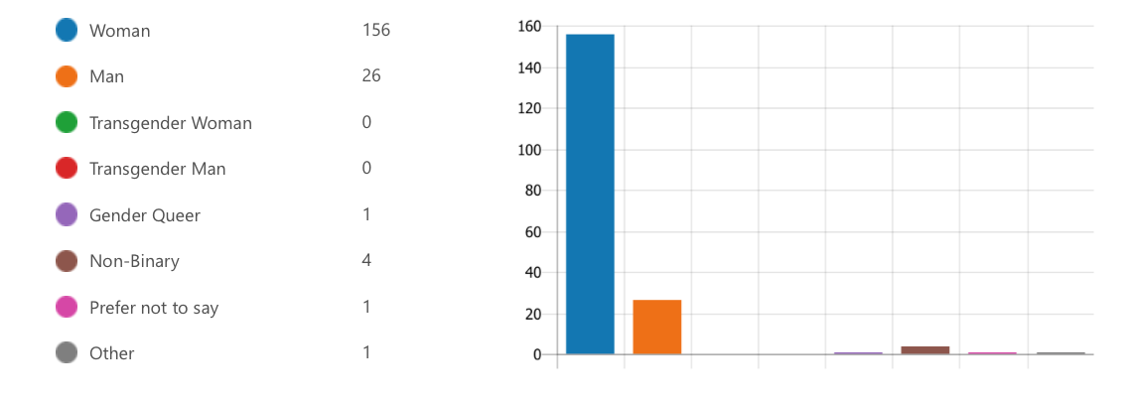
- How would you describe your ethnicity? (Check all that apply.) *
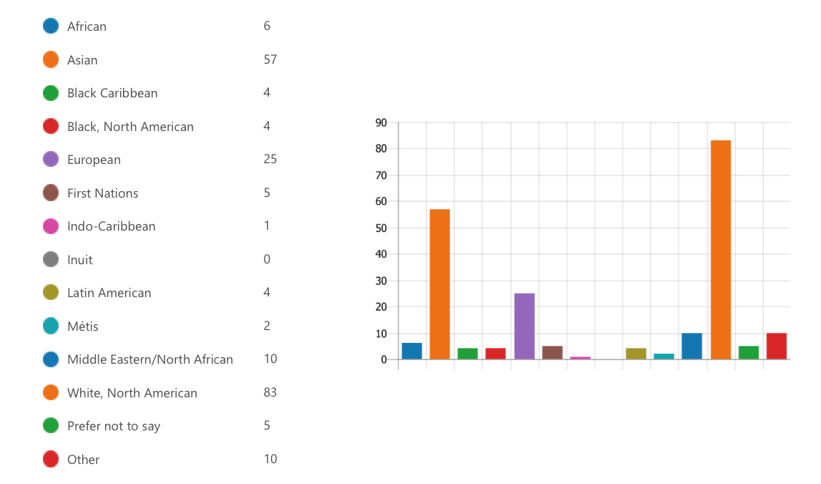

- What is your level of study?*
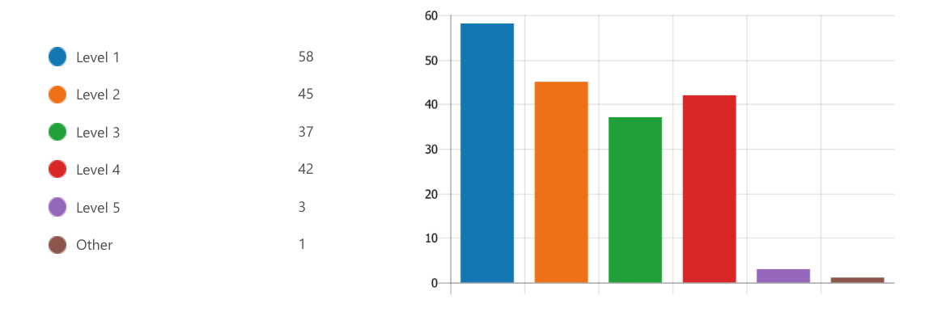
- What faculty are you in?*
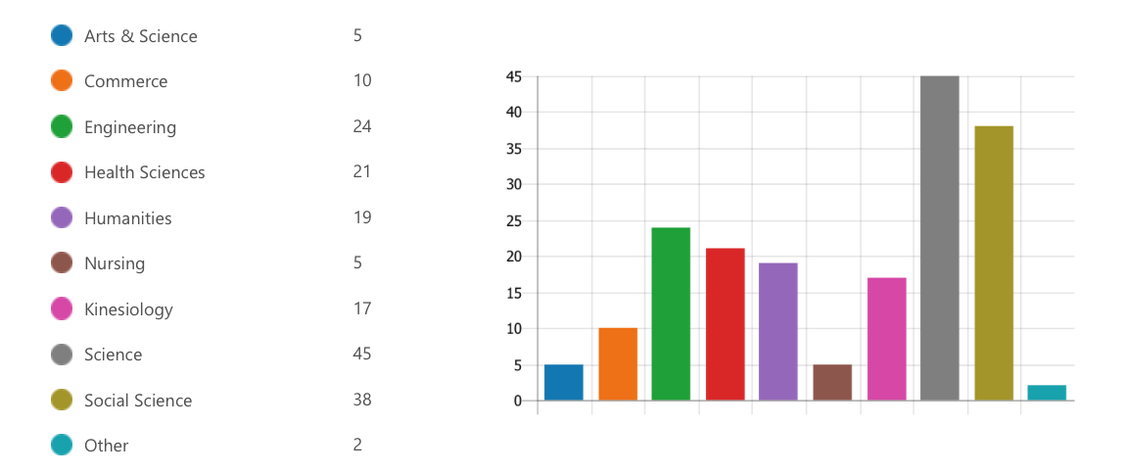
- Where are you living for this semester?*
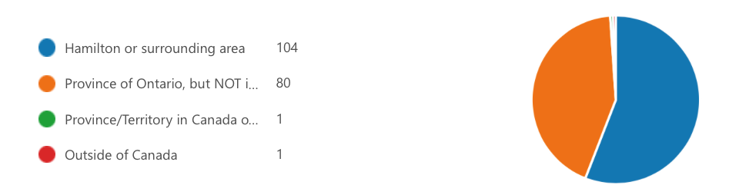
- Are you an international student?*
Mental Health During The Pandemic
- Have you faced any of these specific challenges over the course of the pandemic? Please select all that apply.*
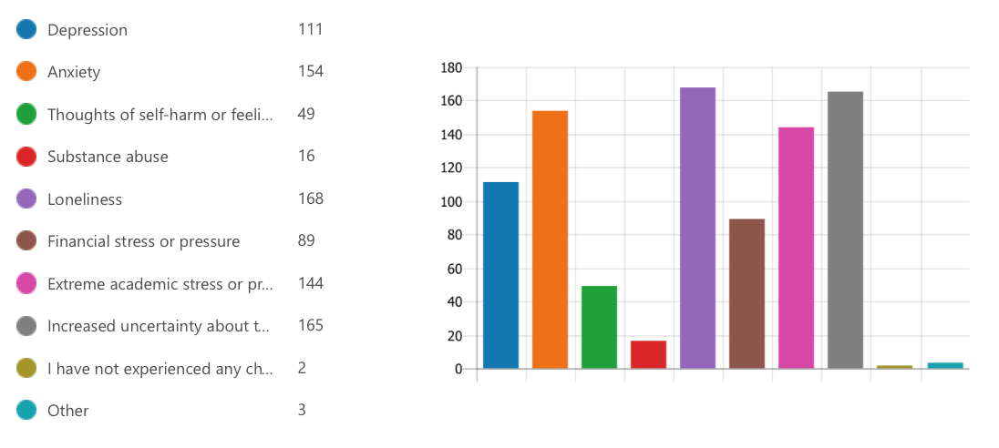
- Please select all of the following which have been concerns for you during the pandemic.*
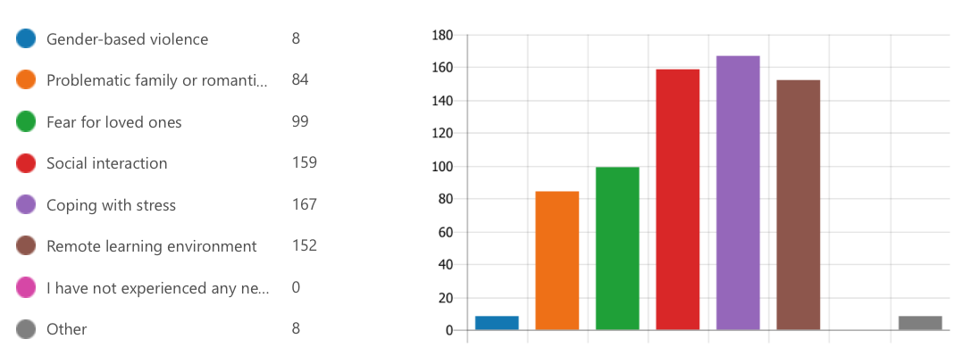
- Do you have a diagnosed mental health condition?*
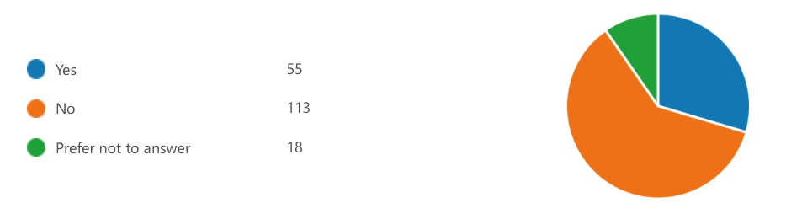

- If you need support with your mental health, how likely are you to reach out to the following groups or institutions for support? *
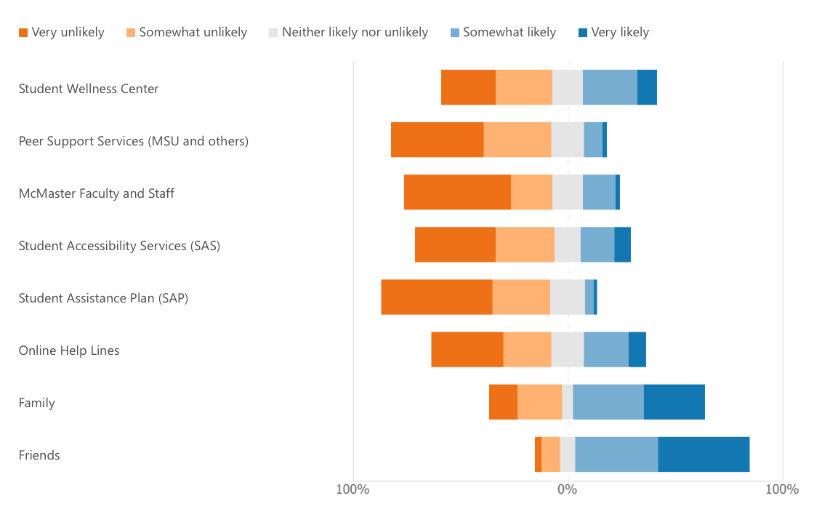
- Have you ever felt unable to access accommodation due to stigmatizing attitudes surrounding mental health?*
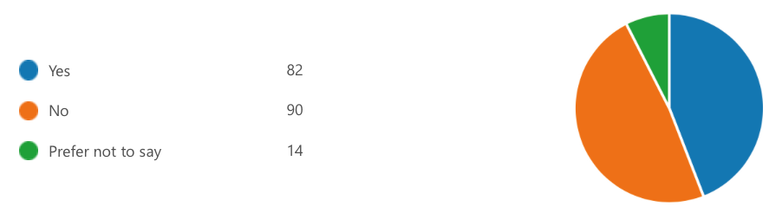
- Please rate how much you see yourself benefiting from a Mental Health and Resilience module that will be available to every McMaster student. This will feature all available mental health resources for McMaster students, as well best strategies to manoeuvre stress during university.*

- In a potential Mental Health and Resilience course currently in development, please rate the following topics based on how beneficial you believe them to be.*
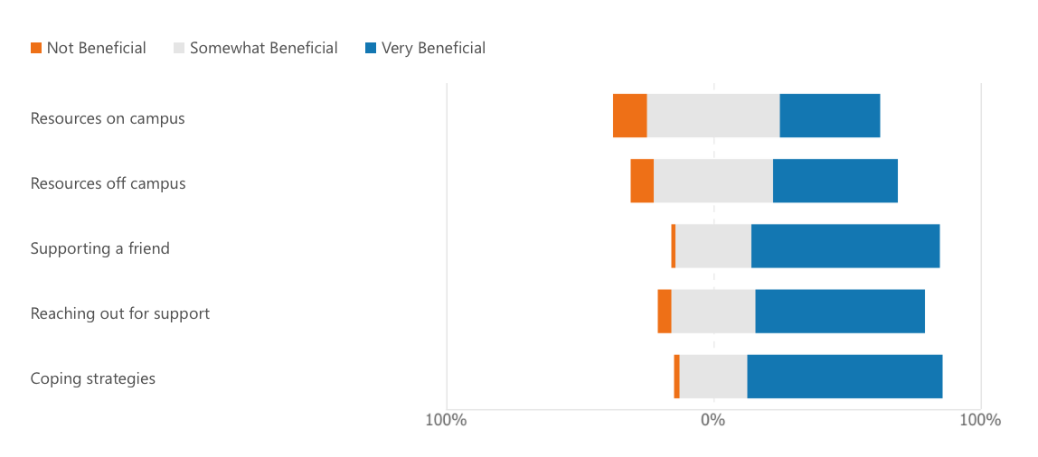
Impact of COVID-19
The following section is split into two parts: (1) your experiences prior to the pandemic and (2) the same statements based on your experiences this semester.

- Please rate these statements based on your experiences PRIOR to the COVID-19 pandemic.*
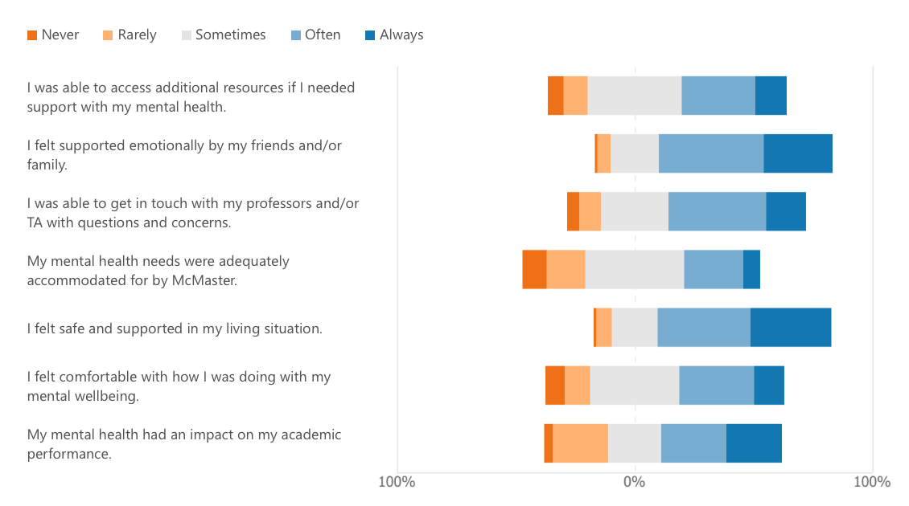

- Please rate the following statements based on your experiences over the past semester (August through November 2020).*
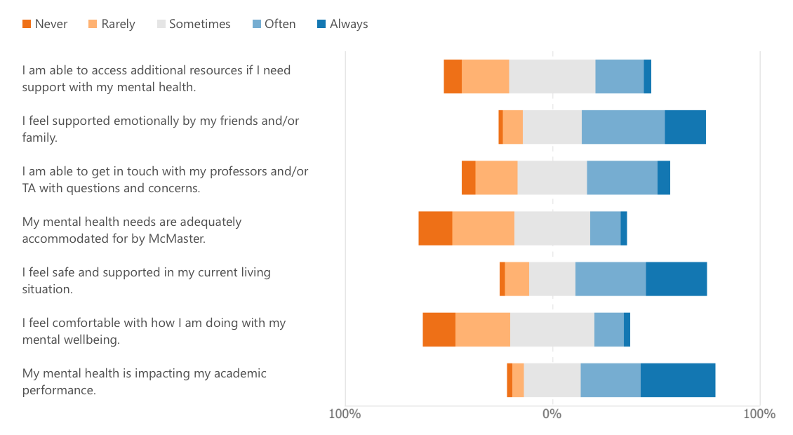

Focus Groups
Focus groups will be held during the last week of November as well as early January. It will involve a Zoom call of one hour or less.
- Would you be interested in participating in a focus group regarding some of the topics mentioned earlier in the survey?*
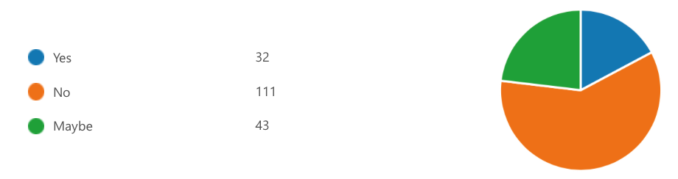
- If you would like more information about focus group participation, please provide an email address below:

Thank You!
19. In appreciation of your time and completion of this survey, if you would like to be entered in a raffle for 1 of 4 $25 giftcards, please enter your email below.

"Consequences of Student Mental Health Issues," Consequences of Student Mental Health Issues | Suicide Prevention Resource Center, accessed March 16, 2021, https://www.sprc.org/colleges-universities/consequences
Public Health Agency of Canada, "About Mental Health," Canada.ca, June 22, 2020, accessed March 16, 2021, https://www.canada.ca/en/public-health/services/about-mental-health.html
Government of Canada, “Perceived Mental Health, by Age Group,” Statistics Canada: Canada's national statistical agency / Statistique Canada : Organisme statistique national du Canada, 2019,
Mental Health Commission of Canada, “Children and Youth,” Mental Health Commission of Canada, accessed October 13, 2020, https://www.mentalhealthcommission.ca/English/what-we-do/children-and-youth.
"The Crisis Is Real," CAMH, accessed March 16, 2021, https://www.camh.ca/en/driving-change/the-crisis-is-real
Helen M. Stallman, “Psychological Distress in University Students: A Comparison with General Population Data,” Australian Psychologist 45, no. 4 (2010): pp. 249-257, https://doi.org/10.1080/00050067.2010.482109.
Changwon Son et al., “Effects of COVID-19 on College Students’ Mental Health in the United States: Interview Survey Study,” Journal of Medical Internet Research 22, no. 9 (March 2020), https://doi.org/10.2196/21279.
Chrysi K. Kaparounaki et al., “University Students’ Mental Health amidst the COVID-19 Quarantine in Greece,” Psychiatry Research 290 (2020): p. 113111, https://doi.org/10.1016/j.psychres.2020.113111
Amelia Gulliver, Kathleen M Griffiths, and Helen Christensen, “Perceived Barriers and Facilitators to Mental Health Help-Seeking in Young People: a Systematic Review,” BMC Psychiatry 10, no. 1 (2010), https://doi.org/10.1186/1471-244x-10-113.
Office of the Surgeon General (US); Center for Mental Health Services (US); National Institute of Mental Health (US). Mental Health: Culture, Race, and Ethnicity: A Supplement to Mental Health: A Report of the Surgeon General. Rockville (MD): Substance Abuse and Mental Health Services Administration (US); 2001 Aug. Chapter 2 Culture Counts: The Influence of Culture and Society on Mental Health. Available from https://www.ncbi.nlm.nih.gov/books/NBK44249/
Henderson, Claire, Sara Evans-Lacko, and Graham Thornicroft. “Mental Illness Stigma, Help Seeking, and Public Health Programs.” American journal of public health. American Public Health Association, May 2013. https://www.ncbi.nlm.nih.gov/pmc/articles/PMC3698814/.
"Addressing Stigma," CAMH, accessed March 15, 2021, https://www.camh.ca/en/driving-change/addressing-stigma
Rawlins, William Campbell, and Madeline Bishop. “Trying To Stop Suicide: Guyana Aims To Bring Down Its High Rate.” NPR. NPR, June 29, 2018. https://www.npr.org/sections/goatsandsoda/2018/06/29/622615518/trying-to-stop-suicide-guyana-aims-to-bring-down-its-high-rate.
Ibid.
Office of the Surgeon General (US); Center for Mental Health Services (US); National Institute of Mental Health (US). Mental Health: Culture, Race, and Ethnicity: A Supplement to Mental Health: A Report of the Surgeon General. Rockville (MD): Substance Abuse and Mental Health Services Administration (US); 2001 Aug. Chapter 2 Culture Counts: The Influence of Culture and Society on Mental Health. Available from https://www.ncbi.nlm.nih.gov/books/NBK44249/
Dutta, Mithun, Mamidipalli Sai Spoorthy, Shrimaan Patel, and Nitish Agarwala. “Factors Responsible for Delay in Treatment Seeking in Patients with Psychosis: A Qualitative Study.” Indian journal of psychiatry. Medknow Publications & Media Pvt Ltd, 2019. https://www.ncbi.nlm.nih.gov/pmc/articles/PMC6341933/.
“The Importance of Cultural Competence.” Ottawa University - Prepare for a Life of Significance, n.d. https://www.ottawa.edu/online-and-evening/blog/august-2020/the-importance-of-cultural-competence.
Ibid.
Jayasinghe, Romesh. “Spirituality for Holistic Health and Wellness.” ResearchGate. Institute of Mental Health (IMH), 2017. https://www.researchgate.net/publication/315772043_Spirituality_for_Holistic_Health_and_Wellness.
Ibid, pp. 4.
Newman, Tim. “Reiki: What Is It and Are There Benefits?” Medical News Today. MediLexicon International, September 6, 2017. https://www.medicalnewstoday.com/articles/308772#what-happens-in-a-reiki-session.
“Pranic Healing.” Olive Tree Cancer Support Centre, n.d. https://www.olivetreecancersupport.org.uk/therapies/pranic-healing.
Indigenous Inclusion Directorate. Smudging Protocol and Guidelines for School Divisions. Manitoba Education and Training, 2019, https://www.edu.gov.mb.ca/iid/publications/pdf/smudging_guidelines.pdf
Ibid.
Ontario Human Rights Code, R.S.O.1990, c. H.19 [Code].
Sub-section 10(3) of the Code, supra note 2.
"Policy on Accessible Education for Students with Disabilities," Policy on Accessible Education for Students with Disabilities | Ontario Human Rights Commission, accessed March 16, 2021, http://www.ohrc.on.ca/en/policy-accessible-education-students-disabilities
"Policy on Accessible Education for Students with Disabilities," Policy on Accessible Education for Students with Disabilities | Ontario Human Rights Commission, accessed March 16, 2021, http://www.ohrc.on.ca/en/policy-accessible-education-students-disabilities
Ezez. 2020. "Impacts on Mental Health". Www150.statcan.gc.ca. https://www150.statcan.gc.ca/n1/pub/11-631-x/2020004/s3-eng.htm.
Duffy, A., C. Keown-Stoneman, S. Goodday, J. Horrocks, M. Lowe, N. King, W. Pickett, et al. “Predictors of Mental Health and Academic Outcomes in First-Year University Students: Identifying Prevention and Early-Intervention Targets.” BJPsych Open 6, no. 3 (2020): e46. doi:10.1192/bjo.2020.24.
American College Health Association. “American College Health Association-National College Health Assessment II: Canadian Consortium Executive Summary Spring 2019.” Silver Spring, MD: American College Health Association; (2019).
Amelia Gulliver, Kathleen M Griffiths, and Helen Christensen, “Perceived Barriers and Facilitators to Mental Health Help-Seeking in Young People: a Systematic Review,” BMC Psychiatry 10, no. 1 (2010), https://doi.org/10.1186/1471-244x-10-113.
Harman S. Sandhu et al., “Mental Health Stigma: Explicit and Implicit Attitudes of Canadian Undergraduate Students, Medical School Students, and Psychiatrists,” The Canadian Journal of Psychiatry 64, no. 3 (2018): pp. 209-217, https://doi.org/10.1177/0706743718792193.
Andriyka Papish et al., “Reducing the Stigma of Mental Illness in Undergraduate Medical Education: a Randomized Controlled Trial,” BMC Medical Education 13, no. 1 (2013), https://doi.org/10.1186/1472-6920-13-141.
Gil Zalsman et al., “Suicide Prevention Strategies Revisited: 10-Year Systematic Review,” The Lancet Psychiatry 3, no. 7 (2016): pp. 646-659, https://doi.org/10.1016/s2215-0366(16)30030-x.
Anthony F. Jorm, “Mental Health Literacy: Empowering the Community to Take Action for Better Mental Health.,” American Psychologist 67, no. 3 (2012): pp. 231-243, https://doi.org/10.1037/a0025957.
S. Kutcher et al., “Educator Mental Health Literacy: a Programme Evaluation of the Teacher Training Education on the Mental Health & High School Curriculum Guide,” Advances in School Mental Health Promotion 6, no. 2 (2013): pp. 83-93, https://doi.org/10.1080/1754730x.2013.784615.
“Priorities,” McMaster Student Mental Health & Well-Being Strategy, September 11, 2015, https://mentalhealthstrategy.mcmaster.ca/priorities/.
“Programs,” Student Wellness Centre, McMaster University, https://wellness.mcmaster.ca/programs/
William Sharp et al., "Mental Health Education: An Evaluation of a Classroom Based Strategy to Modify Help Seeking for Mental Health Problems," Journal of College Student Development47, no. 4 (2006): doi:10.1353/csd.2006.0051
"Addressing Stigma," CAMH, accessed March 16, 2021, https://www.camh.ca/en/driving-change/addressing-stigma
Gulliver, Amelia, Kathleen M. Griffiths, and Helen Christensen. "Perceived barriers and facilitators to mental health help-seeking in young people: a systematic review." BMC psychiatry 10, no. 1 (2010): 1-9: /10.1186/1471-244x-10-113.
Sosei Yamaguchi, Yoshio Mino, and Shahir Uddin, "Strategies and Future Attempts to Reduce Stigmatization and Increase Awareness of Mental Health Problems among Young People: A Narrative Review of Educational Interventions," Psychiatry and Clinical Neurosciences65, no. 5 (2011): doi:10.1111/j.1440-1819.2011.02239.x
Statistics Canada Government of Canada, “Impacts on Mental Health,” Government of Canada, Statistics Canada, March 4, 2021, https://www150.statcan.gc.ca/n1/pub/11-631-x/2020004/s3-eng.htm.
McMaster Virtual Learning Task Force. Task Force on the Fall 2020 Virtual Learning Experience Final Recommendations. McMaster University, 24 Nov. 2020, https://www.mcmaster.ca/vpacademic/documents/Taskforce/Fall_VLT_Final_Recommendations_Report.pdf.
“Language Matters”, Mental Health Commission of Canada, accessed March 15, 2021, https://www.mentalhealthcommission.ca/sites/default/files/2020-08/language_matters_cheat_sheet_eng.pdf
Gulliver, Amelia, Louise Farrer, Kylie Bennett, and Kathleen M. Griffiths. "University staff mental health literacy, stigma and their experience of students with mental health problems." Journal of Further and Higher Education 43, no. 3 (2019): 434-442.
“Mental Health First Aid Training,” McMaster University, accessed March 15, 2021, https://hr.mcmaster.ca/employees/health_safety_well-being/my-health/mental-health-resources-and-training/mental-health-first-aid-training/
Andriyka Papish et al., “Reducing the Stigma of Mental Illness in Undergraduate Medical Education: a Randomized Controlled Trial,” BMC Medical Education 13, no. 1 (2013), https://doi.org/10.1186/1472-6920-13-141.
"Professor Hippo-on-Campus," MacPherson Institute, accessed March 15, 2021, https://mi.mcmaster.ca/professor-hippo-on-campus/
Khan, Mariam, Misja Ilcisin, and Katherine Saxton. "Multifactorial discrimination as a fundamental cause of mental health inequities." International Journal for Equity in Health 16, no. 1 (2017): 1-12.
Louisa Degenhardt et al., “Toward a Global View of Alcohol, Tobacco, Cannabis, and Cocaine Use: Findings from the WHO World Mental Health Surveys,” PLoS Medicine 5, no. 7 (January 2008), https://doi.org/10.1371/journal.pmed.0050141.
K Chen and D B Kandel, “The Natural History of Drug Use from Adolescence to the Mid-Thirties in a General Population Sample.,” American Journal of Public Health 85, no. 1 (1995): pp. 41-47, https://doi.org/10.2105/ajph.85.1.41.
White, Helene Raskin, Barbara J. McMorris, Richard F. Catalano, Charles B. Fleming, Kevin P. Haggerty, and Robert D. Abbott. "Increases in alcohol and marijuana use during the transition out of high school into emerging adulthood: The effects of leaving home, going to college, and high school protective factors." Journal of studies on alcohol 67, no. 6 (2006): 810-822.
Derefinko, Karen J., Richard J. Charnigo, Jessica R. Peters, Zachary W. Adams, Richard Milich, and Donald R. Lynam. "Substance use trajectories from early adolescence through the transition to college." Journal of studies on alcohol and drugs 77, no. 6 (2016): 924-935.
Louisa Degenhardt et al., “The Increasing Global Health Priority of Substance Use in Young People,” The Lancet Psychiatry 3, no. 3 (2016): pp. 251-264, https://doi.org/10.1016/s2215-0366(15)00508-8.
Canadian Paediatric Society, “Harm Reduction: An Approach to Reducing Risky Health Behaviours in Adolescents,” Paediatrics & Child Health 13, no. 1 (2008): pp. 53-56, https://doi.org/10.1093/pch/13.1.53.
Health Canada, "Government of Canada," Canada.ca, July 08, 2019, accessed March 16, 2021, https://www.canada.ca/en/health-canada/services/substance-use/canadian-drugs-substances-strategy.html
Ibid
“New Program Launched for Students With Substance Use Issues,” Queen’s Gazette, November 2, 2020. https://www.queensu.ca/gazette/stories/new-program-launched-students-substance-use-issues
“COVID-19 and Increased Alcohol Consumption: NANOS Poll Summary Report”, Canadian Centre on Substance Use and Addiction, accessed March 15, 2021, https://www.ccsa.ca/sites/default/files/2020-04/CCSA-NANOS-Alcohol-Consumption-During-COVID-19-Report-2020-en.pdf
“Non-Medical Prescription Stimulant Use Among Post-secondary Students”, Canadian Centre on Substance Use and Addiction, accessed March 15, 2021, https://www.ccsa.ca/sites/default/files/2019-04/CCSA-Non-Medical-Prescription-Stimulant-Use-Students-Summary-2018-en.pdf
“Canadian Tobacco, Alcohol and Drugs Survey (CTADS): summary of results for 2017” Government of Canada, Health Canada, accessed March 15, 2021, https://www.canada.ca/en/health-canada/services/canadian-tobacco-alcohol-drugs-survey/2017-summary.html
"Harm Reduction: What's in a Name?" Canadian Centre on Substance Use and Addiction, accessed March 16, 2021, https://www.ccsa.ca/harm-reduction-whats-name
“In it Together: Taking Action on Student Mental Health” Ontario’s Universities, accessed March 15, 2021, https://ontariosuniversities.ca/reports/in-it-together
College of Registered Psychotherapists of Ontario, “Practice Matters,” accessed October 14, 2020, https://www.crpo.ca/practice-matters/.
Hoyer, Carolin et al. 2020. "Decreased utilization of mental health emergency service during the COVID-19 pandemic". European Archives of Psychiatry and Clinical Neuroscience. Springer Science and Business Media LLC. doi:10.1007/s00406-020-01151-w.
Nicholas Grubic, Shaylea Badovinac, and Amer M. Johri, "Student Mental Health in the Midst of the COVID-19 Pandemic: A Call for Further Research and Immediate Solutions," International Journal of Social Psychiatry66, no. 5 (2020): doi:10.1177/0020764020925108
“Counselling.” Student Wellness Centre, October 2, 2020. https://wellness.mcmaster.ca/services/counselling/.
“Make an Appointment.” Dalhousie University. Accessed March 16, 2021. https://www.dal.ca/campus_life/health-and-wellness/services-support/student-health-and-wellness/make-an-appointment.html.
“Counselling.” Vancouver Community College. Accessed March 16, 2021. https://www.vcc.ca/services/services-for-students/counselling/.
“Accenture Names Kanioura Chief Analytics Officer.” News Group, 2019. https://doi.org/10.1287/lytx.2019.02.18n.
PatientPop. “Healthcare Providers' Perspective: Online Reputation Management.” PatientPop. PatientPop, January 22, 2020. https://www.patientpop.com/blog/online-reputation-reviews/healthcare-provider-perspective-online-reputation-management/.
Press Releases.” Intuit Health Survey Americans Worried About Costs Want Greater Access to Physicians. Accessed March 16, 2021. https://www.intuit.com/company/press-room/press-releases/2011/IntuitHealthSurveyAmericansWorriedAboutCostsWantGreaterAccesstoPhysicians/.
Moradveisi, Latif, Marcus Huibers, Fritz Renner, and Arnoud Arntz. “The Influence of Patients' Preference/Attitude towards Psychotherapy and Antidepressant Medication on the Treatment of Major Depressive Disorder.” Journal of Behavior Therapy and Experimental Psychiatry 45, no. 1 (2014): 170–77. https://doi.org/10.1016/j.jbtep.2013.10.003.
Moradveisi, Latif, Marcus Huibers, Fritz Renner, and Arnoud Arntz. “The Influence of Patients' Preference/Attitude towards Psychotherapy and Antidepressant Medication on the Treatment of Major Depressive Disorder.” Journal of Behavior Therapy and Experimental Psychiatry 45, no. 1 (2014): 170–77. https://doi.org/10.1016/j.jbtep.2013.10.003.
“UX Design Tips - Avoiding Information Overload.” RSS. Accessed March 16, 2021. https://www.ground.co.uk/post/ux-design-tips-avoiding-information-overload.
Student Wellness Centre, March 9, 2021. https://wellness.mcmaster.ca/.
Student Wellness Centre, March 9, 2021. https://wellness.mcmaster.ca/resources
Office of the Privacy Commissioner of Canada, “The Privacy Act,” September 6, 2019, https://www.priv.gc.ca/en/privacy-topics/privacy-laws-in-canada/the-privacy-act/.
Office of the Privacy Commissioner of Canada, “The Personal Information Protection and Electronic Documents Act (PIPEDA),” Office of the Privacy Commissioner of Canada, September 4, 2019, https://www.priv.gc.ca/en/privacy-topics/privacy-laws-in-canada/the-personal-information-protection-and-electronic-documents-act-pipeda/.
Office of the Privacy Commissioner of Canada, “Provincial and Territorial Privacy Laws and Oversight,” Office of the Privacy Commissioner of Canada, June 11, 2020, https://www.priv.gc.ca/en/about-the-opc/what-we-do/provincial-and-territorial-collaboration/provincial-and-territorial-privacy-laws-and-oversight/.
British Association For Counselling & Psychotherapy, “Knowledge of Psychological Processes Relevant to Offering Telephone and e-Counselling,” British Association For Counselling & Psychotherapy, n.d., https://www.bacp.co.uk/media/2045/bacp-competences-for-telephone-ecounselling.pdf.
Canadian Counselling and Psychotherapy Association, “Guidelines for Uses of Technology in Counselling and Psychotherapy,” Canadian Counselling and Psychotherapy Association, n.d., https://www.ccpa-accp.ca/wp-content/uploads/2019/04/TISCGuidelines_Mar2019_EN.pdf.
“Standard 3.4 Electronic Practice.” College of Registered Psychotherapists of Ontario. Accessed March 16, 2021. https://www.crpo.ca/standard-3-4-electronic-practice/.
“Student Wellness Centre: Privacy Information, Governing Law &amp; Jurisdiction Agreement,” 2017. https://wellness.mcmaster.ca/app/uploads/2020/04/SWC-student-confidentiality-information-and-agreement-Mar-2019.pdf.
“Recommendation Progress.” Mental Health and Wellness. https://uwaterloo.ca/mental-health-wellness/progress-dashboard/recommendation-progress#MentalHealthAwareness.
Openness and Transparency in Post-Secondary Institutions, n.d. https://www.caut.ca/about-us/caut-policy/lists/caut-policy-statements/policy-statement-on-openness-and-transparency-in-post-secondary-institutions.
“Student Mental Health & Well-Being Strategy: McMaster University.” Student Mental Health & Well-Being Strategy | McMaster University, n.d. https://mentalhealthstrategy.mcmaster.ca/.
“Recommendation Progress.” Mental Health and Wellness. https://uwaterloo.ca/mental-health-wellness/progress-dashboard/recommendation-progress#MentalHealthAwareness.
Ibid.
Ibid.
Jongbloed, Ben, Frans A van Vught, Hans Vossensteyn, and Don F Westerheijden. “Transparency in Higher Education: The Emergence of a New Perspective on Higher Education Governance.” Essay. In European Higher Education Area: The Impact of Past and Future Policies , 441–54, 2018. DOI: 10.1007/978-3-319-77407-7_27
Hirji, MM, Wilson MG, Yacoub K, Bhuiya A. Rapid Synthesis: Identifying Suicide-prevention Interventions. Hamilton, Canada: McMaster Health Forum, 30 June 2014. https://www.mcmasterforum.org/docs/default-source/Product-Documents/rapid-responses/identifying-suicide-prevention-interventions.pdf?sfvrsn=2
Kahn, April. “What You Should Know About Suicide.” Healthline. Healthline Media, December 21, 2019. https://www.healthline.com/health/suicide-and-suicidal-behavior.
Ibid.
Ibid.
Strauss, Valerie. “Analysis | Why We Should Stop Labeling Students as 'at Risk' - and the Best Alternative.” The Washington Post. WP Company, January 23, 2019. https://www.washingtonpost.com/education/2019/01/23/why-we-should-stop-labeling-students-risk-best-alternative/.
Ibid.
Porter, Shirley. “A Descriptive Study of Post-Secondary Student Mental Health Crises .” College Quarterly, 2019. http://collegequarterly.ca/2019-vol22-num01-winter/descriptive-study-of-post-secondary-student-mental-health-crises.html.
Jeff Doyle, “Fostering Student Success Outside of Online Classes,” What's the role of student affairs and academic support staff when most students aren't on campus? (opinion), April 7, 2020, https://www.insidehighered.com/advice/2020/04/07/whats-role-student-affairs-and-academic-support-staff-when-most-students-arent.
Ibid.
Ibid.
Greenfield, Nathan. “Stress and Isolation behind Rising Student Suicides.” University World News, February 29, 2020. https://www.universityworldnews.com/post.php?story=20200227125212379#:~:text=A%20study%20conducted%20by%20Professor,to%20the%20general%20Canadian%20population.
Jeff Doyle, “Fostering Student Success Outside of Online Classes,” What's the role of student affairs and academic support staff when most students aren't on campus? (opinion), April 7, 2020, https://www.insidehighered.com/advice/2020/04/07/whats-role-student-affairs-and-academic-support-staff-when-most-students-arent..
Ibid.
Ibid.
Ibid.
Hirji, MM, Wilson MG, Yacoub K, Bhuiya A. Rapid Synthesis: Identifying Suicide-prevention Interventions. Hamilton, Canada: McMaster Health Forum, 30 June 2014. https://www.mcmasterforum.org/docs/default-source/Product-Documents/rapid-responses/identifying-suicide-prevention-interventions.pdf?sfvrsn=2
Ibid.
Ibid, pp. 10.
Jayasinghe, Romesh. “Spirituality for Holistic Health and Wellness.” ResearchGate. Institute of Mental Health (IMH), 2017. https://www.researchgate.net/publication/315772043_Spirituality_for_Holistic_Health_and_Wellness.
“Suicidal Thoughts and Depression: 7 Holistic Ways to Prevent Suicide.” Vantage Point Recovery. Vantage Point Recovery, July 12, 2019. https://vantagepointrecovery.com/suicidal-thoughts-depression/.
Ibid.

