|  |  |
| --- | --- |
| . | MemoFrom the office of the…Vice-President (Administration) |
| To: | SRA Members and Committee Chairs |
| From: | Graeme Noble, Vice-President (Administration) |
| Subject: | Amend Operating Policy – Information Systems Committee |
| Date: | March 21, 2021 |

### Introduction

Dear Members of the Assembly,

As any organization grows in size, so too do its technological needs. Of course, the pandemic has only exacerbated this need: whether through increasing security risks, changes in workspaces, or the general need for adapted user interfaces, information technology (IT) departments are really feeling the brunt of these shifts to online living. Perhaps it goes without saying then that the MSU’s IT department of 1 is ill-fit for the needs of our organization in a normal year (undercutting industry standards anywhere from 200%–500% for relative IT annual operational spending), but highly understaffed for the years ahead of us. In addition, in the MSU’s public statement concerning the results of our KPMG internal audit, it was noted that our IT department was under-supported to achieve the needs of the MSU as a whole, even with the help of third-party contracts to supplement the difference.

After extensive consultation with Pauline, the Network Administrator, as well as other relevant staff members, the Board of Directors has approved the Job Descriptions for two full-time IT staff members to join the MSU’s ranks. The new structure would look something like this:

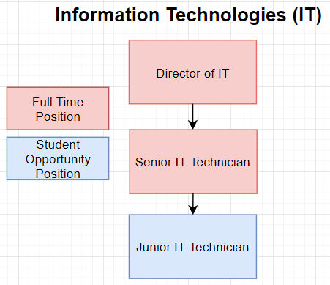

Within this structure, the Network Administrator has been substituted with the Director of IT. While this mostly constitutes a simple name change and an updated Job Description that reflects the actual duties Pauline performs, it also warrants a higher technical skill set for Pauline’s successor in a few years time. The rest of the structure is geared towards serving the MSU in creating an internal IT support network for staff members, handled primarily by the permanent full-time Senior IT Technician. This position shall serve as the lieutenant of IT, so to speak, to help the Director with any and all technical staff requests, purchase orders, installations, and general upkeep for the MSU’s servers. They shall also oversee the Junior IT Technician, who will be tasked with attending to special projects, less technical IT tasks, and any other areas that would be viewed as appropriate given their expertise as a Student Opportunity Position (SOP). While I highly recommend that the MSU pursues this position as an internship opportunity with the Faculty of Engineering in the future—due to time limitations—we’ll likely have to post the role as an SOP for this coming hiring cycle. To offset the costs for these changes, the MSU will phase out its contracts with external third-party IT support entities and reallocate those funds towards catered, on-demand, high-quality internal IT services. While this doesn’t entirely assume all the costs on its own, the expenditures and discarded profit from inefficiencies, mal-/ransomware attacks, inappropriate workstation purchase cycles, and so much more will undoubtedly prove just how worthwhile this investment will be.

Of course, with any structural changes often accompanies a policy change or two. As such, the proposals for **Operating Policy – Information Systems Committee** is attached below:

### Proposal

Earlier in the year, the Network Administrator recommended that this Operating Policy be rescinded due to its lack of utility and how infrequently its procedures were followed. However, with additional support for the IT Department, I’ve included a new model and mandate that turns the committee into a fruitful expansion to IT discussions within the MSU to add a required level of communication between all staff with IT needs and the IT Department staff. These amendments also include all key stakeholders related to IT within the MSU, unlike the previous makeup of the committee, to ensure that it broadly encapsulates all aspects of technological functioning within the MSU from event technologist to webmasters.

Please let me know if you have any questions or concerns prior to the meeting.

Kind regards,



**Graeme Noble**

Vice-President (Administration) & Chief Administrative Officer

McMaster Students Union

[vpadmin@msu.mcmaster.ca](mailto:vpadmin@msu.mcmaster.ca)