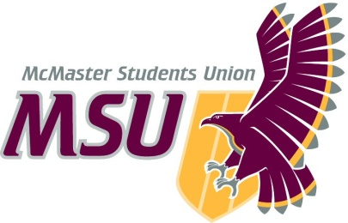
Year-End Report
From the office of…
WGEN
To: Members of the Executive Board (EB)
From: Yimeng Wang, WGEN Coordinator
Subject: Service Year-End Report
Date: March 21, 2021

Table of Contents
Table of Contents 1
Report Summary 3
General Information 3
Year Plan Update 5
Events, Projects, & Activities 5
General Service Usage 5
Projects & Events 5
Project 1: Prison Abolition & Survivorship Campaign 5
Project 2: Summer Abolition Book Club 6
Project 3: Community Care Groups 7
Project 4: A Guide to Supporting Survivors 7
Project 5: Trans(forming) Mac 8
Project 6: Exam De-Stressor Events 8
Project 6: Collective Care Program 9
Project 7: Bodies Are Dope 9
Project 8: Making Waves 10
Outreach & Promotions 11
Summary 11
Promotional Materials 11
Social Media Engagement 15
Finances 15
Budget Summary 15
Personnel 17
Executive 17
Volunteers 17
General 18
Miscellaneous 18

Report Summary

General Information

This year, WGEN has had to overcome unprecedented obstacles through a period of extreme political and social volatility. On one hand, the completely new circumstances we had to face means this year’s operations cannot be measured against past years’. On the other hand, the amount of high quality work that WGEN has produced this year is additionally remarkable because of this.

In the early days of the pandemic, in response to new stressors experienced in our communities as well as the political climate, WGEN ran summer programming for the first time. We ran an online educational campaign on the Prison Abolition movement and how it can go hand-in-hand with supporting survivors of sexual violence. We also ran a 2.5-month long abolition reading group. Finally, our support group, Survivors, ran for the last few weeks of summer.

WGEN was present at 5 events for Welcome Week and helped host a training on responding to sexual violence disclosures with other MSU peer support services and SVPRO.

In Fall Semester, WGEN opened our virtual safe(r) space on Zoom for the first time in October, with the space operating for full hours starting in November. We also started our Community Care Groups for the following communities: Muslim women and non-binary folks; East Asian diaspora and migrants; racialized non-cis folks; Black & Gendered. We also launched an online resource around supporting survivors, tailored for folks who have not had the opportunity to receive official training. Our first annual campaign week, Trans(forming) Mac, also occurred. We ran 10 drop-in events as well as 3 digital events. This includes an event to recognize Trans Day of Remembrance. We closed out the semester with 3 event-time de-stressor events.

In Winter Semester, WGEN opened our virtual safe(r) space at the end of January, introducing our new Discord space. At the same time, we launched Collective Care with SHEC, a new program to continue allowing students to access free resources in a digital world. We also re-launched Survivors. In February, we held our annual campaign, Bodies Are Dope, to celebrate and create space for Black, Indigenous, and racialized individuals. We ran 11 events total and 8 distinct events. For the first time ever, we also ran a day of programming specifically for Black folks, in recognition of Black History Month. During this time, we also ran a Black History Month giveaway for Black students and daily affirmations on our social medias. Finally, in March we are currently running our final campaign week, Making Waves. We are running 15 distinct events, including 4 collaborations and 1 keynote speaker. Two events will run throughout the week. Finally, in April we will re-launch our East Asian diaspora and migrant Community Care Group in response to the current political climate.

Other activities WGEN was involved in: 5 different University committees (WWSTAPC, PACBIC, PACBIC Planning & Priorities, Gender & Sexuality Working Group, SVPR Task Force) and hiring and training of 52 volunteers.

Year Plan Update
Objective 1: Standalone Events
Planned in accordance to WGEN’s past schedule (e.g. opening trivia night event, Halloween event, etc.). Due to reduced capacity, quickly realized that both the ambition to hold these events and the timelines were unfeasible.

Objective 2: Training Timelines
Due to bureaucracy, MSU timelines, and efforts to accommodate volunteer needs, training development and timelines were significantly pushed back. The WGEN space, which usually opens in mid-September, was only able to open fully in November.

Objective 3: Regular Socials
Although originally planned to occur every month to promote a sense of community, this did not happen both due to reduced capacity on the side of the exec team and the disinterest from volunteers to spend more time on Zoom.

Events, Projects, & Activities

General Service Usage

Please refer to EB reports throughout the year for more detailed numbers. 44 users entered the WGEN space this year, as recorded by safe(r) space volunteers. I had 3 users reach out for individual peer support on several occasions.

Projects & Events

Project 1: Prison Abolition & Survivorship Campaign
Project Status: Complete
General Information:
A 3-tier campaign focused on the prison abolition movement and specifically how it intersects with supporting survivors of sexual violence. The 3 topics were: Canada’s Criminal Justice System; Anticarceral Feminism and Abolition; and Supporting Survivors without Police.

Challenges:
An ambition to cover a large amount of information in a short amount of time and less support from the exec team. An under-planned promotions plan.

Successes:
Really relevant and high-quality information. Significant social media engagement.

Project 2: Summer Abolition Book Club
Project Status: Complete
General Information:
A 5-session reading group of multimedia materials relating to the prison abolition movement. Sessions included: The Punitive State; Policing and Identity; Abolitionism; and Practicing Abolitionism.

Challenges:
Balancing digestible amounts of information with covering a breadth of topics. Pre-planning content to send to members.

Successes:
A high level of interest – 19 signed up. Really fruitful discussions in all sessions.

Project 3: Community Care Groups
Project Status: Ongoing
General Information:
The creation of new groups for folks to celebrate identities and share closed spaces together.

Challenges:
Identifying which groups to run and language to be used for promo. Recruiting exec team facilitation. Low interest.

Successes:
Creating space for folks. Being able to return to pre-established promo and structures when the political climate called for it.

Project 4: A Guide to Supporting Survivors
Project Status: Complete
General Information:
Developed for individuals with little to no official training on supporting survivors, responding to disclosures, and addressing comments in day-to-day life.

Challenges:
Promotion plan to ensure the guide receives the attention it deserves.

Successes:
First project led by my Social and Political Advocacy Coordinator with high quality content produced.

Project 5: Trans(forming) Mac
Project Status: Complete
General Information:
WGEN’s first annual campaign week for trans folks. Ran from November 20–25, starting on Trans Day of Remembrance. 10 distinct events ran, with 4 collaborations, 5 speakers, and an attention to intersecting identities.

Challenges:
A lack of exec team capacity and support from non-trans execs. Timelines and finalizing all events and promo with enough time to promote the campaign.

Successes:
Students beyond McMaster circulated and attended events. Smaller events generated really good conversation and positive spaces. Really knowledgeable speakers agreed to participate.

Project 6: Exam De-Stressor Events
Project Status: Complete
General Information:
3 events run throughout December exam period: Baking & Vibes; Tea & Lo-fi study; Arts & Crafts.

Challenges:
Engaging students during a stressful time.

Successes:
Imagined and run completely by the Events Committee!

Project 6: Collective Care Program
Project Status: Ongoing
General Information:
A joint effort by SHEC and WGEN to offer resources to students despite not sharing a common space.

Challenges:
Acquiring enough funding to meet all expressed needs.

Successes:
Extremely high interest and complete use of budget dedicated to the program. Request for additional funding through the Service Special Projects Fund. 71 requests as of this report.

Project 7: Bodies Are Dope
Project Status: Complete
General Information:
WGEN’s annual campaign to celebrate and highlight the excellence of Black, Indigenous, and racialized folks. To create space for BIPoC bodies. Ran from February 24–27.

Challenges:
Attempting to book speakers. Attempting to brainstorm and facilitate events for Bodies Are Dope while also supporting Black History Month. Forgot to submit EOHSS prior to event.

Successes:
Engagement with social media posts throughout the week, including a Black History Month Giveaway. Interest and engagement in our day dedicated to programming for Black students.

Project 8: Making Waves
Project Status: Ongoing
General Information:
WGEN’s final annual campaign to promote engagement with decolonial, intersectional feminism. This year, re-centering creating survivor-centric spaces as a priority. Running from March 22–26.

Challenges:
Balancing other end-of-term commitments with planning and facilitating events. Communications with speakers.

Successes:
Involvement from exec team and Events Committee. Collaborations with other McMaster organizations. Contacting a really cool speaker! Currently 24 responses as of this report, and rising.

Outreach & Promotions

Summary
General Information:
Social media presence was crucial in an online world to ensure WGEN events were seen. Also important to foster relationships with other organizations that could share through other venues.

Challenges:
My personal lack of interest and familiarity with social media. Over-saturation of events on social media. A general decline in social media use because of constantly being online.

Successes:
Using Facebook boost, especially free credits through my personal connections. Circulating to staff and faculty through PACBIC. Building social media connections to other organizations with similar mandates on Instagram.

Promotional Materials
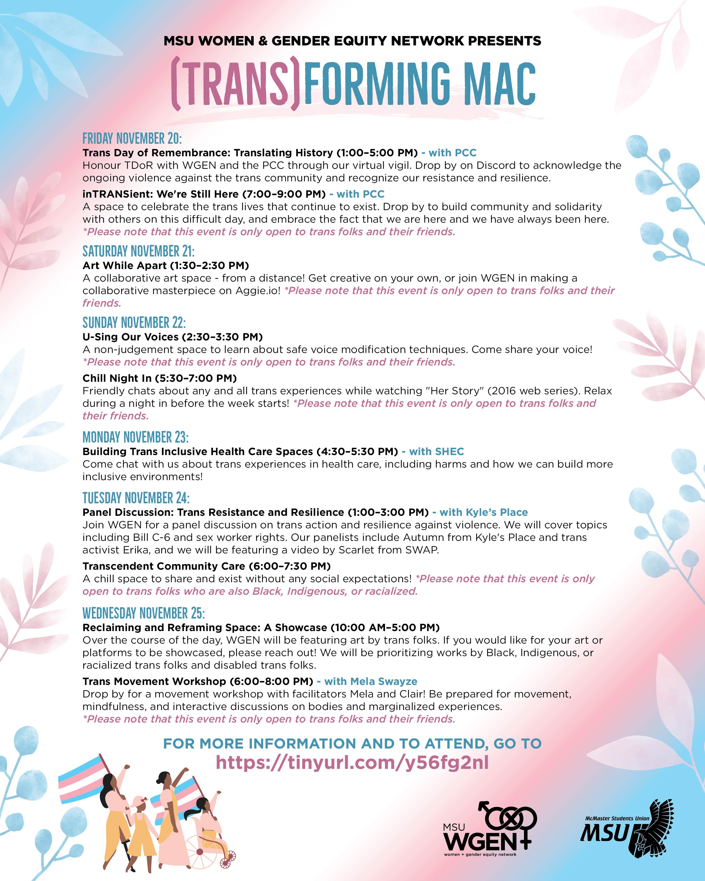
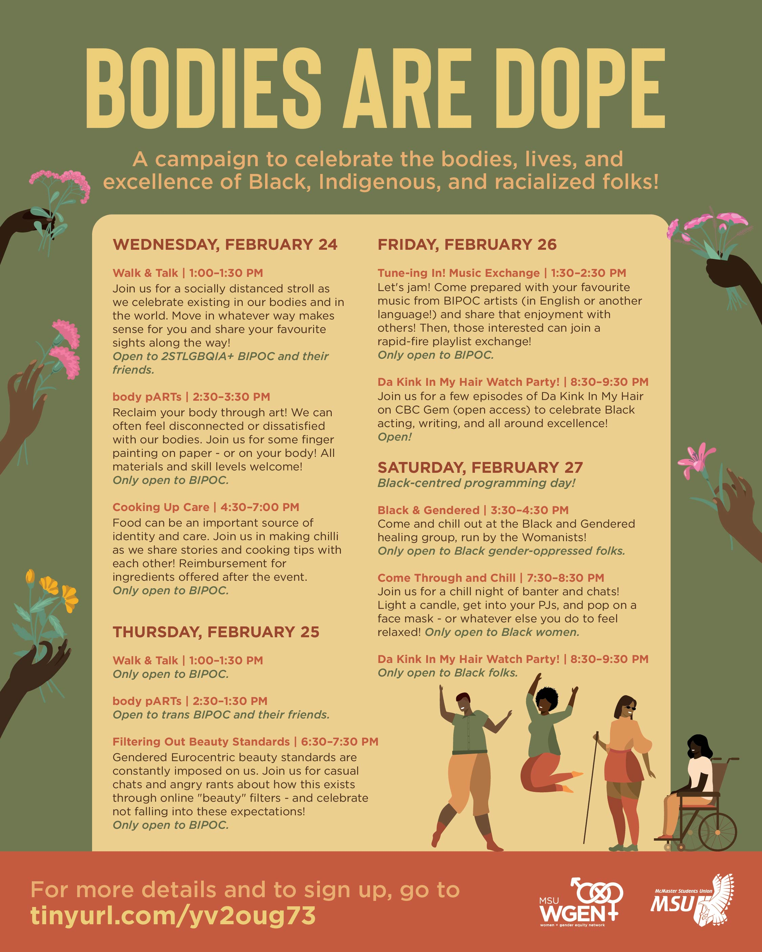
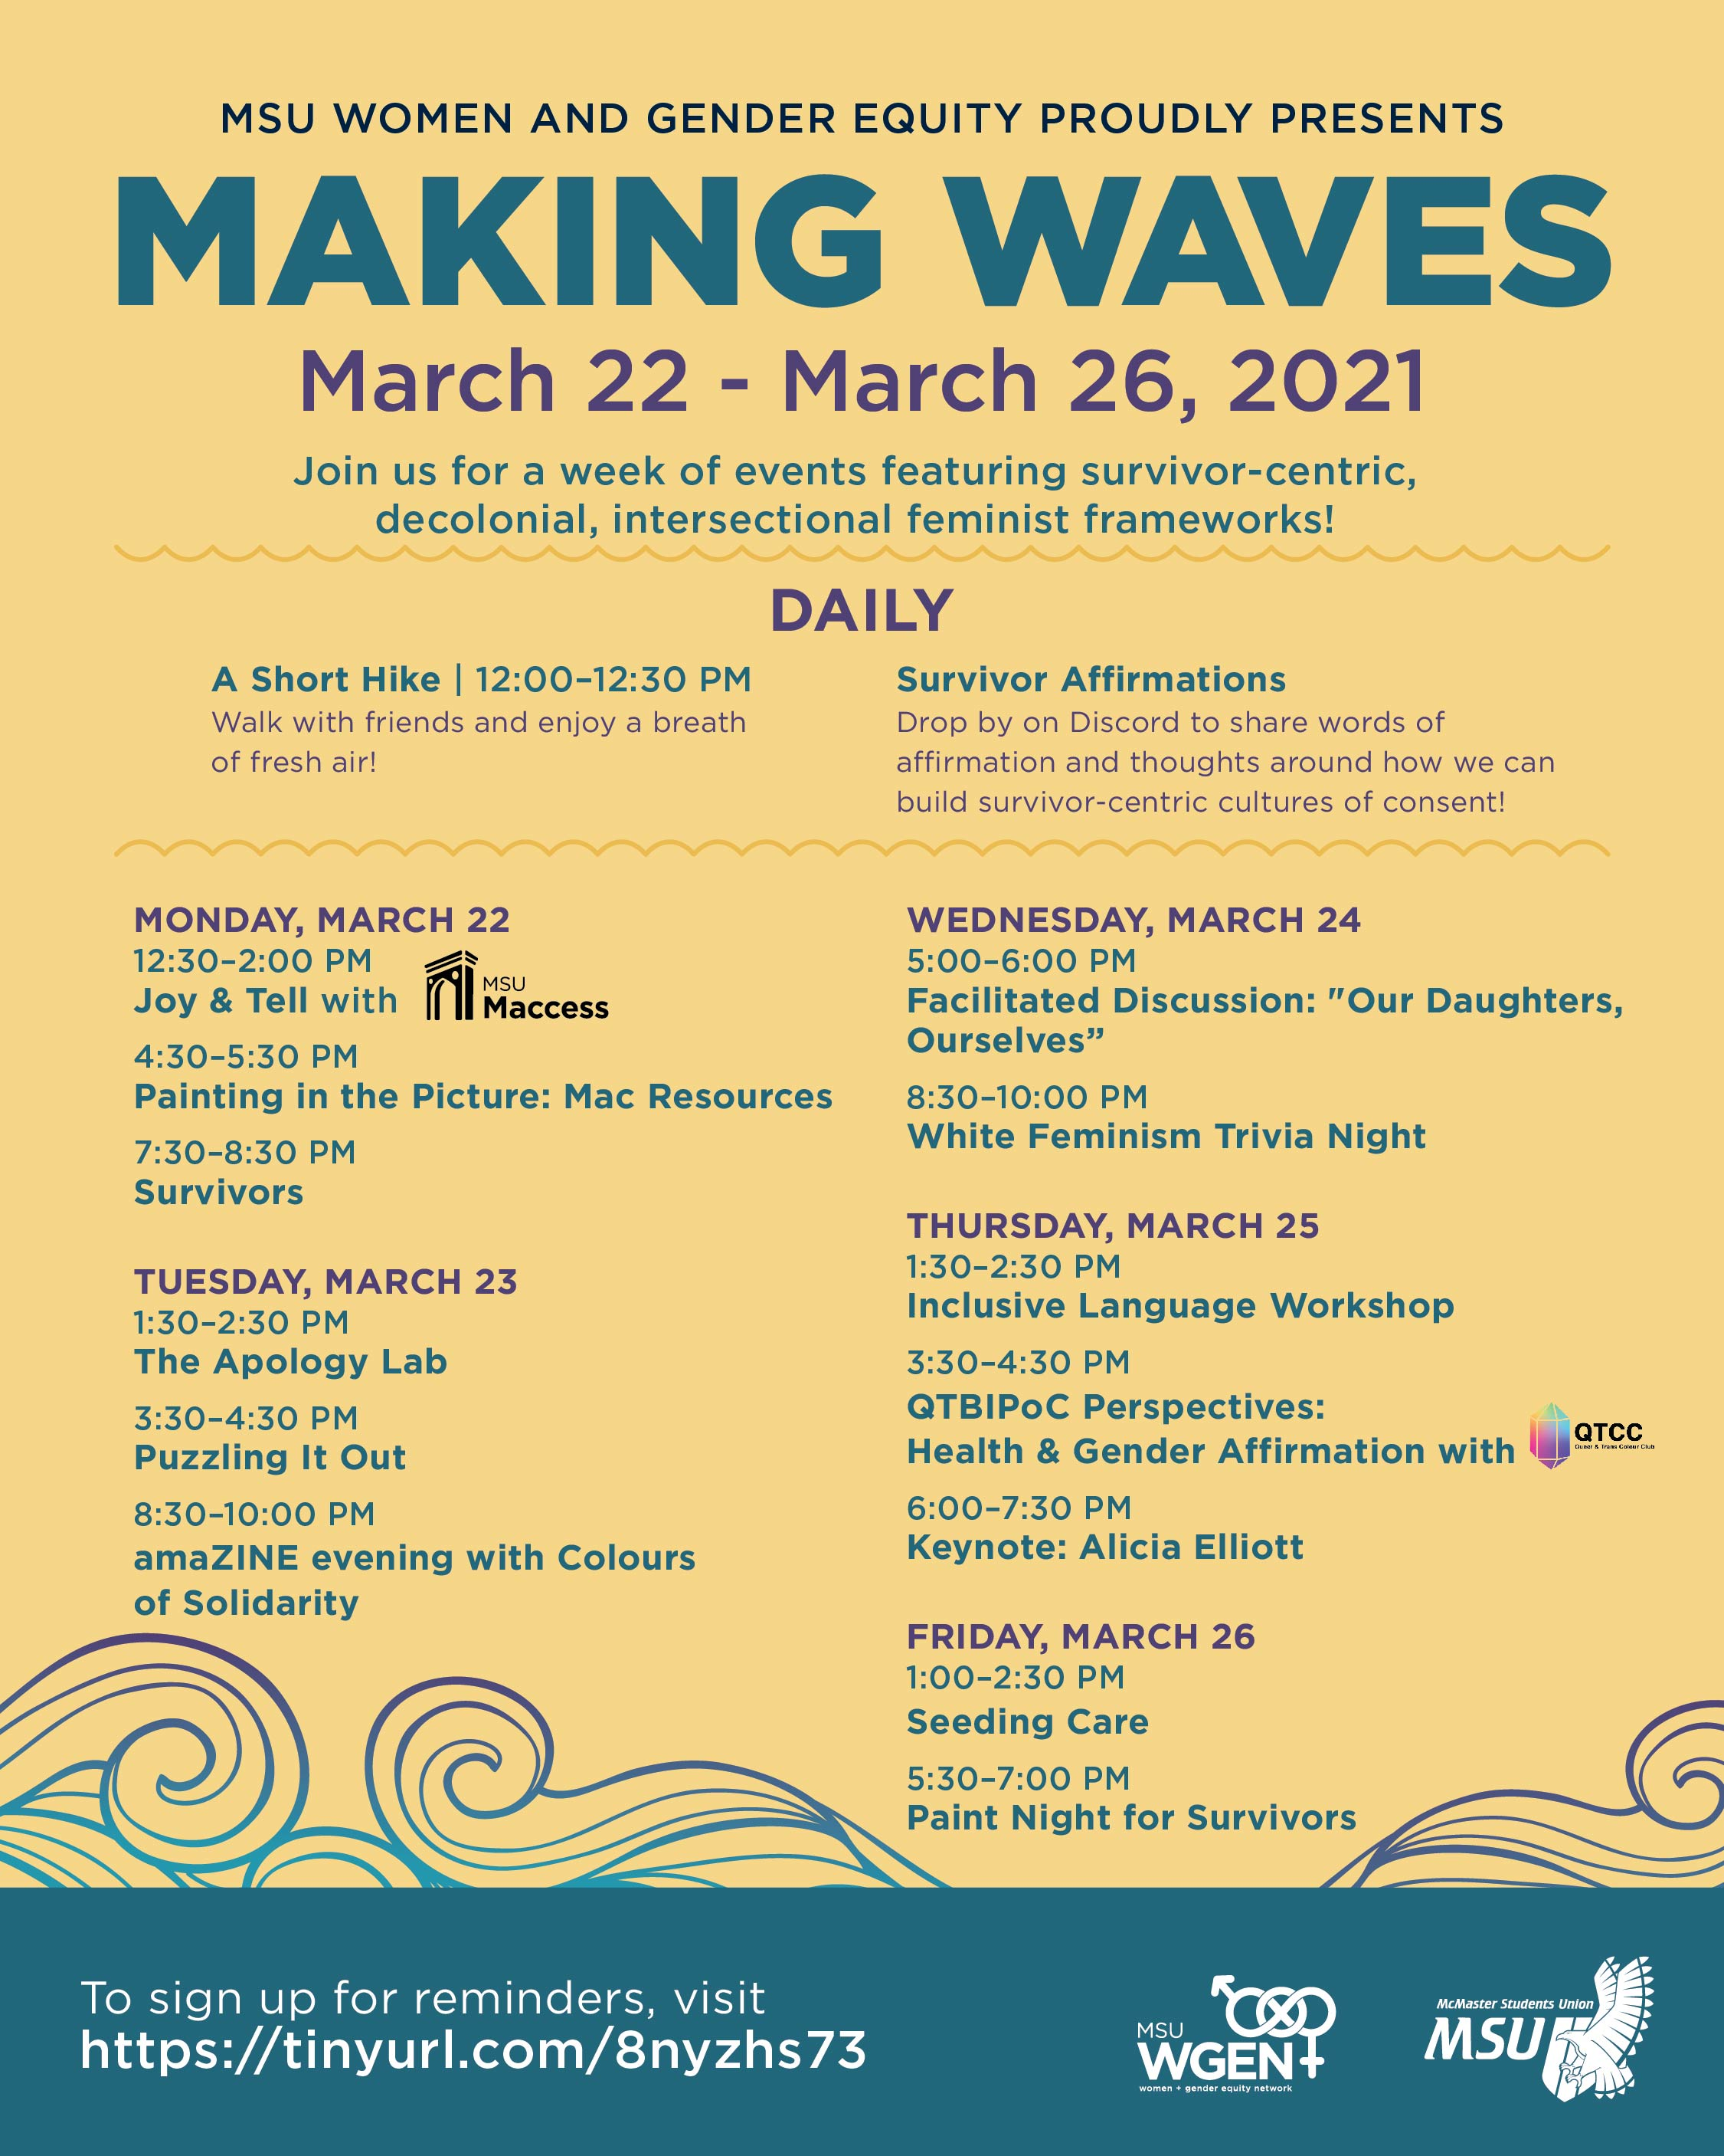

Social Media Engagement

Please refer to EB reports throughout the year for more detailed numbers, especially as social media platforms are only able to retain certain statistics for a limited amount of time. As of the time of this report, our Instagram has 762 followers (compared to 640 in August, 2020) and our Facebook has 2,195 (compared to 2,124 in May, 2020).

Finances
General Information:
This year required new and creative ways of using the budget given that many of our usual spending (e.g. food for events) was unnecessary. I attempted to make long-term investments or spend in ways central to our mandate that we normally would not have the means to commit to.

Challenges:
Thinking of creative ways to use the budget. Keeping track between projected spending and actual spending. Submitting P/Os to be approved in advance of events. $50 donation cap – informed after the fact.

Successes:
Coming up with creative ways of using the budget (e.g. Collective Care Program). Saving funds through promo to be invested in stickers for the long-term. Finding ways of resourcing additional funds through collaborations/University organizations.

Budget Summary
Table 4: Budget Tracker
ACCOUNT CODE | ITEM | BUDGET / COST
5003-0308 | OFFICE SUPPLIES
 | TOTAL SPENT IN LINE  - LibraryCat subscription  - Verso books (6) | $48.78  $50.93
 | REMAINING IN LINE | $0.29
6102-0308 | ANNUAL CAMPAIGNS
 | TOTAL SPENT IN LINE  - Trans(forming) Mac speakers  - Bodies Are Dope events  - Making Waves – Alicia Elliott  - Making Waves – events | $732.50  $75.00  $1,500.00  TBD
 | REMAINING IN LINE | $492.50
6104-0308 | WOMANISTS
 | TOTAL SPENT IN LINE  - Books | $TBD
 | REMAINING IN LINE | $250.00
6103-0308 | SPECIAL PROJECTS
 | TOTAL SPENT IN LINE  - Financial Advocacy – Black Women in Motion  - Gender-affirming products project  - Collective Care program (Jan/Feb) | $50.00  $130.64  $568.92
 | REMAINING IN LINE | $0.44
6494-0308 | VOLUNTEER RECOGNITION
 | TOTAL SPENT IN LINE  - Jackbox.tv  - Volunteer t-shirts | $21.13  $728.00
 | REMAINING IN LINE | $0.87
6501-0308 | ADVERTISING & PROMOTION
 | TOTAL SPENT IN LINE  - Community Care Groups Promo  - Trans(forming) Mac Promo  - Bodies Are Dope Promo  - BHM Giveaway  - WGEN Sweaters  - Alicia Elliott Poster  - Making Waves Promo  - Social Media Boost  - WGEN Virtual Spaces Infographic  - Stickers | $75.00  $150.00  $125.00  ~$170.00  ~$500.00  $60.00  $125.00  $50.00  $120.00  $611.00
 | REMAINING IN LINE | $14.00
6804-0308 | TRAINING EXPENSES
 | TOTAL SPENT IN LINE  - SACHA Training | $500.00
 | REMAINING IN LINE | $0.00
TOTALS
TOTAL BUDGETED DISCRETIONARY SPENDING |  | $7,150.00
TOTAL ACTUAL DISCRETIONARY SPENDING |  | $6,881.90
REMAINING DISCRETIONARY SPENDING |  | $268.10

Personnel

Executive
Challenges:
Building a strong team dynamic in a digital world. Requesting and obtaining engagement in the middle of a pandemic and with other responsibilities (personal, academic, etc.). 1 exec stepped away from the role due to being overwhelmed with other responsibilities. Asking for time to attend 1-on-1s.

Successes:
Building strong personal relationships with execs! Celebrating many of the projects completed by execs, and celebrating the work they do contribute to WGEN. Having execs willing to reach out and share event ideas or raise concerns.

Volunteers
Challenges:
Volunteer engagement with the space – many often forget or are unable to make their shifts. More difficult for the exec team to check whether the space needs to be closed. The Zoom space automatically closes after a certain period of inactivity, requiring my Volunteer Coordinator or myself (mainly my VC) to reopen. Less relationship building between volunteers and less thorough engagement with training materials.

Successes:
Willingness to engage with training and dedication to WGEN! Understanding of delays and the lower capacity of the exec team. Willingness to engage in additional training opportunities.

General
Challenges:
Balancing relationship as a peer/friend with one as a manager. Acting as a support no matter personal feelings towards an individual. Recognizing the greater needs of the service over personal sentiments.

Successes:
Meeting and forming strong relationships with really wonderful people! Being able to spend time and shared efforts bringing important events to fruition. Being surrounded by folks with shared values during a difficult period of time.

Miscellaneous

There are so many activities that I took on as a PTM that did not make it into this report, so I would encourage folks to read through EB reports for more specific details.

I am so grateful for my exec team and volunteer committees for helping enable all of WGEN’s activities this year. I deeply believe that our actions speak just as loud as our words, and I am proud of the actions we took this year for our communities.

