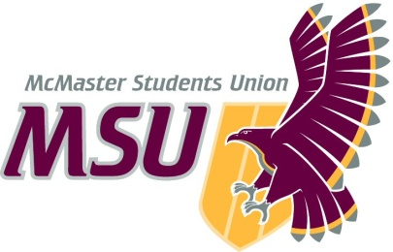
Year-End Report
From the office of…
MSU Spark
To: Members of the Executive Board (EB)
From: Baila Lovejoy, Spark Coordinator
Subject: Service Year-End Report
Date: March 23, 2021

Table of Contents
Table of Contents 1
General Summary 1
General Thoughts 1
Action-Items & Inquiries 1
Year Plan Update 2
Events, Projects, & Activities 2
General Service Usage 2
Projects & Events 2
Project 1: 2
Project 2: 3
Project 3: 3
Outreach & Promotions 4
Summary 4
Promotional Materials 4
Social Media Engagement 4
Instagram (Last 30 Days) 4
Twitter (Previous Month) 5
Facebook (Last 28 Days) 5
Finances 5
Budget Summary 6
Personnel 8
Executive 8
Volunteers 8
General 9
Miscellaneous 9

Report Summary

General Information
This year was incredibly well. This was definitely not the year any of us were expecting by any means but proud doesn’t even begin to describe how I feel about what the team has accomplished this year. Our goals and plans definitely changed throughout the year from our initial plans but we’ve accomplished so much. We came together and supported over 700 students through sessions, events and online resources. We adapted the service to a fully online format and to what first years would need support with this year. I’m incredibly grateful to have had this experience and honoured to have been part of this team.

Year Plan Update
I will talk about my 3 main goals for the year from my original year plan and their outcomes from this year.
Objective 1: Revamp sessions to accommodate to online programming, while using feedback from the past to increase retention.
We definitely accomplished this. Guneet and Mitch worked extremely hard to adapt to online formats and were able to successfully create 18 sessions that were delivered over the course of the year. We were able to slightly improve retention from the past, but more importantly, we focused a lot on collecting first year feedback. Mitch and Guneet created a feedback form available to TLs, as well as another one available to students to provide feedback on their sessions experience. We will also be holding two first year feedback sessions this Friday to collect further feedback on all aspects of Spark.

Objective 2: Improve service cohesion and create more opportunities for collaborations between exec portfolios to create a more immersive experience for first year students.
I wouldn’t say we necessarily accomplished this, this year. I think I underestimated how time consuming this challenge would be to tackle and just how big of a challenge it would be. This is something that I would encourage future Spark PTMs to consider to take on, but view it as a long term goal instead of something to be tackled in one year.

Objective 3: Improve the consistent gap from first semester to second semester in TL engagement and student engagement through increased supports and effective and extensive promotions.
Again, I wouldn’t say we accomplished this this year. However, I knew very quickly at the beginning of the school year that this wouldn’t necessarily be the best use of our energy. Going into the role, I completely underestimated the toll that the pandemic would take on myself and my team. We had to reshift our focus from quantity to quality, and reconsider our priorities. I prioritized our wellbeing and the quality of programming available to students over the quantity of students using the programming. Again, I would encourage future Spark PTMs to consider ways to mitigate this gap, if they feel like they have the capacity to do so.

Events, Projects, & Activities

General Service Usage
We had high and meaningful engagement from students this year, especially considering the pandemic. For first semester sessions, we had over 300 students register. Second semester was quite a bit lower with 50 students registering, but this is very typical for second semester Spark. Additionally, we have reached over 200 students with our events this year. We were also able to reach > 4000 students on social media with particularly high outreach on our Social Distancing with Spark post and our Resources Guidebook, created in collaboration with Horizons. Despite lower turnout than expected for some things, the folks that did attend sessions and events were very engaged. This really was important to me this year that instead of focusing on low turnout, we focused on participation of the folks that were coming to events and sessions. We had students in session that returned each and every week to participate and spend time with their groups. For every event we ran, there was students that were noticeably engaged in whatever the event was, rather that was asking questions at the exam review and destressors event or actively participating in the yoga event. Overall, both general service usage/turnout and engagement levels were fantastic this year.

Projects & Events

Project 1: Events
Project Status: Almost Complete
General Information:
This year, we held 4 events and still have a few more to go. We have held a yoga event, an exam review and destressing night, first semester sessions closing ceremonies, and our trivia day. For the rest of the year, we still have closing ceremonies for second semester sessions, as well as our Applicants Workshop in collaboration with First Year Council.

Challenges:
One slight challenge that we had was lower turnout than expected for most of our events. I think, to a certain extent, a lot of this is out of our hands. Especially this year, I feel like students were less likely to go to events because they were already spending so much time online and looking at screens for school. However, looking back, I think we could have spent more time on promotions for events. I think I underestimated how much time is needed to promote events, especially online. For the future, I think having promotional materials out sooner and promoting for longer periods of time, could help with this turnout a little bit!

Successes:
One thing that I’m incredibly proud of our team for is creating unique event ideas. Sofia and Julian worked really hard to make unique event ideas like the exam review sessions and the applicant’s workshop we have coming up. They were super creative in their planning of events and it paid off! Another huge success this year has been the amount of collaborations we’ve done with other services. We collaborated with the Student Success Centre and the Maroons on the exam review and destressor night. We also collaborated with First Year Council, Campus Events and the Maroons on our Trivia Day at the beginning of March. We also are collaborating with First Year Council and the Student Success Centre on our applicant’s workshop coming up. A lot of these collaborations are new for Spark so I’m glad that we got to build those connections and potentially continue collaborations in the future. One really memorable event for me and possibly one of my favourite memories from all of my time in Spark was first semester closing ceremonies. Generally, closing ceremonies is a very chill event that’s normally a coffee house or a games night and usually has very low turnout from students in session. However, this year, Sofia and Julian worked alongside the events committee to plan a session debrief discussion where students and TLs could talk about what they learned from sessions over the course of the semester and reflect on how much they’ve grown. Not only were TLs engaged, but there were students completely engaged in the discussion and talking about how much they appreciated sessions and all they learned from their TLs. It’s really easy, especially in an online environment, to feel like you’re putting in a ton of work with very little pay off or impact on students. This event was a reminder to me and the team that everything we do makes an impact on students whether we know it or not and that all our hard work is worth it. Overall, events this year were very successful. They gave students new experiences and opportunities to connect with others and I’m incredibly proud of what Sofia, Julian and the events committee accomplished this year.

Project 2: Sessions
Project Status: Almost Complete
General Information:
Each sessions program this year ran for 9 weeks. The sessions themes this year were: Intro to Spark, Academics, Goal Setting and Reflection, Collaboration and Communication, Safe® Spaces and Social Advocacy, Wellness, Leadership and Self Reflection, Self-Care, and Life After Spark.

Challenges:
One slight challenge we ran into this year was registration numbers second semester for sessions. Typically, there is a large disparity in the number of students registered for session because first semester and second semester. This was one of my goals to tackle this year and improve, but I underestimated the toll that being an online student, the workload and the pandemic would take on myself and my team. This led to a shift in focus from quantity to quality. Instead of maximizing efforts on getting all the students registered that we could, we focused on creating the best quality programming possible for students throughout the year. I feel like this could be mitigated more easily in the future if returning to in person programming.

Successes:
One huge success for sessions this year was the fact that it was the first-time sessions had been run online. We really weren’t sure what they would look like or if students would be engaged but Mitch and Guneet worked really hard on creating engaging and accessible sessions that were able to run smoothly online. Another unique success to sessions is that we were able to supply students with materials for one new activity per semester. First semester, students and TLs planted sunflower seeds that we had mailed them in the wellness session. Second semester, students and TLs made bracelets as part of the wellness session; we mailed everyone string and beads to do so. These were two super unique activities that Mitch and Guneet created and I’m really glad that we got to provide students with the ability to do so. The main success for sessions this year has been the level of engagement from students. We have had many students return each and every week and remain engaged throughout the semester with their TLs. This has been a very pleasant surprise; I’m really grateful that TLs got this experience.

Project 3: Programming Leading Up to September
Project Status: Complete
General Information:
Spark did a lot of new programming this year, leading up to the start of the school year. We collaborated with Horizons on a guidebook, held a series of weekly themed Instagram lives to answer first year questions, and participated in a few different aspects of Welcome Week Programming. During Welcome Week, we held a WWSTAPC-funded guest speaker event in collaboration with SHEC and participated in various student services fairs.

Challenges:
The biggest challenge that we had was scheduling everything. In terms of the Instagram lives, it was just a larger time commitment because execs had to find time to prepare and do the Instagram lives together. In terms of the Welcome Week programming, a lot of the scheduling was out of our hands and it just happened that all of Sparks events were within the same 24-hour time frame. This made it slightly difficult to coordinate volunteers and ensure everyone including myself and the executive team had time to rest when needed.

Successes:
I think it was a huge success that we actually created a lot of this new programming. Summer programming traditionally isn’t done by Spark but our team saw the value in running summer programming to introduce the service to first years at a time when they’d need more support than ever before. Students were very engaged in our programming, which resulted in higher registration numbers for sessions first semester. As well, our welcome week events were very successful. The partnership with Nova Nicole, our guest speaker, and SHEC was incredible and a great experience for both volunteers and students. Over 120 students attended our event and were engaged in discussions around wellness and harm reduction. This was truly a great event and was a huge success.

Project 4: Hiring
Project Status: Complete
General Information:
This year for TL hiring, we had over 200 applications, a record for Spark. We interviewed approximately 120 candidates and hired 38 individuals to make our team of 46, including exec. We held synchronous group interviews over Microsoft Teams.

Challenges:
Scheduling the hiring process was definitely our biggest challenge. 5 out of 8 of our exec wrote their MCATs this summer, all at different times. This made it difficult to schedule interviews to ensure they weren’t too close to anyone’s test date and that everyone had adequate time to study. As well, online interviews are quite draining because of screen fatigue and having to pay attention for long periods of time at once. I wanted to create a schedule that allowed adequate breaks and were accessible for applicants and executives. We ended up spacing interviews over 4 days with 6 interview time slots; I feel like this schedule worked for the most part. However, I would change it so we didn’t have more than 2 timeslots on any day (we had 1/day for 3 days and then 3 on one day).

Successes:
One success with hiring was the ways we promoted. We created a main promo/announcement video as well as a Q&A video to answer questions about the hiring process and the role. While these were time consuming, I really think they made our hiring process more accessible and promoted the TL role extremely well. Something I’m pretty proud of is the fact that for the first time, we had applicants from every single faculty. This was something that I don’t think has ever happened for Spark and was something that was really important to me to accomplish. I also think that converting the hiring process to an online format was a huge success. It was a huge challenge to tackle logistically but we were able to adapt the hiring process to an online format and create an accessible and efficient hiring process for everyone involved.

Outreach & Promotions

Summary
General Information:
We used various outreach and promo strategies this year, as well as implemented new outreach programming. We mainly used our social media channels for promo, along with 2 videos specifically created for TL hiring. In terms of outreach strategies, we used campus partners to increase our reach, such as SSC mailing lists and Archway communities. We also participated in events such as Students Services Fairs, that would introduce Spark to larger groups of students.

Challenges:
One challenge that we ran into this year was starting up ambassadors and setting a solid structure to it. It was something that had lacked structure often in the past but also genuinely got put on the back burner this year. I think the team focused a lot on other aspects of the service and missed on this but, I do think that we utilized other outreach strategies to connect with students. I’d encourage future PTMs to focus energy on this aspect of the service and give it some sustainable structure for the future.

Successes:
I think a huge success was growing our social media following by over 2200 followers, on Instagram alone. We really increased our outreach exponentially and I believe this set us up for success for the remainder of the year. Additionally, I really am proud that we created and implemented new and innovative outreach ideas to make the Spark experience a unique one. For example, we will be working over the next month or so to create a virtual yearbook for students and volunteers to have as a takeaway from their time in Spark. As well, we created a Social Distancing with Spark campaign on social media that highlighted different activities and games that can be done safely online during the pandemic. Sinthiha and Vivien both worked extremely hard on increasing our outreach and promo this year and I’m very proud of all they accomplished.

Promotional Materials
Below, I have attached one main graphic from each of our main promo campaigns: TL Hiring, first semester sessions registration and second semester sessions registration. I have also attached the entirety of our guidebook, created in collaboration with Horizons, along with the Social Distancing with Spark campaign we created.

Promo Campaigns
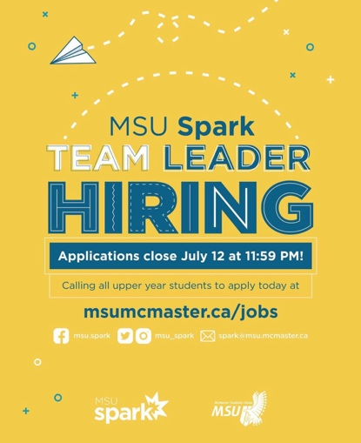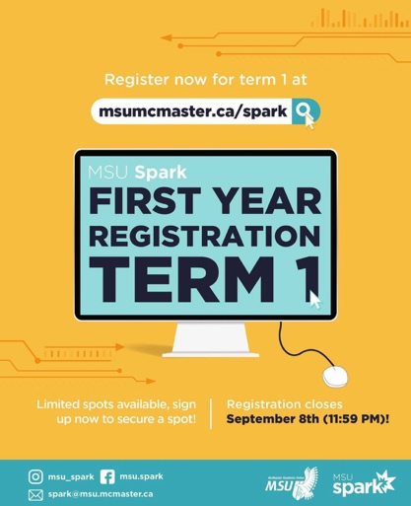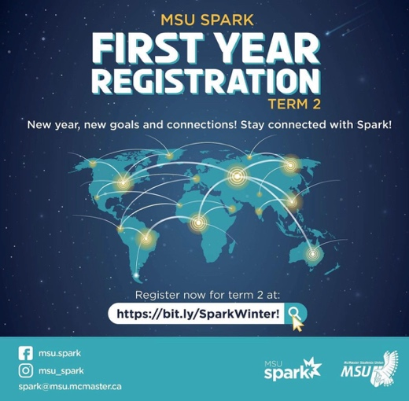
270 likes  24 comments  65 saves  7885 people reached  172 profile visits  6 follows  13, 673 impressions | 218 likes  17 comments  140 sends  61 saves  3941 people reached  208 profile visits  10 follows  4,908 impressions | 86 likes  3 comments  89 sends  11 saves  2344 people reached  117 profile visits  3 follows

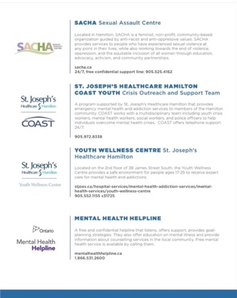
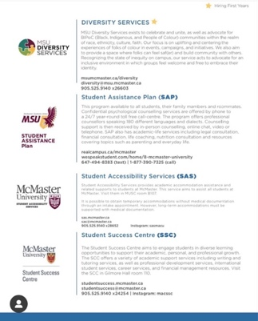
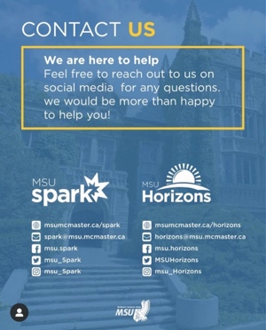
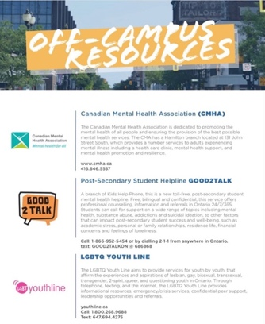
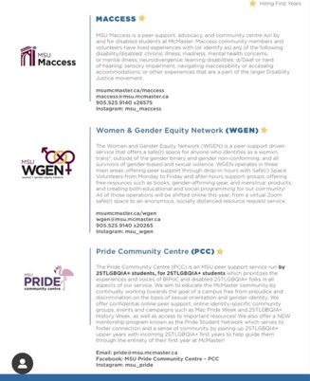
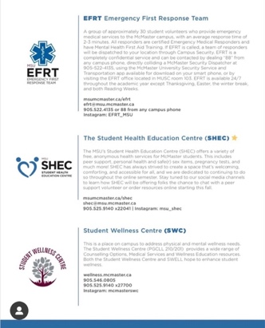
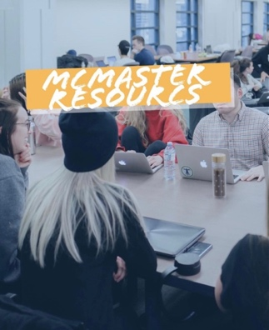
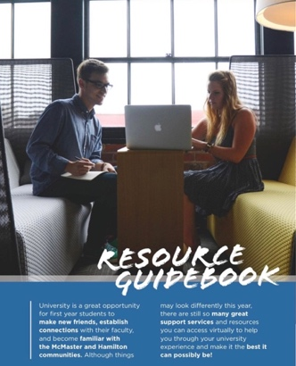

177 likes
1 comment
11 sends
34 saves
2663 people reached
20 profile visits
3684 impressions
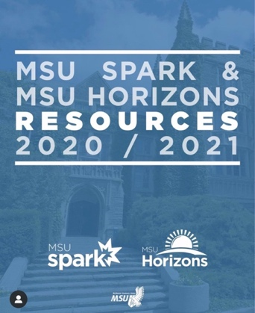
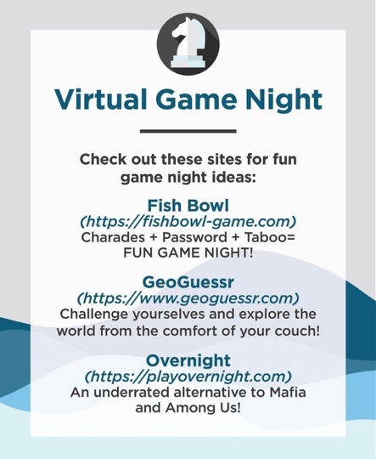
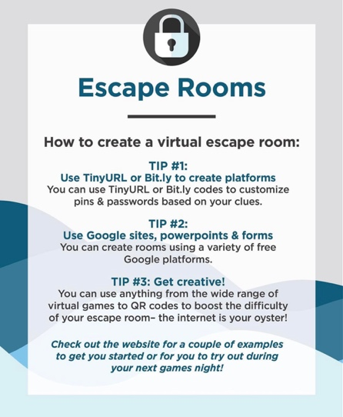
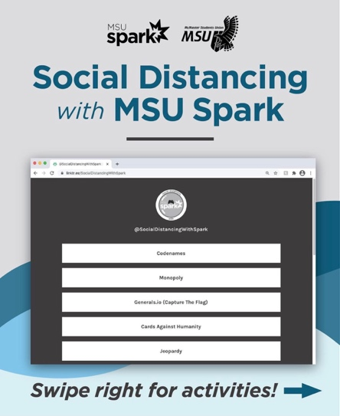
Social Distancing with Spark Campaign

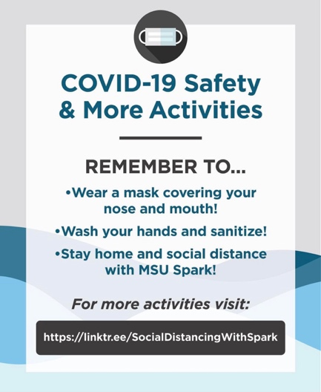
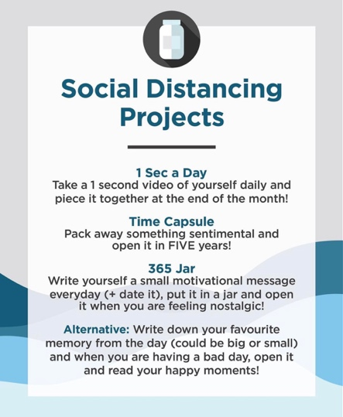
77 likes
2 comments
15 sends
30 saves
2124 people reached
26 profile visits
2913 impressions

Social Media Engagement
I unfortunately only have data on our Instagram growth from this year. However, I have outlined that in the chart below:

May 2020 | Report 1 | Report 2 | Report 3 | Report 4 | Report 5 | Report 6 | Report 7 | March 2021
2025 | 4275 | 4531 | 4625 | 4572 | 4543 | 4431 | 4361 | 4375

To make the report more organized, I have put Instagram engagement stats for the graphics I’ve attached above with the graphics.

Finances
General Information:
Most of our costs this year came from promo materials, sessions materials and mailing them, and buying gift cards for incentives/prizes for events. In our budget, we also had a large cost for the WWSTAPC speaker. However, this will be covered by WWSTAPC and we should be reimbursed very soon. We have a few more costs coming in the rest of the year, mainly for volunteer appreciation gifts and for gift cards for event prizes.

Challenges:
We honestly didn’t have any challenges with finances this year! The only thing is I want to ensure Spark is reimbursed from WWSTAPC because I don’t think Spark was reimbursed last year. Other than that, everything was great!

Successes:
One thing that really helped us this year is that for campaigns, the Underground allowed us to outline them ourselves and then charged us an hourly rate. This worked for a couple reasons. First, we were able to almost create our own package and choose what we needed. We really liked the flexibility of this for campaigns. Second, we weren’t having to pay more than what we needed to for the assets we wanted (i.e. we didn’t have to buy a full digital package for only one asset).

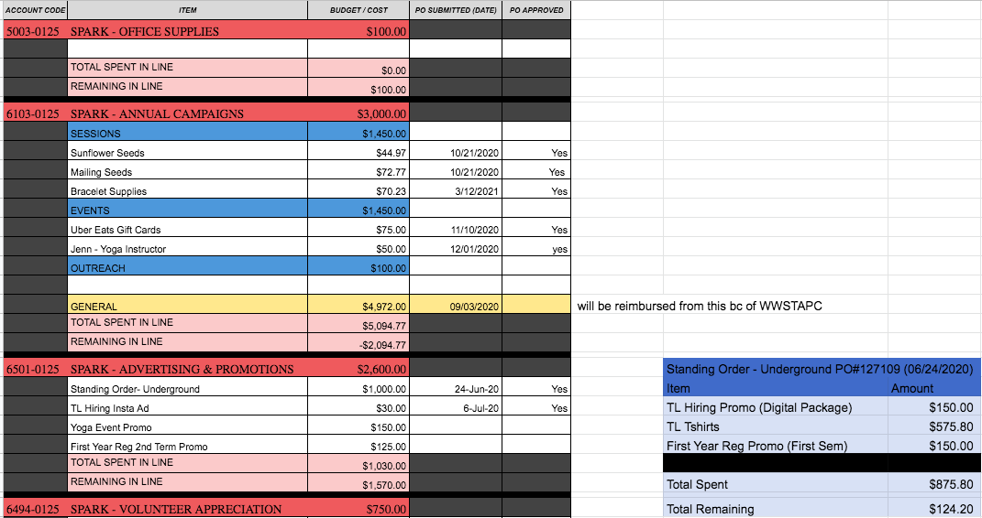
Budget Summary
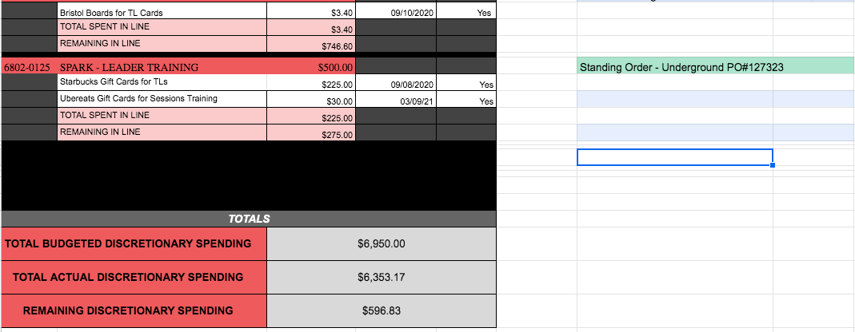

Personnel

Executive
Challenges:
One main challenge I personally faced was balancing exec’s schedules with different timelines of programming. This was especially a challenge with the summer. As mentioned before, there were 5 execs writing their MCAT and everyone had other commitments outside of Spark. This made scheduling hiring difficult but in the end it all worked out! Another challenge I found difficult that I think specifically existed because of the online format was ensuring that every role is taken care of with no tasks being left out. I often found myself leaving a meeting, writing down follow up questions to message that exec with later and then forgetting to do that or missing some. I think it was a mix of the online nature and just the fact that there was so much to do that was done differently this year. Overall, I feel like I definitely improved a lot with this over the course of the year and is something that I learned a lot from in the role!

Successes:
I honestly don’t know where to start. The exec team has been incredible. This was not the year they were expecting when they started in their roles and despite all the challenges thrown their way (a change in PTM, a change in exec members, a switch to an online format, online school, living in a pandemic etc.) they were able to adapt to all of the changes so easily and truly made my job incredibly easy. Their adaptability has inspired me and made me rethink how I approach challenges. From new and innovative events, online sessions, creative volunteer socials, new outreach strategies, unique campaigns, and everything in between, they’ve given their all into their roles this year and the hard work has definitely paid off. I’m super lucky to work with such an incredible team and I’m beyond proud of everything they’ve accomplished this year.

Volunteers
Challenges:
The only challenge we really faced this year was training participation. While attendance was great, participation was quite low at times. We tried multiple training methods, including smaller groups and having TLs lead training. We also encouraged any feedback that TLs had to make it more accessible. Some methods of training worked more than others and we implemented any feedback we received. I think to a certain extent, it’s out of our hands because there’s only so much you can do in an online format. However, TLs remained engaged in their roles and in sessions and offered feedback that they thoroughly enjoyed training.

Successes:
Again, I’m not sure where to start. The TLs have been absolutely incredible. They have been SO engaged and enthusiastic with their roles throughout the entire year. Traditionally with Spark, folks are less engaged second semester, but the team this year has remained enthusiastic and committed. They are truly the backbone of the service and Spark would not be able to run without our volunteers. They’ve been able to support first years through sessions and volunteering at events. They’ve made connections with students and will never fully understand the incredible impact they have individually made on students and on each other. I truly think the volunteers are what makes Spark what it is. Each TL brings such unique experiences and perspectives, creating such a diverse team, This helps us support students that much more and is something I’m really grateful for. Overall, this team has been absolutely incredible. The TL team’s commitment, dedication and resilience has inspired me beyond measure this year and I’m truly so grateful to have gotten to work with them all.

General
Challenges:
In terms of balancing everyone’s wellbeing with the service, this was a bit of a challenge I faced personally. The pandemic definitely took a toll on my mental health so I think I was hyperaware of the effects it could have on others’ wellbeing. I slightly struggled with finding the line of ensuring work was getting done within the service while also ensuring that everyone (whether it was execs or volunteers) was prioritizing their wellbeing. Finding this team dynamic where there was excitement to get work done but also an understanding that there was always an opportunity for folks to take a step back if they felt they needed it definitely helped this. I did this by remaining engaged in the service and ensuring the team was to, but also by continuously checking in with folks and reiterating that I’m always here if anyone needs anything, whether it has to do with Spark or not. I got lots of feedback from both TLs and exec that I have been extremely approachable this year and I did have folks approach me for support. I feel like in the end, I found this balance and was able to support the team and prioritize our well-being while also ensuring we’re supporting first years.

Successes:
Overall, I feel like this team is what made the service so successful this year. They supported one another and worked together to support over 700 first year students through the pillars of our service. They learned from one another and the growth that I’ve seen in the team over the course of a year is immeasurable. It’s been incredibly rewarding to get to see and have a hand in helping others grow in similar ways that Spark has helped me grow as a person and as a leader. I’ve said it before but I will say it again. Every interaction I have with any member of the team reminds me how incredible of a team I have and how lucky I am to get to work with them all. They all inspire me as leaders and as people and they have taught me so much this year. I just want to give a shout out to all the TLs and execs for all their hard work and for making the service what it is. They have put in hours and hours of work into the service and it has truly paid off. They have made my job so easy this year and I couldn’t ask for a better group of people to work with.

Miscellaneous
I just want to take this time to thank EB and everyone who helped me out this year! I was super intimidated coming into the role and everyone helped and made me feel more comfortable by answering my questions, no matter how silly they were, and being there to cheer on Spark. I’ve been a part of Spark for the entirety of my undergrad and have worked with the service for the last 3 years. It’s definitely been a huge part of my undergrad experience and I’m super grateful to have had the opportunity to give back to the service in this role!

