. 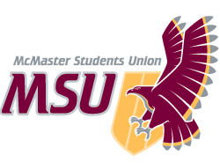 | REPORT  From the office of the…  Spark Coordinator
TO: | Members of the Executive Board
FROM: | Baila Lovejoy
SUBJECT: | Spark Report 7
DATE: | March 18th, 2021

Year Plan Update
We’ve been doing well on working away at our year plan! We are working towards finishing up sessions for the semester by the beginning of April. We’ve had one event so far this semester and will be having two more by the end of the term. We’ve had two socials so far this term and hope to have two more. As well, we are working on creating a few social media campaigns, along with some outreach projects. Overall, things have been going really well and I’m looking forward to ending off the year strong!

Service Usage
Sessions have been going great! We are currently on Session 7 and have 2 weeks of session left! Most groups have students returning each and every week, which is incredible! I’ve gotten a lot of positive feedback from TLs about strong connections being made with students. This has made me really happy because having small session groups/low retention can be very difficult. It’s been nice to see that this has actually been a benefit in that TLs get to connect more with students. In terms of Instagram following, I have outlined it in the chart below:
Report 1 | Report 2 | Report 3 | Report 4 | Report 5 | Report 6 | Report 7
4275 | 4531 | 4625 | 4572 | 4543 | 4431 | 4361

Past Events, Projects, & Activities
Last week, we collaborated with FYC and Campus Events on a trivia event as part of Maroons Wellness Week. We ran general teams trivia twice on March 10th, once at 10am and another at 7pm. We had lower registration than anticipated, with only around 15 students attending total. However, the students that did come seemed like they had a great time and volunteers enjoyed the event a lot! It was my first time running an event like this and with so many campus partners and it was a great learning experience. Overall, it was a successful event! I’ve additionally been working a lot on hiring the incoming director for Spark. This has been a really great learning experience as well and has been super exciting to get to pass on Spark and all the excitement the role brings.

Upcoming Events, Projects & Activities
We have quite a few projects upcoming to complete in the next month or so! We have two main outreach projects that I’m really excited for. I will be supporting Sinthiha, Spark’s outreach and engagement coordinator, in creating a virtual yearbook! We’re hoping to make it somehow on google slides and have students and TLs submit messages to one another, similar to signing a yearbook. We will then format it into a google slides/PDF that we will send out to students and TLs for them to have a takeaway from their time in Spark. Similar projects have been done in the past in Spark but never this way so I’m really excited to see it come to life! As well, we are hoping to create a video with first year students that have been a part of the sessions program. The details are still being worked out with this project but I believe we will be using FlipGrid Mixtapes, an online format that easily stitches videos together. This is a link to some examples that they have: https://help.flipgrid.com/hc/en-us/articles/360009565793-Mixtapes-Sharing-videos-across-your-Topics-and-Groups. Our hope is that it will be a collection of videos of students talking about what they’ve learned from their TLs, what their favourite memory of Spark has been this year etc. Overall, it’s meant to be a nice way for students to reflect on the year as well as give TLs some appreciation for the impact they have made. As well, it could potentially be used for promotional purposes in the future. I’m currently working with Vidushi, our volunteer coordinator, on planning appreciation gifts for our volunteers. We are also planning our final volunteer social and will be collaborating with Sinthiha on this as well. Sessions have two sessions left until the end of the year. Events is collaborating with FYC on an Applicant’s Workshop which I will talk about in more detail below. They are also hoping to host closing ceremonies before the end of the year. We are also working on a few campaigns! The first to be completed will be one on social distanced/online activities for students and is something I’m really excited for!

Currently Working On
My biggest current task is working on getting executive applications open for the incoming team so it’s ready for when the assistant director starts on April 1st. The Events team is collaborating with First Year Council on running an Applicants Workshop on April 1st at 1pm. This is an event that has traditionally been run by Spark and essentially will have different stations including individual interviews, group interviews, written applications, cover letters etc. for students to rotate through and receive help in these areas. As well, the SSC will attend to assist and offer resources to students. This event was actually one of my favourite events that I went to when I was in first year and it is SO helpful! I’m really looking forward to this. Additionally, Sinthiha and I will be holding first year feedback sessions for students in session, one on the morning of March 25th and one in the evening of the 25th. This will be for students to come and offer feedback on their experience in sessions. As well, we’ll be offering some type of gift card draw as an incentive for students.

Budget
We’ve recently set up a standing order with underground, purchased gift cards for training incentive, and bought bracelet materials for sessions materials.
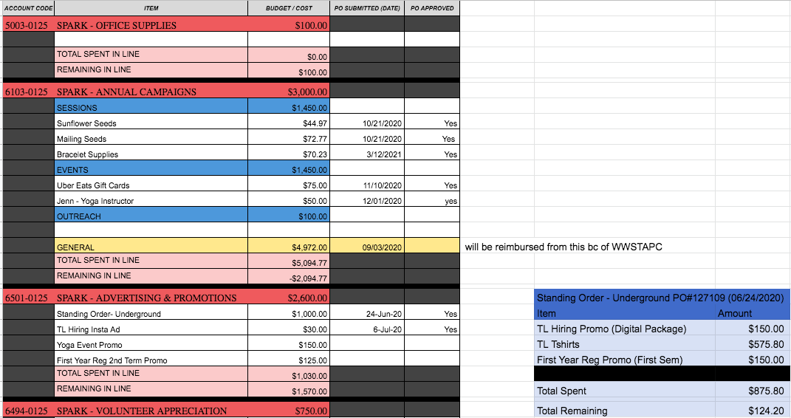
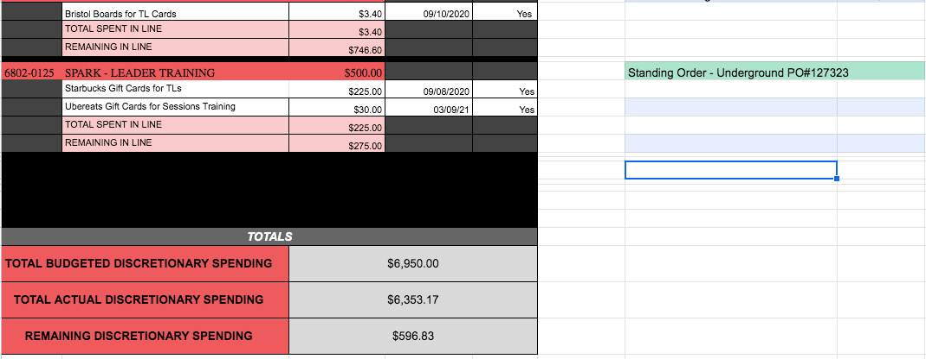

Volunteers
I really can’t say enough good things about the volunteers. Whether it’s the TLs or the execs, with every interaction I have with a member of the team, I am reminded how lucky I am to get to work with such an amazing group of people. The TLs have been incredibly enthusiastic about their role and remained committed. The exec team has been beyond supportive of me personally and has been so adaptable to everything that has changed this year. I’ve genuinely made such incredible connections with the team and I feel beyond lucky to get to work with them.

Current Challenges
Honestly we aren’t having any challenges right now! Everything’s going pretty smoothly and things have been great! I am just aware that the end of the year is a busy time for folks and I want to make sure everyone on the team is balancing their wellbeing and other commitments and not overextending themselves.
Successes
FYC has been incredible to work with. They were great for the trivia collaboration and I’m really looking forward to continuing to work with them for the Applicants workshop! As well, I’ve gotten some really great feedback from students in sessions about how helpful their TLs are. It’s nice to see that students are appreciating the impact TLs can have on them. Overall, I feel like the entire year has been a success. I’ve gotten to see TLs, and execs grow exponentially all while making an incredible impact on students and the community. This team is absolutely amazing and I’m pretty sad that the year is quickly coming to an end.

