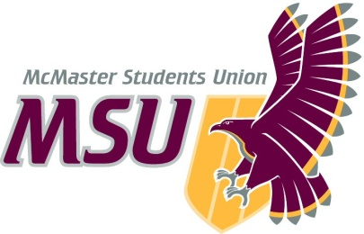
Year-End Report
From the office of…
MSU MAROONS
To: Members of the Executive Board (EB)
From: Hemantika Mahesh, Maroons Coordinator
Subject: Service Year-End Report
Date: March 21, 2021

Table of Contents
Table of Contents 1
General Summary 1
General Thoughts 1
Action-Items & Inquiries 1
Year Plan Update 2
Events, Projects, & Activities 2
General Service Usage 2
Projects & Events 2
Project 1: 2
Project 2: 3
Project 3: 3
Outreach & Promotions 4
Summary 4
Promotional Materials 4
Social Media Engagement 4
Instagram (Last 30 Days) 4
Twitter (Previous Month) 5
Facebook (Last 28 Days) 5
Finances 5
Budget Summary 6
Personnel 8
Executive 8
Volunteers 8
General 9
Miscellaneous 9

Report Summary

General Information

This year has been very unconventional for the Maroons! Nevertheless, we have has a great year if events and bringing the noise and unleashing the spirit. Our main events were:

- Welcome Week:
  - We collaborated with campus events and also developed our own programming for the week. We also handled the WW charitable giving this year.
- We took a lot of efforts to connect our student body to the local Hamilton community, We did this with our Food Tour where we did give-aways for foe local favourites in Hamilton
- We collaborated with a few services this year to organize and execute a variety of events for students including Exam de-stressors and Wellness Week

Furthermore, the team made a huge effort to improve our social media platform through give-aways and meet the team campaigns.

The main challenges this year with the team was adapting to the changed in our roles and expectations and developing new ways to achieve our service goals and mandate. This was done by working with systems of support such as VP Admin and the finance team and developing new strategies for our services to operate under. We achieved a strong team dynamic by adapting our styles of communication and ensuring members felt that their voices and opinions were heard and they felt that their efforts were appreciated.

This year the service also tried to collaborate more with other services and clubs in an effort to further unite MSU services and provide students an avenue to explore opportunities within the MSU. We did this through Wellness Week and Exam De-stressors. We also always included a safe(r) space in our events for students to talk to reps and upper years and develop connections, but also explore and inquire about the MSU and the McMaster community.

Ultimately, this year was very different, but the team and the service made full efforts to create something special amongst the uncertainty. I am proud to say that we have and will continue to bring the noise and unleash the spirit as representatives of the McMaster community.

Year Plan Update
Objective 1:
LIASON: The Maroons are often termed as a liaison between the student body and the MSU. I believe now, more than ever, this liaison is necessary to bring the Mac community together, while we are apart.

My main goal with this objective was to integrate more collaborations between the Maroons and other student services and even local organizations. I believe we have successfully collaborated with a number of services this year such as Spark, Campus Events, Macademics. We also took the opportunity to collaborate with and support our local businesses such as Burnt Tongue, Empowerment Squared, Ashie designs, Beachwood apparel, etc… For the following year I would encourage the team to strengthen existing relationships with services, and continue to build new relationships with services we haven’t worked with extensively thus far.

Objective 2:
OUTREACH: The Maroons pride themselves as representatives of the McMaster community.

This year we had the opportunity to work with SACHA which was really beneficial for the team. However, local organizations such as Boy and Girls Club and The Good Shepard were trying to adjust their operating policies to the drastic changes in restrictions and regulations, and therefore it became difficult to collaborate with them as we ourselves were adjusting to virtual environments. Now that we have successfully gotten through 1 full virtual year, the Maroons have a better understanding on how to navigate events and collaborations on a virtual platforms. I think it would be beneficial to reach out to these organizations now, as we are more prepared to accommodate to a virtual setting.

Objective 3:
TRANSPARENCY: Increasing transparency between the service and its volunteers and the student body

We implemented open lines of communication and had our anonymous feedback forms available for the team to provide their comments and opinions. For future years, I would recommend to post event specific feedback forms once an event is completed. We implemented this in the beginning, and I think it would be useful if the forms became more consistently involved in our events and planning processes.

Events, Projects, & Activities

General Service Usage

Projects & Events

Project 1:
Project Status: complete
General Information:
I would say the first large project for the Maroons team is Welcome Week. This is a crazy time for the reps and the LT and PTM alike. Welcome Week this year looked very different than past years. The Maroons collaborated with Campus Events and ran trivia nights, and we also ran our own programming – Marauder Zone. This year we also took on the responsibility of charitable giving’s for Welcome Week.

Challenges:
A big challenge this year was charitable giving because it was the first year that it was implemented, that to in a virtual setting. I think the guidelines and expectations were unclear because the operating policy was still being drafted. This year we have created a more detailed operating policy which clearly outlines the roles and expectations from the Maroons and other stakeholders in the charitable giving process. Furthermore, the Maroons now have a virtual template from WW 2020 to refer to as well as previous in-person WW charitable givings run by Shinerama.

Another challenge was developing our own programming for WW while balancing screen-time exhaustion for the reps. Usually, the Maroons are working with other services and faculties for the majority of WW. This year, due to the virtual nature of WW, we had to plan a lot of our own programming. This was a challenge because there was no previous Maroons-only programming from past years, and to do this within a virtual platform was definitely difficult. However, working with a diverse team and looking to the exec for support was definitely helpful, and we developed a plan for WW that was actually very successful and had full registration! I also tried my best to be cognisant about rep’s time and efforts as it was a difficult time of year, and asking for rep’s to take extra time off from paying jobs for a volunteer position did not seem right to me. Therefore, I tried to make all the events outside of the regular working hours (after 5pm) and gave reps advance notice of the times that they would be needed so that they could adjust their work-schedules accordingly.

Successes:
I think WW was a big success! We had full registration for all of our events and the reps and first years gave back great feedback. I think I was very proud of the entire team for working so hard and committing to this role especially during such a difficult time. Also the first-years came in with great enthusiasm and energy and I think that made the event that much more successful. Training with SACHA was really useful and I think it made a huge difference and the reps also appreciated this extra training. I would recommend future teams to also bring in SACHA for bystander training and disclosure training.

Project 2:
Project Status: completed
General Information:
FOOD TOUR:
The food tour was meant to highlight local businesses in our Instagram and give students to virtually explore local favourites! We unfortunately could only do give-aways with businesses that offered e-gift cards, and many businesses (such as Paisley) did not have that option.

Challenges:
We unfortunately could only do give-aways with businesses that offered e-gift cards, and many businesses (such as Paisley) did not have that option. Therefore, we had to improvise and use Uber-Eats gift cards, but still promote local businesses as a potential place students could order from using their Uber Eats gift card.

Successes:
I think the big success from this event is increasing our followers and number of students that interacted with our online platforms and social media accounts. I think we had a lot of great event ideas, and marketing, but the reach was limited to our followers. Therefore, this project not only highlighted local businesses, but also improved our student engagement.

Project 3:
Project Status: completed
General Information:
Exam De-stressor: The exam de-stressor was done in collaboration with Spark and SSC! The first half of the event was conducted by SSC giving exam tips and time-management techniques. The second half of the event was run by Maroons and Spark and we ran de-stressor events such as online games, and chill study sessions.

Challenges:
Being exam time for the reps as well, it was a difficult time of year to ask reps and TL’s to commit their time and efforts. I also think the marketing for this event could have gone out earlier. Therefore, for future years, when collaborating with other services, I would suggest to get the marketing ready and sent out as early as possible so that registration numbers can be higher.

Successes:
I am really happy that we had the reps come in for this event and give their full enthusiasm and attention for this event. Furthermore, the students really enjoyed this event and found it really helpful.

Project 4:
Project Status: completed
General Information:
Wellness week: This event was meant to provide students an opportunity to de-stress before a busy time of year starts again. I aimed to work with a few services to provide students the opportunity to explore other MSU services and have a platform to meet other students and reps as well.

Challenges:
I think it was difficult to coordinate with a lot of services because many of them had their own schedules and it was a busy time of year for them as well. I think the main issue was scheduling a variety of events with so many services. However, with time and a lot of email chains and meetings, we were able to finalize a schedule and send it off for marketing. I think when collaborating with services it would be important to smooth out the final details ahead of time to send out marketing as soon as possible to give students the time to sign-up and register for events. Furthermore, the earlier the marketing and info-graphics are made, we have the time to make edits if changes in the events occur!

Successes:
I think this event showcase what the maroons are able to do! I am really happy that we were able to coordinate with the services that we did, and execute this event. I think Wellness week has great potential to be a re-occurring event for the Maroons, as it brings together the McMaster community and show-cases the variety of services and clubs Mac has to offer.

Outreach & Promotions

Summary
General Information:
This year our focus has been to improve our social media engagement, because it was the main avenue through which students interacted with the Maroons, especially with a virtual year. We made a lot of efforts through give-aways and “meet the team” campaigns to not only increase our followers, but to also put a face to the members of our team.

Challenges:
I found it challenging to continuously see growth on our social media platforms. Once we did a few give-aways, the growth plateaued. This year, with planning new online programming, efforts and time diverged away from improving our social media presence. I believe our events (especially if they are virtual) will be more successful if more time is dedicated to developing our social media platforms.

Successes:
I believe that our give-away events and campaigns did exactly what we wanted them to, which was to increase our social media followers. I am happy that we made more efforts with our Instagram compared to our Facebook, because most interactions happen through Instagram! I think our collaborations with other services also helped improve our social media presence. I would recommend doing take-overs or virtual collaborations over Instagram. This way, both services could benefit from the engagement with the diverse audiences on each other’s platforms.

Promotional Materials

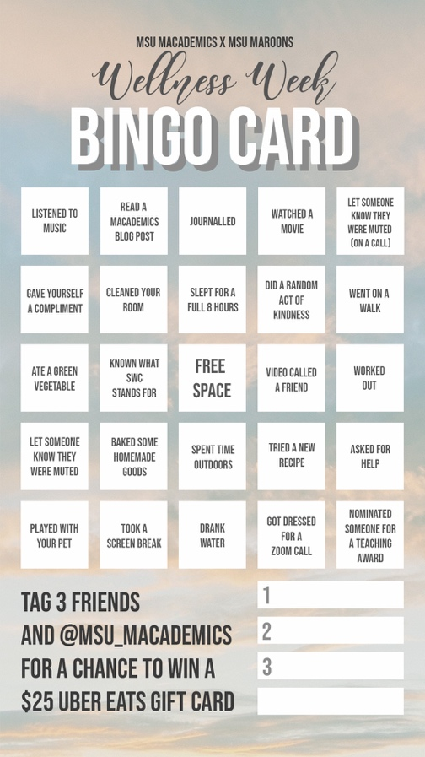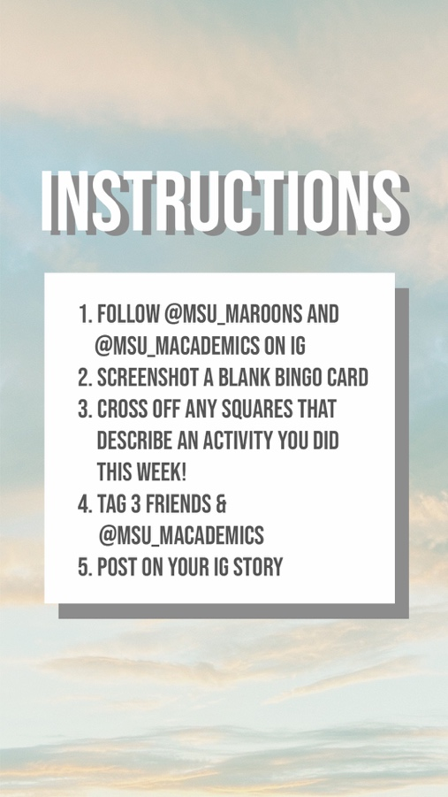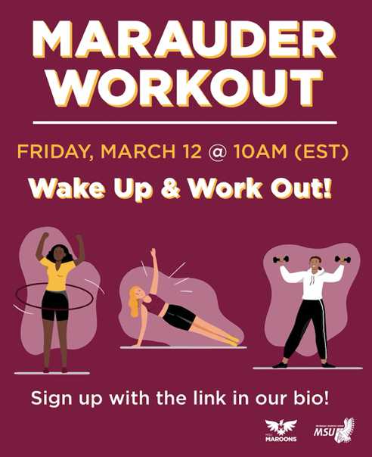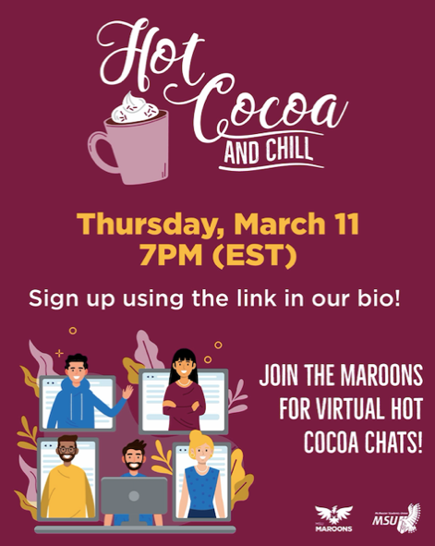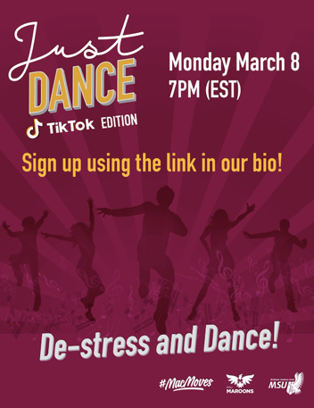
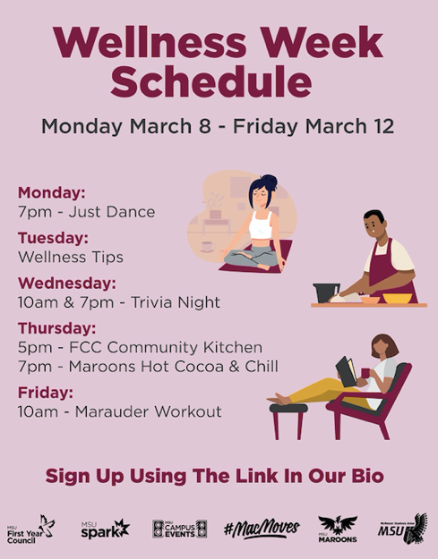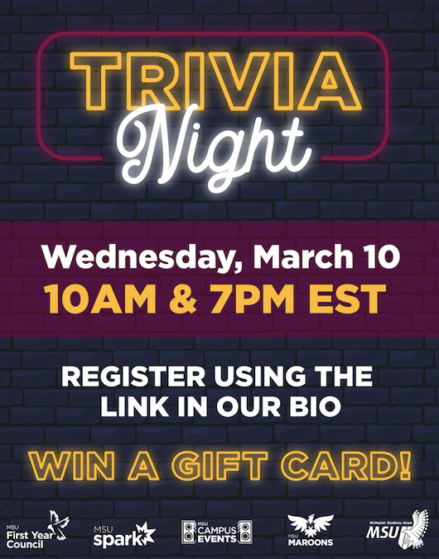

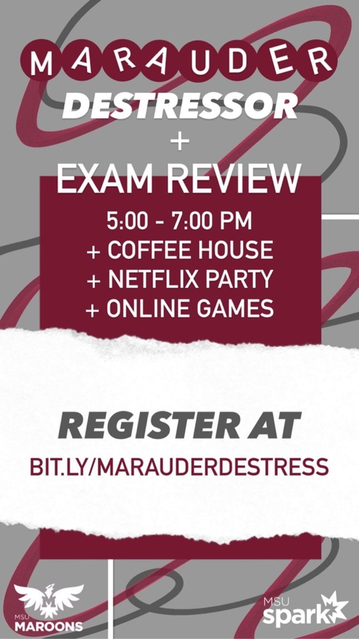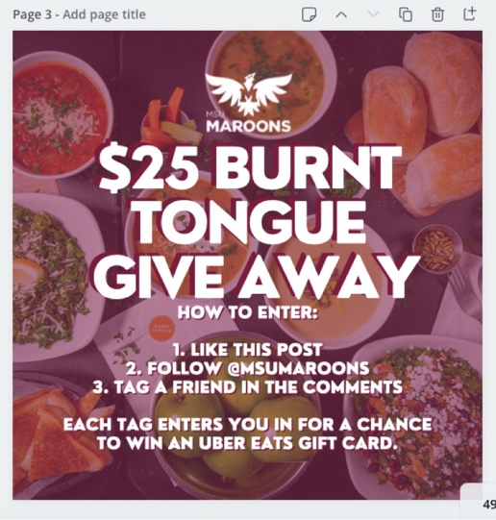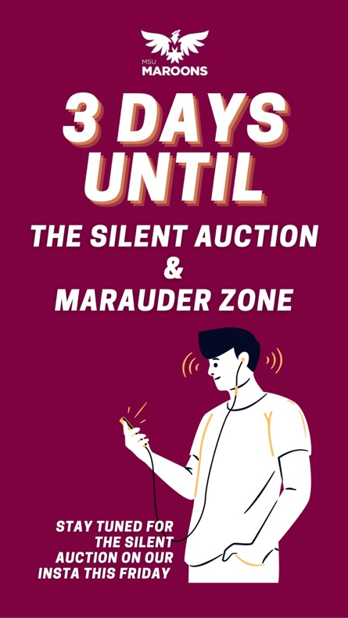

Social Media Engagement

Platform | Stats
Facebook | 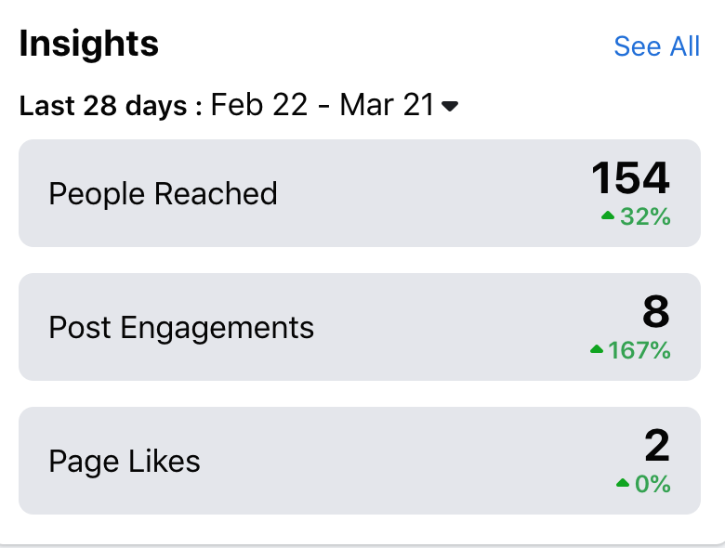
Instagram | 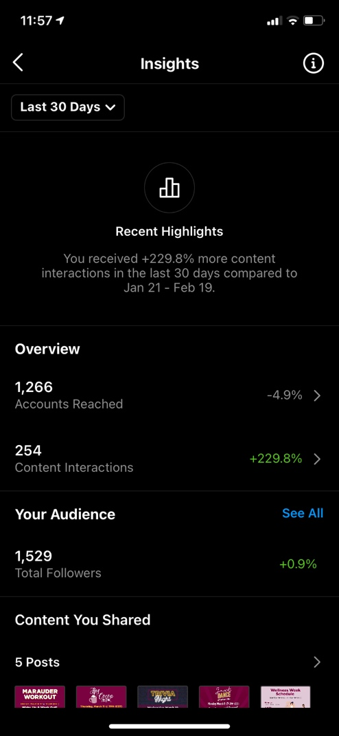

Finances
General Information:
This year we came in under-budget because our usual expenses (team lunches during training, uniforms, office supplies, etc…) were not needed with virtual programming.

Challenges:
I found that the set-up of our budget was a little challenging to work with during a virtual year. Unexpected costs of shipping, and other expenses that were a result of virtual programming were not considered in the lay-out of our budget. It was really great to have the support of the finance team to overcome these challenges and get adjusted to the expenses of online programming. I would recommend having more money allocated to volunteer appreciation because I feel that with a virtual semester, it takes so much more effort, and commitment than usual to be a part of a service and volunteer during such a difficult time.

Successes:
I think a huge success was being able to work with such a great finance team this year and find ways to make things work. At the beginning I did not have a comprehensive understanding about how each account worked and did not know how to send money into the MSU account for the WW fundraisers. However, working with a supportive finance team helped make this transition very smooth made our WW fundraisers a success.

Budget Summary
Table 4: Budget Tracker

 | TOTAL SPENT IN LINE | $0.00
 | REMAINING IN LINE | $450.00
6415-0120 | MAROONS - VOLUNTEER APPRICIATION | $750.00
 | TOTAL SPENT IN LINE | $0.00
 | REMAINING IN LINE | $750.00
6501-0120 | MAROONS - ADVERTISING & PROMOTIONS | $1,000.00
 | TOTAL SPENT IN LINE | $0.00
 | REMAINING IN LINE | $1,000.00
6603-0120 | MAROONS - SPECIAL PROJECTS | $750.00
 | Uber Eats Gift Card | $50.00
 | Burnt Tongue Gift Card | $25.00
 | Trivia Night gift cards | $200.00
 | TOTAL SPENT IN LINE | $75.00
 | REMAINING IN LINE | $475.00
6633-0120 | MAROONS - UNIFORMS | $7,000.00
 | Westend Sports | $1,600.00
 | TOTAL SPENT IN LINE | $1,600.00
 | REMAINING IN LINE | $5,400.00
6804-0120 | MAROONS - MEMBER TRAINING | $500.00
 | SACHA | $450.00
 | TOTAL SPENT IN LINE | $450.00
 | REMAINING IN LINE | $50.00

TOTAL BUDGETED DISCRETIONARY SPENDING | $10,500.00
TOTAL ACTUAL DISCRETIONARY SPENDING | $2,325.00
REMAINING DISCRETIONARY SPENDING | $8,175.00

Personnel

Executive
Challenges:
The main challenges this year was the unexpected role changes for the executive team. The whole team was now functioning on a virtual platform. Furthermore, our events coordinators had to undertake the charitable giving for Welcome Week. We also had to figure out how to adjust the roles of the athletic coordinators because athletic teams were not running this year. Therefore, there was a long adjustment period where the LT had to re-define their roles and goals for the team. However, what is helpful is to meet with each exec members individually and re-assess their roles together, and reaching out to VP admin for support during this process.

Successes:
I am so proud of my LT because this year would not have been possible without them. Due to the virtual nature of this year, a lot of planning fell onto the hands of the LT. It was also a huge success how the LT adapted so well to all the changes to the service, all while remaining enthusiastic throughout the year and supporting their pod members and other general reps.

Volunteers
Challenges:
Volunteer retention and engagement was definitely challenging this year. I found that communication solely over Facebook or emails was really not effective. Therefore, communication through the pods was more effective because the LT was working with a smaller group. I also really wanted to make sure our volunteers felt appreciated and valued. The virtual platform takes a toll on everyone, students and reps. I think it is especially difficult with an online platform for reps to see the effect they have during these events. I am planning on doing virtual shout-outs where reps can send in “shout-outs” or positive comments to their team members. This is something I plan on doing at the end of the year, but maybe could be implemented at the end of each semester in the future.

Successes:
Once again, so proud of my team. Despite the challenges, the reps continuously showed up and brought the noise and unleased the spirit Their dedication to the service and the team was evident with their participation and enthusiasm during our events and socials. I think with the circumstances, the team adapted so well and helped fulfill our service mandate.

