Year-End Report

From the office of MSU Macademics

Service

To: Members of the Executive Board (EB)

From: Catherine Hu, Macademics Coordinator (Position)

Subject: Service Year-End Report

Date: March 22, 2021

# Table of Contents

Table of Contents 1

General Summary 1

General Thoughts 1

Action-Items & Inquiries 1

Year Plan Update 2

Events, Projects, & Activities 2

General Service Usage 2

Projects & Events 2

Project 1: 2

Project 2: 3

Project 3: 3

Outreach & Promotions 4

Summary 4

Promotional Materials 4

Social Media Engagement 4

Instagram (Last 30 Days) 4

Twitter (Previous Month) 5

Facebook (Last 28 Days) 5

Finances 5

Budget Summary 6

Personnel 8

Executive 8

Volunteers 8

General 9

Miscellaneous 9

# Report Summary

## General Information

# Year Plan Update

|  |
| --- |
| Objective 1: |
| **Increase overall MSU Macademics outreach:** Coming into this role last summer, Macademics was relying solely on Facebook for promotions. We have now transitioned to using both Instagram and Facebook which has been very effective in engaging with the incoming first years! |

|  |
| --- |
| Objective 2: |
| **Transition to a fully online atmosphere:** Given the current circumstances, my goal for school year was to be able to maintain and improve Macademic’s engagement with students even with everything being virtual. My executive team has made this possible by always thinking of creative ways to engage with students through online means. |

|  |
| --- |
| Objective 3: |
| **Keep Teaching Awards:** Not only was my team able to keep the teaching awards and adjust our plans to accommodate for the virtual environment, but we made it better than ever with record breaking number of nominations and more anticipated attendees than what would have been physically possible! |

# Events, Projects, & Activities

## General Service Usage

## Projects & Events

### Project 1: Teaching Awards Ceremony

Project Status: Complete on March 26th

|  |
| --- |
| General Information: |
| COVID-19 led to the complete transformation of the annual TAC awards which has enabled my team to create a more effective and rewarding experience. The ceremony has completely transitioned to be online over ZOOM and the nominations were also fully advertised online and found it just as effective. |

|  |
| --- |
| Challenges: |
| Despite a multitude of campaigning methods, it was still very difficult to reach students when there was no incentive included. We attributed this to ZOOM fatigue and the fact that all services and clubs are only promoting online now. So we heavily relied on reaching out to professors and having them promote the awards during class which was effective. |

|  |
| --- |
| Successes: |
| First semester, with a greater integration of Macademics blog posts and the nomination marketing campaign, we saw a uptick in nominations by about 6-fold which was very exciting! Similarly, because everything was online, there was a lot of the budget left over so we were able to also order plaques for last year’s winners who unfortunately could not attend teaching awards due to lockdown which is incredibly rewarding to see come to fruition. For this part I wanted to thank co-coordinators Emma and Judy for their incredible leadership and partnership, they really outperformed their roles and is why TAC was such a success this year. |

### Project 2: Consistent Blog Posts

Project Status: Complete

|  |
| --- |
| General Information: |
| As a part of the increased online presence, it was very important to ensure that our online engagement was both consistent and impactful. With great leadership from Rabeeyah, Research and Resources coordinator, Macademics was able to release essentially one blog post a month covering topics related to burn out, study tips, summer school advice, teaching excellence recognition and much more. |

|  |
| --- |
| Challenges: |
| There was an initial challenge with which platform we would have to use given hat Buzzfeed’s community platform was no longer functioning adequately. This is why we had to change to Medium, but beyond that there have been very little challenges with this goal! |

|  |
| --- |
| Successes: |
| Success was honestly the ability to be incredibly consistent and engage not only with the McMaster student body but also with our volunteer team and giving them the opportunity to be a part of the creative process and author a bunch the blog posts. These blog posts also allowed Macademics to be seen as a more cohesive service by also using it as promotional pieces for other service events. |

### Project 3: Promotional Campaigns

Project Status: On-going

|  |
| --- |
| General Information: |
| This year, we wanted to release two big campaigns: the Undergraduate Guidebook and “What is Macademics” given that infographic campaigns take time to design and create, this was a longer process than expected but these pieces can be reused countless times and are just wonderful promotional pieces to have so getting them done at the end of this year is just as beneficial! Additionally, we were able to remake all of our old promotional pieces for our consistent events and initiatives which in part helped with creating a more engaging online presence. |

|  |
| --- |
| Challenges: |
| As mentioned, the size of the project as well as the other promotional projects for events and initiatives meant that the campaign graphics took longer to create given the need for a lot more correspondence with the Underground. |

|  |
| --- |
| Successes: |
| These campaigns are almost done and will be ready for next year’s coordinator to use and we created more engaging and eye-catching promotions which can also be reused for more events to come! For this I just wanted to thank Sofia for coming up with awesome ideas and being incredible at social media postings! |

### Project 4: Social Media Presence

Project Status: Complete

|  |
| --- |
| General Information: |
| Getting onto Instagram was a very big goal of mine for Macademics this year because the younger demographic was mainly on Instagram and Facebook did not capture the full undergraduate class anymore. |

|  |
| --- |
| Challenges: |
| Gaining followers continues to be a struggle but with consistent posts and enticing promotions we are gaining followers daily! |

|  |
| --- |
| Successes: |
| Instagram has made it possible for Macademics to have a greater outreach and more consistent posting as it also had story and reel features! This addition also allowed for more service crossover and promotional support which has also helped boost our engagement! |

# Outreach & Promotions

## Summary

|  |
| --- |
| General Information: |
| As mentioned previously, promotions this year included adding a few more promotional pieces, revamping old promotional pieces, increasing our social media platforms, and more integration of our resources with events to create a more cohesive service identity. |

|  |
| --- |
| Challenges: |
| Obviously with all this change it required a lot more work and correspondence between subcommittees, but it was very doable and weekly executive meetings served as an opportunity to have more direct discussions! |

|  |
| --- |
| Successes: |
| Everything mentioned in the general information was able to get done and we have seen a lot more engagement with our service as well as more services reaching out to collaborate and support Macademics! Thanks to my whole team for making this a top priority. |

## Promotional Materials

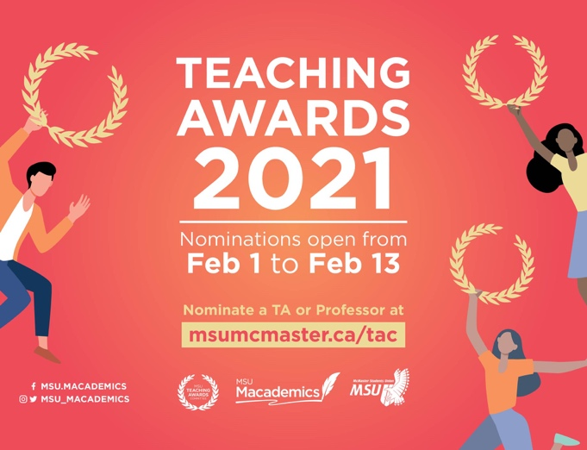 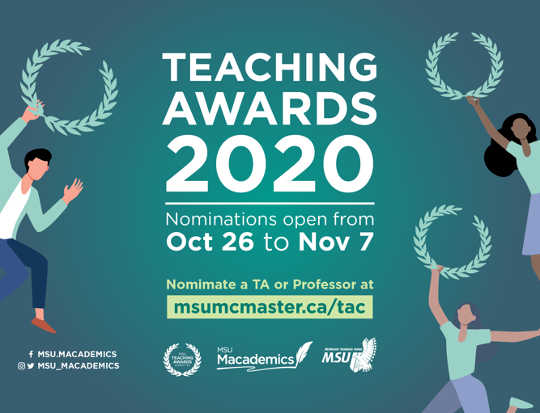

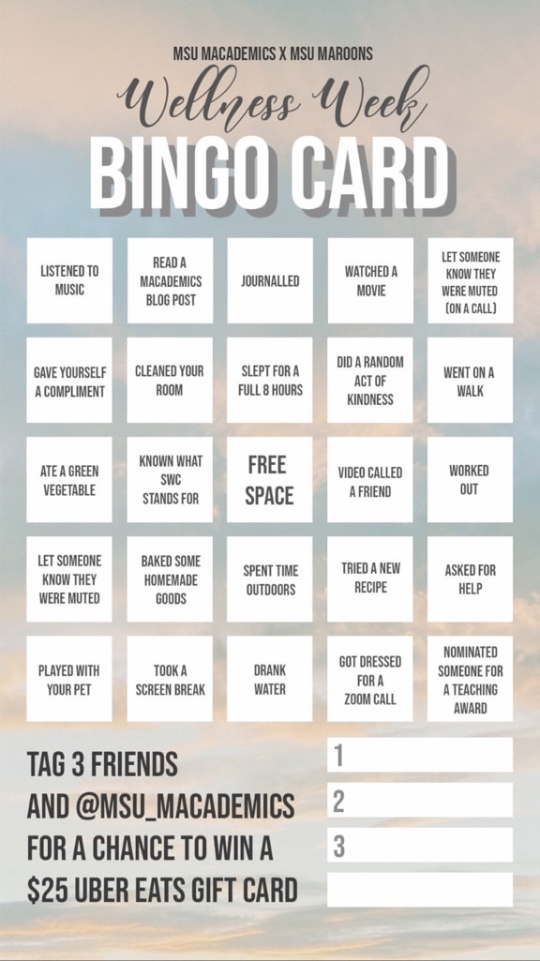

## Social Media Engagement

On Facebook:

# 

On Instagram:

* As Instagram does not show engagement past 30 days it’s difficult to gauge total engagement but we are now at 360 followers and continue to increase daily with some posts receiving over 1000 views.

# Finances

|  |
| --- |
| General Information: |
| Due to everything being online, finances were very easy to manage due to limited expenditures and no physical events. Costs included: Promotional material, Teaching awards plaques, gift cards, and volunteer appreciation apparel. |

|  |
| --- |
| Challenges: |
| Trying to ensure that despite the budget being more flexible, to not spend extravagant amounts and to always keep track of any spending. |

|  |
| --- |
| Successes: |
| Our limited spending enabled us to purchase plaques for last year’s winners and get better volunteer appreciation appeal which was very gratifying to see happen. |

## Budget Summary

Table 4: Budget Tracker



# Personnel

## Executive

|  |
| --- |
| Challenges: |
| At the beginning of this position, there was definitely feelings of imposter syndrome since I was just finishing my second year when I transitioned into this role and it felt daunting to have such responsibilities. However, hiring a wonderful team and have the guidance of everyone in the MSU and my old PTM’s has been incredibly helpful and alleviated this challenge immensely. |

|  |
| --- |
| Successes: |
| The greatest success was the smooth transition into a fully virtual service and seeing my teams hard work pay off with great engagement numbers as well as the satisfaction that they were also able to create initiatives from start to finish! |

## Volunteers

|  |
| --- |
| Challenges: |
| High volunteer engagement was definitely a concern at the beginning because of uncertainties with school being fully online, but we have had really great retention! Finding a time to meet with everyone and host socials/meetings have been difficult plus raises concerns about adding to online fatigue which has been difficult to balance. |

|  |
| --- |
| Successes: |
| The executive team has worked incredibly well and I am so proud of every single one of them for rising to the occasion and making the most out of this year! As for the volunteers, we purposefully hired a smaller team and it has worked out wonderfully because meetings are a lot more efficient and also gives each volunteer more opportunities to partake in our events and initiatives. Wanted to also give a quick thanks to Taya, the volunteer and logistics coordinator for always connecting with our volunteers and making this year go smoothly! |

## General

|  |
| --- |
| Challenges: |
| In general, a challenge was not being to host as many events/collaborations with other services having been cognizant of the fact that attendance would likely be low since these are not mandatory events and students would likely not want to be online longer than what they have to. This is one challenge I hope next year’s PTM can resolve and hopefully have more collaborations! |

|  |
| --- |
| Successes: |
| Having a great year and accomplishing everything we set out to complete! Moreover, ending with the Teaching Awards Ceremony where we can celebrate in a year full of struggles! |

# Miscellaneous