A REVIEW OF THE STUDENT CHOICE INITIATIVE AT McMASTER UNIVERSITY AND OTHER UNIVERSITIES
______________________________________________________

To: Jessica Anderson (VP Finance) & Chen Liu (AVP Finance)
Re: Student Choice Initiative Report
October 20th, 2020
Student Choice Initiative Report Overview
________________________________________________________________

Announced in early 2019, the Student Choice Initiative (SCI) was a provincial mandate for post-secondary institutions to give students an opt-out option for certain ancillary fees. These almost universally included the fees funding services run by student unions. Thus, many student service operations across Ontario experienced drastic decreases in funding for the 2019-2020 school year. This included the McMaster Students Union (MSU).

Although the SCI was struck down by an Ontario court and declared unlawful in late 2019, the SCI has unveiled student attitudes toward certain services and groups at McMaster. This report was conducted by an SRA Representative (Health Sciences) and MSU Finance Committee Member in consultation with the Vice-President (Finance) and Associate Vice-President (Finance). The report is the result of extensive research into the provincial post-secondary landscape and specifically at McMaster. The objective of this report is to compile the impact of SCI on student groups across the province and allow the MSU to see how different universities have responded to the SCI. In turn, the MSU may use this report to help inform and potentially implement new strategies in the future. Any questions regarding its contents and the information within this report can be directed to the Associate Vice-President (Finance) at avpfinance@msu.mcmaster.ca.

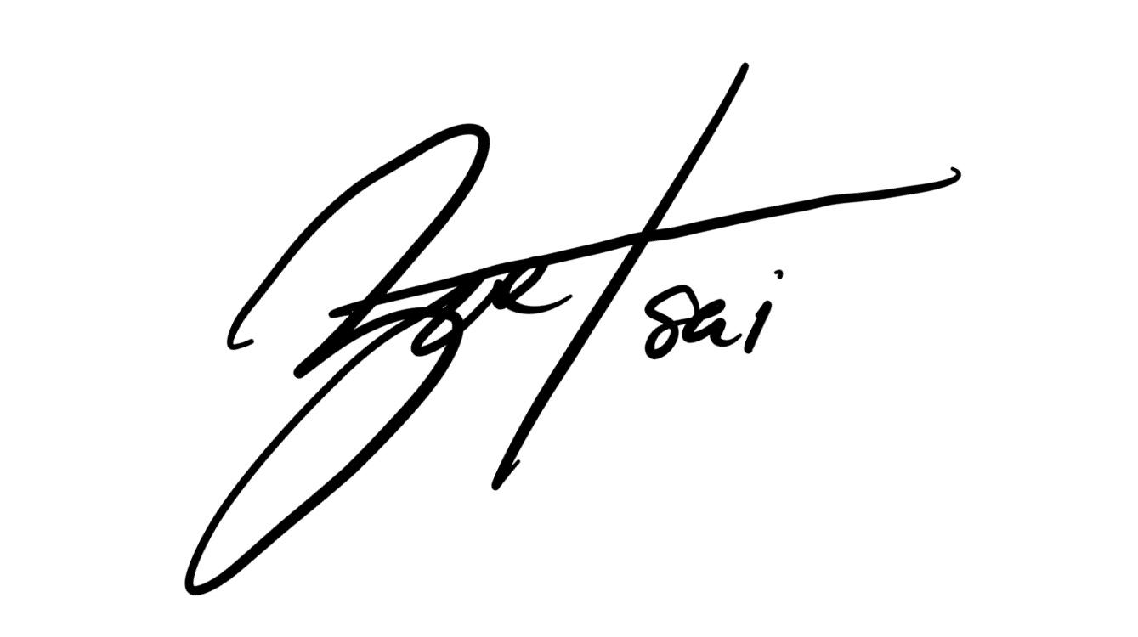
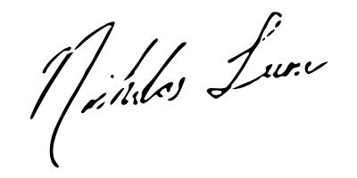

Zoe Tsai Nicholas Lum
SRA Representative (Health Sciences) MSU Finance Committee Member
srahealth@msu.mcmaster.ca

Introduction
________________________________________________________________

- How the Student Choice Initiative came to be

Post-secondary students continue to see higher upfront costs for attending and continuing their education. In addition to this, living costs and student fees have increased, which has made it difficult for financial aid mechanisms to keep up with current demands from students. The current provincial government lowered available funding In response to this, the Minister of Colleges and Universities (formerly called Minister of Training, Colleges and Universities) created a new policy in 2018 that would allow students to opt-out of ancillary fees, and in early 2019, the province introduced the Student Choice Initiative (SCI).

- The Student Choice Initiative

The SCI was a mandate that made many student ancillary fees (e.g. student government, special services, etc) voluntary for post-secondary students. In late March 2019, the Minister released the SCI directives, primarily consisting of the “Policy Directive” and the “Fee Guideline”. These two directives provided the guidelines to distinguish between “essential” and “optional” fees. As the names suggest, only fees that supported what the government deemed essential activities could continue to be funded via a mandatory fee levy. All other activities were required to give students the choice of opting out. By making this choice, the province’s stated position was to "empower" students "to choose which students fees they wanted to pay and how that money will be allocated". Schools such as McMaster opted for the refund model whereby students paid for fees upfront and were credited back the optional fees later. Services and student groups across campuses were deemed “essential” or “non-essential” based on the definition set out by the Ministry and the interpretation by individual universities. The Ministry also specified that the fees must be itemized so that students can see where money is going, as opposed to the general “student activity” fee. To ensure compliance with these policies, the Ministry implemented these policies directly through the Minister’s powers under the OCAAT Act which allowed the Ministry to reduce a non-compliant college’s operating grant. Universities that did not comply with the policies could be required to reimburse students or may have a reduction of their operating grants. At McMaster, the opt-out period for Fall 2019 lasted from September 12th to 20th. During this period, students were able to go into Mosaic to opt-out of non-essential supplementary fees.

Student Choice Initiative across Ontario
________________________________________________________________

- Common Non-essential Services
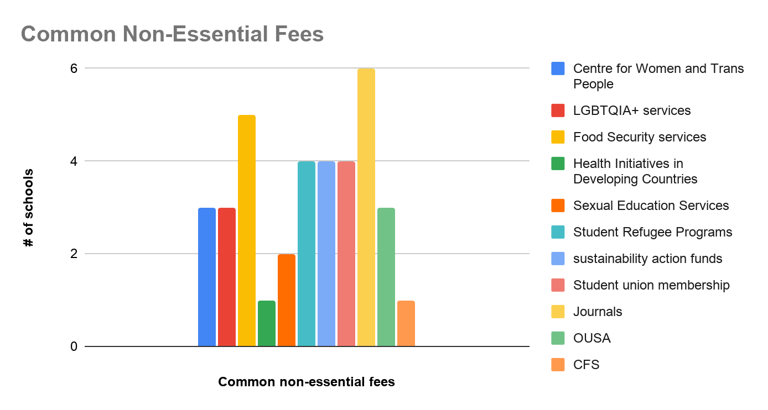

Figure 1. Common services deemed non-essential and available for opt-out across universities.

Services were deemed “essential” through a combination of Ministry definition and university interpretation. This is based on the framework established by the Government of Ontario’s Tuition Fee Framework and Ancillary Fee Guidelines document. The document defines “essential” services as services that include:

- Academic support
- Athletics and recreation
- Campus safety
- Career services
- Financial aid offices
- Health and counselling
- Student achievement and records
- Student buildings
- Student ID cards

- Marketing Campaigns

There was not a formal campaign on the part of universities to increase awareness of the SCI, largely due to the SCI being a student union issue. After reaching out to universities across Ontario, it was determined that the only involvement of the universities was providing general information (i.e. deadlines, what to be aware of when opting out) regarding the SCI to students.

According to the students’ unions contacted, most chose to carry out campaigns. The only exception was the University of Ottawa Students’ Union (UOSU). The UOSU is a reincarnation of the Student Federation of the University of Ottawa (SFUO) and was not in a position to run a full campaign focusing on the SCI due to the previous organization not being able to account for thousands of dollars and subsequent withdrawal of recognition from the University of Ottawa. That said, they were able to implement Facebook campaigns alongside tabling, Q&As, and posters across campus with a more general scope, ultimately relying on the goodwill of the student population to opt-in for ancillary fees.

The student unions who campaigned utilized a variety of advertising methods including social media posts, physical posters, graphics, pamphlets, and informative events. Some unions used additional means of marketing. The Carleton University Students’ Association (CUSA) made use of paid advertisements on Facebook and created a website for students to gain more insight into the ancillary fees and CUSA. York and Wilfrid Laurier University’s respective student unions augmented their campaigns by going “into the field” to communicate face-to-face with students. The unions that included person-to-person communication in their campaigns were likely able to appeal to students through a more personal approach. A common theme among these campaigns was the use of a positive attitude; rather than focusing on the consequences of opt-outs, the student unions chose to highlight the services and programs they provide for the student body.

McMaster Students Union (MSU) also engaged in a marketing campaign (Google Drive Link). The MSU created a website (www.choosestudentlife.com), had physical displays outside SCI-impacted venues, campaigned on the MSU website, held in-person information sessions, created a digital marketing campaign with over 15,000 views on the videos (Video 1 and Video 2), received local and national media coverage, as well as communicated the SCI through social media and the student-run newspaper, The Silhouette. The degree of transparency is a significant contributor to the observed opt-out rates exhibited by McMaster University, which was the highest among the Ontario universities that were surveyed (Figure 2).

Results
________________________________________________________________

- Opt-Out Rates Across Ontario

We were able to gather the average opt-out percentages at various universities across Ontario, as displayed in Figure 2.

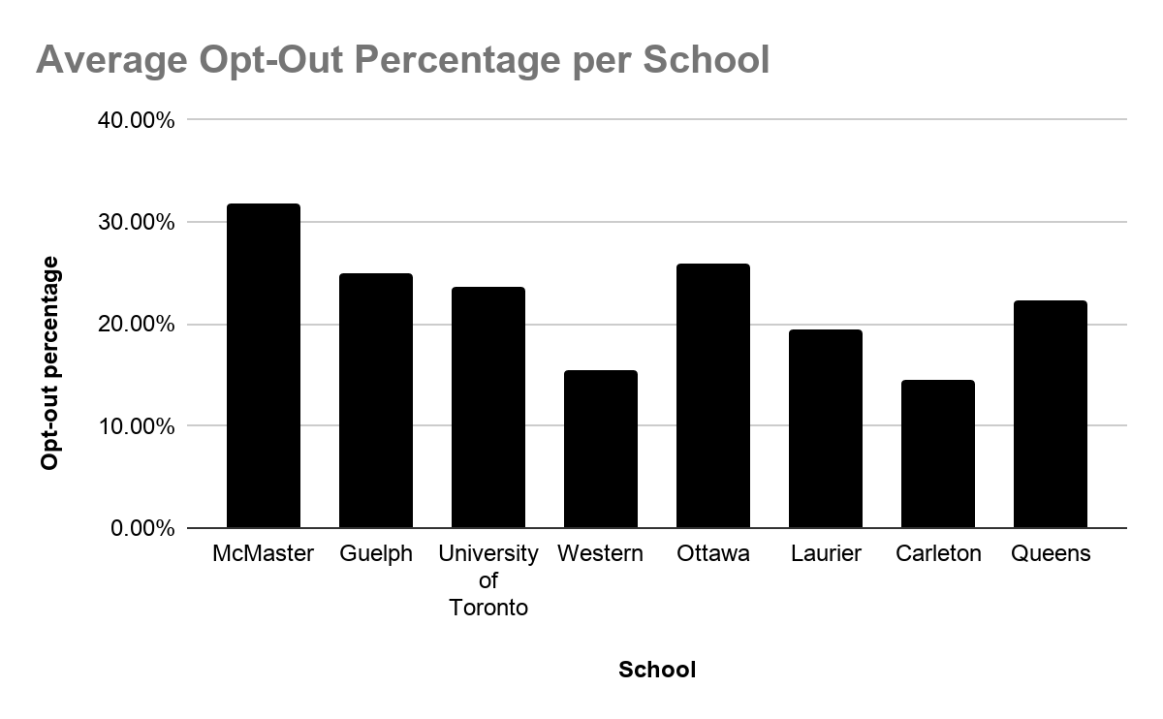
Figure 2. Opt-out percentages across Universities

McMaster held the highest overall opt-out percentage (at approx. 32%) compared to other universities from which data is available. The next highest average opt-out rate was at the University of Ottawa, at 26%.

- Breakdown of McMaster’s Opt-Out Rates

McMaster’s list of essential versus “non-essential” services can be found here. Many of the services listed as non-essential pertained to first year students (e.g. Horizons, Maroons, FYC). Figure 3 depicts the distribution of opt-out rates per service.
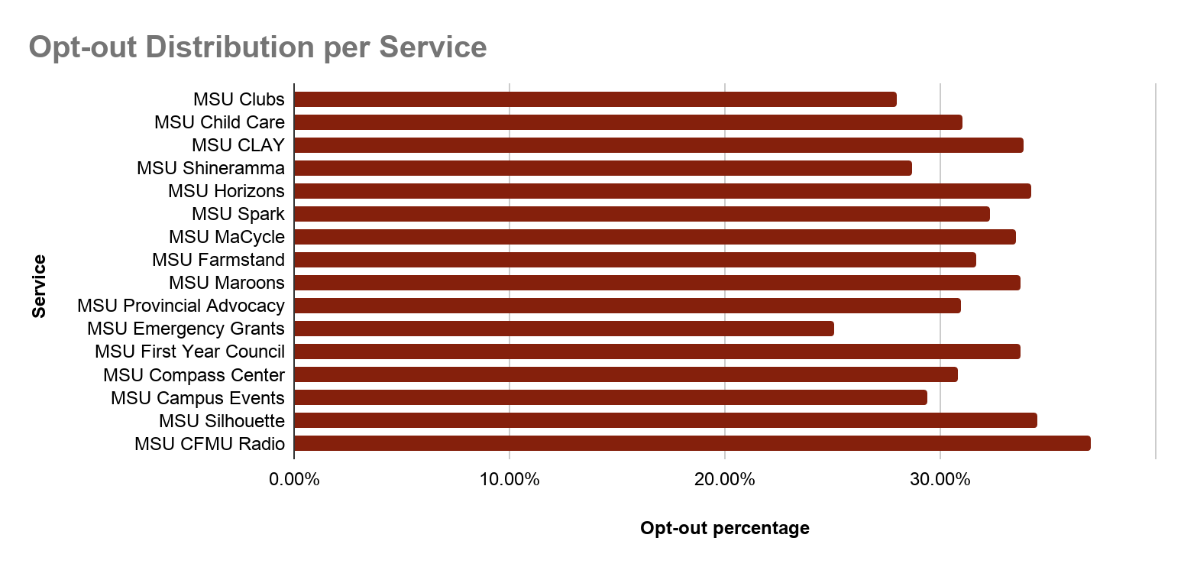
Figure 3. Distribution of opt-out percentages per Service at McMaster

Opt-out percentages ranged between 29.08% to 36.97%. The service with the highest opt-out rates was the CFMU 93.3FM, and the lowest being MSU Emergency Grants. Further insight into the significance of these numbers will be discussed in Discussion & Recommendations.

The End of the Student Choice Initiative
________________________________________________________________

On November 21st, 2019, the Ontario Divisional court struck down the SCI, deeming it unlawful. Earlier on, the York Federation of Students (YFS) and Canadian Federation of Students (CFS) had brought forth an application challenging the SCI’s legality for judicial review. The province argued that SCI was immune from judicial review as it was a “core policy” decision of the Cabinet, and in fact, SCI represented a lawful exercise of the Crown’s power in public expenditure. However, in the end, the court ruled that the government had not offered any explanation for why it had labelled student organization fees as “optional”, while athletics and other similar but more expensive fees, as “essential”. Ultimately, the SCI could not be justified as an exercise of the Crown’s spending power, as it “contravened statutory and common law limits on the province’s ability to regulate colleges, universities, and their student governments”.

On December 9th, 2019, Ontario launched an appeal to the Court of Appeal for Ontario. Further progress has been halted due to COVID-19. Nonetheless, SCI was not in place for the Winter 2020 semester – although many fees continued to be affected - and will remain absent until a decision to overturn the existing ruling has been made.

Discussion & Recommendations
________________________________________________________________

Overall, the extent of the impact of the SCI is unknown due to the MSU surplus covering shortfalls due to a reduction in funding, however, it is important to acknowledge the implications that the SCI has for McMaster.
Notable campaigns include those run by schools such as Carleton (CUSA Facts), and Laurier (SUDOESTHAT). Carleton had an average opt-out rate of 14.5% and Laurier had a slightly higher opt-out rate ranging around 18% to 21%. It should be noted that Western University did not run a campaign. Given this, their opt-out percentages ranged between 3.9% for Welcome Week fees to 21.4% for the Western Radio, with an average opt-out of about 15.4% across their services.

Over 30% of the McMaster student population chose to opt-out of many of the “optional” services provided by MSU. It could be reasonably inferred that because the MSU was effective in widely communicating the opt-out to the student body, it resulted in high opt-out rates compared to others schools. In addition, McMaster’s opt-out rate could be attributed in part to other factors than just a widespread information campaign, such as the growing the financial insecurities of students, or potentially as a reflection of discontent by students with service offerings. The challenge for McMaster University and the MSU is to address the concerns of students to make sure that it ise being transparent and accountable to them.

Three of the student unions contacted said that the SCI was an infringement on student unions, but it provided them with a sense of urgency to thoroughly evaluate how their organizations are spending and allocating funding both internally and externally. We believe that through the organizational review that the MSU has undergone in the winter 2020 semester, the organization as a whole will come out of this with even more knowledge and helpful suggestions on how we should proceed.

In the future, the MSU should devise a strategic plan for Welcome Week to better promote the direct relationship between the MSU governing body/associated fees and the various services offered. This will allow first year students to have a stronger, more positive attitude towards the MSU. While recognizing the challenge of COVID-19 with regard to programming, we believe the connection that needs to be highlighted is the direct relationship between the services shown at the services fest and the MSU. We also believe it will be beneficial to show first year students how they can become involved in the various MSU committees, political roles, services and volunteer opportunities.

Defined Terms, Abbreviations and Acronyms
________________________________________________________________

SCI: Student Choice Initiative

YFS: York Federation of Students

CFS: Canadian Federation of Students

OCAAT Act: Ontario Colleges of Applied Arts and Technology Act

OUSA: Ontario University Students’ Association

UOSU: University of Ottawa Students’ Union

SFUO: Student Federation of the University of Ottawa

CUSA: Carleton University Students’ Association

MSU: McMaster Students’ Union

Divisional Court: primary forum for judicial review of government action in Ontario

CFMU (93.3): McMaster radio broadcasted to the entire Hamilton-Wentworth region and beyond.

https://thevarsity.ca/2019/03/29/provincial-government-releases-official-guidelines-on-student-choice-initiative-details-of-tuition-cuts/
https://www.mondaq.com/canada/trials-appeals-compensation/881908/the-ontario-government39s-student-choice-initiative-is-heading-to-the-province39s-highest-court#_edn12
http://www.tcu.gov.on.ca/pepg/mtcu-university-tuition-framework-guidelines-mar2019-en.pdf
https://news.ontario.ca/en/release/50954/government-for-the-people-to-lower-student-tuition-burden-by-10-per-cent
https://www.mondaq.com/canada/trials-appeals-compensation/881908/the-ontario-government39s-student-choice-initiative-is-heading-to-the-province39s-highest-court#_edn12
https://dailynews.mcmaster.ca/articles/student-choice-initiative-ready-for-a-september-roll-out/
https://studentchoiceinitiative.yorku.ca/
http://www.tcu.gov.on.ca/pepg/mtcu-university-tuition-framework-guidelines-mar2019-en.pdf
https://www.universityaffairs.ca/news/news-article/ontario-court-strikes-down-controversial-student-choice-initiative/
https://cfsontario.ca/wp-content/uploads/2019/11/Cdn-Fed-Students-v-Ontario-20191121.pdf
https://www.mccarthy.ca/en/insights/blogs/canadian-appeals-monitor/ontario-governments-student-choice-initiative-heading-provinces-highest-court#_edn22
https://ipolitics.ca/2019/12/10/ford-government-to-appeal-student-choice-initiative-court-ruling/
https://www.mccarthy.ca/en/insights/blogs/canadian-appeals-monitor/ontario-governments-student-choice-initiative-heading-provinces-highest-court#_edn22
https://www.mccarthy.ca/en/insights/blogs/canadian-appeals-monitor/ontario-governments-student-choice-initiative-heading-provinces-highest-court#_edn22

