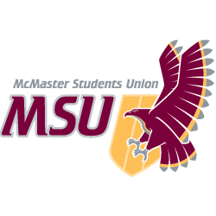. | REPORT  From the office of the…  Kinesiology Caucus
TO: | Members of the Student Representative Assembly
FROM: | Charlie Violin, Manpreet Chopra
SUBJECT: | SRA 20O Report
DATE: | March 7, 2021

Progress on Year Plan
- Increased engagement with Kinesiology students through Instagram stories and FB posts
- Increased interactive online events
- Worked with Kinesiology Society on KINmmunity podcast

Past Events, Projects, & Activities
- Worked on Bylaw 7/A w/ Michelle
- Advocated the opinions of Kinesiology students in regards to Presidential Elections and acclimations
- Continued advocacy for a safe reopening of The Pulse, as it is a big need for the Kinesiology

Upcoming Events, Projects, & Activities
- Planning Kinesiology Society Annual General Meeting on Gather

Current Challenges
- Continuing to increase engagement on online platforms
- Proctoring

Successes
- 36 ‘likes’ on Instagram post
- Lots of constituents messaging us on various social media with questions and concerns

Best,
Manpreet Chopra
SRA Kinesiology Caucus Leader
McMaster Students Union
srakin@msu.mcmaster.ca

