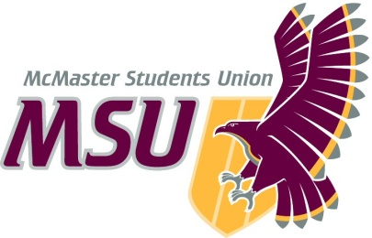. | Report  From the office of the…  Executive Board
To: | Members of the Student Representative Assembly
From: | Kyle Fraser, SRA Representative (Business)
Subject: | Executive Board
Date: | March 1, 2020

Introduction
Dear Members of the Assembly & Committee Chairs,

Here are the major points to hit on from the past meeting of the Executive Board (EB) in 2021:

Service Reports/Updates
We heard reports from:
- EFRT
  - Gaining a better idea of how they will function next year, on campus or off campus etc.
  - Gave positive feedback on all there volunteers and are ahead of schedule on next years hiring’s.
- WGEN
  - Reported they ran successful student support events for students during exam period.
  - They were completing final planning for their campaign “Bodies are dope” promoting body positivity.
  - Also working on there “Making Waves” campaign focused on intersectional feminism and cross movement.

Service Review

- Macademics
  - Looking at a potential service reconstruction/Redefining of operating policy to ensure they can better meet both the original objectives of Macademics and what the service has grown into.

  - Provided a large amount of research and polling before giving some of the recommendations below (if you’d like further detail, I really encourage to read the full report online):

    - A new operating policy and rescinding of the old one
    - Hiring of a new PTM dedicated exclusively to the awards MacAcademics deals with, including a teaching award.
    - Further commitment to working with faculty societies on said awards.
  - The EB has tabled these recommendations for the upcoming meeting and so no final decisions have yet been reached by EB or been passed along to the SRA.

Hiring Updates:
- Assigned EB members are in hiring committees, reviewing resumes and video interviews to hire for a few positions.
  - Diversity services director, assistant director, etc.

Capital Requests:
- Approved the purchase of a laptop for campus events for the coming year.

Kyle Fraser
SRA Representative (Business)
McMaster Students Union
Frasek9@mcmaster.ca

