. 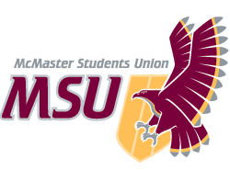 | REPORT  From the office of the…  Student Health Education Centre (SHEC) Services Coordinator
TO: | Members of the Executive Board
FROM: | Sydney Cumming (they/her)
SUBJECT: | SHEC Report (VII)
DATE: | Thursday March 11th, 2021

Year plan Update
Normally at this point in the school year, the outgoing executive team would be focused on hiring for our incoming executive and/or volunteer team. However, we are currently waiting for the MSU to wrap-up recruitment for the paid PTM roles before these positions can be opened, as the PTMs are mandatory members on all subsequent hiring boards.
It is likely that the incoming PTMs will be recruiting their executive team in mid- to late-April and that volunteer hiring may extend into the midst of the summer. This will almost certainly ruin their timelines for the remainder of the year, but there is little that I can do to prevent this from happening.

Since all hiring timelines remain uncertain, I have decided to offer students the chance to sign-up for an email notification as soon as applications go online. Students can enter their contact information, and which roles they are interested in applying for, in our “Email Me, Please!” form (linked here). This information will only be accessible to the PTM but will be stored until applications go live, at which point the PTM will then BCC everyone interested in the role(s) on one email. Hiring opportunities will also be promoted on social media, as per usual. Hopefully, this new job alert system will the lack of applications that are generally received for volunteer positions that are posted during the summer months.

As mentioned in the last EB Report, the Service has decided to focus on offering chat-based support on a drop-in basis while video calls and phone calls will only be available upon request via Bit.ly/SHEC-In. We are also running “What the SHEC? Community Drop-In’s” (W.T.S.) on Microsoft Live Events four evenings a week from 6:30-7:30 pm (EST), links are updated weekly for students here.
Please note: W.T.S. on Tuesdays and Thursdays are open to students of all identities and lived experiences. However, Monday evenings are reserved 2STLGQBIA+ students and Wednesday sessions are reserved exclusively for Disabled/ Mad/ Chronically or Mentally Ill students!

MSU SHEC and WGEN recently launched our new virtual fund distribution program, “Collective Care”! As such, a large portion of the Service’s “Health Supplies” budget line has been devoted to providing students with gift cards (virtual or physical) to help cover the costs of buying essential personal health items.
The official request form can be anonymously accessed at Bit.ly/Collective_Care or, if they prefer, folks can (confidentially) message the organizers at the email address SHEC-WGEN@MSU.McMaster.ca. Both the form and the provided email address are monitored by the Part-Time Manager’s from each service, who are responsible for responding to all requests and inquiries. Additionally, a ‘Status Request’ form will be shared with students that request gift cards so that they may anonymously ask for an update on the status of their original request if it is taking longer than expected.

Service Usage

In total, only about 10 to 12 students have used our new Tawk.to page this year to contact our peer support volunteers for one-on-one anonymous support. Ultimately, interest in this service has remained minimal, however, this is not shocking as our distribution of free material resources (i.e. pregnancy tests, safe(r) sex items, etc.) has always been more popular with service users! I believe it’s important to continue offering an anonymous route for peer support amongst Undergraduate students but that peer support need not be the center of all of our efforts, especially when what folks truly need at this moment is increased access to resources and mutual aid.

Between its launch on February 27th and now, the Collective Care program has distributed almost $2,000 worth of support to 59 requestees. The project will continue until funding is no longer available.
Notably, 57% of students using the program indicated that they need help paying for menstrual products; 34.5% require assistance purchasing safe(r) sex items and contraceptives; while 79% of respondents requested money to cover the cost of other personal care items such as O.T.C. medications, wound care, dental hygiene products, etc. There were also a considerable number of individuals requesting funds for gender-affirming gear, children’s necessities, and school expenses.

Past Events, Projects, & Activities
On Wednesday, February 10th, MSU PCC and MSU SHEC teamed up to bring in Pharmacist Drew (he/him) from the PrEP Clinic for a one-hour webinar from 3-4pm [EST]! During “Fully PrEP’d”, we discussed everything folks need to know about PrEP and PEP, including how to get full prescription coverage. Other topics included medications as a form of safe(r) sex and harm reduction and more about how Drew’s clinic has been breaking down barriers across Ontario for folks trying to access this care.
In lieu of an honorarium for the work that Drew put in, he requested that both the MSU PCC and MSU SHEC donate money to the AIDS Network which is a community-led prevention and outreach service in the Hamilton area. As such, MSU SHEC happily complied and made a one-time donation of $150 to the AIDS Network in honour of the PrEP Clinic and Andrew Schonbe!

The PTM and the Promotions Coordinators recently hosted a virtual raffle for three ($50) fifty-dollar gift cards to some of MSU SHEC’s most highly recommended online stores for sensual exploration! Students could enter the “SHECxy Valentine’s Giveaway” anonymously via Microsoft Forms. Each student was then asked to provide their student number in the form so that, if they won, the PTM could send the gift card directly to their McMaster inbox without knowing their name. The form closed automatically on February 14th at 11:59 pm (EST) and the winners were sent their gift cards over the following two weeks.
Students were also asked to indicate their preferred gift card when filling out the form with an alternate “Surprise me!” option for those that weren’t sure what store they would like best. Featured shops included Bonjibon., Come As You Are, Venus Envy, Spectrum Boutique (USA), & Honey Play Box (USA)!

Currently Working On
Work on the Collective Care program with MSU WGEN will continue until funds run out and/or the end of the current Part-Time Manager contracts are reached (April 9th, 2021). Both Yimeng and I seem much more comfortable with the logistics of the program now, however we expect that funds will run out in the next few weeks. Ultimately, I am recommending that the next MSU SHEC Director continue this initiative next year but that they seek out more funding partners or opportunities at the beginning of their contract in the early spring (i.e. Okanagan Charter, PACBIC, SWC, Mac Libraries, etc.).
The PTM is focusing most of their working hours towards preparing their executive and volunteer team for the end of the term, while also assisting the VP Administration to hire the incoming PTMs (the MSU SHEC Director and Assistant Director). I am also in the process of responding to approximately 15 requests for collaboration that were received over the span of three days, however, I must admit that I barely have time to read these invitations in full let alone to reply to them.
The Resources & Advocacy team has just submitted an Intake to the MSU Underground for their first full-sized campaign, “Closer Than Ever: Staying Connecting during COVID-19”. This campaign focuses on fostering healthy relationships with those that are important to you while staying true to your boundaries and taking precautions to protect yourself from the spread of COVID-19. The two executives for the committee are currently working alongside the Promotions Coordinators to create supplementary materials on Canva (such as a short Instagram Reel and a basic worksheet for setting collective boundaries with household members).
The team is very excited to see how the Closer Than Ever campaign turns out and are hoping to coordinate a very special Share-a-Thon campaign alongside its release. The idea of the Share-a-Thon is very similar to that of MSU SWHAT’s famous biannual Walk-a-Thon events, with each share of SHEC’s designated fundraising post warranting a $1 donation to a featured charity! To ensure that this is financially feasible for the Service, there will be a clearly defined cap on the amount of money to be donated (i.e. Any # of shares > 300 = $300)… The Service would like to run this fundraiser in benefit of the Sexual Assault Centre of Hamilton & Area (SACHA) as they are a peer-support organization that focus on supporting folks that might not otherwise feel safe isolating at home.

Upcoming Events, Projects & Activities

From March 29th to April 2nd, our team will be facilitating MSU SHEC’s Exam Giveaways – Spring Edition! This will once again take the form of online raffles for prizes that address the additional stress caused during exams in a more holistic manner. We will be partnering with the MSU Food Collective Centre this semester and will offer some awesome items like a tower fan to keep you cool or 3-months of paid Spotify to keep you entertained! All featured prizes will be selected to ease the discomfort of isolating at home during warmer weather, in preparation of Summer Break.
Entries will be facilitated in two ways:
- Like & tag one pal on the designated Instagram post = [1] One entry.
- Visit tawk.to/msuSHEC during open chat hours, then send a message with the word “exams” and your student number = [3] Three entries.

On March 25th, the service will be hosting a virtual Arts Night on Zoom from 7:30 to 8:30pm (EST)! The event will have two separate rooms, one for folks that want to follow a Bob Ross tutorial video and another for folks interested in learning how to create origami from a volunteer! There will then be three $25 Amazon gift cards to be raffled off to those that submit a photo of their artwork by March 27th at noon. Students that require assistance purchasing arts supplies should email the PTM (or text their temporary #, 365-653-0880) by March 22nd at 11am to have SHEC cover the costs! The aim of the event is to provide an accessible means of socializing with peers from a safe(r) distance while engaging in holistic coping strategies.

Volunteers

In place of our normal tradition of distributing chocolates and mini valentines to our SHEC volunteers, we recently ran an online Valentine’s meme contest amongst the volunteer team. Interested volunteers were asked to submit their favourite memes about self-love, dating, family connections, friendships, etc. through a designated Google Form. The top-rated memes came from Corbin M. (1st place), as well as John C., Sierra V., and Carolyn W. (all tied for 2nd)!
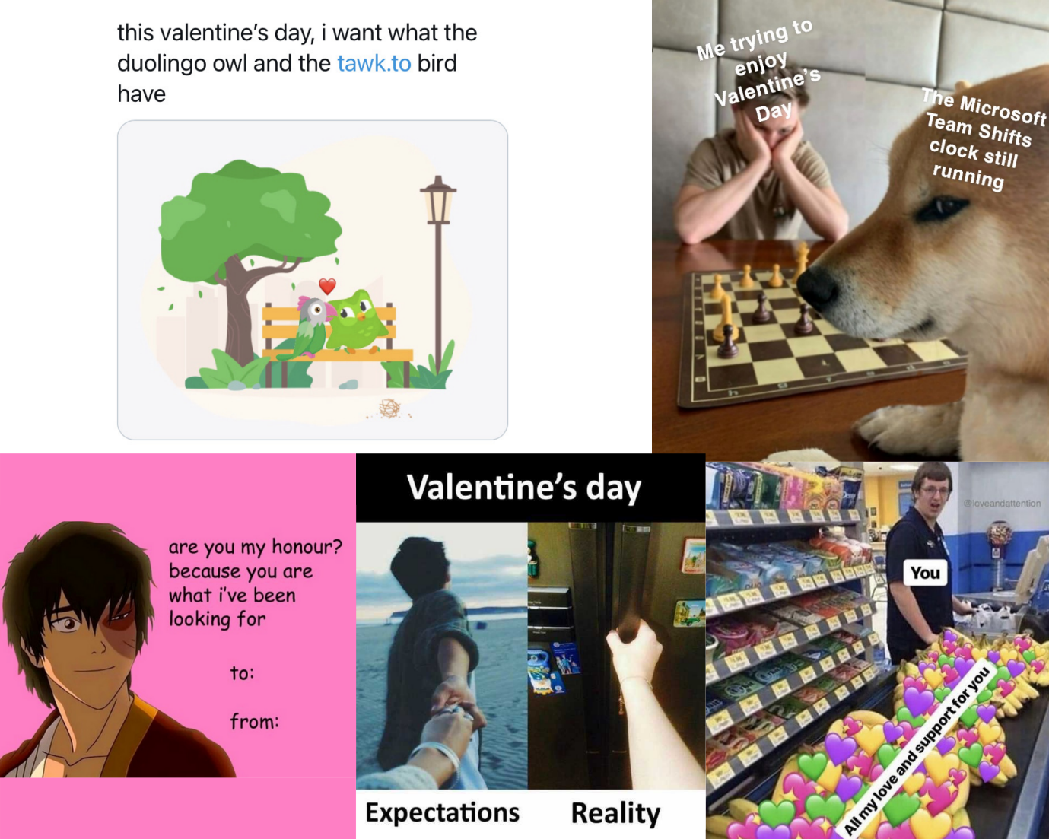
The Volunteer Coordinators are currently arranging a virtual Escape Room for our end of the year social with the peer support team! This is set to be run through Google Forms and Zoom/MS Teams with one executive acting as the ‘guide’ for each room. The date has yet to be finalized but is set for late March. We are hoping to be able to have the new SHEC Director attend to promote their upcoming executive hiring timelines. As for the executives, I am thinking of running another Game Night or doing a virtual Museum Tour for our last social, but I will probably consult with the team first to see if anybody else has a better idea!

Executive team meetings for the Winter term were only recently started due to scheduling conflicts. We have now landed on hosting a ‘core’ executive meeting every Monday morning with a second timeslot reserved on Saturday morning for ‘supplementary’ meetings. All executives are expected to try to attend the Monday meeting but, since each executive member has a ‘co’, it is alright if only one ‘co’ is present to represent them on Monday. However, the two co’s are expected to meet to go over the information later in the week and (if necessary) to schedule a meeting with the PTM during the ‘supplementary’ time if anything is unclear or still needs to be discussed. All executive members are also encouraged to request an impromptu meeting with the PTM during the Saturday morning slots if they forgot to schedule one. I am very optimistic about how this new meeting configuration will help to keep the team on track as we finish off the term.

Successes

The Service has successfully launched our new “What the SHEC? Community Drop-In” hours on Microsoft Live Events. These live broadcasts have mimicked the vibes of our physical safe(r) space on-campus very well and have also given volunteers a great excuse to chat with one another while they wait for visitors! Since these are broadcasts, students can watch anonymously from their web browser and submit questions or comments to the hosts. However, they are prevented from interrupting the hosts by turning on their own microphone or camera or otherwise or interfering with the livestream. This allows us to create a safe(r) environment for any students to swing by to ask questions about health-related topics or student issues without having to start up a full conversation with the peer support volunteer(s) or being subjected to comments from other visitors.
In an unusual chain of events, I decided to make a tiktok-esque Instagram Reel to promote recruitment for the incoming MSU SHEC Director position. The video received 4,200 views which is a pretty healthy dose of engagement! It took about 9 hours to film and edit with my roommates, but it was an entertaining use of a snow day for them and a good way for me to still work while recovering from some medical complications.
Applications for the position of MSU SHEC Assistant Director (AD) are currently open on the MSU job opportunities webpage! Applications will remain open until March 17th at 11:59 PM [EST]. The position is open to any MSU members that plan to return to full-time studies at McMaster in the upcoming academic year (2021 – 22).
About the role: The MSU SHEC AD will work closely with the Director to oversee all service operations and supervise the volunteer team. The AD will be taking the lead on “internal operations” such as managing the Service’s designated safe(r) space and distribution of free health supplies – akin to the current duties of the Volunteer Coordinators.

I am more than happy to discuss what this position will look like with interested students and how it might fit into their pandemic routine! I encourage such folks to reach out to me confidentially via Facebook.

Late last week, I received a confirmation message from SWAP Hamilton that they will accept a bulk donation from MSU SHEC, if it can be drop-offed at their private distribution centre. Thus, I will be requesting access to the on-campus Service space sometime over the next several weeks so I can pack the supplies up and bring them to the organizers.
MSU SHEC will be donating several hundred safe(r) sex and reproductive health items, which are set to expire between now and January 2022. We will also be donating about 40 hCG pregnancy kits so that we have a reliable (and anonymous) organization to refer students to over the summer months.

It’s important to remember that many of these items are being donated at no-cost to the Service, since Public Health Hamilton provides us with lots of stock for free. In fact, in 2019, Public Health gave the PTM 3-4 x the quantity of supplies we had requested, so this will rectify that overstock issue while ensuring that folks get use of the products before they expire!

Current Challenges
Everything has been referred to Closed Session.

Budget

BUDGET LINE | ITEM | BUDGET / COST
REFERENCE LIBRARY | Gift Card Incentives – Resource list updates & additions | 60.00
 | TOTAL SPENT IN LINE | $60^{.00}
HEALTH SUPPLIES | Reproductive Wellbeing – Pregnancy Testing Strips & Collection Cups | 170.63
 | Collective Care – Gift cards from Blackhawk, Well.ca, Loblaw, …, etc. | 1,130.00
 | **Harm Reduction – Deterra Medium-Sized Deactivation Pouches | 128.48
 | **Harm Reduction – Rapid Response Fentanyl Contamination Strips | 70.18
 | TOTAL SPENT IN LINE | $1,499^{.29}
ANNUAL CAMPAIGNS | Cum One, Cum All! – Guest Speaker Payment | 550.00
 | Winter Giveaways – Amazon Prime Orders | 197.68
 | Winter Giveaways – Gift Card Orders (Loblaws, Blackhawk & Costco) | 300.00
 | Fully PrEP’d – One-Time Donation to AIDS Network | 150.00
 | Chess & SHECkers – Amazon.ca Gift Cards, Raffle Prizes | 45.00
 | Closer Than Ever – Infographic Campaign package from the UG | 350.00
 | TOTAL SPENT IN LINE | $1,592^{.68}
ADVERTISING & PROMOTION | Shipping Accessories – Polyethylene bags for sweaters | 9.47
 | New Student Hiring (September) – Paid social media ads | 14.00
 | Cum One, Cum All! – Promotional Assets & Paid social media ads | 155.53
 | Warmline (Fall) – Digital Package promotional assets | 150.00
 | Winter Giveaway – Digi-Lite Package promotional assets | 60.00
 | Seasonal SHEC In’s (Exam) – Digi-Lite Package promotional assets | 60.00
 | Entripy Order – Branded sweatpants for executive team | 370.20
 | Chess & SHECkers – Promotional Assets & Paid social media ads | 140.00
 | SHECxy Giveaway – Digi-Lite Package promotional assets | 60.00
 | SHECxy Giveaway – Virtual Gift Cards $50 CAD/e (CAYA, V.E. & H.P.B) | 213.05
 | Warmline (Winter) – Digital Package promotional assets | 125.00
 | WTS Drop-Ins – Digital Package promotional assets | 125.00
 | TOTAL SPENT IN LINE | $1,482^{.25}
VOLUNTEER RECOGNITION | Token of Appreciation – Electronic Gift Cards for PSVs (x50) | 250.00
 | Dec. Volunteer Social – Prime Video Movie Rental for “Elf” | 5.00
 | Feb. Volunteer Meme Contest – Prizes from Amazon & Blackhawk | 50.00
 | TOTAL SPENT IN LINE | $305^{.00}
TRAINING  EXPENSES | Indigenous Wellbeing & Community – One-Time Donation to DAHAC | 300.00
 | Gender, Sexuality, & Affirmation – Honorariums for Student Speakers | 173.85
 | TOTAL SPENT IN LINE | $473^{.85}
TOTALS
TOTAL BUDGETED DISCRETIONARY SPENDING |  |  | $8,450^{.00}
TOTAL ACTUAL DISCRETIONARY SPENDING |  |  | $5,413^{.07}
REMAINING DISCRETIONARY SPENDING |  |  | $3,486^{.93}
**Purchase Orders were approved, but the purchases have not yet been finalized or placed due to time limits.

It is noteworthy that the Service received a generous sponsorship of $450 from the McMaster Student Wellness Centre for our Winter Giveaway with MSU Maccess. This additional funding has been accounted for in the budget tracker and under the ‘remaining discretionary spending’ section of this report [above].
I am hoping to spend our $100 Office Supplies budget line over the next few weeks to purchase a changing table and a new electric kettle for the SHEC space. Additionally, the remaining Reference Library funds will be used to get some modern sexual wellbeing and contraceptive models (i.e. Mifegymiso, Plan B, etc.) – these can still be used over the next year to create educational videos or Instagram reels, if the space remains closed.

We also have end-of-year thank you gifts going out to the Peer Support Volunteers later this month or early April, as well as gifts for the executive team. These gifts will use the rest of the funds from the Volunteer Recognition line. The committees will also give out small appreciation tokens to the volunteers that invested additional time to work on the committee(s) over the year – these will come out of the Annual Campaigns line though.

Until now, MSU SHEC & WGEN have been splitting the Collective Care expenses according to the types of purchases the student indicated needing to make. However, both services have now surpassed their original allowances for the initiative and thus we have been given a small sum of money from the MSU under their Special Funds budget to extend the initiative a bit. The two services have also recently submitted a request for additional funding from the McMaster University Alumni Association to carry the initiative out through the rest of the term and/or the Spring.

