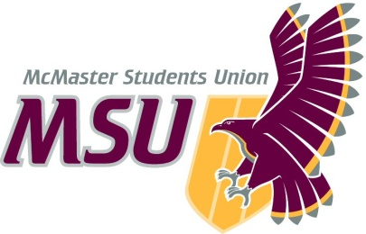
Year-End Report
From the office of…

MSU Pride Community Centre (PCC) Coordinator

Christian Barborini
2020–2021

(Submitted March 22nd, 2021)
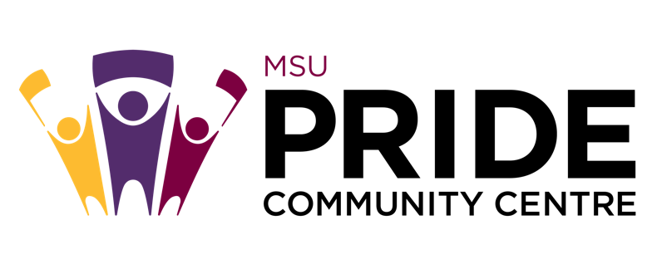

MSU Pride Community Centre
To: Members of the Executive Board (EB)
From: Christian Barborini, PCC Coordinator
Subject: PCC Year-End Report
Date: March 22, 2021

Table of Contents
Table of Contents 2
Report Summary 3
General Information 3
Year Plan Update 3
Events, Projects, & Activities 4
General Service Usage 4
Projects & Events 7
Pride Student Network 7
PCC Welcome Week Programming 2020 8
Community Engagement Groups 9
Online Campaigns 10
Campaign Weeks 11
Queer in STEM 12
2STLGBQIA+ Handbook Resource 13
Outreach & Promotions 14
Summary 14
Promotional Materials 14
Social Media Engagement 18
Finances 18
Budget Summary 19
Personnel 20
Executive 20
Volunteers 21
General 22

Report Summary

General Information

The majority of items outlined in the 2020-2021 PCC Year Plan have been brought to completion this year. The few exceptions whereby timelines were slightly altered are discussed below.

Year Plan Update
Objective 1: Volunteer Hiring
This year, we created a new general volunteer position called the Events and Advocacy Committee Volunteer which was approved in April 2020 by SRA and added to the PCC Operating Policy. The job description for this position was approved by EB on June 5th. We also updated the job descriptions for our Peer Support Volunteer (now Safe(r) Space Volunteer) Position as well as the Volunteer and Training Executive Position. Both of these job descriptions were approved by EB on June 5th, 2020. Myself and our Volunteer and Training Coordinator released PCC General Volunteer Applications on June 17th, 2020 and conducted a total of four rounds of hiring culminating in a team of 33 volunteers. The final round of hiring closed on September 16th which is later than we had planned on having volunteers hired by in our year plan. Finally, our year plan outlines that our team would re-open volunteer applications at the end of first semester for folks looking to get involved with PCC in term 2. However, we made the decision not to do this since we had full volunteer retention and had a variety of other projects taking place during this time.

Objective 2: PCC Service Rebrand
The PCC Service Rebrand process was started by the previous Coordinator and their team. Upon entering this role, myself and my team, along with Michael Wooder and the Communications Department were tasked with completing this process. Our year plan indicated that a new logo and brand be implemented by September 2020, in time for the new school year. However, the logo creation process took the entirety of the year and a new logo was not approved by EB and incorporated into all promo and communications until March 4th, 2021. See approved logo below.
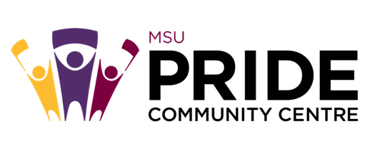

Objective 3: Pride Student Network
Our Pride Student Network had a total of 56 mentors who identify within the 2STLGBQIA+ community. Training for our mentors took place on August 27th from 7:00-9:30PM. Applications for first-year sign-up opened on July 7th, 2020 and enrollment was open well into September. In the end, we had a total of 25 first- and second-year students sign-up for the Pride Student Network.

Although the goal was to have more events throughout the year, our first event for mentors and mentees did not take place until second semester.

Objective 4: Community Engagement Groups
In our year plan, we had indicated to start community groups by September 2020. However, due to hiring timelines as well as getting our virtual space running, we were not able to start groups until the week of November 2nd, 2020. All groups were run through Zoom (rather than MS Teams) with live captioning offered via Otter.ai. We were able to find volunteers to coordinate each of the 10 groups we wanted to run this year except for our 2STLGBQIA+ International Students Group which can hopefully run in the future (depending on volunteer capacity).

Objective 5: 2STLGBQIA+ Handbook Resource
In our year plan, we had planned to launch our 2STLGBQIA+ Handbook Resource in time for the beginning of the year (September 2020). However, due to priorities with opening our virtual space, this was delayed. Our handbook was officially launched on March 8th, 2021.

Events, Projects, & Activities

General Service Usage

PCC Discord Space:
Since launching, our Discord Server has expanded to a total of ~120 members (including our 29 Safe(r) Space volunteers and 8 executive members). This was launched on September 30th, 2020 and operated Monday-Friday 10AM-4PM in the Fall
semester. The discord server was closed for the winter break and re-opened on January 18th, 2021 with new operation hours being Monday-Friday 12-3PM and 6-9PM.

PCC Peer Support Line Offered via tawk.to (non-crisis support line):
During volunteer shifts, in addition to managing our Community Discord Server, Safe(r) Space volunteers were also responsible for being responsive to any peer support requests we got through our tawk.to page which can be accessed via this link: https://tawk.to/msupridecommunitycentre

This was launched on November 2nd, 2020 and operated Monday-Friday 10AM-4PM in the Fall semester. The support line was closed for the winter break and re-opened on January 18th, 2021 with new operation hours being Monday-Friday 12-3PM and 6-9PM.

Table 1: PCC Safe(r) Space Usage 2020-2021:
Dates | Platform | Space Usage
September 30th – October 3rd | Discord | ~21
October 3rd – October 30th | Discord | ~23
October 30th – November 20th | Discord | ~8
November 2nd – 20th | Tawk.to | 1
November 20th – January 22nd | Discord | ~16
November 20th – January 22nd | Tawk.to | 1
November 20th – January 22nd | Zoom (Video Support) | 1
January 22nd – March 22nd | Discord | ~44
January 22nd – March 22nd | Tawk.to | 2
January 22nd – March 22nd | Zoom (Video Support) | 1

Table 2: Summer 2020 PCC Community Group Attendance:
Date | Community Group | Attendance | Sessions | Average
Tuesdays | BIPoC 2STLGBQIA+ Group | 3 | 6 | 1
Wednesdays | Disabled Queer & Trans Group | 8 | 7 | 1
2020-08-31 | Newcomers 2STLGBQIA+ Group | 8 | 1 | NA
2020-09-09 | 2STLGBQIA+ International and Immigrants Group | 1 | 1 | NA

Table 3: Fall 2020 PCC Community Group Attendance:
Date | Community Group | Attendance | Sessions | Average
Mondays | Asexual & Aromantic Group | 15 | 5 | 3
Mondays | Bi-Pan-Poly Hour | 3 | 5 | 1
Mondays | Newcomers 2STLGBQIA+ Group | 11 | 5 | 3
Tuesdays | Where We Come From | 1 | 5 | 1
Tuesdays | Black 2STLGBQIA+ Group | 0 | 5 | 0
Wednesdays | Men Loving Men | 4 | 5 | 1
Wednesdays | Women Loving Women | 8 | 5 | 2
Wednesdays | Trans & Non-Binary Group | 0 | 5 | 0
Thursdays | BIPoC 2STLGBQIA+ Group | 0 | 5 | 0

Table 4: Winter 2021 PCC Community Group Attendance (still in progress):
Date | Community Group | Attendance | Sessions | Average
Mondays | Where We Come From | 5 | 7 | 1
Mondays | Disabled Queer & Trans Group | 8 | 6 | 2
Tuesdays | Bi-Pan-Poly Hour | 9 | 7 | 2
Tuesdays | Women Loving Women | 19 | 7 | 3
Tuesdays | Newcomers 2STLGBQIA+ Group | 3 | 7 | 1
Wednesdays | Men Loving Men | 7 | 7 | 1
Wednesdays | BIPoC 2STLGBQIA+ Group | 2 | 7 | 1
Wednesdays | Trans & Non-Binary Group | 0 | 7 | 0
Thursdays | Black 2STLGBQIA+ Group | 0 | 7 | 0
Thursdays | Asexual & Aromantic Group | 18 | 7 | 4

Projects & Events

Pride Student Network
Project Status: Complete:
General Information:
A mentorship program within our service which paired 2STLGBQIA+ identifying Welcome Week representatives with incoming 2STLGBQIA+ first years. The hope was that this program would foster connection and a sense of community between 2STLGBQIA+ upper years and incoming first years to help guide them through the entirety of their first year at McMaster. Moreover, COVID-19 has been especially challenging for 2STLGBQIA+ students, particularly those who are forced to live at home with homophobic or transphobic parents/guardians. This program served to connect students with a fellow member of the 2STLGBQIA+ community which functioned as a valuable support network during these challenging times. Reps who signed up to be a mentor for this service needed to undergo additional training hosted online by the PCC in August 2020.

Challenges:
We did not have as many sign-ups from first years as we were expecting. We received 31 applications from first- and second-year students. Since we had accumulated a total of 56 mentors, this meant that many mentees had two mentors. Moreover, applications for the Pride Student Network opened to first years in the beginning of July 2020. I think it would be much more beneficial to open up sign-ups for the Pride Student Network as early as possible in the summer months, potentially in May. Not only would this increase sign-ups, but it would allow the PCC team to pair up mentees and mentors before school starts in September such that pairings could hopefully be put together prior to Welcome Week. This year, mentor/mentee pairings were not finalized until the end of September 2020 which I think reduced interest in the program especially since the semester starts to pick up for students at this point. Moreover, it took the entire Fall semester for some mentors to get in touch with their respective mentees. I believe that having pairings complete prior to school starting could resolve a lot of these issues we noticed this year. Finally, we did not utilize the Pride Student Network throughout the year as much as I would have liked to. Running frequent community events for mentors and mentees to connect would be a great way to create community and increase engagement within the program. It would also be a great idea to create a channel on our Discord for the Pride Student Network for mentors and mentees to connect within the program. Overall, it would be potentially beneficial to rebrand this from a mentorship program, to a community program that aims to connect new McMaster 2STLGBQIA+ students with upper year 2STLGBQIA+ students. I think this was our initial goal, however, our message got somewhat lost throughout the year.

Successes:
We had a lot of Welcome Week Representatives interested in being mentors which was amazing (56 mentors to be exact). In addition, I had heard from some mentors that they frequently connected with their mentee which was really rewarding to hear. I think continuing the Pride Student Network in the future, even when we return to in-person classes would be a great idea, however, since this year was very much a pilot project, work will be required in order to expand it.

PCC Welcome Week Programming 2020
Project Status: Complete
General Information:
For Welcome Week 2020, we had to begin adapting our service to an online format by trying to reach students via virtual events and community groups. We wanted to still ensure that new students were aware of programming offered by the PCC despite the very real reality of school being online. Throughout the week we offered 4 different community groups (BIPoC 2STLGBQIA+ Group, Newcomers 2STLGBQIA+ Group, Disabled Queer and Trans Group, and 2STLGBQIA+ International & Immigrants Group). In addition, we offered one event, Plants, Pets, and Paper.

Challenges:
Promoting this more in advance of Welcome Week could have been helpful in increasing our attendance numbers. Having two events (rather than just the one) would have also been a way to increase engagement especially if the time of the one event we ran did not work for many students.

Successes:
All community groups received relatively good attendance, with each group receiving at least one participant. In particular, our Newcomers Group had 8 participants which was great to see. This is a great group to offer during Welcome Week since it offers incoming 2STLGBQIA+ students the opportunity to connect with other 2STLGBQIA+ students as well as become connected with the MSU PCC. Although attendance at our Plants, Pets, and Paper event was lower than expected, this event facilitated a super relaxed safe(r) space were attendees learned how to do origami, and chatted with executives and volunteers about first year, and some of the services offered by the PCC.

Community Engagement Groups
Project Status: Complete
General Information:
Initially, we offered two community groups throughout the summer months (July-August 2020) including both our BIPoC 2STLGBQIA+ Group as well as our Disabled Queer and Trans Group with MSU Maccess. These two groups stopped at the end of the summer in order to begin preparations for volunteer hiring and safe(r) space opening.

We started offering 9 community groups the week of November 2nd, 2020. All groups ran through Zoom with live captioning offered via Otter.ai. We were able to find volunteers to coordinate each of the groups we wanted to run except for our 2STLGBQIA+ International Students Group which the PCC can hopefully run in the future (depending on volunteer capacity). All 9 community groups stopped for the winter break and resumed the week of January 25th, 2021. In January we also began offering our Disabled Queer and Trans Community Group in collaboration with MSU Maccess.

Challenges:
Our Black 2STLGBQIA+ Community Group received zero sign-ups throughout the entire year despite trying to push this group on our socials and with our connections. We also tried to reach out to the Black Students Association (BSA) to potentially collaborate with them on the group, however, we never heard back. It would be extremely beneficial to try to connect again with Black Students Association (BSA) or other Black student groups such as Macafricans to make this a collaborative community group. Likewise, although our Trans & Non-Binary Group and BIPoC 2STLGBQIA+ Groups had people sign-up, we rarely had folks actually show up to these groups. It might be a good idea to consider collaborating with Diversity Services on our BIPoC Group, and WGEN for our Trans & Non-Binary Group in the future.

Successes:
This year, we offered 10 different community engagement groups which is the most our service has offered in a long time. Our most popular groups were the Asexual & Aromantic Group, Bi-Pan-Poly Hour Group, WLW, and Disabled Queer and Trans Group. Our consistently, most highly attended group was our Asexual & Aromantic Group which has not been offered by the PCC, at least in the last 4 years. This really spoke to the clear need for closed spaces for asexual and aromantic folks which our service has neglected for years.

Online Campaigns
Project Status: Complete
General Information:
Pride Myth Busters Campaign:
This was our Pride month campaign which aimed to debunk various myths surrounding Pride. We introduced a new myth/fact combo each day leading up until June 28th (historical day of Stonewall Riots). This campaign took place online (via Facebook, Instagram and Twitter) from June 22nd-29th, 2020.

Letters of Support Campaign:
This campaign was a collaboration with MSU Maccess, WGEN, SHEC and SVPRO in order to allow students who are survivors of sexual violence, identify as 2STLGBQIA+ or are living with mental illness or disability to write a letter to students who may share one of these common lived experiences especially in the current age of COVID-19.

2STLGBQIA+ Trailblazers Campaign for 2STLGBQIA+ History Month:
This campaign began on the week of October 19th, 2020 and served to commemorate 2STLGBQIA+ History Month (October) by showcasing various 2STLGBQIA+ trailblazers who have been critical in forging 2STLGBQIA+ rights and the movement as a whole. Various trailblazers were showcased on a daily basis with individual posts.

Challenges:
With informative campaigns, it would have been interesting to find a way to engage people with the campaigns rather than just asking them to comment and repost. Perhaps this could be accomplished by creating more discussions and interactive posts. Generally, I think engaging our social media audience is an area where the PCC can improve on in the future.

Successes:
Generally, online campaigns received very good online engagement with our followers. Campaigns like this are super useful because both queer students and allies can learn something from these.

Campaign Weeks

2STLGBQIA+ History Week, Mac Pride Week, Transcendence
Project Status: Complete
General Information:
2STLGBQIA+ History Week: History in the Making
An annual campaign week which the PCC runs to recognize, pay homage to, and celebrate our vibrant queer history. This campaign week was run from November 16th-20th, 2020. The theme for 2STLGBQIA+ History Week this year was History in the Making: An Ongoing Resistance. We ran a series of nine events during the week.

Mac Pride Week: Joy in Queerness
PCC’s largest annual campaign week which celebrates queer existence and the diverse identities that make up our community. We ran this campaign week from February 8th-12th, 2021. The theme for Mac Pride Week this year was Joy in Queerness. We ran a series of nine events throughout the week.

Transcendence:
A campaign week dedicated to celebrating the beauty, resilience, and excellence in the identities of transgender, non-binary, Two-Spirit, and questioning folks. This campaign week took place from March 17th – March 22nd, 2021 and consisted of 5 different events.

Challenges:
Although I think that it is super great that we were able to offer 9 different events for both 2STLGBQIA+ History Week and Mac Pride Week, I think that this can perhaps be reduced in the future. Rather than cramming 9 events into one week, it may be more sensible to do 6-7 events maximum for both of these campaigns and spread-out remaining event ideas throughout the following weeks. I think we had so many great ideas that we wanted to run them all during our campaign weeks, but it is totally okay to save some of those great ideas for isolated events throughout the rest of the term! This would especially be beneficial for folks who may not be able to attend events during a campaign week should they be busy with school and provides more opportunity to create community throughout the term.

Successes:
I am extremely happy with the variety of events and collaborations we were able to arrange for our three major campaign weeks. We really tried our best to ensure that there was always something for everybody. These collaborations and closed spaces for BIPoC, disabled, and trans folks are super important and I would love these great relationships we have forged with many other student groups and Hamilton organizations to continue on in the future.

Queer in STEM
Project Status: Complete
General Information:
The PCC along with the Bachelor of Health Science Student Society (BHSS), McMaster Science Society (MSS), McMaster Engineering Society (MES), and EngiQueers hosted a panel of scientists, engineers, and medical professionals who are also 2STLGBQIA+ and were willing to share their experiences. The purpose of this event was to raise awareness to allies about the unique barriers faced by 2STLGBQIA+ folks in STEM but also aimed to empower 2STLGBQIA+ students who may share similar experiences. The event took place on March 1st, 2021 with the graduate student’s panel taking place from 1-2pm and the professionals panel taking place from 3-4pm.

Challenges:
Although this event was extremely successful, there is plenty of space for it to expand in the future. First, it would have been beneficial to have the professionals panel be slightly longer than an hour (~1.5 hours). This is because we felt as though we were a little bit rushed and would have liked to ask panelists 2-3 additional questions. That being said, the professionals panel may have felt more rushed than the graduate students panel since we had 5 panelists on the professionals panel. The amount of time delegated to the panel should be based on the number of panelists. Generally, we found that 1 hour was sufficient for a panel of 4 people. Furthermore, the professionals panel would have benefited from more Black and transgender representation. Conversely, our graduate panel had a great mix of Black, racialized, and transgender representation though it lacked engineering representation. Finally, in the future, it would be amazing if we could take note of action items from experiences, and perspectives brought up in the panel which could then be brought forward to either the MSU or McMaster University (via PACBIC or EIO). This would allow Queer in STEM not only to serve as a community building and educative event, but also one that goes further to bring forward actionable items to the University regarding what can be done to promote 2STLGBQIA+ safe(r) and inclusive spaces on campus.

Overall, although our Queer in STEM panels were cumulatively 2 hours in length, it would be amazing to offer this as a full day of programming. This would definitely require much more coordination amongst the faculty societies. I think that it would be really great to get MSS, MES, and BHSS more closely involved with the event in the future, rather than just have them as sponsors as was the case this year.

Successes:
This event was extremely successful with 87 people registering for the event and ~40 people actually attending the event culminating in PCC’s most highly attended event in our recent past. Although we were required to conduct the event online due to COVID-19 restrictions, our team found that continuing the event online in the future would be a better idea than in-person. This is because it allowed us to invite people living far away from McMaster (ie. the USA). Moreover, collaborating with EngiQueers, MSS, MES, and BHSS really helped us with our event outreach and interest. I would highly recommend continuing to formulate connections with these student groups, especially if Queer in STEM becomes an annual event run by the PCC. Altogether, this event was an incredible success, and I would strongly recommend (very strong emphasis) that the PCC considers running this again in the future because it was incredibly impactful. Our collaborators were also super excited about it and would most likely be interested in joining together again to create this space.

2STLGBQIA+ Handbook Resource
Project Status: Complete
General Information:
Our 2STLGBQIA+ Handbook is at completion and was launched on March 8th. The handbook contains three sections including general terminology, pronouns and use of transgender inclusive language, as well as resources. We also have incorporated an appendix with detailed descriptions and information on gender-affirming procedures and surgeries. The hope is that this resource will continue to be expanded over the years by future PCC teams.

The handbook can be accessed on our website as well as has been published on ISSUU: https://issuu.com/msu_mcmaster/docs/msu_pcc_handbook_2021
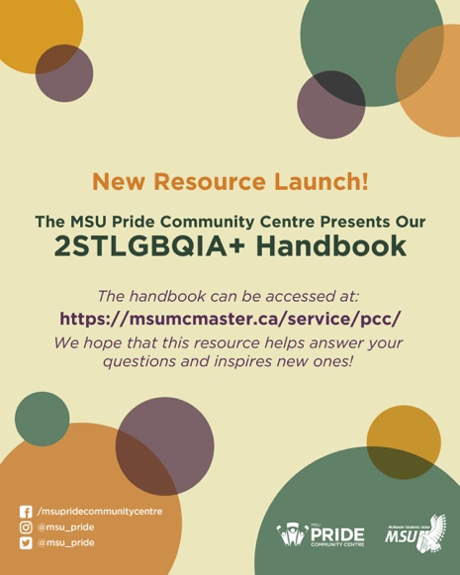

Outreach & Promotions

Summary
General Information:
The PCC Team is quite content with our social media presence this year especially given the fact that it was really the main method of communicating with the McMaster 2STLGBQIA+ community about our programming. We have worked on trying to increase the visibility of PCC on campus by increasing our collaborations and connections with other student groups and off-campus partners.

Challenges:
Throughout the year, we experienced some miscommunication issues with MSU Underground regarding requests for promotional material. Specifically, in communicating to us the cost of promotional material. At multiple points throughout the year, delays experienced by MSU Underground also delayed our ability to release our campaigns and programming despite requesting changes and updates well in advance.

Successes:
Our 2020-2021 Promotions Coordinators have worked really hard this year to increase our social media presence especially on Instagram. Since October 2020, our following on Instagram has increased from 803 followers to 917 followers.

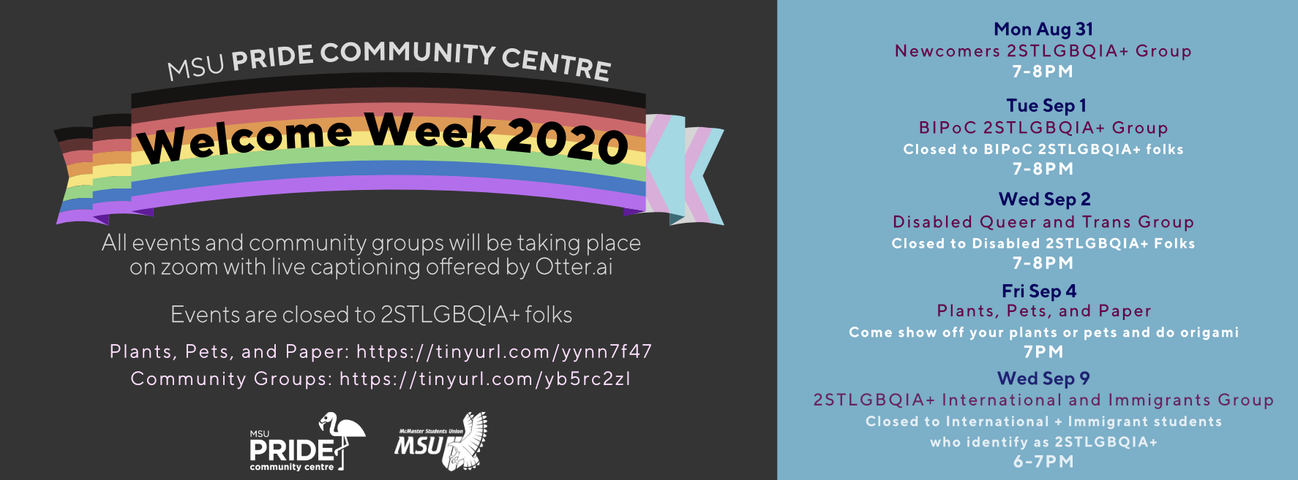
Promotional Materials
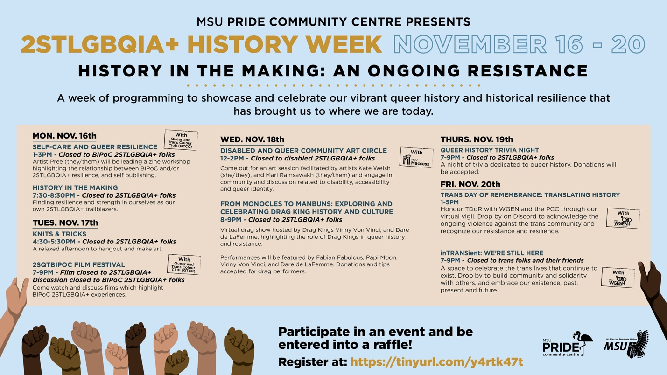

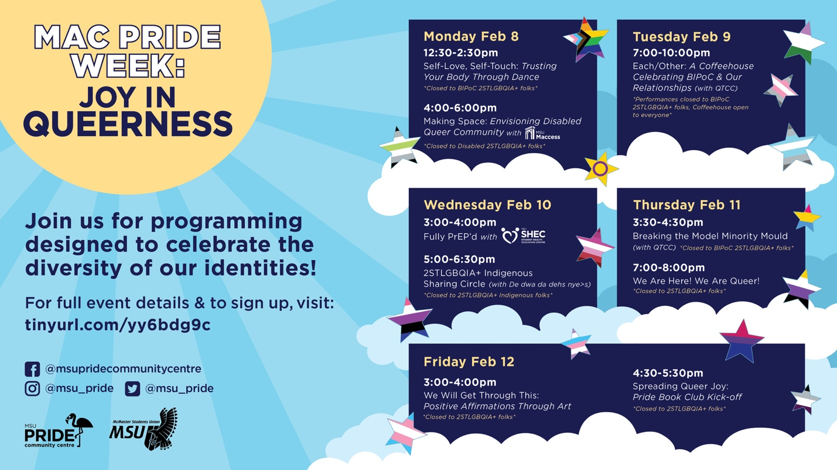
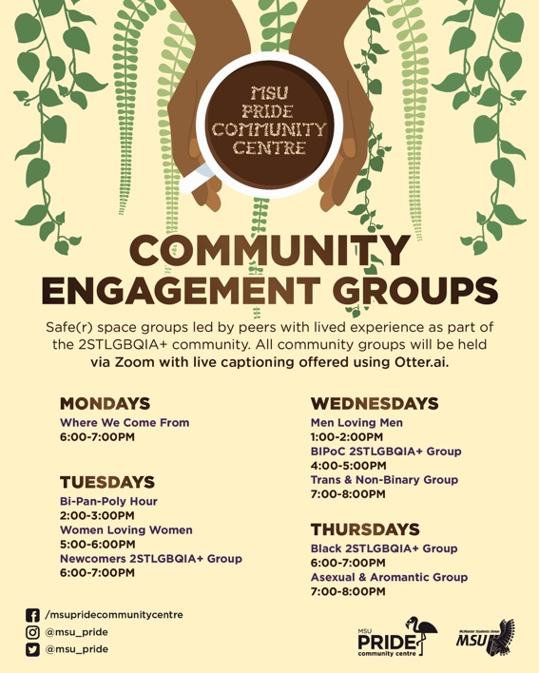
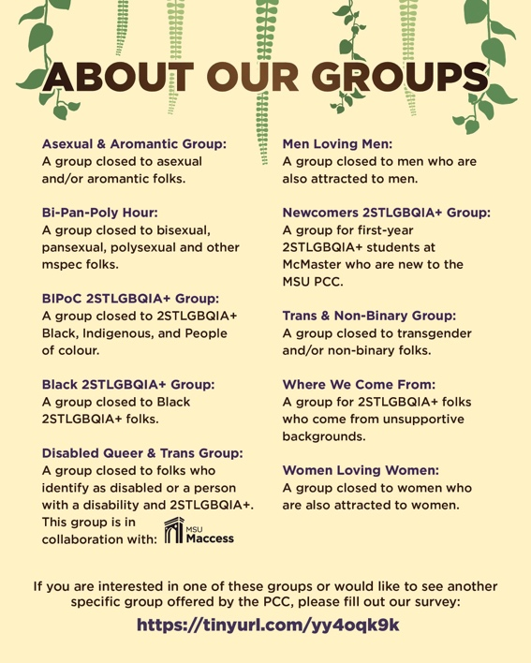
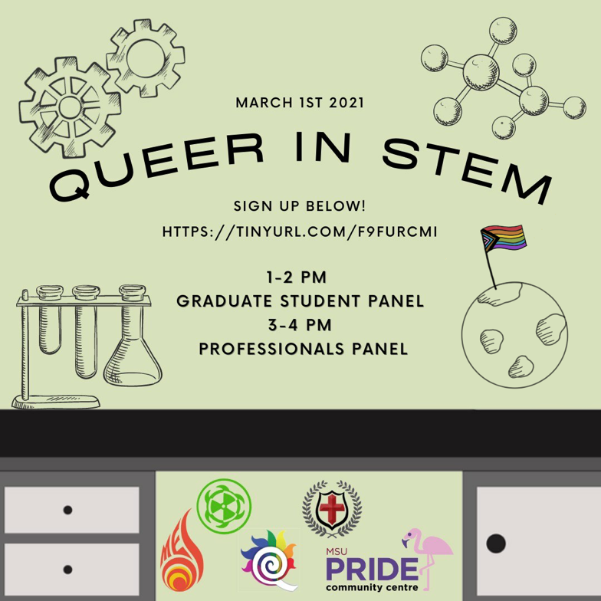

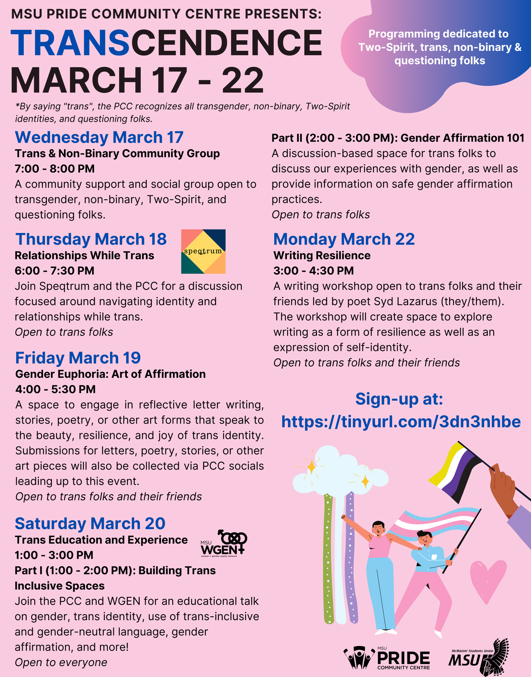

Social Media Engagement

Table 5: The following numbers for our three social media platforms throughout the course of the year are shown below:

Platform | 2020-10-03 | 2020-10-31 | 2020-11-20 | 2021-01-22 | 2021-03-22
Facebook | 1215 followers | 1211 followers | 1211 followers | 1210 followers | 1205 followers
Instagram | 803 followers | 825 followers | 857 followers | 870 followers | 917 followers
Twitter | 1024 followers | 1026 followers | 1032 followers | 1032 followers | 1047 followers

Finances
General Information:
No issues were experienced this year with finances. The PCC was able to run three different campaign weeks, two of which consisted of nine events, and the other which consisted of five events. We were also able to invite multiple different guests for each of these campaigns including 4 drag kings (2STLGBQIA+ History Week), the PrEP Clinic (Mac Pride Week), as well as multiple workshop facilitators and speakers. We were also able to invite nine different panelists for Queer in STEM with the help of funding from MSS, MES, BHSS, and EngiQueers. Finally, we made a donation to Speqtrum Hamilton to support the wonderful work they do for the 2STLGBQIA+ community. For a detailed outline of purchases made this year by the PCC, please see Table 6 below (Budget Tracker).

Challenges:
There were no challenges experienced with finances this year.

Successes:
Not having to purchase food or refreshments for events allowed us to use a lot of that money towards holding more events and programming instead! This included producing our 26-page 2STLGBQIA+ Handbook Resource which we are hoping is a resource which will be part of the PCC for years to come.

Budget Summary
Table 6: Budget Tracker
ACCOUNT CODE | ITEM | BUDGET / COST
5003-0119
Office | TOTAL SPENT IN LINE | $0.00
 | REMAINING IN LINE | $100.00
5202-0119 | 1.) Disabled & Queer Community Art Circle  2.) Donation to Speqtrum Hamilton
Outreach | TOTAL SPENT IN LINE | $250.00
 | REMAINING IN LINE | $0.00
6102-0119 | 1.) Self-Care and Queer Resilience Event  2.) From Monocles to Manbuns: Drag Show  3.) Self-Love, Self-Touch: Trusting Your Body Again Through Dance  4.) We Will Get Through This: Positive Affirmations Through Art  5.) 2STLGBQIA+ Indigenous Sharing Circle  6.) Queer in STEM  7.) Writing Resilience
Campaigns | TOTAL SPENT IN LINE | $2475.00
 | REMAINING IN LINE | $525.00
6494-0119 | 1.) PCC Crewneck Shirts (48)
Volunteer | TOTAL SPENT IN LINE | $717.34
 | REMAINING IN LINE | $32.66
6501-0119 | 1.) Pride Myth Busters Campaign  2.) Pride Student Network Promo  3.) Community Engagement Group Promo  4.) 2STLGBQIA+ History Week Promo  5.) Queer History Trivia Starbucks Gift card  6.) 2STLGBQIA+ History Week Raffle Prize  7.) Mac Pride Week Promo  8.) Mac Pride Week Skip the Dishes  9.) 2STLGBQIA+ Handbook Launch Promo  10.) Transcendence Promo Boost  11.) PCC Stickers (1000)
Promo | TOTAL SPENT IN LINE | $1595.50
 | REMAINING IN LINE | $104.50
6604-0119 | 1.) Pronoun Buttons
Resources | TOTAL SPENT IN LINE | $120.00
 | REMAINING IN LINE | $180.00
6804-0119 | 1.) Fully PrEP’d Workshop
Training | TOTAL SPENT IN LINE | $150.00
 | REMAINING IN LINE | $350.00
TOTALS
TOTAL BUDGETED DISCRETIONARY SPENDING |  |  | $6600.00
TOTAL ACTUAL DISCRETIONARY SPENDING |  |  | $5307.84
REMAINING DISCRETIONARY SPENDING |  |  | $1292.16

Personnel

2020-2021 PCC Executive Team:

Christian Barborini – Pride Coordinator
Dixon Pinto – Volunteer and Training Coordinator
Noah Yang – Community Facilitation Coordinator
Declan Mullane – Research and Resources Coordinator
Meera Chopra – Social and Political Advocacy Coordinator
Stephanie Chin – Events Coordinator
Matthew Aksamit & Maria Denk – Promotions Coordinators

Executive

Challenges:
I was extremely impressed with how well the PCC executive team meshed this year considering that many of us have not actually met in person! We did not experience any large challenges or issues. If anything, I would say that communication was often somewhat of a challenge that we had to work through. Our team used both Slack as well as a Facebook Group to communicate throughout the year. I think communication could have definitely occurred more quickly, and efficiently through Slack; however, I also realize that on my end, having two platforms for communication (both Slack and Facebook) might have been confusing and reduced exec engagement with the Slack. For future teams, I would suggest agreeing on a single platform for communication throughout the year and sticking to that platform.

Successes:
A success was the hiring of a full executive team which contains multiple BIPoC, transgender, as well as disabled 2STLGBQIA+ voices. I was very concerned when I stepped into this job about the direction of the PCC after the space was closed in January 2020 and that this would have created a strong distrust of BIPoC folks. Although this is definitely true, we were able to hire multiple BIPoC execs as well as transgender, and disabled folks, culminating in a diverse exec team with multiple voices and perspectives. This was really important to me in ensuring that we were able to deliver a wide range of programming and spaces throughout the year. Furthermore, our team was able to operate an entirely virtual peer support service along with run three ambitious campaign weeks fully online. Our execs have surpassed my expectations and I am super grateful for each and every one of their time, commitment and enthusiasm towards making safe(r) spaces for students on campus.

Volunteers

Challenges:
One of the main challenges we noticed with our virtual space has involved volunteers not showing up for their shifts without giving notice. We decided to enforce a three-strike policy with volunteers whereby if there is a no-show based on the attendance sheet 3 times, they were to have a meeting with an exec to check-in and remind them of the commitment they have made to the PCC. Although this sometimes occurred within our physical space, our team found that it was much harder to actually track this year since all support forums were offered virtually and thus it became impossible to determine if volunteers were present during their shift.

Successes:
The addition of the novel volunteer position “Events and Advocacy Committee Volunteer” has been a huge success. The Pride Community Centre has been an important part of my undergraduate experience at McMaster, and as a volunteer in the past, I have always felt the desire to offer the volunteers the opportunity to become more involved in the research and planning of campaigns and events run by the PCC. I really feel that as a volunteer, I would have loved this opportunity, so I am excited that we were able to open this opportunity up to the broader McMaster 2STLGBQIA+ community. Our events volunteers have done an exceptional job supporting us throughout all of our events this year and the executive team has highly valued the perspectives and ideas of our lovely events team! I am excited to see this position grow in future years since there were definitely some hiccups to work through in the beginning with regards to discerning which tasks to delegate to events volunteers.

Altogether, I wanted to express how grateful the PCC exec team and I are for our wonderful volunteers who have stuck with us the entire year. Specifically, we had full retention of all 29 safe(r) space volunteers throughout the entire academic year despite the challenges of online school and pandemic life. The success of our service this year in the online setting would not have been possible without the incredible commitment and work of our volunteers.

General

Final Comments:
Reflecting on the year, I am really happy and fulfilled to see what our team has done with the PCC and the way the service has grown. One of our largest successes was our Queer in STEM event, attracting the greatest amount of attendance and interest the PCC has seen in a while. Furthermore, over the course of the year, we have managed to engage in 12 different collaborations with student groups on campus as well as partners in Hamilton and the GTA. This is a success for us because we have always felt that the PCC, like many MSU services, is stuck within the bubble of the MSU and I think it is important to expand our reach beyond the MSU and McMaster University.

I am very optimistic for the future of the PCC and have much faith that Stephanie, our next Director will continue to take the PCC to new heights!

~Christian Barborini (they/them) – 2020-2021 PCC Coordinator

