. 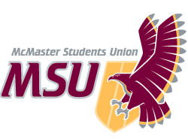 | REPORT  From the office of the…  MSU Pride Community Centre Coordinator
TO: | Members of the Executive Board
FROM: | Christian Barborini
SUBJECT: | Pride Community Centre Report #7
DATE: | 2021-03-18

Yearplan Update:
Since the last time I reported, the PCC has planned and implemented 14 different events between Mac Pride Week, Queer in STEM, as well as our Transcendence Campaign Week. We are currently in the midst of running Transcendence, a campaign dedicated to transgender, non-binary, Two-Spirit and questioning folks. Our safe(r) space, and community groups continue to operate as previously reported from Monday-Friday 12-3PM and 6-9PM. We have also launched our new logo, 2STLGBQIA+ Handbook, and the next PCC Director has been hired.

Service Usage:

Community Groups:
Community Groups have been running since the week of January 25th. We have also started our Disabled Queer and Trans Group with Maccess. We have still been experiencing no attendance to our Black, and Trans & Non-Binary Groups.

Winter 2021 PCC Community Group Attendance:
Date | Community Group | Attendance | Sessions | Average
Mondays | Where We Come From | 5 | 6 | 1
Mondays | Disabled Queer & Trans Group | 8 | 5 | 2
Tuesdays | Bi-Pan-Poly Hour | 9 | 6 | 2
Tuesdays | Women Loving Women | 19 | 6 | 3
Tuesdays | Newcomers 2STLGBQIA+ Group | 3 | 6 | 1
Wednesdays | Men Loving Men | 7 | 6 | 1
Wednesdays | BIPoC 2STLGBQIA+ Group | 2 | 6 | 1
Wednesdays | Trans & Non-Binary Group | 0 | 6 | 0
Thursdays | Black 2STLGBQIA+ Group | 0 | 6 | 0
Thursdays | Asexual & Aromantic Group | 18 | 6 | 4

Events:
Since my last report, we have run 11 events (see below).

Date | Event | Attendance | Collabs
2021-02-08 | Self-Love, Self-Touch: Trusting Your Body Through Dance | 1 (recording) | NA
2021-02-08 | Making Space: Envisioning Disabled Queer Community | 5 | MSU Maccess
2021-02-09 | Each/Other Coffeehouse | ~16 | QTCC
2021-02-10 | Fully PrEP’d | 4 | MSU SHEC
2021-02-10 | 2STLGBQIA+ Indigenous Sharing Circle | 0 | De dwa da dehs nye>s
2021-02-11 | Breaking the Model Minority Mould | 1 | QTCC
2021-02-11 | We Are Here! We Are Queer! | 1 | NA
2021-02-12 | We Will Get Through This: Positive Affirmations Through Art | 4 | NA
2021-02-12 | Spreading Queer Joy: Pride Book Club Kick-Off | 8 | NA
2021-03-01 | Queer in STEM: Graduate Panel | ~40 | MSS, MES, BHSS, EngiQueers
2021-03-01 | Queer in STEM: Professionals Panel | ~40

PCC Safe(r) Space Usage:
Since my last report, we have had 10 new members join our Discord Space with a grand total of 121 members currently occupying our Discord. Space usage between the dates 2021-01-22 and 2021-03-12 are shown below (excluding PCC execs and volunteers). Our space is open Monday-Friday from 12-3PM and 6-9PM.

Dates | Platform | Space Usage
September 30th – October 3rd | Discord | ~21
October 3rd – October 30th | Discord | ~23
October 30th – November 20th | Discord | ~8
November 2nd – 20th | Tawk.to | 1
November 20th – January 22nd | Discord | ~16
November 20th – January 22nd | Tawk.to | 1
November 20th – January 22nd | Zoom (Video Support) | 1
January 22nd – March 12th | Discord | ~41
January 22nd – March 12th | Tawk.to | 1
January 22nd – March 12th | Zoom (Video Support) | 1

Social Media:
The following numbers for our three social media platforms are shown below:

Platform | 2021-01-22 | 2021-03-12
Facebook | 1210 followers | 1206 followers
Instagram | 870 followers | 914 followers
Twitter | 1032 followers | 1074 followers

Past Events, Projects, & Activities:

Mac Pride Week:
PCC’s largest annual campaign week which celebrates queer existence and the diverse identities that make up our community. We ran this campaign week from February 8th-12th. The theme for Mac Pride Week this year was Joy in Queerness. We ran a series of nine events throughout the week and were very happy with how the week went. Our most successful events were our Each/Other Coffeehouse with QTCC and Spreading Queer Joy which was our Pride Book Club Kickoff. We unfortunately had no attendance to our 2STLGBQIA+ Indigenous Sharing Circle with De dwa da dehs nye>s.

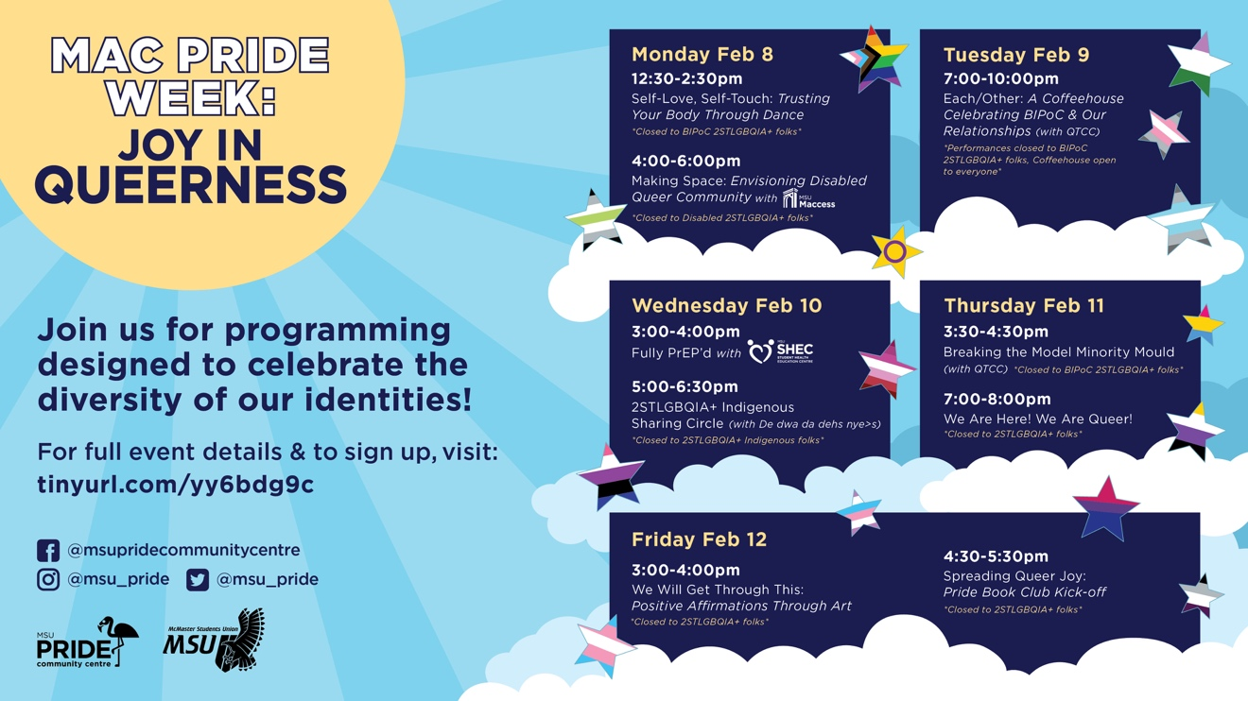

Queer in STEM:
PCC along with the McMaster Science Society (MSS), Bachelor of Health Science Student Society (BHSS), McMaster Engineering Society (MES), and EngiQueers, hosted a panel of scientists, engineers, and medical professionals who are also 2STLGBQIA+ and willing to share their experiences. The purpose of this event was not only to raise awareness to allies about the unique barriers faced by 2STLGBQIA+ folks in STEM but also served to empower 2STLGBQIA+ students who may share similar experiences.

Queer in STEM took place on March 1st and involved two separate sections. The first (1-2pm) was a panel of 2STLGBQIA+ Graduate Students followed by a panel of 2STLGBQIA+ Professionals and Professors from 3-4pm. This event was incredibly successful with a grand total of 87 people registering including students, McMaster Faculty members as well as staff. To each respective panel, we had ~40 people actually attend. Our team was exceptionally proud of this attendance and the exposure this gave the PCC to other faculty groups as well as professors at McMaster.

Big shoutout to Maria Denk (2020-2021 Pride Promotions Coordinator) and Declan Mullane (2020-2021 Pride Research & Resources Coordinator) who did a wonderful job moderating these panels as well as my entire executive team for their work on putting this event together.

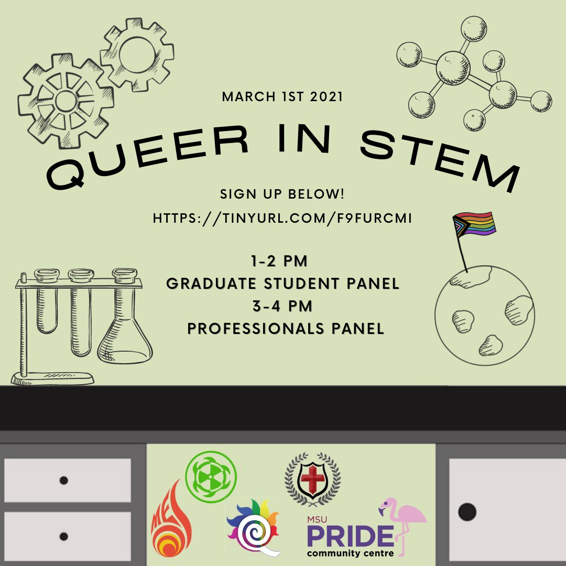

Resources:
Our 2STLGBQIA+ Handbook is at completion and was launched on March 8th. The handbook contains three sections including general terminology, pronouns and use of transgender inclusive language, as well as resources. We also have incorporated an appendix with detailed descriptions and information on gender-affirming procedures and surgeries.

The handbook can be accessed on our website as well as has been published on ISSUU: https://issuu.com/msu_mcmaster/docs/msu_pcc_handbook_2021

PCC Service Rebrand:
The PCC Service Rebrand is at completion and the new PCC logo was approved by Executive Board on March 4th, 2021.
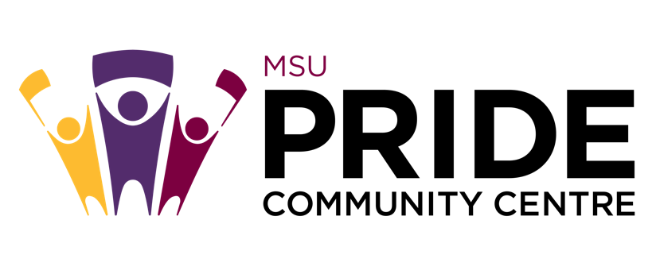
Upcoming Events, Projects & Activities:
We have been focusing much of our attention on our upcoming and final campaign week of the year, Transcendence 2021. We have also hired the new PCC Director and will begin the transition on March 18th into April.

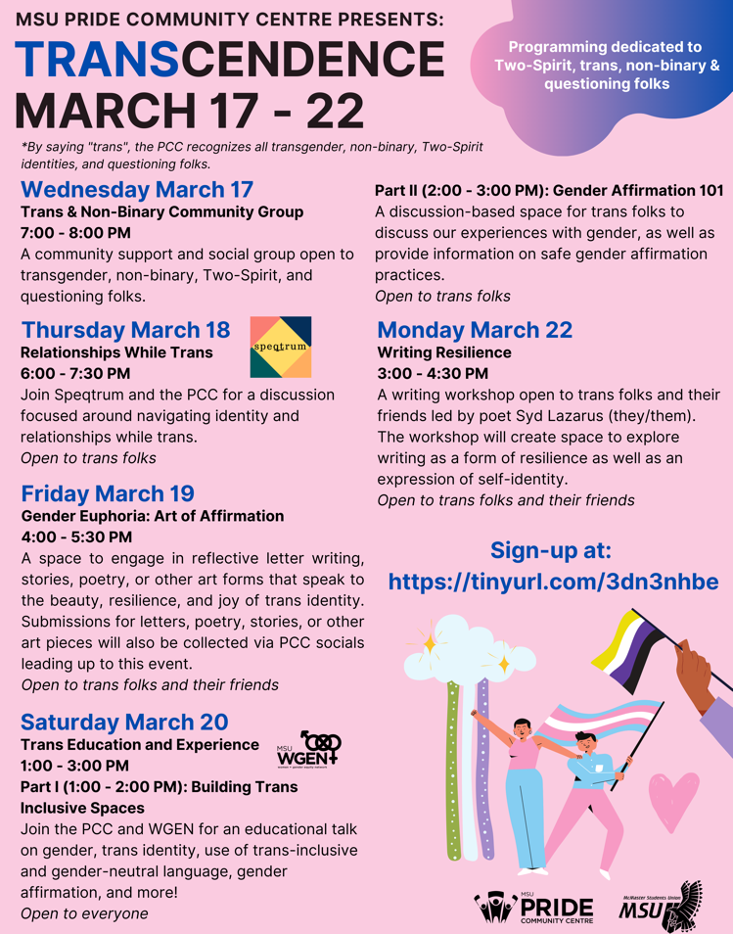
Transcendence:
Our final campaign week of the year which is dedicated to transgender, non-binary, Two-Spirit, and questioning folks. This campaign will be taking place March 17th-22nd and consists of a series of 5 different events all of which are summarized below.

- Trans & Non-Binary Community Group (open to trans folks)
A community support and social group open to transgender, non-binary, Two-Spirit, and questioning folks.

- Relationships While Trans (open to trans folks) – with Speqtrum
Join speqtrum and the PCC for a discussion focused around navigating identity and relationships while trans.

- Gender Euphoria: Art of Affirmation (open to trans folks and their friends)
A space to engage in reflective letter writing, stories, poetry or other art forms that speak to the beauty, resilience, and joy of trans identity. Submissions for letters, poetry, stories, or other art pieces will also be collected via PCC socials leading up until this event.

- Trans Education and Experience – with MSU WGEN

  - Building Trans Inclusive Spaces (open to everyone)
Join the PCC and WGEN for an educational talk on gender, trans identity, use of trans-inclusive and gender-neutral language, gender affirmation, and more!

  - Gender Affirmation 101 (open to trans folks)
A discussion-based space for trans folks to discuss our experiences with gender, as well as provide information on safe gender affirmation practices.

- Writing Resilience (open to trans folks and their friends)
A writing workshop open to transgender folks and their friends led by writer Syd Lazarus (they/them). The workshop will create space to explore writing as a form of resilience as well as an expression of self-identity.

Currently Working On:

Coming of Age: A queer & trans anthology
The PCC is collaborating with McMaster Unspoken to put together a poetry anthology. We will be collecting submissions until March 31st and compiling the anthology thereafter. Submissions will be compiled in the form of a booklet to be featured on PCC socials. We are also hoping to feature the anthology in our final “wrap-up” event of the year for PCC space users, as well as PCC execs and volunteers.

Budget:

ACCOUNT CODE | ITEM | BUDGET / COST
5003-0119
Office | TOTAL SPENT IN LINE | $0.00
 | REMAINING IN LINE | $100.00
5202-0119 | 1.) Disabled & Queer Community Art Circle  2.) Donation to Speqtrum Hamilton
Outreach | TOTAL SPENT IN LINE | $250.00
 | REMAINING IN LINE | $0.00
6102-0119 | 1.) Self-Care and Queer Resilience Event  2.) From Monocles to Manbuns: Drag Show  3.) Self-Love, Self-Touch: Trusting Your Body Again Through Dance  4.) We Will Get Through This: Positive Affirmations Through Art  5.) 2STLGBQIA+ Indigenous Sharing Circle  6.) Queer in STEM  7.) Writing Resilience
Campaigns | TOTAL SPENT IN LINE | $2475.00
 | REMAINING IN LINE | $525.00
6494-0119 | 1.) PCC Crewneck Shirts (48)
Volunteer | TOTAL SPENT IN LINE | $717.34
 | REMAINING IN LINE | $32.66
6501-0119 | 1.) Pride Myth Busters Campaign  2.) Pride Student Network Promo  3.) Community Engagement Group Promo  4.) 2STLGBQIA+ History Week Promo  5.) Queer History Trivia Starbucks Gift card  6.) 2STLGBQIA+ History Week Raffle Prize  7.) Mac Pride Week Promo  8.) Mac Pride Week Skip the Dishes  9.) 2STLGBQIA+ Handbook Launch Promo  10.) Transcendence Promo Boost
Promo | TOTAL SPENT IN LINE | $1345.00
 | REMAINING IN LINE | $355.00
6604-0119 | 1.) Pronoun Buttons
Resources | TOTAL SPENT IN LINE | $70.00
 | REMAINING IN LINE | $230.00
6804-0119 | 1.) Fully PrEP’d Workshop
Training | TOTAL SPENT IN LINE | $150.00
 | REMAINING IN LINE | $350.00
TOTALS
TOTAL BUDGETED DISCRETIONARY SPENDING |  |  | $6600.00
TOTAL ACTUAL DISCRETIONARY SPENDING |  |  | $5007.34
REMAINING DISCRETIONARY SPENDING |  |  | $1592.66

Volunteers:
We have been working on creating volunteer appreciation packages for each volunteer which will include a PCC Crewneck and pronoun button (designed courtesy of our lovely Events Coordinator, Stephanie). We are also hoping to hold a final volunteer social this upcoming month after our service closes on April 14th for the year.

A games night was held on March 6th with our Pride Student Network mentors and mentees.

Current Challenges:
Referred to Closed Session.

Successes:
Reflecting on the year, I am really happy and fulfilled to see what our team has done with the PCC and the way the service has grown. One of our largest successes was our Queer in STEM event, attracting the greatest amount of attendance and interest the PCC has seen in a while. Furthermore, over the course of the year, we have managed to engage in 12 different collaborations with student groups on campus as well as partners in Hamilton and the GTA. This is a success for us because we have always felt that the PCC, like many MSU services, is stuck within the bubble of the MSU and I think it is important to expand our reach beyond the MSU and McMaster University.

I am very optimistic for the future of the PCC and have much faith that Stephanie, our next Director will continue to take the PCC to new heights!

