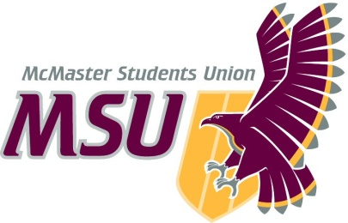. | MEMO  From the offices of the…  Vice-President (Education)
TO: | SRA Members and Committee Chairs
FROM: | Ryan Tse, Vice-President (Education)
SUBJECT: | Operating Policy – Education & Advocacy Department  and  Bylaw 8 – Policy Approval Process
DATE: | March 21st 2021 – SRA 20Q

Dear Members of the Assembly,

Over the last year, our three Advocacy & Policy Research Assistants have worked with the three policy author teams to develop and/or revise three Advocacy Policies: Mental Health; University Accessibility; and Ancillary Fees. I have placed a large emphasis on consultation this year, and the Research Assistants have done a great job of reaching out to different student groups and campus partners.

Sections 10.1.2.2 of the OP – Education Advocacy Department and 10.1.2.2. of Bylaw8 – Policy Approval Process state that the deadline for presenting policies written in the Winter academic term to the SRA is the meeting penultimate to the conclusion of the SRA’s term. This year, that deadline was SRA 20P on March 7th. However, mainly due to the extenuating circumstance of the COVID-19 pandemic and the difficulties of coordinating consultations and policy development online over the whole year, the policy teams had not fully completed the final round of consultation for the policy papers by the SRA 20P agenda deadline. The last phase of consultation is critical: during this time, we collect feedback from the general student population and incorporate any suggestions that come out of Policy Conference (held virtually this year). At the time of last meeting, I felt it was extremely important to complete this final consultation phase to the fullest extent possible before presenting the policies. Because of this, the Education & Advocacy Department did not present the policies at SRA 20P. As the leader of the team, I take full responsibility for the failure to meet this deadline. However, the policies will be ready for presentation to the SRA for SRA 20Q on March 21st. As such, I am requesting that the Assembly vote to suspend Sections 10.1.2.2 in OP – Education & Advocacy Department and Bylaw 8 10.1.2.2. to allow the Education & Advocacy Department to present the three Advocacy Policies at the final meeting of the SRA’s term, i.e., SRA 20Q.

Section | Current | Proposed | Explanation
10.1.2.2 | States deadline of penultimate meeting to the SRA’s term for presenting Advocacy Policies to SRA. | Suspend for 2021 Winter | Due to extenuating circumstances and consultation difficulties associated with the COVID-19 pandemic

Please reach out if you have any questions.

Sincerely,

Ryan
Tse
vped@msu.mcmaster.ca

