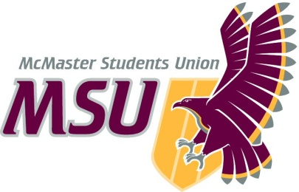
Memo
From the office of…
Vice-President (Administration)
To: Members of the Student Representative Assembly (SRA)
From: Graeme Noble, Vice-President (Administration)
Subject: Amend Bylaw 8 – Policy Approval Process
Date: February 26, 2021

Rather ironically, it seems that the changes to this policy have slipped through the cracks that the process was intended to fill. As such, there is a need to make a modification to remove an incomplete clause in the policy that currently holds no meaning.

Please let me know if you have any questions or concerns prior to the meeting.

Kind regards,

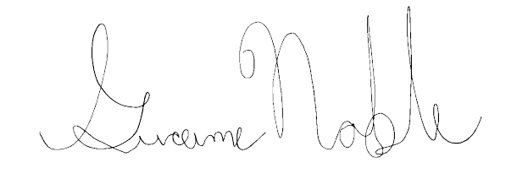
Graeme Noble
Vice-President (Administration) & Chief Administrative Officer
McMaster Students Union
vpadmin@msu.mcmaster.ca

