Yearplan Update
. 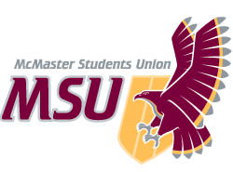 | REPORT  From the office of the…  Maroons Coordinator
TO: | Members of the Executive Board
FROM: | Hemantika Mahesh
SUBJECT: | Maroons Report 7
DATE: | March 15, 2021

- Wellness Week:
  - It was a success! We had trivia night, hot cocao and chill, and virtual workouts planned for the week
- Team Bonding
  - We did another team bonding event this month right before wellness week just to get the team together again
  - I was very happy that we had a large turn-out and the team was engaged and enthusiastic
- Outreach event
  - In support of black-owned businesses we are planning on doing a splot-light on our Instagram page of these black-owned businesses alongside a give-away!
  - We are thinking of working with Chesco Box, which is a company that works with local BIPOC businesses to create gift-boxes
  - We also want create posts about the specific businesses that will be in the gift-box

Service Usage
Over the Winter break, there has been a lack of posts on our social media platforms. However, with the upcoming events and programming, there will be a lot of activity on our online platforms

Platform | Stats
Facebook | 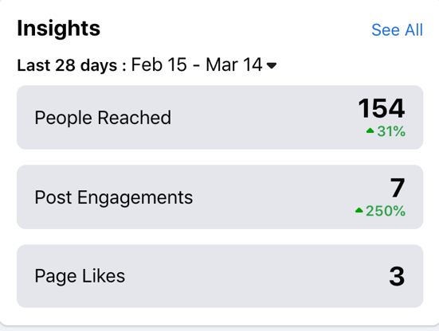
Instagram | 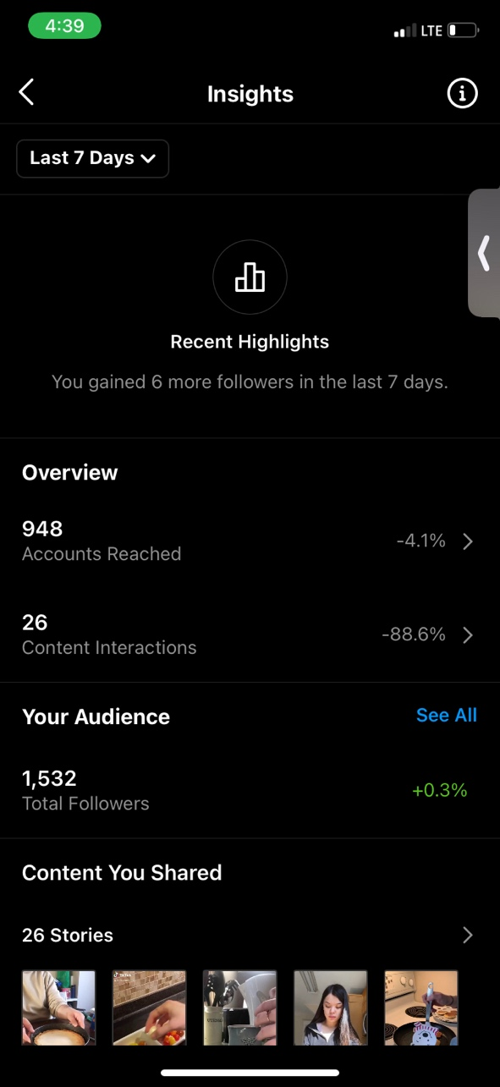

Past Events, Projects, & Activities
The new PTM is slowly transitioning into their role and getting familiar with a few of the PTM responsibilities. Furthermore,

Wellness week went well! We did not have high registration numbers, but all the events ran smoothly and we were happy to collaborate with Spark, FYC, Campus Events, Macademics, and Mac Moves.

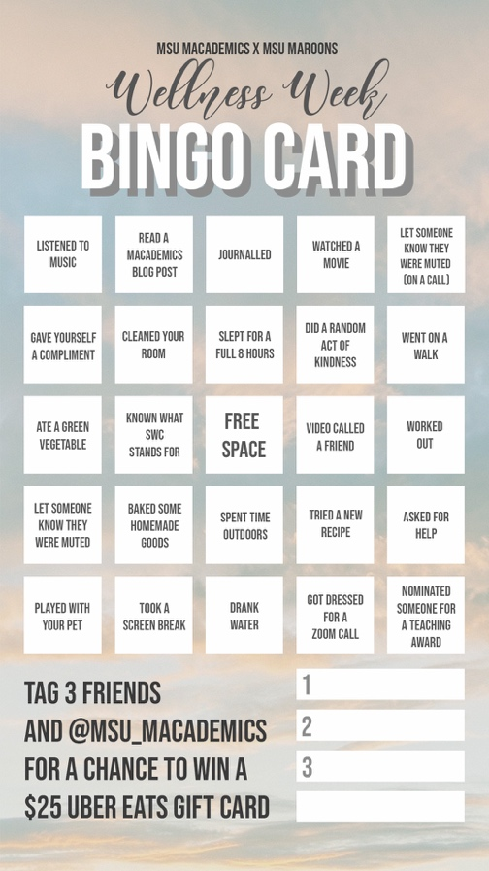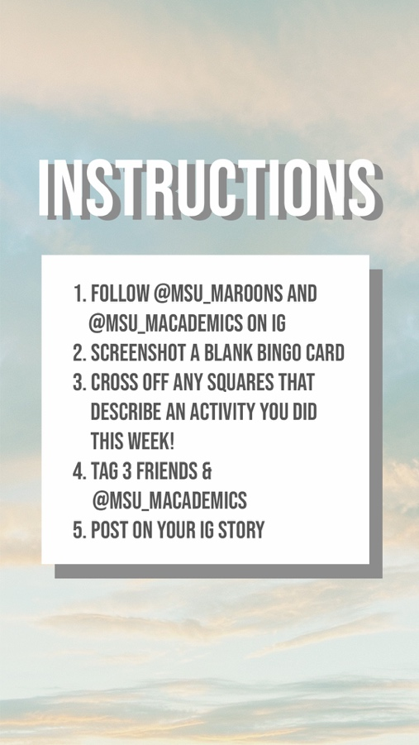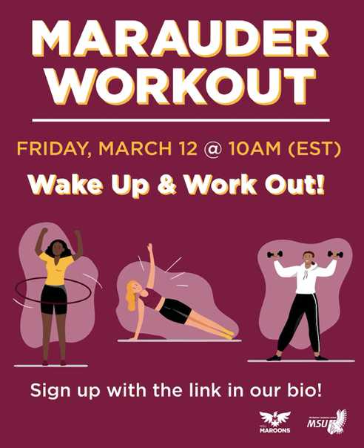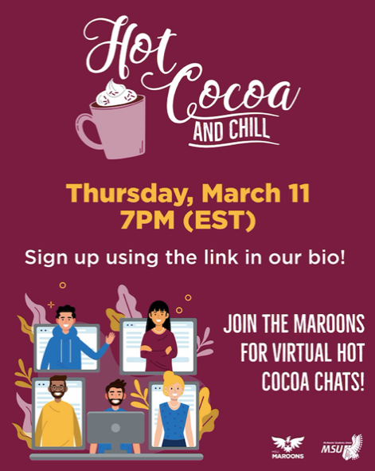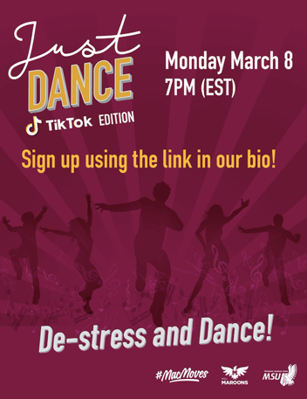
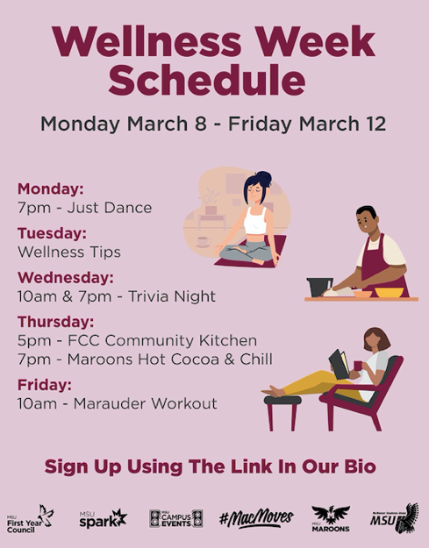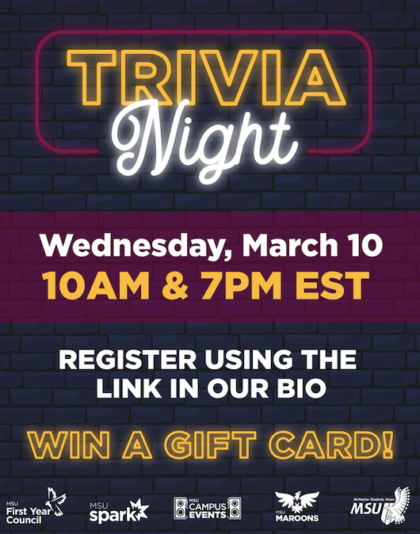

Upcoming Events, Projects & Activities

Transition and Hiring of the Leadership team (LT)
- We are currently in the process of starting the hiring for the new LT team. I am working with the incoming PTM and the VP admin to get this process started, revising and confirming job descriptions,
- We are still hoping to review our hiring process for general reps to ensure our hiring protocols are as equitable as possible

Currently Working On
- We are finishing up organizing the jerseys and t-shirts and hoping to drop them off at the MSU office by the end of next week
- I am hoping to finalize out volunteer appreciation set in the next couple weeks, the team is thinking of e-gift cards or lanyards!

Budget
ACCOUNT CODE | ITEM | BUDGET / COST
5003-0120 | MAROONS - OFFICE SUPPLIES | $50.00
 | TOTAL SPENT IN LINE | $0.00
 | REMAINING IN LINE | $50.00
6102-0120 | MAROONS - ANNUAL CAMPAIGNS | $450.00
 | TOTAL SPENT IN LINE | $0.00
 | REMAINING IN LINE | $450.00
6415-0120 | MAROONS - VOLUNTEER APPRICIATION | $750.00
 | TOTAL SPENT IN LINE | $0.00
 | REMAINING IN LINE | $750.00
6501-0120 | MAROONS - ADVERTISING & PROMOTIONS | $1,000.00
 | TOTAL SPENT IN LINE | $0.00
 | REMAINING IN LINE | $1,000.00
6603-0120 | MAROONS - SPECIAL PROJECTS | $750.00
 | Uber Eats Gift Card | $50.00
 | Burnt Tongue Gift Card | $25.00
 | Trivia Night gift cards | $200.00
 | TOTAL SPENT IN LINE | $75.00
 | REMAINING IN LINE | $475.00
6633-0120 | MAROONS - UNIFORMS | $7,000.00
 | Westend Sports | $1,600.00
 | TOTAL SPENT IN LINE | $1,600.00
 | REMAINING IN LINE | $5,400.00
6804-0120 | MAROONS - MEMBER TRAINING | $500.00
 | SACHA | $450.00
 | TOTAL SPENT IN LINE | $450.00
 | REMAINING IN LINE | $50.00
TOTAL BUDGETED DISCRETIONARY SPENDING | $10,500.00
TOTAL ACTUAL DISCRETIONARY SPENDING | $2,325.00
REMAINING DISCRETIONARY SPENDING | $8,175.00

Volunteers
We had a lot of volunteers sign-up for our wellness week events which was great! The team finished up all the events with lots of energy and enthusiasm. I am thinking of doing virtual shout-outs where the team can submit shout-outs on a google form (anonymous or with their names) and at the end of the year each rep will receive shout-outs from the team. It is a tradition we usually do during welcome week, but I think it will be more effective now as the reps have gotten enough time to get to know each other.

Current Challenges
My biggest challenge right now is honestly balancing PTM duties with school. I personally am struggling because I feel like a lot of school and MSU deadlines are all within the same week and so I am trying my best to keep myself on top of the work and not fall behind.

Successes
I think it has been a successful year thus far! I am happy with the energy and effort the team is bringing to our events. Our Wellness week, though it did not have high registration numbers, went smoothly and had a lot of positive feedback!

