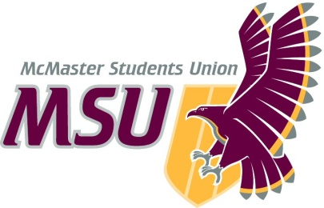
Year-End Report
From the office of…
MSU Maccess
To: Members of the Executive Board (EB)
From: Calvin Prowse, Maccess Coordinator
Subject: Service Year-End Report
Date: March 23, 2021

Table of Contents
Table of Contents 1
Report Summary 3
General Information 3
Year Plan Update 4
Events, Projects, & Activities 6
General Service Usage 6
Events 7
Crip Camp Movie Night: Screening & Discussion: 7
Mad Pride Tea Party: 8
Disability DIScussions: Remote Access/ibility: 8
Consent & Creativity: 9
Pet & Plant Appreciation Event 9
Disability DIScussions: Remote Access/ibility: 10
Disabled & Queer Community Art Circle: 11
Maccess Zine Art Event: 11
Maccess Winter Chill: 12
Making Space: Envisioning Disabled Queer Community: 13
Disability Pride Week: 13
Projects 15
Maccess Mondays: Art as Activism: 15
Skill Sharing Workshops: 15
Outreach & Promotions 16
Summary 16
Promotional Materials 16
Social Media Engagement 19
Finances 19
Budget Summary 19
Personnel 22
Executive 22
Volunteers 23
General 23
Miscellaneous 24

Report Summary

General Information

Unfortunately due to the COVID-19 pandemic and consequent transition of McMaster University to remote learning, Maccess had to transition online as well. We have had to make some adjustments to how we have run our programming this year, most notably the creation of a “Digital Drop-in Space”, run through Discord.

Additionally, as the Maccess Year Plan was created prior to knowing that McMaster would be online, we have largely not been able to follow the structure outlined in our year plan.

This year, we were able to hire a larger team of volunteers than previous years, with 8 executive volunteers and 45 peer support volunteers (total volunteers: 53). In previous years, we have typically had between 20 and 30 peer support volunteers. This larger team has allowed for increased flexibility in regards to volunteer shifts, allowing volunteers to take reduced hours or time off as needed. Additionally, it has allowed us to extend our drop-in space hours – this year, our drop-in space has been open 11:30am – 6:30pm Monday through Friday, whereas in previous years our hours have been 11:30am – 4:30pm.

Year Plan Update
Humans of Maccess
Unfortunately we were unable to complete our “Humans of Maccess” testimonial campaign, due to low engagement with the service over the summer and as a result of the pandemic.

Disability DIScussions
Although typically Maccess runs several Disability DIScussion events in collaboration with EIO on a variety of topics, this year we have only had the capacity to run the sessions on Remote Access/ibility.

“Remote Access” campaign
We were also unable to run our “Remote Access” info campaign due to lack of capacity.

Drop-in & Community Group Launch
Although we had planned to open the drop-in space and launch community groups in October, we were unable to open our drop-in space until November, and community groups were not launched until January.

DisVisibility Week
We were also unable to run our DisVisibility Week. Originally , we had intended to run both a DisVisibility Week, and a Disability Pride Week – as the year progressed we realized we would not have the capacity to run both, and so decided to run our Disability Pride Week Instead.

Disability Language Campaign
We were also unable to run our disability language campaign due to lack of capacity.

Exam Destress Dance Party
Unfortunately we were also unable to run this event due to lack of capacity.

Volunteer Appreciation Event
Unfortunately we have been unable to run a volunteer appreciation event this year, due to lack of capacity.

Maccess s CATS
Unfortunately we were unable to run this event online, as it involved visiting the Campus Accessible Tech Space.

Rare Diseases Day
Unfortunately we were also unable to run this event due to lack of capacity.

Accessibility Forum
Unfortunately we were also unable to run this event due to lack of capacity.

Exam Destress
Unfortunately we were also unable to run this event due to lack of capacity.

Disability Studies Conference
Unfortunately we were also unable to run this event due to lack of capacity. I do not believe that the Reclaiming our Bodies & Minds conference ran this year due to COVID-19.

Events, Projects, & Activities

General Service Usage

Our digital drop-in space is run through Discord, and is open from 11:30am – 6:30pm Monday through Friday. Our drop-in space opened for the year on January 18. We have had an average of 16 people each day visit our drop-in space, with 7 one-on-one peer support requests throughout the year.

We also opened our drop-in space on select days over the winter break:
- Dec. 17, 1pm – 3pm (6 attendees)
- Dec 25, 1pm – 3pm (8 attendees)
- Dec 31, 10pm – 12:30am (14 attendees)

Here is the attendance rates for the community groups we ran over the summer:

Group | Average Attendees/Wk | Collaboration
Coping in Isolation | 2.2
Disabled Queer & Trans | 0.9 | PCC

Here are the number of attendees we had at our community groups, over second term:
Group | Average Attendees/Wk | Collaboration
Disabled Queer & Trans | 2.4 | PCC
Anxiety | 1.2
Disability in Colour | 0 | WGEN & Diversity Services
Dating & Disability | 2.7
ASD (Autism Spectrum) | 0.4
Depression & Mood | 1

Events

Crip Camp Movie Night: Screening & Discussion:
Project Status: Complete
General Information:
On May 15, we held a screening of the movie “Crip Camp: A Disability Revolution,” followed by a guided discussion, in collaboration with the Disability Justice Network of Ontario. The movie was screening using “Teleparty” (formerly Netflix Party), to allow for synchronized playback, and a live discussion chat during the movie. The discussion was hosted through Zoom.

We had 5 attendees for the movie screening, and 4 attendees for the discussion session.

Challenges:
Unfortunately technology always leads to issues. Since Teleparty does not allow for links to be created in advance, we had to wait until the event was starting to send people the link to join the screening. Unfortunately, I also had computer issues shortly after, so we had to re-create a whole new link and send it along – causing some delays and confusion!

Successes:
It was a great opportunity for folks to connect with one another during a difficult and isolating summer. Also great to keep building our relationship between disability community on campus, and within the broader Hamilton area!

Mad Pride Tea Party:
Project Status: Complete
General Information:
On July 18, we hosted a Mad Pride Tea Party in celebration of Mad Pride Day. This was an informal discussion, closed to students who experience madness, mental illness, mental health concerns, or neurodiversity, focusing on topics related to mental health and madness.

We had 6 attendees.

Challenges:
The topic (and language) can be controversial – many people do not resonate with the language of madness, and have valid reasons for not liking that language for themselves! In order to acknowledge this and develop conversation around it, we included discussion questions that specifically asked for folks to share the reasons why they use some terms over others to describe themselves.

Successes:
Although we had discussion questions prepared in advance, we rarely had to use them – conversation was flowing!

Disability DIScussions: Remote Access/ibility:
Project Status: Complete
General Information:
July 27: In collaboration with EIO, we developed and facilitated a focus group conversation for students with disabilities, to share their experiences and concerns with remote learning. Although many issues were raised with the transition to remote learning, some students also identified increased accessibility as a result of this change.

This event was run to give students a chance to share their experiences and concerns, but also to develop a report detailing issues that students are facing, so these can be passed along to the administration and addressed.

We had 16 attendees.

Challenges:
One of the challenges we faced was building interest in this event, when most students were not currently in classes – and had other things on their mind (COVID-19 being one of them)! That said, we still had a really great attendance – speaking to the importance of an event like this!

Successes:
Students seemed to really appreciate having a space to discuss these concerns, and knowing that their feedback was going to be passed on to the administration – hopefully leading to increased accessibility and disability inclusion within remote learning. This was one of our most well attended events!

Consent & Creativity:
Project Status: Complete
General Information:
Sept 3: In collaboration with the other peer support services, SVPRO came to deliver a presentation on topics related to consent, for Welcome Week. It was an interactive workshop, where students were shown how to create their own “zine” on the topic of consent.

We had 6 attendees.

Challenges:
This event was thrown together rather quickly, due to peer support service PTMs recognizing significant gap in Welcome Week programming. We had originally invited SACHA to run this event, however only a few days before were informed that the McMaster SVPRO office would be running the event instead. This last minute change, and the fact we did not get approval for the event until a week prior, made it difficult to advertise the event or implement other accessibility considerations (we had originally aimed to have ASL Interpretation provided, which unfortunately was not possible as they require 2 weeks notice).

Successes:
It was great and important content, delivered in a fun and engaging way – and an event on Consent was desperately needed for Welcome Week!

Pet & Plant Appreciation Event
Project Status: Complete
General Information:
On Nov. 12, we ran a Pet & Plant Appreciation Event – allowing for casual conversation, showing off your pets/plants, or just joining to look at other peoples’ pets/plants!

We had 4 attendees, and 5 exec team members join.

Challenges:
This was the first event we ran during first semester, and students may not have known we were running yet. We used MS Teams for this event, which unfortunately due to how it prioritizes some people’s videos over others – was a little disorienting, and felt more like a meeting than a community event.

Successes:
A fun and light way to kick off the year!

Disability DIScussions: Remote Access/ibility:
Project Status: Complete
General Information:
In collaboration with EIO, we developed and facilitated a focus group conversation for students with disabilities, to share their experiences and concerns with remote learning. Although many issues were raised with the transition to remote learning, some students also identified increased accessibility as a result of this change.

This event was run to give students a chance to share their experiences and concerns, but also to develop a report detailing issues that students are facing, so these can be passed along to the administration and addressed.

We first ran this event in the summer, and decided to run it again during first semester – to give students an opportunity to have their concerns heard who may have missed the summer session, and to see if any changes had occurred.

We offered this session on two dates. On Nov 16, we had 3 attendees (and 5 facilitators). On Nov. 19, we have 4 attendees (and 5 facilitators)

Challenges:
One of the challenges we faced was building interest in this event, as many students were already feeling burnt out from first semester.

Successes:
Students seemed to really appreciate having a space to discuss these concerns, and knowing that their feedback was going to be passed on to the administration – hopefully leading to increased accessibility and disability inclusion within remote learning.

Disabled & Queer Community Art Circle:
Project Status: Complete
General Information:
In collaboration with the PCC for their Pride History Week, we ran a facilitated art workshop on Nov. 18, closed to students who identified as both 2STLGBQIA+ and disabled.

We had 4 attendees, in addition to our 2 paid facilitators and 3 representatives from both Maccess & PCC.

Challenges:
None to note.

Successes:
This was a lovely and intimate event! Students really appreciated the opportunity to take time away from their studies, and do something fun, all while building community with one another.

Maccess Zine Art Event:
Project Status: Complete
General Information:
On Dec. 10, we held an art workshop, with the intention of building interest and gaining submissions for a Maccess-created zine.

We had two attendees, in addition to one Maccess exec who was facilitating.

Challenges:
This event was difficult to raise interest in, as it was organized last minute and took place after the last day of classes.

Our original intention was to ask attendees to submit to our Maccess Zine – unfortunately, we decided not to continue with the Maccess zine as a result of low engagement, and a similar disability zine project being launched by MacPherson.

Successes:
Was lovely to have some time away from school to do something fun and creative!

Maccess Winter Chill:
Project Status: Complete
General Information:
On Dec 28, we hosted a “Winter Chill” event, allowing for casual conversation and community connection over the winter break.

We had 6 attendees.

Challenges:
It was definitely a challenge to promote an event being held over the winter break – but despite this, we still had several people attend!

Successes:
Students often feel isolated over the winter break; with COVID-19, this has meant people are more isolated than ever. Students may be living in unsupportive environments, be cut of from their friends and social support system, or may not be able to spend the holidays with their families. This event gave students an opportunity for connection and community over a difficult and isolating winter break.

Making Space: Envisioning Disabled Queer Community:
Project Status:
General Information:
In collaboration with the PCC for their Mac Pride Week, on Feb. 8 we ran an event closed to students who identify as both disabled and 2STLGBQIA+, to discuss how we can make queer and disabled communities more inclusive, intersectional, and accessible. Following this, we had community building and Jackbox games.

Challenges:
Unfortunately we were not able to collaborate with the PCC as much as we may have liked. Maccess attended the session and helped facilitate, but wasn’t engaged in the coordination and development process due to lack of time.

Successes:
The conversations were lively, passionate, and lovely! Folks really connected during the session, and also enjoyed the Jackbox games!

Disability Pride Week:
Project Status:
General Information:
Maccess launched our very first Disability Pride Week, during the week of March 22 – 26.

This week included the following events:
- Joy & Tell: a closed discussion for racialized disabled students to share their latest joy, big or small. Co-hosted by WGEN & Diversity Services.
- Disability Moves!: An accessible movement class facilitated by GoodBodyFeel.
- Disabled People Fuck: A presentation on sex & disability. Co-hosted by SHEC.
- Dating & Disability Group Discussion: A discussion session on the topic of sex & disability, closed to disabled students.
- In Conversation with Nina Tame: An interview with UK-based disability rights activist Nina Tame.
- ODSP Workshop: A workshop and Q&A on applying to ODSP, open to disabled students.
- Mad Pride Party: A casual discussion and hangout for students who identify as mad, mentally ill, or neurodiverse.
- Maccess Alumni Mixer: A meet & greet with former disabled students at McMaster.
- Disabled & Queer Community Art Circle: An art workshop for students who identify as both disabled and 2STLGBQIA+. Co-hosted by the PCC.
- “Crip Camp” Screening: A live screening of the film Crip Camp: A Disability Revolution
- “Crip Camp” Discussion: A discussion about the film, closed to students with disabilities.

Unfortunately I cannot report on the attendance of these sessions, as, at time of writing, these events have not happened yet.

Challenges:
It has been challenging pulling together a campaign week this close to the end of the year, and we worry that student burn out may result in lower turnout.

Successes:
We’re really happy with the event line up, and are so excited for these events to happen! We’re also really happy to be bringing McMaster a “Disability Pride Week” – a much needed perspective, with the intent of challenging dominant perspectives of disability as tragedy.

Projects

Maccess Mondays: Art as Activism:
Project Status: Complete
General Information:
Starting in February, we would post a series of Instagram stories every Monday highlighting a disabled artist. The goal of this was to highlight the ways in which disabled identity is often erased or ignored in dominant culture, and also to connect with the idea of Disability Pride – recognizing and demonstrating the amazing things that disabled folks have done in the realm of arts and culture!

Challenges:
The stories are only included on our Instagram page, leading to folks who are not connected with us there to miss the content.

Successes:
This campaign has been really appreciated by community members!

Skill Sharing Workshops:
Project Status: Ongoing
General Information:
We developed a framework to have disability community members sign up to facilitate an interactive workshop, where they could share a skill with their peers and be compensated for their efforts, with the support of the Maccess team for logistics, promotions, etc. One reason for this was to allow community members to have a greater influence on the programming we run.

Challenges:
Unfortunately we did not have the capacity to fully implement this by the end of the year. That said, it would be great to see this project carry over into future years!

Successes:
The ideas has been well received, and is a great way to encourage community member co-development of Maccess programming!

Outreach & Promotions

Summary
General Information:
We have promoted events through our social media channels, in addition to a variety of mailing lists.

Challenges:
It has been difficult getting full engagement, due to student burnout. It has also been difficult to reach students, due to all services promoting their events through social media.

Successes:
We’ve managed to reach students that were not connected to Maccess in the past – it’s great that new people are hearing about us, and deciding to join our programming!

Promotional Materials
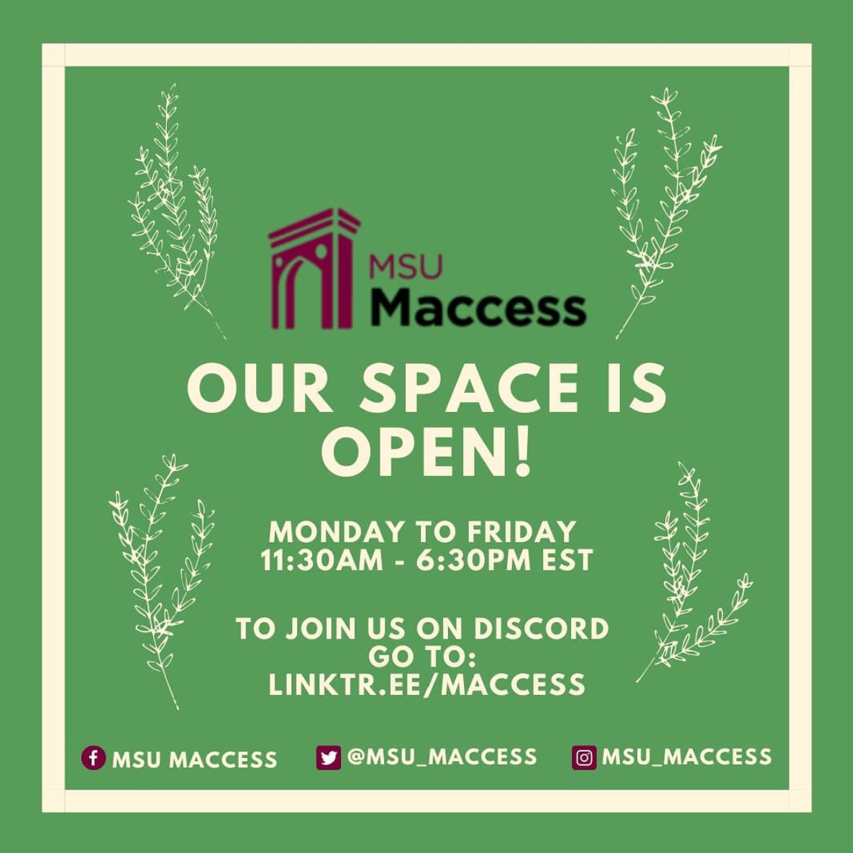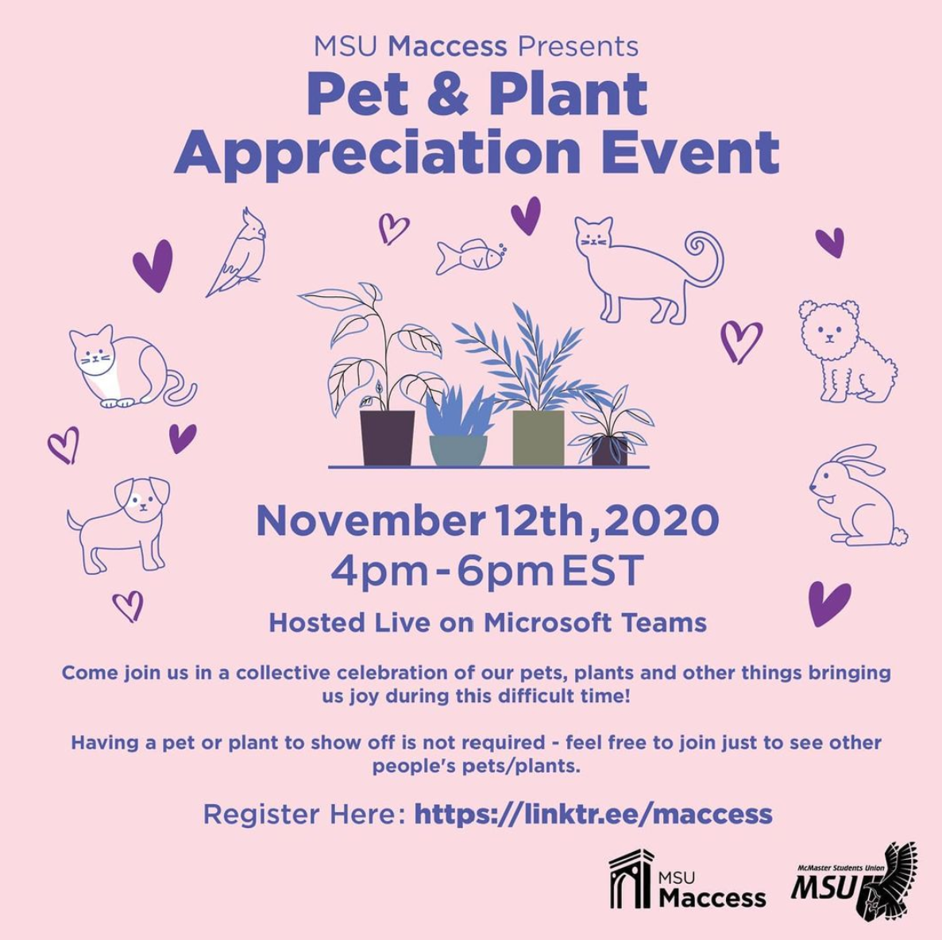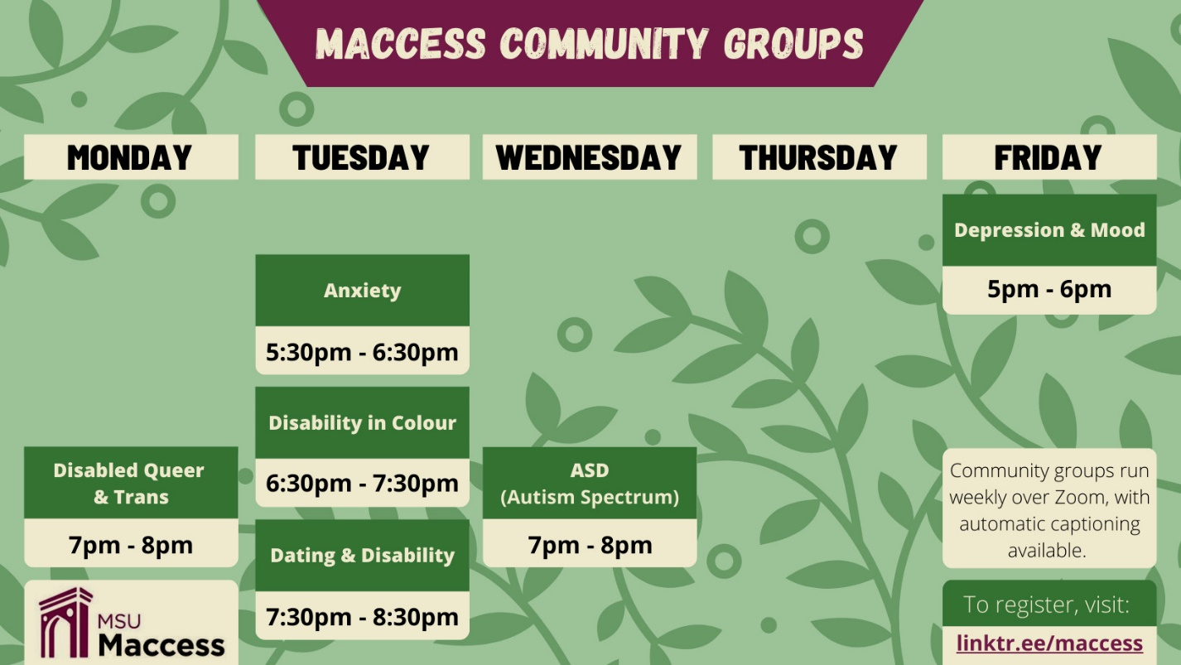

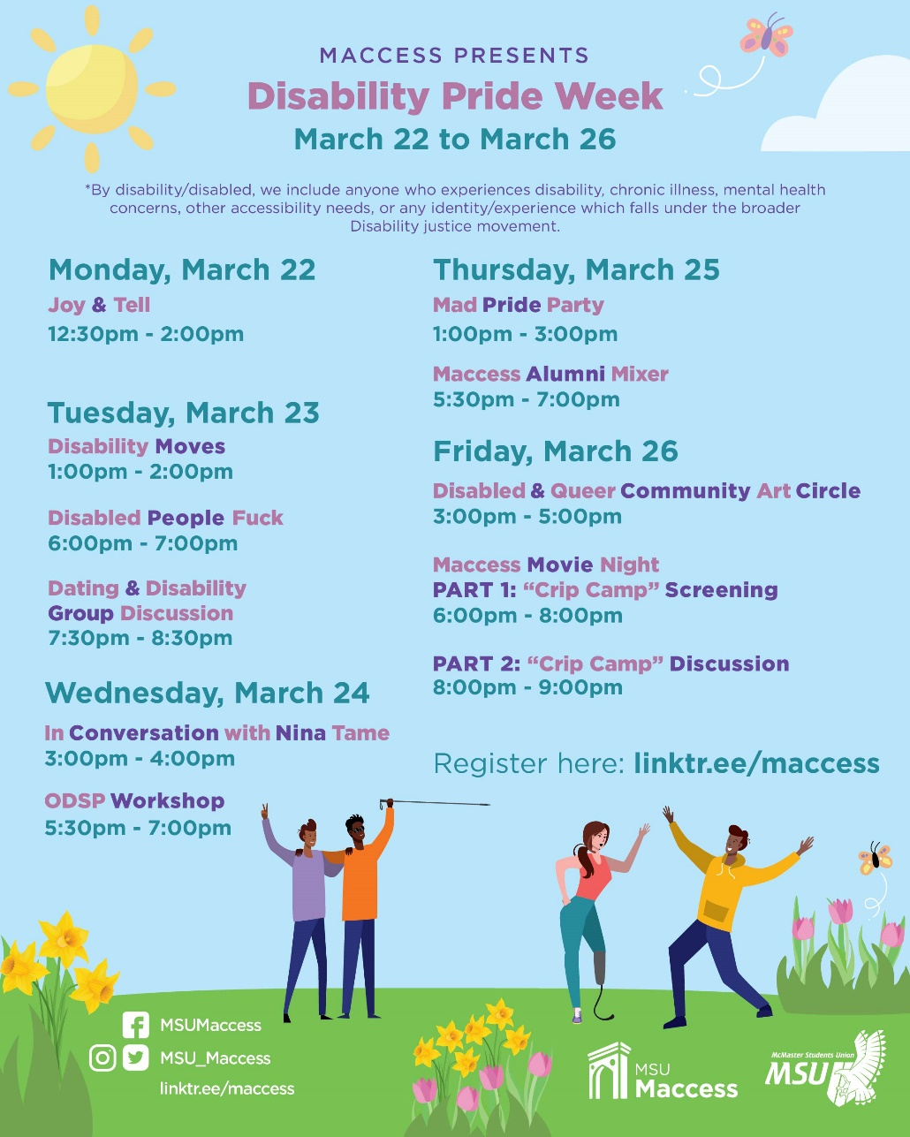

Social Media Engagement

Instagram followers: 610
Facebook followers: 965
Twitter followers: 307

Finances
General Information:
It has been difficult to use our budget this year as a result of the COVID-19 pandemic, delayed start of the service, and the lack of in-person events which associated costs (snacks, etc).

Challenges:

Successes:

Budget Summary
Table 4: Budget Tracker

MACCESS
EXPENDITURE
ACCOUNT CODE | ITEM | BUDGET / COST | PO SUBMITTED (DATE) | PO APPROVED
5003-0118 | MACCESS - OFFICE SUPPLIES | $100.00
 | TOTAL SPENT IN LINE | $0.00
 | REMAINING IN LINE | $100.00
6102-0118 | MACCESS - ANNUAL CAMPAIGNS | $2,800.00
 | Art workshop Collaboration with PCC for 2STLGBQIA+ History Week | $200.00 | 03-Nov-20 | 04-Nov
 | DISABILITY PRIDE WEEK
 | 03/23 Disability Moves! Facilitated by GoodBodyFeel | $200.00 | 20-Mar | 21-Mar
 | 03/23 Disabled People Fuck - presentation by Megan Linton | $500.00 | 20-Mar | 21-Mar
 | 03/24 In Conversation with Nina Tame | $502.99 | 20-Mar | 22-Mar
 | 03/24 ODSP Workshop - Facilitated by Sophie Geffros | $500.00 | 20-Mar | 21-Mar
 | 03/26 Disabled & Queer Community Art Circle - facilitated by Kate Welsh | $500.00 | 20-Mar | 21-Mar
 | ASL Interpretation - Nahed Dajjani | $150.00 | 20-Mar | 21-Mar
 | ASL Interpretation - Emily Rayner | $150.00 | 22-Mar
 | Promo Boost on Facebook & Instagram | $40.00 | 22-Mar
 | TOTAL SPENT IN LINE | $2,742.99
 | REMAINING IN LINE | $57.01
6494-0118 | MACCESS - VOLUNTEER RECOGNITION | $750.00
 | The Jackbox Party Quintpack | $62.28 | 29-Dec | 04-Jan
 | TOTAL SPENT IN LINE | $62.28
 | REMAINING IN LINE | $687.72
6804-0118 | MACCESS - TRAINING EXPENSE | $500.00
 | TOTAL SPENT IN LINE | $0.00
 | REMAINING IN LINE | $500.00
6501-0118 | MACCESS - ADVERTISING & PROMO | $1,700.00
 | Executive Team Hiring Promo | $75.00 | 10-Jun
 | Peer Support Volunteer Hiring Promo | $75.00 | 12-Aug
 | Pet & Plant Appreciation Event | $150.00 | 04-Nov
 | Disability Pride Week Promo | $275.00 | 10-Mar
 | TOTAL SPENT IN LINE | $575.00
 | REMAINING IN LINE | $1,125.00
6603-0118 | MACCESS - SPECIAL PROJECTS | $750.00
 | TOTAL SPENT IN LINE | $0.00
 | REMAINING IN LINE | $750.00
TOTALS
TOTAL BUDGETED DISCRETIONARY SPENDING |  | $6,600.00
TOTAL ACTUAL DISCRETIONARY SPENDING |  | $3,380.27
REMAINING DISCRETIONARY SPENDING |  | $3,219.73

These numbers are accurate as of March 23, 2021. However, it is worth noting that there are several budget items which have not been purchased (ex, materials for our lending library).

Personnel

Executive
Challenges:
This year we have had 8 executive team members, including:
- 1 Promotions Executive
- 1 Community Outreach Coordinator
- 1 Resources Executive
- 1 Logistics Executive
- 2 Social & Political Advocacy Executives
- 2 Training & Volunteer Coordinators

It has been challenging to find times to meet this year due to a larger than normal exec team. Additionally, our team has also been impacted by the COVID-19 pandemic and the transition to remote learning, so many of us have been experiencing increased time and challenges with school, limiting our capacity.

Successes:
I have been so glad and honoured to have such a fantastic, passionate exec team this year

Volunteers
Challenges:
It has been difficult to stay connected with the day-to-day operations of the space this year, due to a larger team of Peer Support Volunteers (45), and the online context which has made it difficult to spend significant amount of times in the drop-in space.

Successes:
We have had a larger team than normal, with 45 Peer Support Volunteers. This has allowed us to open the space for more hours than previous years – this year, our drop-in space was open from 11:30am – 6:30pm Monday through Friday, whereas in previous years our hours have been 11:30am – 4:30pm. Additionally, it has allowed opportunity for volunteers to take time off as needed.

General
Challenges:

Successes:

Miscellaneous

