Report

From the office of the…

Associate Vice-President (Services)

To: Members of the Executive Board

From: Martino Salciccioli, Associate Vice-President (Services) Graeme Noble, Vice-President (Administration)

Subject: EFRT Service Review, Final Report & Recommendations

Date: March 11, 2021

**Introduction**

Dear Members of the Executive Board,

The following report is a review of the McMaster Students Union (MSU) Emergency First Response Team (EFRT) service conducted by the Associate Vice-President (Services). This report will critically examine EFRT by looking at the service’s mission, history, structure, and engagement. The report also takes a look at similar initiatives within the McMaster community and at other post-secondary institutions to compare and contrast EFRT to provide context for its evaluation. After displaying all the aforementioned information, the report is concluded with recommendations made by myself, the committee, and the Vice-President (Administration).

**Service Overview**

***Mandate and History***

EFRT is an emergency first response service primarily supervised by the MSU, with shared oversight by McMaster University through the EFRT Advisory Council. As stated in **Operating Policy – MSU Emergency First Response Team (EFRT)**, the purpose of this service is:

*“To provide basic life support and first aid care, free of charge to the McMaster community. (1.1)”*

To achieve its purpose, EFRT is responsible for upholding and maintaining the following Operating Parameters:

*(Note: The following Operating Parameters do not depict all parameters listed.)*

*“The EFRT shall:*

*Provide basic first-aid assistance and basic life support (CPR) 24-hour 7 days per week service beginning on the first day of Welcome Week and ending on the final day of exams, with [some exceptions]; (2.1)*

*Provide basic first-aid assistance and basic life support (CPR) from 9:00 a.m. to 5:00 p.m. from Monday to Friday beginning on the day following Residence move-out and ending the day before the start of Welcome Week with [some exceptions]; (2.3)*

*Operate out of the EFRT office located in the McMaster Student University Centre (MUSC) as well as respond to calls to the EFRT Response Line (905) 522-4135, the McMaster phone extension "88" or Emergency buttons on campus telephones; (2.5)*

*Update the emergency health services that they provide by performing monthly training and individually completing continued medical education; (2.6)*

*Remain a confidential service with limited access to information to executive members and the Medical Director for quality assurance purposes; (2.7)*

*Any information disclosed to the team shall not be identifiable and purely for educational purposes; (2.7.1)*

*No patient information shall be discussed outside of the team. (2.7.2)*

*Assist McMaster Security Services in arranging transportation for patients to appropriate medical facilities; (2.8)  
Create public awareness about the emergency services available to the McMaster community; (2.9)  
Provide First Responders with the opportunity to further develop their first-aid skills. (2.10)”*

EFRT has done incredible work for the McMaster community. While this year has significantly impacted the regular delivery of this service, we have seen excellent strides from EFRT in the past when assisting with emergency calls and participating in campus events during the year. Based on the work EFRT has done in the past and their attempts to continue amidst a pandemic, it is evident that the service upholds its purpose through the operating parameters listed in **Operating Policy – EFRT**.

***Service Structure***

The service consists of a group of approximately 30 student volunteers and a group of 6 volunteer executives who provide this emergency medical services to the McMaster campus with an average response time of 2–3 minutes. All EFRT volunteers are certified Emergency Medical Responders, while some members are also trained in International Trauma Life Support (ITLS) and Advanced Medical Life Support (AMLS). The team is overseen by the Director, who is responsible for managing all EFRT activities, the EFRT budget, and supporting the executive team, and performing any other responsibilities outlined in their job description. The executive team also consists of the Assistant Director, the Training Coordinator, the Scheduling Coordinator, the Public Relations Coordinator, and the Internal Coordinator. The Assistant Director is responsible for liaising between the Director and executive team, planning EFRT’s Canadian red cross, first aid, and CPR courses, and performing any other responsibilities outlined in their job description. The Training Coordinator is responsible for organizing the training of the EFRT Responders. The Scheduling Coordinator is responsible for making the monthly schedules for the team. The Public Relations Coordinator is responsible for organizing all promotional and community relations activities. Finally, the Internal Coordinator is responsible for managing inventory, supplies, and equipment for EFRT. Additionally, EFRT has an Advisory Board Member, who is a volunteer elected to sit on the EFRT Advisory Board to represent Responders. The EFRT also consist of a Medical Director who is the primary authority over all medical records and be responsible for approving changes in first aid and emergency care provided by the EFRT.

**Internal Research**

***Student Engagement***

The following data come from an open survey conducted earlier this year to ask students for their opinions on the EFRT service. In total, the general public survey received a total of 46 responses. The following five figures represent data collected from this public survey:

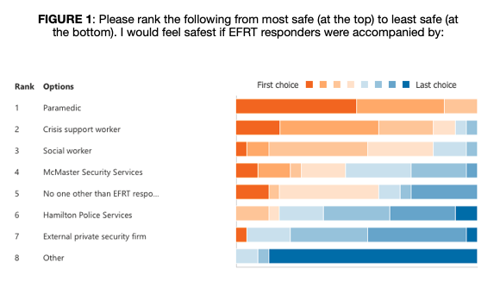

Starting with **Figure 1**, we asked students to rank a number of different individuals on how comfortable they would feel if they were to accompany EFRT Responders while they responded to an emergency call. Currently, McMaster’s Security Services accompanies EFRT responders on each call received. We decided to ask this question with concerns growing related to student’s comfortability and safety with campus police presence, especially when being faced with an emergency. When looking at the graph from the student survey, it is clear that majority of students ranked paramedic highest, indicating that they would prefer EFRT be accompanied by a paramedic rather than any other option. Crisis support worker and no accompaniment also received a high number of first choice for this question. Notably, the data from **Figure 1** strongly suggest that students do not seem to feel comfortable with McMaster Security Services accompanying EFRT responders and would prefer if someone else took their place, even to the point of having no accompaniment at all. **Figures 2–5**, on the other hand, all indicate the positive student feedback this service has received. The majority of survey responders agree that EFRT responders are capable of dealing with the situation at hand, responding and arriving in a timely manner, creating a sense of comfort, and effectively communicating with folks they are helping. This is a wonderful response to see on surveys, as it shows that EFRT is fulfilling its purpose and following its operating parameters. Overall, students can see the great work this service is doing and are utilizing it for its effectiveness.

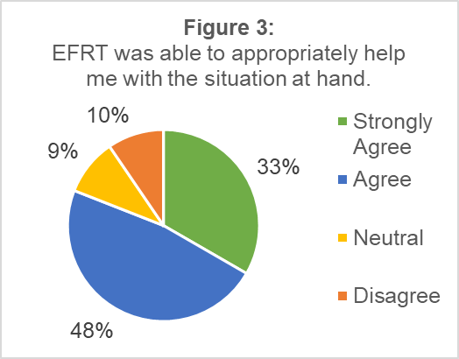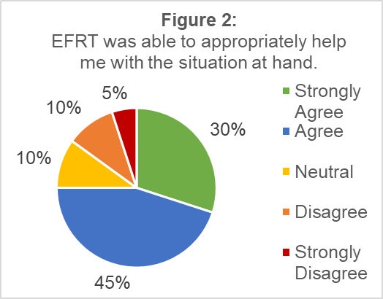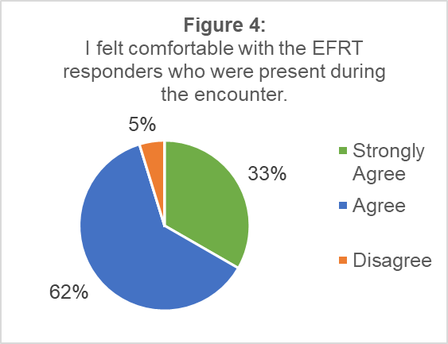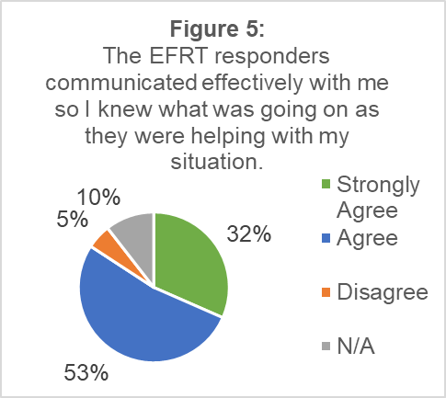

***Volunteer Engagement & Retention***

The following data come from an open survey conducted earlier this year to ask EFRT volunteers for their opinions on the EFRT service. In total, the survey received a total of 12 responses. The following four figures represent the data collected in the volunteer survey:

Starting with **Figure 6**, we asked volunteers the same question we gave students: to rank their levels of comfort with who might accompany EFRT Responders on a call. The response from volunteers contrasted drastically from that of students: amongst volunteers, the data show that McMaster Security Services only received a first, second, or third choice placement. Meaning that EFRT responders are clearly the most comfortable with McMaster Security Services attending their calls with them. Furthermore, paramedic and crisis support worker were the only other options which received a first-choice ranking. When asked to expand on their thoughts, one survey responder said:

*“For the majority of the options (crisis worker, EMS, social worker), I think that they aren't necessary for most of our calls. However, they definitely help me feel safe at tough mental health or intoxication calls. At that point however, I don't think they would have the responsiveness/timely arrival that security currently has/we need.”*

This is an interesting perspective to see from an EFRT volunteer and demonstrates why responders feel it is important to be accompanied and have McMaster Security Services be that accompaniment. Notably, their only concerns appear to stem from issues relating to response time for the individual accompanying them, with all other comments being neutral or positive. Linking this to **Figure 7**, 58% of responders indicated that the presence of Security Services was necessary for when responding to a patient. All of this information indicates that EFRT volunteers see the value and importance of being accompanied on their calls by a service that can help them in a timely manner, which, in this case, appears to be McMaster Security Services. In the best interest of students who indicated they are not the most comfortable with Security Services being present for calls, we asked volunteers if they would feel safe if they were the sole responders to a call. **Figure 8** highlights that volunteers would not feel safe being unaccompanied, with every response chosen in the disagreement direction. These data indicate that the individuals who accompany EFRT need to be more critically examined so that students and volunteers both feel safe to best achieve the mandate for the service.

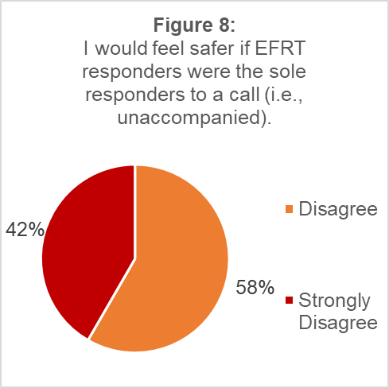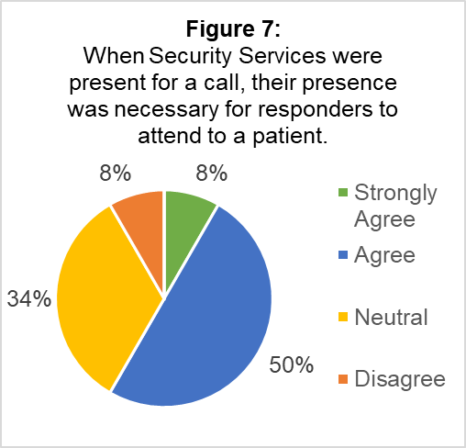

Volunteers were also asked if they feel supported by their team members both on and off shift: these questions received only agree/strongly agree responses. It is great to see that volunteers who responded to the survey agree that there is a strong sense of support within the team, through the Director, Assistant Director, executive team, and fellow Responders. **Figure 9**, on the other hand, asks them to indicate if they feel supported by a number of external groups that EFRT associates with. Most of these responses fell within the “neutral” category, meaning that volunteers neither agree nor disagree that they receive support from these groups. While it can be hard to quantify support from non-McMaster groups, it would be much better to see that MSEFRT volunteers who work hard each year to support the operations of all McMaster services also feel supported by the organizations they hold partnerships with. There seems to be an immense amount of work that can be done so that volunteers recognize they can receive support outside of their team so that they do not feel stuck or overwhelmed with supporting each other in any situation, as well as increases in supports available to them to warrant that elevated awareness.

**External Research**

With the help of the Services Committee, research was conducted into a number of other post-secondary institutions to see what their emergency response services are like and any similarities and differences they have with EFRT. Queen’s University, Waterloo University, Nipissing University, McGill University, and York University were all researched for their emergency first response services. Each of these schools seemed to have services that were run either only by (1) the students union as a club or (2) a separate service offered by the university, with none of these initiatives mimicking the structure of EFRT that directly collaborates with both the students’ union and university. Furthermore, these emergency services were entirely volunteer-based with no paid positions, whereas EFRT’s Director and Assistant Director are paid part-time student positions. Trent University’s TUEFRT is similar to the other institutions in that it is exclusively run by the student union, though their service coordinator is a paid part-time student role.

During the researching process, I got in touch with the Vice-President: Student Services for the Wilfrid Laurier University Students’ Union to discuss their Emergency Response Team structure, since it was quite similar to EFRT in that it was a student union- and university-led initiative. From my discussions with Rachel, the WLUSU ERT, like EFRT, collaborates with the university’s Special Constable Service when responding to emergencies and they also provide their volunteers with mental health first aid and first responder training. WLUSU ERT functions very similar to EFRT, with the largest difference being there are no paid positions on their team: it is entirely volunteer-run.

One notable exception to these structures comes from an out-of-province example emergency response service run by students at Dalhousie University. Unlike other services that operate as collaborations between the students’ union and the university itself, Dalhousie’s program is entirely volunteer-led through a partnership with St. John’s Ambulance. This somewhat mimics EFRT’s connections to the Medical Director but could warrant further investigation into how EFRT works in collaboration with community partners.

From the research conducted, it is clear an emergency response service is necessary. This research is useful to see where EFRT stands as a service in comparison to other institutions for the service to grow effectively. It would be beneficial to continue researching what other schools are doing and adapting our approach for the service to further enhance the service to meet changing student needs. Based on this research, EFRT seems to have a very organized structure that is effective and allows for it to serve the broad needs of the McMaster community above and beyond similar services present at other institutions.

**Final Thoughts**

***Concluding Remarks***

When taking into account the research and survey data, there is not much that needs to be immediately changed with EFRT. Students have positive feedback for the service, with volunteers enjoying their time and feeling relatively supported, and with students getting immediate help when they need it. However, based on what students had to say regarding their safety and willingness to engage with the service in cases of crisis, it may be best for the MSU to take time to further investigate the relationship EFRT has with McMaster Security Services. As it is evident that volunteers find security’s presence on calls necessary, there seem to be many concerns among students when security is present at these emergencies that may deter students from calling as an emergency arises, endangering the McMaster community. It may be beneficial for the MSU to further investigate all of their options and see what the best response will be to ensure students feel safe accessing the service, volunteers feel safe on and after calls, and patients are getting the help they need.

Furthermore, when chatting with the current EFRT Director, Kevin Park, I asked them what they think the biggest area of improvement for the service can be. Park noted that the biggest area of improvement will be providing responders with more support. Park said, “we are currently working to provide responders with possible meals during the shift [sic] as the shift requires responders to be on campus for a long duration and [this issue is especially important] for full-time students.” Taking in this response, in combination with **Figure 9**, I believe it will be in the best interest of the MSU to investigate more opportunities for supporting EFRT volunteers through external partnerships. In doing so, the MSU can find ways to build stronger relationship between the MSU, EFRT, the Student Wellness Centre (SWC), and other community partners. The MSU could use this as a way to investigate meal or dietary vouchers for volunteers on shift, potentially partnering with McMaster Hospitality Services. Moreover, this would be a great way to establish procedures for supporting volunteers that have experienced trauma on shift, as well as procedures for how to manage the volunteer pool after a Responder experiencing an on-shift trauma.

Finally, considering the amount of work and organization it takes to be the EFRT Director, it may in the best interest of the service to hire the EFRT Director as a permanent full-time staff who would assume the responsibilities of both the current EFRT Director and Assistant Director. This individual would be in charge of the service and work with the EFRT Medical Director and Executive Team to achieve the service’s purpose and operating parameters with additional qualifications. When discussing this with the current EFRT Director, they said that if this position were to be a full-time MSU staff position, they would carry out the same responsibilities as both the Director and Assistant Director, so long as the executive team were to remain the same. This is a direction the MSU may want to consider taking the service, especially when exploring opportunities to increase support for volunteers through the addition of highly qualified on-call personnel. With a permanent full-time EFRT Director, there would be a designated person who could work with various MSU staff to establish support procedures and initiatives for volunteers. This could also be beneficial considering someone in a full-time position would be more aware of the supportive responsibilities they have compared to a part-time manager who is also a student with other responsibilities that overlap with the role. This change could also eliminate concerns of slow response times, as the EFRT Director would then take on an embedded role within the service.

***Recommendations***

1. The MSU should further investigate the nature of Emergency First Response Team’s relationship with and reliance on McMaster Security Services.
2. The MSU should investigate opportunities to increase support for EFRT Volunteers (i.e., meal vouchers, trauma/crisis support protocols, relationships with SWC and community partners).
3. The MSU should consider hiring the EFRT Director as a permanent full-time staff position with qualifications analogous to a paramedic.

Warm Regards,



**Martino Salciccioli**

Associate Vice-President (Services)

McMaster Students Union

[avpservices@msu.mcmaster.ca](mailto:avpservices@msu.mcmaster.ca)



**Graeme Noble**

Vice-President (Administration) & Chief Administrative Officer

McMaster Students Union

[vpadmin@msu.mcmaster.ca](mailto:vpadmin@msu.mcmaster.ca)