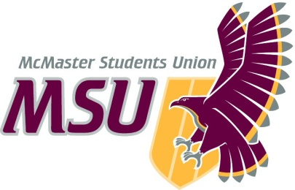
Year-End Report
From the office of…
First Year Council
To: Student Representative Assembly
From: Aiman Dhiloon, First Year Council Chair
Subject: Service Year-End Report
Date: March 16, 2021

Table of Contents
Report Summary
Events, Projects and Activities
Event 1: Marauder Mystery Night
Event 2: Winter Wellness with FYC
Event 3: Speed Friendshipping x Roommate Residence Escape
Event 4: Residence Holiday Door Decorating Contest
Event 5: Residence Candy Grams
Event 6: Teams Trivia Night
Event 7: Applicants Workshop
Project 1: Meet Your FYC
Project 2: First Year Advocacy
Project 3: First Year Representative Assembly
Project 4: Consultation Committees
Project 5: Housing Initiative
Outreach and Promotions
Summary
Promotional Materials
Finances
Budget Summary
Personnel

Report Summary

General Information

This report provides information regarding the pertinent activities of First Year Council (FYC) this year. We include descriptions of various virtual events, both FYC-wide and those run in collaboration with groups such as the First Year Representative Assembly. These include Marauder Mystery Night, Winter Wellness with FYC, Speed Frienshipping x Roommate Residence Escape, Trivia Night, Applicants Workshop and events run specifically for students currently living in PGCLL (which included Valentine’s Day candy-grams and a holiday door decorating contest). Though these events had their challenges with technology and turnout as a result of being entirely online, they each provided opportunities for students to connect with each other and student leaders. Additionally, summaries are included of the various projects FYC has participated in this year, such as first-year advocacy initiatives, the formation and collaboration of the First Year Representative Assembly, and the adapted activities of our three consultation committees (Student Life, Student Code of Rights & Responsibilities, and Hospitality).

Furthermore, we outline our use of social media, namely Instagram, for the purposes of outreach and engagement, and include examples of promotional graphics that were created and posted for the events mentioned above. A summary of our annual budget is also attached showing our spending for the year thus far. Finally, we include comments on the challenges and successes faced by FYC members during this unique year – even with the various challenges this year presented, FYC was able to form a cooperative and resilient team that had a valuable impact on the first-year community.

Events, Projects, & Activities
Projects & Events

Event 1: Marauder Mystery Night

Project Status
Complete
General Information
This event was a Zoom scavenger hunt/escape room themed around Harry Potter and McMaster, where members worked in teams to answer trivia questions surrounding the two aforementioned themes. Gift cards were awarded to the winning team, as well as some randomly selected attendees.
Successes
This event was very well received by the first-year community, with those who attended expressing that they had an enjoyable experience and were excited to attend our future events. It was also an excellent opportunity for first years to meet fellow students and be personally introduced to FYC members. Overall, this instilled FYC with a positive attitude towards future events.
Challenges
Despite initial concerns regarding turnout, which were quickly overcome, this event experienced no notable challenges.

Event 2: Winter Wellness with FYC

Project Status
Complete
General Information
This event was a winter wellness night and was meant to give students the chance to socialize in a virtual setting while participating in de-stressing activities such as online gaming and baking. We also featured music bingo and gift cards for activity winners and randomly selected attendees.
Successes
Though the turnout was low, the smaller group of people resulted in a very intimate and relaxed event, with much more conversation between first year students and FYC members. Those who attended expressed that they had a lovely time and were all awarded gift cards.
Challenges
The challenges faced with this event were in regard to turnout, which was lower than anticipated. Though many students signed up, not many ended up attending. As such, we were not able to run all the activities we had planned.
Event 3: Speed Friendshipping x Roommate Residence Escape

Project Status
Complete
General Information
This was designed as a collaboration between FYC and the FYRA to provide first year students an opportunity to make cross-faculty connections and complete an escape room with their peers. Participants signed up using a Google Form that asked them about their interests; FYC and the FYRA then used their responses to assign a number of breakout rooms. The first few rooms were for speed friendshipping, with randomly assigned participants having a small amount of time to meet a fellow student. To facilitate the conversation in these rooms, participants were each given a bingo card with questions selected to break the ice. After multiple rounds of speed friendshipping, participants were meant to be put into larger groups (assigned based on similar interests) to complete an escape room activity, themed around escaping a hoard of zombies that had invaded a residence building.
Successes
We had an amazing number of signups (about 200!) and excellent turnout. Though things deviated considerably from our original plan (due to technical difficulties with Zoom) the event ended up running for longer than we had anticipated, with students talking and laughing with each other while completing the escape room we created. The emails sent out after the event furthered the connections between students, with many choosing to virtually meet to get to know each other better. Additionally, there was a huge amount of collaboration between FYC and the first-year representatives from the numerous faculty societies. Overall, this event turned out to be an exciting opportunity for first years to meet and connect with their representatives and FYC members, while also meeting peers from different faculties.
Challenges
This event experienced significant technical difficulties, which were quite disappointing given the effort and time FYC and the FYRA had contributed to planning. The breakout rooms we had set up were not able to function properly as a result of Zoom, so we were not able to complete the speed friendshipping portion of the event as we had hoped. The meeting glitched several times, which resulted in many participants being removed from the call, and the event having to switch to a new call in the midst of everything. Ultimately, we had to email participants to announce that we decided to end the event early, though people were free to stick around and chat with us while we collectively completed the escape room. Many participants opted to stay and connect with each other. To achieve the initial goals we had for this event, we sent out follow up emails to everyone who signed up, providing them with the contact information for the other students in the groups we had assigned them to, as well as the link to the escape room. Those who chose to meet up virtually and complete the activity, providing FYC with proof of completion, were entered into a draw for a $100 gift card.

Event 4: Residence Holiday Door Decorating Contest

Project Status
Complete
General Information
This event was run by our PGCLL Residence Chair, Henry Laing. It was a week-long door decorating contest, where Henry provided materials for participants to use to decorate the doors to their rooms. Henry, as well as the Residence Life Area Coordinator (RLAC) judged the submissions, with the winning door from each floor receiving a gift card. There was also a grand prize awarded to the winning door from the entire building.
Successes
Henry expressed that the percentage of engagement did turn out to be an overall success, with a little over half of the building participating in the contest by the deadline. It was definitely a nice way to boost spirits and provide residence students with their own, special event around the holidays.
Challenges
There were some initial challenges regarding participation and engagement; though supplies were provided, many students did not end up decorating their doors. This resulted in Henry extending the deadline and reaching out to CAs and friends to encourage more students to participate. After a slow start, more people did end up participating than in the initial stages of the event, although participation was still not as high as we had hoped. Another challenge was faced when ordering the supplies that were used during decorating - it was difficult to coordinate the arrival of items ordered online, as a result of shipping delays

Event 5: Residence Candy Grams

Project Status
Complete
General Information
This event was run by our PGCLL Residence Chair, Henry Laing, in collaboration with current community advisors (CAs) to distribute candy-grams for Valentine’s season. Residents were encouraged to use a Google Form that highlighted who they wished to send their candy gram to. Henry then compiled this information onto small cards that were cut out and paired with lollipops, which were delivered by CAs.
Successes
This event was met with very positive feedback from residence students and served as a delightful way to brighten spirits as well as foster collaboration between Henry and CAs.
Challenges
This event posed a challenge because Henry was not present on residence at the time due to the pandemic. This made it more difficult to plan and execute this event efficiently, however this challenge was mitigated by ongoing collaboration with CAs.

Event 6: Teams Trivia Night

Project Status
Complete
General Information
This was a collaboration between FYC and numerous other MSU services (Spark, Maroons, and Campus Events). The goal of this event was to allow first years to connect with each other as well as upper year students in an engaging and fun trivia team. The event was facilitated by FYC members as well as volunteers from the services we collaborated with.
Successes
It was definitely a success to be able to combine efforts with other MSU services to plan the logistics of the event and to increase turnout. The event achieved its goal of connecting first years with upper years in an enjoyable environment, which was fantastic giving that first-year students had not had much opportunity to meet students outside their own cohort because of the circumstances of this year
Challenges
Turnout at the event was lower than expected but those who did attend had a fantastic time!

Event 7: Applicants Workshop

Project Status
In Progress
General Information
FYC will be working alongside Spark and the Student Success Centre to run Applicants Workshop that will provide students at McMaster to practice and learn more about written application skills, one-on-one interviewing and group interviewing. There will also be opportunities to learn more about what a strong cover letter and resume looks like through representatives from the SSC
Successes
TBD
Challenges
TBD

Project 1: Meet Your FYC

Project Status
Complete
General Information
This was a weeklong Instagram takeover, hosted in an effort to introduce students to the members of FYC. Each day, one FYC member was in charge of posting a series of Instagram stories introducing themselves, providing some facts to allow students to get to know them, and engaging with students online using polls, quizzes, and answering questions. These stories were accompanied by Instagram posts (photos of each member, posted on the day of their takeover to allow a staggered introduction) and highlighted on our account.
Successes
This project was successful as it allowed first years to see who was on FYC this year (which was beneficial, as three out of the five FYC members were acclaimed to their positions and did not have the opportunity to campaign during the election period), as well as get a general idea of our roles and responsibilities. Though it is difficult to quantify the impact of our introductions, we are confident that this project allowed FYC to demonstrate our approachability and willingness to virtually connect with each other and other first-years during this unique year.
Challenges
It was certainly challenging to reach many first years using only Instagram, and to get people to interact and get to know us through social media. The introductions were very one-sided, with students having reduced opportunity and interest in having genuine conversations with FYC members.

Project 2: First Year Advocacy

Project Status
Complete
General Information
The initiatives FYC has decided to focus on include rescheduling fall reading week, minimizing the number of online platforms, implementing a calendar system to help students keep track of assignments, reducing the workload/length of online classes and communicating the real-world applications of various courses. We had multiple meetings with Brittany (AVP University Affairs) and Giancarlo (MSU President), during which they provided valuable guidance on advocacy and how to proceed with initiatives we are passionate about – the feedback from these initial meetings was used to present our ideas to Kim Dej (Vice-Provost Faculty) and Sean Van Kougnett (McMaster Dean of Students). They were very supportive of our ideas, and we are continuing to work with them to elaborate upon these initiatives as well as to provide feedback on McMaster’s Teaching & Learning Strategy. Additionally, Kim & Sean were able to refer us to relevant projects that are currently in progress, such as the course portal project, and connect us with the groups who are managing them. As such, FYC has been able to provide feedback to these groups while integrating first-year wants, needs and concerns.
Successes
FYC has been able to receive information and assistance from numerous different outlets, who have all been very supportive of our ideas and willing to discuss and answer our questions. Through much refinement of these ideas, we are confident that we have proposed initiatives that align with student needs and concerns, while simultaneously being feasible. The ideas we have presented are being considered in the development of various projects that they are relevant to, such as the course portal project. In summary, the initiatives we have developed are doable and supported by the people who can make them happen.
Challenges
As a result of the circumstances of this year, FYC has faced increased difficulties in implementing the changes we propose – much of this year has been focused on connecting with the right people and determining how and when these changes will be feasible. Though we have been referred to many projects that are currently being worked on, it is difficult to say when we will see tangible changes being made, as many of these initiatives are still in the preliminary stages.
Project 3: First Year Representative Assembly

Project Status
Complete
General Information
The First-Year Representative Assembly (FYRA) was run by FYC Vice Chair External, Charlotte Chan. It comprised elected first year representatives from each faculty, who met to discuss first-year concerns on a broad scale. Additionally, the FYRA also promoted cross-faculty collaboration in regard to first-year advocacy and event planning.
Successes
In its entirety, the assembly certainly served its purpose during this online year, which was to communicate and funnel first-year wants and concerns from the wide range of McMaster faculties to FYC in an efficient and organized manner. The assembly was able to create a central place for first year leaders, who formed a united front to represent students. Additionally, the increased amount of unity was extremely beneficial due to the reduced size if FYC this year – the FYRA was able to collectively reach many more students for promotional purposes than FYC alone.
Challenges
Charlotte expressed that challenges were faced with the FYRA surrounding engagement of the representatives – at times, it felt as though there was a lack of passion within the committee to make the most out of their roles. Challenges were also faced when forming the FYRA; as it was not a standardized group, Charlotte had to search for contact information and reach out to every representative individually to see if they were interested in participating in this group. Furthermore, it was difficult to find and organize meeting times where the entire assembly was available, and to hold the numerous representatives accountable for their assigned tasks. Overall, Charlotte feels that the FYRA would benefit from a stronger connection with the SRA and other governing bodies, as many of the concerns presented during assembly meetings would be more relevant to groups outside of FYC.
Project 4: Consultation Committees

Project Status
Complete
General Information
FYC has three consultation committees (Student Life, Hospitality, and Student Code of Rights & Responsibilities), which met at regular intervals throughout the year to plan and discuss various projects. Our Student Life committee, in collaboration with our campus partners Chris and Carley, has been focused on providing feedback for the residence budget. We are currently in the process of discussing a residence financial accessibility option which would allow incoming students to apply to live in residence at a free or discounted cost. This committee also provided feedback for future facility additions to residence buildings. Further, our hospitality committee has focused largely on providing possible ideas to improve the MacEats app, as well as the McMaster community garden. Finally, our Student Code committee has met with our campus partner Michelle to familiarize ourselves with and understand the Code, as well as having discussed how to effectively promote awareness the Code to students.
Successes
All of the committees have provided a channel for FYC to provide a first-year perspective on a number of topics surrounding campus life. Though most of us have not been able to experience campus ourselves, our participation and involvement in these committees has given us the opportunity to have a say in what we will see when we eventually arrive. The residence financial accessibility initiative is also a very new idea that FYC came up with and we are really excited to see how positively it has been received by the Student Life Committee. We look forward to pursuing this initiative and providing more students opportunities to stay in residence.
Challenges
We faced a notable challenge this year providing input and initiatives for campus facilities given the unique circumstances of this year, and the fact that the vast majority of council members do not have experience being on campus. Our partners expressed that they aren’t quite sure where to head with the committees this year, however this is something we actively worked to overcome by providing alternative feedback and ideas adapted to the current situation.

Project 5: Housing Initiative
Project Status
Complete
General Information
This was a collection of housing related tips and resources compiled by FYC Vice-Chair Internal, Michelle Song. The goal of this project was to facilitate the process for first years to find housing for the upcoming year. The tips came from upper year students who had experience finding housing, and some of the key pieces of advice were compiled onto a graphic that was posted onto the FYC Instagram account. The remaining resources were collected in a Google Drive folder which was linked in our Instagram bio; these included an extended document with more advice from upper year students, a document from Archway McMaster that provided a list of tips and FAQs, and a list of resources for finding off-campus housing near McMaster.
Successes
We were able to compile a very useful collection of resources for first year students, in response to the stresses students were experiencing with finding housing accommodations for next year. Additionally, the services we reached out to (including McMaster Student Navigators and Archway) were very supportive of this project and happy to let us use their resources.
Challenges
This project had no significant challenges.

Outreach and Promotions

Summary

General Information
The main platform utilized by FYC this year for promotions and engagement was Instagram and Facebook. Our account served not only to inform first-year students of the events we ran, but also to host gift card giveaways to increase our follower count and story takeovers to introduce students to council members and first year representatives. In addition to cross promoting with other MSU services on Instagram such as Spark and Diversity Services, FYC has also formed a strong relationship with Archway who effectively promote our events through Instagram and their mentor updates. We were also able to form connections with the administrators of the McMaster2024 Instagram page with over 6000 followers who also supported us with our promotional efforts. Furthermore, FYC has been able to meet and collaborate with numerous MSU services (including Spark, Maroons, and Campus Events) to participate in running joint events, while also collaborating with various other committees such as the Information Technology Student Advisory Committee (ITSAC) and various focus groups run by members of the Student Representative Assembly.
Successes
Our Instagram account has been very successful, having gained many followers as a result of our giveaways. We have gained over 500+ followers this year given our strong promotional strategies. Additionally, our collaboration with various services was greatly able to increase student involvement in events. In terms of outreach, services were very willing to support our activities and when possible, connect us to relevant projects.
Challenges
There were evidently numerous challenges with outreach and promotions due to the year being entirely online. All our connections had to be online, which made it more difficult to reach out to people and encourage people to participate in events or collaborations. It was especially challenging to connect and engage with first-year students, as there really wasn’t a pre-existing community that was able to be created before this year.
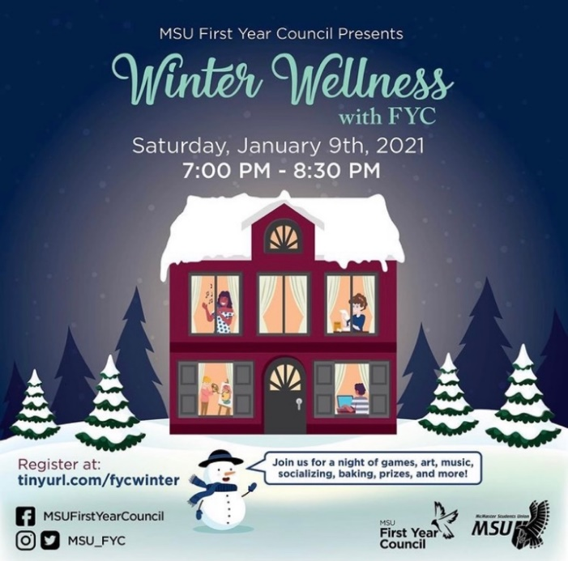
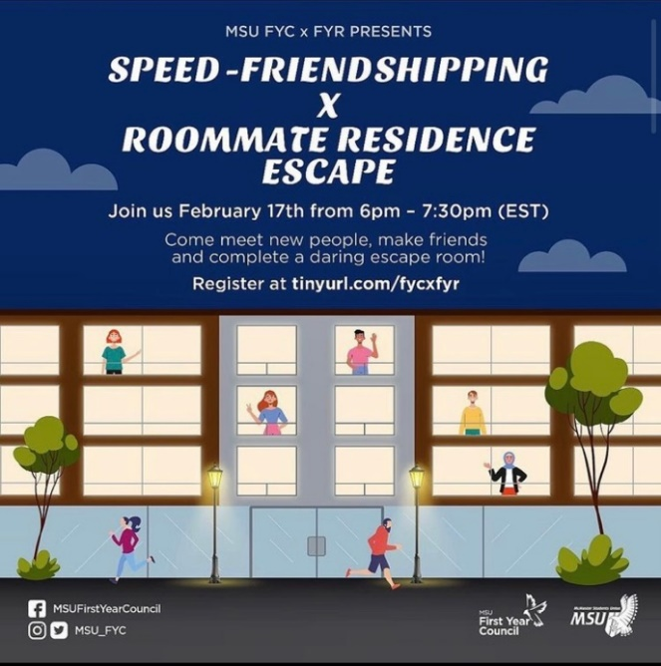
Promotional Materials (some examples)

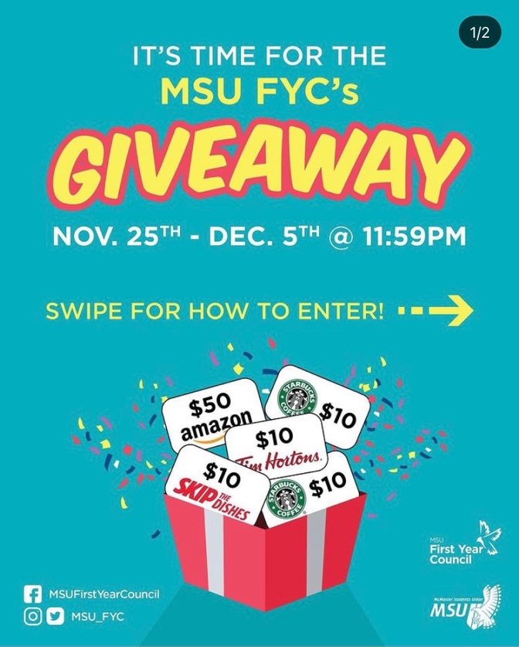
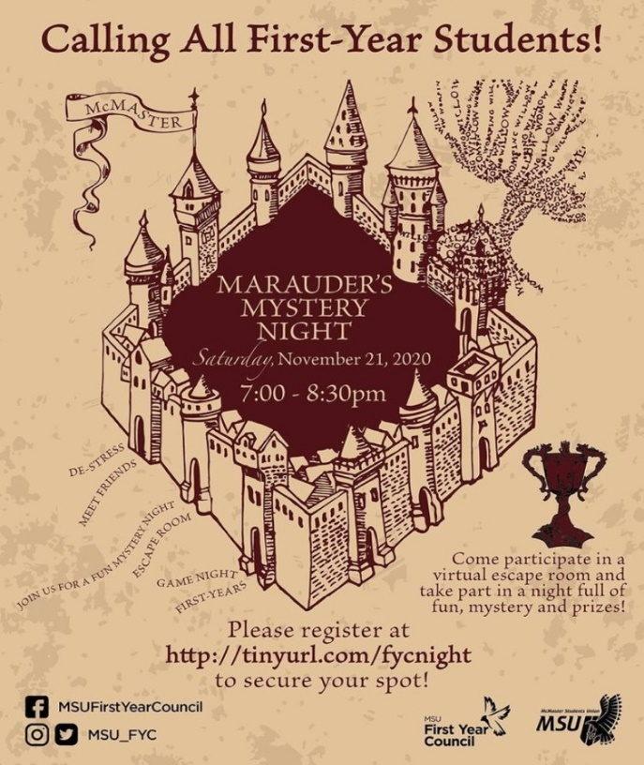

Finances

Budget Summary (As of March 16, 2021)

FYC
EXPENDITURE
ACCOUNT CODE | ITEM | BUDGET / COST | PO SUBMITTED (DATE) | PO APPROVED
6102-0319 | FYC - ANNUAL CAMPAIGNS | $2,500.00
 | Maurauder's Mystery Night | $150.00 | Nov 23/2020 | 127213
 | FYC Giveaway Nov 25 - Dec 5th | $90.00 | Nov 23/2020 | 127214
 | Winter Wellness Event | $80.00 | Nov 30/2020 | 127220
 | Speed Friendshiping x Roommate Residence Escape | $145.00 | Jan 31/2021 | 127269
 | Trivia Night | $170.00 | March 10/2021 | 127320
 | TOTAL SPENT IN LINE | $635.00
 | REMAINING IN LINE | $1,865.00
6301-0319 | FYC - RESIDENCE LIFE EXPENSE | $1,000.00
 | Door Decorating Event | $119.95 | November 19, 2020 | 127209
 | Door Decorating Winners | $60.00 | November 30, 2020 | 127222
 | Candy Gram Event | $64.56 | January 25, 2021 | 127263
 | TOTAL SPENT IN LINE | $244.51
 | REMAINING IN LINE | $755.49
6402-0319 | FYC - AWARDS & MEETINGS | $150.00
 | Fall Awards | $100.00 | Nov 30, 2020 | 127221
 | TOTAL SPENT IN LINE | $100.00
 | REMAINING IN LINE | $50.00
6403-0319 | FYC - VOLUNTEER RECOGNITION | $750.00
 | Jackbox for FYC Socials | $27.99 | Dec 8, 2020 | 127234
 | TOTAL SPENT IN LINE | $27.99
 | REMAINING IN LINE | $722.01
 | Underground Standing Order | $750.00 | November 16, 2020 | 127205
 | Marauder's Mystery Night ($150) |  | November 16, 2020 | 127205
 | Giveaway Promo ($110) |  | November 16, 2020 | 127205
 | Winter Wellness Event ($125) |  | November 16, 2020 | 127205
 | Speed Friendshipping Event ($125) |  | January 31, 2021 | 127205
 | Housing Graphics ($110) |  | March 2, 2021 | 127205
 | Applicants Workshop ($125) |  | March 10, 2021 | 127205
 | Boosting Winter Wellness Event | $15.00 | December 2, 2020 | 127223
 | TOTAL SPENT IN LINE | $765.00
 | REMAINING IN LINE | $935.00
TOTALS
TOTAL BUDGETED DISCRETIONARY SPENDING |  | $6,100.00
TOTAL ACTUAL DISCRETIONARY SPENDING |  | $1,772.50
REMAINING DISCRETIONARY SPENDING |  | $4,327.50

Personnel

Successes
Throughout the year, council members became confident in their roles and functioned cohesively as a team. Each meeting was approached with a synergistic attitude and created a positive space for members to share ideas and connect with each other. We persevered through the many challenges this year presented and overcame obstacles to represent and unite first- years during this unprecedented time.

The PGCLL Chair has done an excellent job facilitating residence events, advocating for student concerns and leading the Student Life Committee. Henry’s leadership has been integral in enhancing the student experience in Residence this year, bringing residence concerns to light and developing the Residence Financial Accessibility Initiative.

The Vice-Chair Events has done an incredible job this year facilitating virtual events that have supported first year students in forming connections with others in the McMaster community. They have worked well alongside the FYC Coordinator and other services such as Spark and the Maroons to run meaningful events that enhance the student experience during this challenging time.

The Vice-Chair External has gone above and beyond in facilitating the First Year Representative Assembly this year. Through their hard work and dedication, they were able to bring together a group of twenty student leaders to discuss student concerns and facilitate a fun cross-faculty wide event.

The Vice-Chair Internal’s role was very different this year given the lack of the Residence Advisory Council. Nonetheless, they effectively supported FYC with advocacy initiatives, events, and worked to address student concerns by connecting with different partners on campus to gather and promote Housing resources

The FYC Coordinator this year has been instrumental in supporting FYC with all our initiatives and helping our ideas come to fruition. They have done an amazing job connecting FYC with appropriate campus partners, actively provided us with feedback and guidance, and addressed all our questions and concerns.

My role as the FYC chair this year has involved me effectively leading council meetings and supporting all members with their events and initiatives. I have actively communicated with different campus partners whether it be our Students Codes of Rights and Responsibilities partner or directly to the SRA bringing FYCs concerns to light.

Challenges
There are certain challenges we faced as a result of the year being online, which is generally unprecedented. One such challenge was the smaller size of the council this year as compared to last year (due to the reduction of residence chairs). As a result of the smaller group, members had to take on more responsibilities in certain areas and less responsibilities in other areas when compared to previous councils.

