Year plan Update
. | REPORT  From the office of the…  Food Collective Centre Director
TO: | Members of the Executive Board
FROM: | Hannan Minhas
SUBJECT: | Food Collective Centre Report [8]
DATE: | March 4th, 2021

At the beginning of the year there was a lot of uncertainty around FCC programing and how we could work around COVID and an online semester. Now that I look back on the year, I cannot be more satisfied with how the team was able to deal with all of the obstacles and uncertainty that came with the pandemic. We were able to adapt the emergency food support service as well as continue running the Good Food Box program. We were able engage volunteers through advocacy projects such as the FCC cookbook, budget guides as well as Foodie Friday Instagram takeovers.

In terms of the year plan we are on track as the team is really excited about executing the last few events in March and April. We will be completing our final Good Food Box distribution on March 2nd. Our last Quarantine Cooking Challenge event will also take place in March with this month’s ingredient being the most needed food items based on Food Banks Canada. This will allow students to share their own creations using items that everyone has or has accessed. We are also holding our last campaign on March 21st – 26th which will explore food insecurity & health. During this campaign we have planned our final Community Kitchen Workshop as well as another live event hosted by Chef Stu Gold to discuss healthy eating. During this time, we also hope to hold a final volunteer appreciation event as well as share the projects that the volunteers have been working on during the year. Our social media accounts will share the city spotlight infographics, the FCC Cook Book website and the grocery guides as resources for students.

My current task is to help transition next year’s director into their role, and aid in the process of the assistant director. I realize that the service structure will look different from what it is currently as the Good Food Box Coordinator role will be volunteer next year, so I hope to help the new team define roles and responsibilities in order to create a cohesive team.

Service Usage
Emergency Food Support Services: Lockers of Love

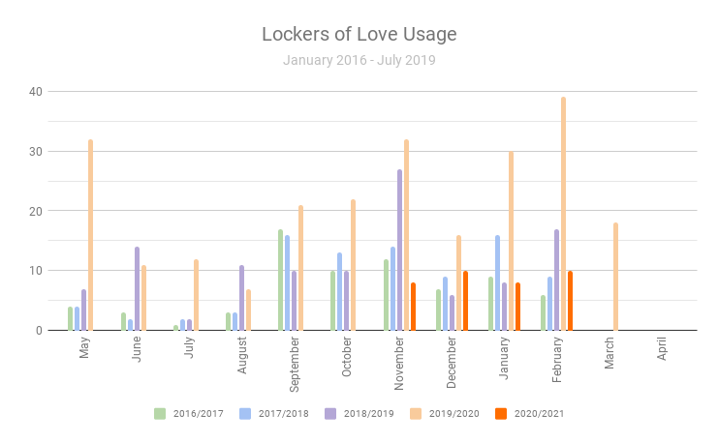

The Lockers of Love program was our primary emergency food support system. For the months that it was operational we averaged 9 orders per month. Initially during the months of November and December, we were giving physical nonperishable foods, however, as Hamilton went into lockdown, we thought the most accessible option for FCC partners was through grocery gift cards. We attribute the low order numbers to students not living in the McMaster community.

Good Food Box

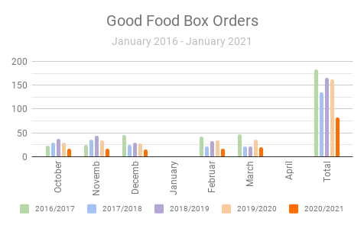

The Good Food Box program has remained quite consistent over the years, however, this year it experienced a drop in order numbers, which we also attribute to the student population not living locally in Hamilton. This year’s orders have been pretty consistent with 16 orders per month and 83 orders this year. Compared to last year’s numbers (165 orders), its decreased by 50% but still a success in our books especially considering the pandemic.

Our program is run only with the support of Grace Lutheran Church and their established produce provider. They will be stopping their program within the next couple years as a result of some internal structuring, and so, our team is hoping to get in contact with another Good Food Box program in Dundas in order to keep the program running for next year.

This program has received some great feedback, from students, staff, and other members of our community who choose to purchase a GFB. Ideally, we would like to continue this program as a means of providing fresh fruits and produce at a highly subsidized cost for folks in our community.

Repeating Events

Quarantine Cooking Challenge

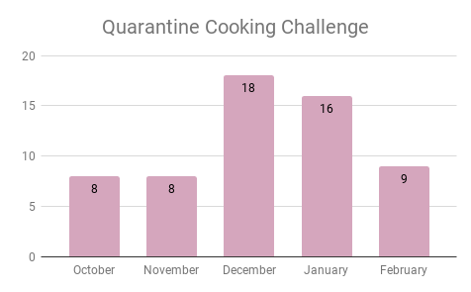

The quarantine cooking challenge has been a nice addition to FCC programing. We really appreciate students creating and sharing recipes with us and all of the engagement that FCC has been receiving as a result of this challenge. We hope to continue this event as well, as a permanent addition to FCC initiatives, however, less frequently. I personally attribute this challenge for the reason why FCC has almost doubled its Instagram followers.

Instagram Followers

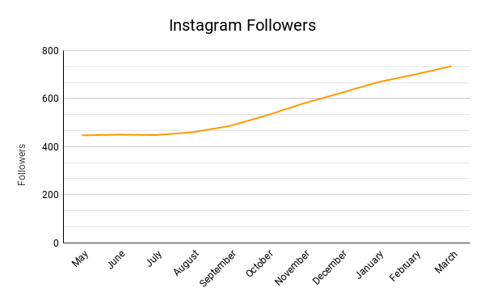

One of my goals for the service this year was to increase outreach and social media presence. I feel that the team has succeeded beyond expectations with our Instagram followers starting at 450 followers and growing to 735 at the end of February.

Past Events, Projects, & Activities

Foodie Friday Collaboration: This was a collaboration that has happened with the McMaster Library Sustainable Committee to help promote plant based cooking through a Foodie Friday Cooking Demo. This takeover was planned to promote plant based cookbooks and sustainability offered by the library.

Discussion and Documentary: This was a new and recent event that we held at the end of February. We had 15 people come out to the event which was expected due to the nature of the event. Our focus for this event was to allow students to learn about food insecurity and how it can manifest in students. The focus for this event was to engage students and hold an advocacy event.

The videos we shared were:
1. Why are grocery prices in Canada’s North so high
2. A family experiences food insecurity in America

Valentine’s Day Contest: This year’s valentine’s day contest was similar to last year in which we gave away 3 GFB prizes. Unfortunately, the winners weren’t able to pick up their GFB so we opted to give $15 gift cards instead. This event was successful and one of the reasons for more followers in February.

Upcoming Events, Projects & Activities

FCC Cookbook Website – This website was created to compile recipes that FCC has used in the past. This will serve as a place to hold all current and future recipes.

Quarantine Cooking Challenge: March – This will be our last challenge for the year. The key ingredient being the most needed food items based on Food Banks Canada

1. Pasta (canned or dry) and pasta sauces
2. Canned vegetables and fruit
3. Whole grain foods (eg. cereal,brown rice)
4. Canned and frozen meat and fish
5. Meat alternatives (eg. peanut butter,soy)
6. Canned goods (eg. beans, soup)
7. Dairy (canned, powdered milk)

Food Insecurity and Health Campaign:
- Monday: Impact of Food Insecurity on Health (infographic):
  - Feelings of shame/mental illnesses → eating disorders
  - Physical health impacts → unhealthy food options lead to chronic conditions, disproportionate effect on specific groups
  - Populations most at risk: race, newcomer population, disabilities/accessibilities

- Tuesday: Blue Zones
  - Access to certain foods increase lifespan
  - Description of blue zones
  - Map highlighting certain blue zones and the foods they eat

- Wednesday: Obesity & Food Deserts:

- Thursday: Chef Stu Health Eating Event (live event)
  - Share file with simple recipes that go along with key points will be touching on when discussing shopping for ingredients
  - Possibly recipes either in photos/videos

- Friday: Resources:
  - Hamilton Food Share & Food4Kids (other resources listed as well)

Study Snack Support This event is planned for the last day of school in which students in the Hamilton community can order a small study snack pack with some nutritious snacks to eat during exam studying. Usually, FCC hosts a room in MUSC with healthy snacks, but creating small packs and distributing seems like a safer option! Students will be able to order during April and the FCC will remotely deliver the snack packs in order for students to have nutritious snacks during late night studying sessions. This event will be similar to the one held last exam season.

Community Kitchen Workshop: This will be the last CK workshop event for the year which will take on March 22nd as a part of our Food insecurity & Health campaign week. These workshops have been successful in order to teach students cooking strategies in which they become more confident in their own cooking skills.

Currently Working On

Volunteer Appreciation: Appreciation event in March to show our gratitude for all the work that Volunteers have done this past year. We would distribute the $10 gift cards at this time as well.

Transition: Meeting and working together with the incoming director in order to answer any questions about the role.

Budget

ACCOUNT CODE | ITEM |  | BUDGET / COST
5003-0318 |  | FCC - OFFICE SUPPLIES
SUPPLIES | TOTAL SPENT IN LINE
 | REMAINING IN LINE |  | $75
6102-0318 |  | FCC - ANNUAL CAMPAIGNS
 |  | QCC Gift cards | $25
 |  | Documentary Giftcard | $30
 |  | Valentines Giveaway | $45
 | TOTAL SPENT IN LINE |  | $100
 | REMAINING IN LINE |  | $1110.11
6603-0318 | FCC - RESERVE
 | 18 Lockers of Love Orders |  | $450
 | TOTAL SPENT IN LINE |  | $542.49
 | REMAINING IN LINE |  | $457.51
TOTALS
TOTAL BUDGETED DISCRETIONARY SPENDING |  |  |  | $6450
TOTAL ACTUAL DISCRETIONARY SPENDING |  |  |  | $4536
REMAINING DISCRETIONARY SPENDING |  |  |  | $1913

Volunteers
We are extremely thankful for all of our volunteers and all the hard work they put in. We will be holding a final volunteer appreciation event as well as distributing $10 gift cards as a token of appreciation. Our service could not run without their hard work and dedication and I am so grateful for the work they have put into the projects this year.

Current Challenges
Transitioning our new director into their role and helping manage the hiring of their executive team for next year. Some of the challenge would be with service restructuring and defining new roles for the paid and volunteer positions as well as finding a way to continue running the Good Food Box as the program in the Grace Lutheran Church is moving.

Successes
We have successfully hired an incoming director for the next year and I’m excited to start the transition process. I have confidence that she will do amazing things within her role as the director and I’m excited to see how this service will evolve. I am so thankful for my team this year and It has been a privilege to be in this role.

