. | MEMO  From the office of the…  Vice-President (Finance) & CFO
TO: | Executive Board
FROM: | The Wage Review Committee (Jess Anderson, Maddison Hampel, Giancarlo Da-Ré)
SUBJECT: | Service AD Wages
DATE: | March 1, 2021

Dear Executive Board,

The Wage Review Committee has met and assigned a wage for the following positions: PCC Assistant Director, SHEC Assistant Director, Diversity Services Assistant Director, WGEN Assistant Director, Maccess Assistant Director and Spark Assistant Director. After scoring these positions, the roles have all been graded as C2 ($15.40 per hour, 6-8 hours per week).
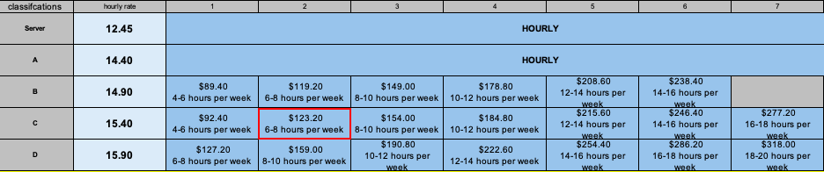

These gradings were determined using the newly created Assistant Director job descriptions. Graeme Noble (VP-Admin), worked with Maddison Hampel (Human Resources Generalist) and gain insight from the current Directors, to create the job descriptions. The review was done based on the newly created descriptions, as responsibilities for the Assistant Directors have been clearly established and done in tangent with the update Director JDs.

Please see an outline of the changes below:
- Pride Assistant Director, SHEC Assistant Director, Diversity Services Assistant Director, WGEN Assistant Director, Maccess Assistant Director and Spark Assistant Director:
  - Reviewed at C2 ($15.40/Hour, 6-8Hours/Week, $123.20/Week)

With these additional Assistant Director Roles added for the 2021-2022 year, should these wage reviews be approved by Executive Board, each of the above listed services (PCC, SHEC, Diversity, WGEN, Maccess and Spark), will have 22 hours of paid staff work per week. This is an increase in paid hours for every service by about 8-10 hours!

Should there be any questions or concerns please do not hesitate to contact any member of the Wage Review Committee.

Jess Anderson
Vice-President (Finance) & CFO
vpfinance@msu.mcmaster.ca

Maddison Hampel
Human Resources Generalist & Clubs Support
hr@msu.mcmaster.ca

Giancarlo Da-Ré
MSU President & CEO
president@msu.mcmaster.ca

