Dear Executive Board,
. 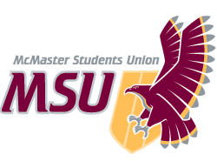 | MEMO  From the office of the…  AVP Finance
TO: | Members of the Executive Board
FROM: | Chen Liu, AVP Finance
SUBJECT: | EB Report for Sponsorship and Donations
DATE: | February 25th, 2021

On February 25th, 2021 the Sponsorship and Donations Committee met to review various applications that we received. We were able to both reach quorum and a mutual decision. In this deliberation, the decision was as follows:

- $200 sponsorship to DeltaHacks. DeltaHacks is a 24-hour hackathon with over 800 participants across North America. For $200, the MSU will receive the following: Logo on the website (Small), two social media posts and a Package Blurb (pamphlet with the MSU’s name).

This is the sixth time this year that the Sponsorship and Donations Committee is making a recommendation to the Executive Board and the sum of these recommendations is $200. As such, should the recommendation be approved the fund will now sit at $7,182 to be used throughout the remainder of the year.

Chen Liu
AVP Finance
McMaster Students Union
avpfinance@msu.mcmaster.ca

