. 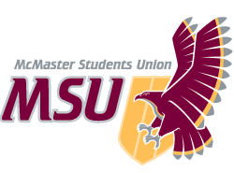 | REPORT  From the office of the…  Spark Coordinator
TO: | Members of the Executive Board
FROM: | Baila Lovejoy
SUBJECT: | Spark Report 6
DATE: | February 11th, 2021

Year Plan Update
Overall, Spark programming has been running really well and things have been successful! Something I’ve been trying to do is prioritize quality over quantity in terms of programming so things have definitely changed since writing my year plan. The pandemic and having school online has been harder than I had anticipated so I’ve been really focusing on prioritizing mine and my team’s wellbeing and that definitely meant changing plans and expectations. Three of my goals for January were to: hold an engaging retraining for TLs to boost morale, hold first year formal, and promo sessions to register 250+ students for session. We held retraining earlier in January, which I will chat about below. Obviously with things online, we are unable to hold formal. However, we’re working on a replacement event with FYC that will be taking place at the end of March. Registration is always much lower in the second semester with sessions so I am proud that we still are making an impact on students, even if it’s less students than anticipated.

Service Usage
Sessions have been going great! Registration has lower registration than first semester; students don’t feel that they need transition programs as much second semester so this is pretty typical for sessions. However, we’ve still been able to register 35 students for sessions that are split into 16 groups! Retention has actually been really good with most groups having 1-3 students each session!

In terms of Instagram following, I have outlined it in the chart below:
Report 1 | Report 2 | Report 3 | Report 4 | Report 5 | Report 6
4275 | 4531 | 4625 | 4572 | 4543 | 4431

Past Events, Projects, & Activities
We held an end of term social at the beginning of December! Around 15 TLs came (⅓ of the team). Even though turnout was a bit lower than expected/what it normally is if in person, the folks that came had a really good time! We got to hang out and play some games online and I really enjoyed seeing other TLs interacting with one another and making connections. We also held closing ceremonies at the beginning of December and it has to be one of my favourite experiences so far in the role. Events committee took the lead on the planning with the support of our Events Coordinators, Julian and Sofia, and planned a fun games night for students and TLs! We had around 5 students come and 10 TLs which is about the same turnout as last year in person! My personal favourite part of the event was a session debrief led by a member of the events committee. We all got to chat about what we learned from each other throughout the term and how we’ve grown over the semester. I wasn’t sure what to expect from this portion of the event but students genuinely participated and spoke about what they learned from their TLs. In Spark, it’s often hard to see the impact we’re having on students so it was nice to hear from students themselves how much they enjoyed the experience. On January 17th, we held a few hours of retraining. We revisited expectations for the term, quickly reviewed any presidential election rules that might have been relevant to TLs, went over situationals that might come up in Spark, and did co-reveals. Overall, it was nice to connect with the team again before the semester got busy!

Upcoming Events, Projects & Activities
We’re hoping to plan a social for the team in the next couple of weeks. We’re also planning a collab with FYC for the end of March. We normally collaborate on First Year Formal but obviously are not able to hold Formal this year. We still wanted to create a fun event for first years and give FYC the opportunity to collab so we’re looking at a few options for the event! One option we’re looking at is running online escape rooms. We’re currently in the process of reaching out to the Alumni Association that ran the escape rooms for light up the night to hear about their experiences running them. FYC has been really great to work with and I’m really looking forward to seeing this event come to life! We also are planning some kind of social media campaign or posts highlighting social distanced (online) games and activities available to students! Something I’m really excited for is hiring the incoming PTM. It’s exciting to see who will be taking over and I’m looking forward to helping them in their transition!

Currently Working On
I’m working on finishing exec 1 on 1s to see how I can support them best throughout the rest of the semester and our time working together. Our events coordinators and I are also working on a collaboration with FYC, Campus Events and Maroons as a part of their Wellness week. The event is tentatively scheduled for the evening of March 10th and is set to be a trivia night! I’m really looking forward to this event and am hopeful that we’ll have lots of turnout! Another small task I’m personally hoping to start working on in the coming weeks is opening exec apps. The incoming coordinator will have a very quick transition so I’m hoping having these apps open ahead of time will not only help their workload but allow for more applications and candidates if they’re open for a longer period of time.
Budget
We have recently just spent money on promo for registration.
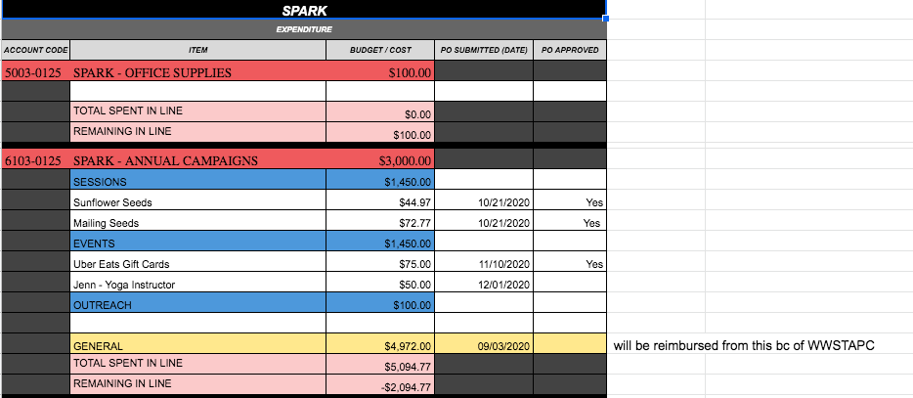
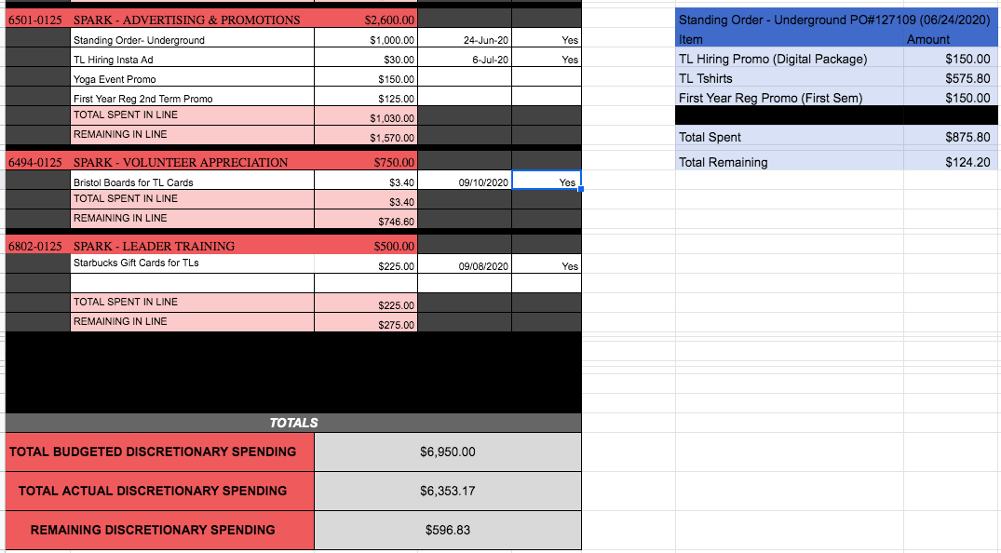

Volunteers
Volunteers have been great! They’ve been super accommodating when expectations have changed and have remained enthusiastic throughout the year! During retraining, I spoke about our lower registration for sessions and that it would be different than last semester. Multiple TLs brought up that its a great opportunity to get to know those students better than if there was more so that was really nice to see. I’ve been in their position before with low retention and a very small session group so I know how hard it can be. I’m really proud of the TLs for how they’ve adapted and handled it, remaining enthusiastic and excited about their roles!

Current Challenges
- Training Participation
Training participation has been a small ongoing challenge throughout the year. We’ve tried multiple ways to engage folks in session training and it seemed to improve near the end of last semester but decreased to almost none at the beginning of this semester. At one of the first sessions trainings of the semester, I spoke to the team about expectations within their role and the overall sessions training environment and things seemed to have improved a bit! The only concern that I have is ensuring TLs are prepared for the session while also ensuring we make training a comfortable and supportive environment for them to participate and grow in. I’ve made it clear to the team that many execs are here to listen to any feedback or chat about how we can improve things or make them more comfortable! I also have an anonymous feedback form that’s available to the team so I’m looking forward to further supporting TLs in their growth through training this semester!

- Starbucks Gift Cards
At the beginning of the school year, we hoped to give every TL a virtual $5 starbucks gift card. I’ve tried quite a few times to do this since then but no matter what, something always comes up (the website was down for a while and now is giving me an error when I try anything). I’ll be working with Vidushi over the next couple of weeks to try and brainstorm some ways to fix this or find other appreciation gifts to send out.

- Contract End Date
Something I’m struggling with is the fact that PTMs have been told that we are losing almost three weeks of pay at the end of our contracts. In our contracts, the last week of paid wage is to end on April 13th. Instead, we have been told we will be not working any hours after March 26th, and seemingly will not be paid. I have a few issues with this. First, the incoming PTM begins on March 18th. This means that we will only have 8 days to transition the incoming PTM, meaning that we have to cram a transition in that very short period of time when we all have other commitments whether that’s school etc. Within that time, I already have 5 assignments due, my thesis presentation, the year in review EB report due, a two-day long event that I’m running with another club and have been planning since October and will be helping review resumes/hire for the Assistant Director position. I understand that there is an expectation to manage commitments and balance various responsibilities as a PTM. However, this is completely unrealistic to now cram a transition into 9 days when we all have various responsibilities. As someone who had a very short transition into my role (I was offered my position, signed my contract and was working in the role essentially the next day), I can now see how a longer transition is helpful. I was very lucky that I had a few past Spark PTMS to help me in my transition so I could adapt quickly to the role and had no other commitments (classes etc) during this time that affected my ability to completely devote all my time to the transition. This will simply not be the case for the incoming PTM and I worry that this quick transition will stress out both myself and the incoming PTM, starting their role off in a rocky way.

Secondly, there will be work to do in the last weeks of my contract. As i’m sure many other services are in the same boat, Spark has programming planned up until the end of classes (the last week of sessions ends on April 1st and we will be having closing ceremonies after that). It would not be fair to myself, my team, or the incoming PTM to have planned programming for that time, then not be able to support the team in executing it because I’m not paid or on contract for that time. It would then leave that responsibility to the incoming PTM to support the current team and programming when they have many other commitments, are trying to adjust to their role and hire their own team. It's unreasonable to ask services to stop supporting students either almost half a month before exams (a time when students often need the most support) or to do so without a PTM.

Thirdly, my contract does not include an early termination clause or change of terms of employment clause. We as PTMs have been told we will be sent a letter of employment but it’s description has been incredibly vague. If PTMs are sent a letter of status of employment change, it has to be agreed upon by both parties (meaning PTMs would have to agree to it). Again if we’re sent a letter, terms of attempted employment status change do not meet legal consideration that is considered enforceable. Therefore, if a PTM does not accept these changes, the MSU is still legally obliged to meet the terms of the original contract, including all weeks of pay. It's coercive to imply that the change has to be accepted by PTMs when in reality, we have the right to decline that change as there is no clause in our contracts regarding change of terms of contract. Lastly, As an employee who’s been working for the MSU for over three months, if the MSU ends my contract early, it’s considered dismissal/termination and they are legally obliged to pay common law severance or termination pay.

Finally, despite the fact that my contract does not include an early termination clause and I (and PTMs in general) will have work to do during this time, I find it extremely disrespectful that we were told (not asked) that our pay was being taken away. It’s evident that we have all worked incredibly hard this year and worked overtime for much (if not most) of the year. The pandemic has been extremely draining, both financially and emotionally. We don’t have easy jobs to begin with and the pandemic has exacerbated that. Despite all of this, every single one of us have worked to support students and our services and done incredible jobs at doing so. It's hard to feel like the value of our work is being recognized when after a year of working ridiculously hard, we are met with attempting to reduce our pay. Additionally, we as PTMs have been told that our wellbeing is a priority and that we should set boundaries in our roles in order to have balance in our lives. However, it is really difficult to feel supported and trust that when this is an active step that is being taken that will inherently stress PTMs out more. I’m very aware that’s not the intention behind this and nobody wants us to be stressed out more but it’s a fact that it will. Whether it’s new time constraints around transitions or losing pay that we’re counting on, it’s inevitable that this will stress everyone out in one way or another. I feel like we as PTMs have been extremely understanding and adaptable amongst all the changes and challenges we have faced this year, but this is unreasonable and not something that we should have to accommodate.

Overall, I feel like this scenario isn’t fair to anyone involved. For incoming PTMs, they are met with a rushed transition into their roles and are thrown into finishing off and supporting previously planned programming that they had no preparation for, while also hiring executives etc. For myself and other outgoing PTMs, we lose almost three weeks of pay that we were promised in our contracts. We also are now tasked with struggling to fit a transition into a very short time frame. For my exec team and volunteer team, this leaves them to run programming without adequate support. This works out for no one and inherently sets up the incoming team in a very difficult position. Finances are tight for many folks and I find it incredibly disrespectful to not only not take this into consideration, but to continue to think that it’s okay to take away pay from staff that have worked incredibly hard and worked overtime for much of the year, and additionally put unpaid volunteers through extra stress in the process.

Successes
Overall, service wise, things have been going well! The exec and volunteer team have been really supportive of each other and it’s been really great to see them interacting and making those connections! I’ve also had a few TLs ask about exec applications so that’s been great to see that they’re enjoying their experience so much that they would want to get involved even more with Spark! One of the things I’m really proud of is how my team and I have balanced our wellbeing over the quantity of output the service has. I think we all came into our roles with very different expectations of circumstances for the year but the team has been so adaptable and I’m so grateful for that! I really can’t say enough good things about the volunteer team and exec team and I’m so grateful that I get to work with them this year!

