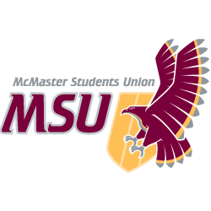. | REPORT  From the office of the…  Social Sciences Caucus
TO: | Members of the Student Representative Assembly
FROM: | Matthew Jones, Social Science SRA
SUBJECT: | SRA 20N Report
DATE: | February 7th, 2021

Progress on Year plan
On February 2, 2021, the Social Science caucus met with the Dean of Social Science to discuss key issues from our year plan, namely online learning, and tuition breakdown. During the meeting, both parties were focused on the importance of establishing a strong relationship for future projects and introducing a taskforce behind making McMaster a more equitable space and what that may look like. In addition, we continue to evaluate the progression of our year plans and to encourage a transparent relationship between the MSU and the student body to truly build a stronger community.

Upcoming Events, Projects, & Activities
Our caucus will continue to have meaningful and productive conversations with the Dean of Social Sciences for the next scheduled meetings (February and March).

Current Challenges
Last semester, coordinating a time that works for all caucus members was largely a challenge due to our diverse and busy schedules. For winter 2021, we have planned to meet every Wednesday and have been consistent with our meeting. There have not been any new concerns about reaching out to faculty members and we are hoping communication with faculty members and university members improves.

Volunteers (Standing Committees only)
N/A

Successes
Our caucus has successfully launched the Online Learning Survey for Socal Science students in order to understand how students are engaging with online learning and other platforms such as Echo360 & Proctor U. We hope to present our findings in the next MSU meetings and identify the problems in online learning and researching support systems.

Best,

Matthew Jones
SRA Social Sciences Caucus Member
McMaster Students Union
srassci@msu.mcmaster.ca

