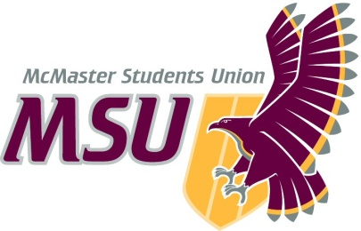. | Report  From the office of the…  Executive Board
To: | Members of the Student Representative Assembly
From: | Jess Anderson, Vice-President (Finance)
Subject: | Executive Board
Date: | February 7, 2020

Introduction
Dear Members of the Assembly & Committee Chairs,

Here are the major points to hit on from the past 2 meetings of the Executive Board (EB) in 2021:

Sponsorship & Donations Request
The following Sponsorships were approved by EB, as proposed by Sponsorship & Donations Committee:
- Sponsorship – $100 Sponsorship to the Degroote Interprofessional Health Leadership Conference
- Sponsorship – $500 Sponsorship to Moscars
- Sponsorship - $500 Sponsorship to HOSA McMaster
No comments or questions came up.

Service Reports/Updates
We heard reports from:
- Diversity Services
  - Have been working on advertising submissions for their large Zine publication in collaboration with Incite Magazine.
  - Very exciting, promo has been posted and are looking to provide a space for BIPOC artists to showcase their work!
- EFRT
  - Filled a seat on the EFRT Advisory Committee
  - Continuing to remain off-call until further notice (or direction from the University and plans for reopening)
- FCC
  - Approved a proposal for giftcards (similar to those previously approved for WGEN & SHEC), that allow the service to continue to provide support to those in need even with the limited access to campus
  - Tabled a request to do deliveries for the Good Food Box until we were able to receive more information regarding safety, adhering to health guidelines etc.
- PCC
  - Have been preparing for Mac Pride Week! TONS of amazing events have been planned and excited to engage with students. Also have some joint events with other services during pride week to broaden their outreach!
- Maccess
  - Running a collab event with PCC for pride week!
  - Engagement numbers seem to have increased which is incredible.
  - Planning to do a Maccess Zine publication to highlight folks within the community.
- Maroons
  - Programming has been going well! Recently started running virtual workouts to engage students to stay active at home.
- & Macademics
  - Have been actively promoting awards & submissions! Teaching awards numbers are looking good and are excited to continue pushing those graphics/messaging out to students.

Hiring Updates:
- Maroons Coordinator, FCC Director and FYC Coordinator have been hired!
- Assigned EB members to respective Assistant Director hiring committees.

Jess Anderson
Vice-President (Finance) & Chief Financial Officer
McMaster Students Union
vpfinance@msu.mcmaster.ca

