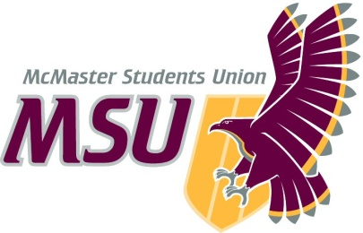. | Memo  From the office of the…  Vice-President (Administration)
To: | SRA Members and Committee Chairs
From: | Graeme Noble, Vice-President (Administration)
Subject: | Operating Policy – Welcome Week Charitable Giving Amendment
Date: | February 21, 2021

Introduction
Dear Members of the Assembly,

After further consultation with Housing & Conference Services, it has since been suggested that Residences no longer participate in our rotational charitable giving initiatives as outlined in Operating Policy – Welcome Week Charitable Giving. Instead, they will continue to support the University’s designated charity: United Way. This way, they can continue to collaborate across their network of partners across campus in support of a consistent charitable cause. This change has a minimal impact on the operations of the committee, but should be documented as a change nonetheless.

Proposal
The position of Residence Orientation Planner has been removed from the Welcome Week Charity Selection Committee.

Please let me know if you have any questions or concerns prior to the meeting.

Kind regards,

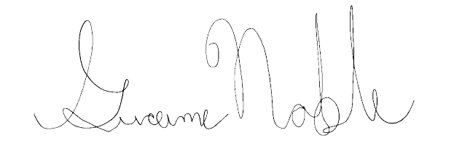
Graeme Noble
Vice-President (Administration) & Chief Administrative Officer
McMaster Students Union
vpadmin@msu.mcmaster.ca

