. 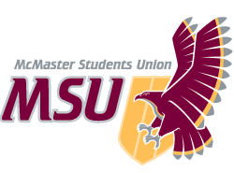 | REPORT  From the office of the…  Maroons Coordinator
TO: | Members of the Executive Board
FROM: | Hemantika Mahesh
SUBJECT: | Maroons Report 7
DATE: | Jan 31, 2021

Yearplan Update
- Exam Destressor:
  - This was a great event in collaboration with Spark!
  - We had SSC come in and run a exams tips session, and then we ran destressors such as a games room, a chill room, and Netflix party room
  - We had approximately 30 students attend the event
- Team Bonding
  - We ran a scavenger hunt social to kick off the year! This was a super fun and engaging event
- Outreach event
  - The events coordinators are in the process of planning an outreach event for February. Some ideas have included collaborating with either Empowerment Squared again or working with a few black-owned businesses
- Wellness Week
  - We are in the process of planning Wellness Week! I am super excited for this event.
  - We are currently collaborating with FYC, Spark, FCC, Macademics, COPE, and MacMoves to run this event

Service Usage
Over the Winter break, there has been a lack of posts on our social media platforms. However, with the upcoming events and programming, there will be a lot of activity on our online platforms

Platform | Stats | Comments
Facebook | 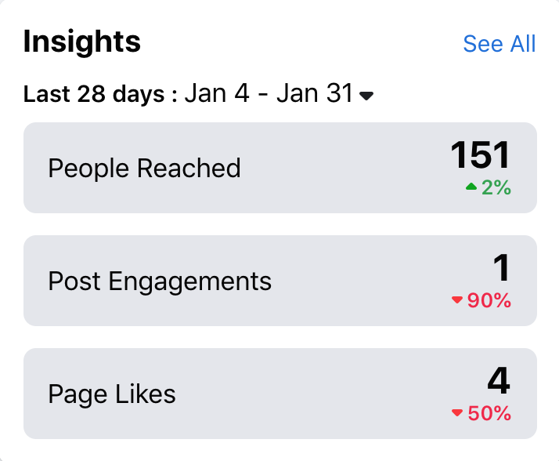 | Once again, not too worries with the red numbers, as there has been a lack of activity over the break. There will be a lot of upcoming events, which will subsequently have a lot of posts and promo associated with it!
Instagram | 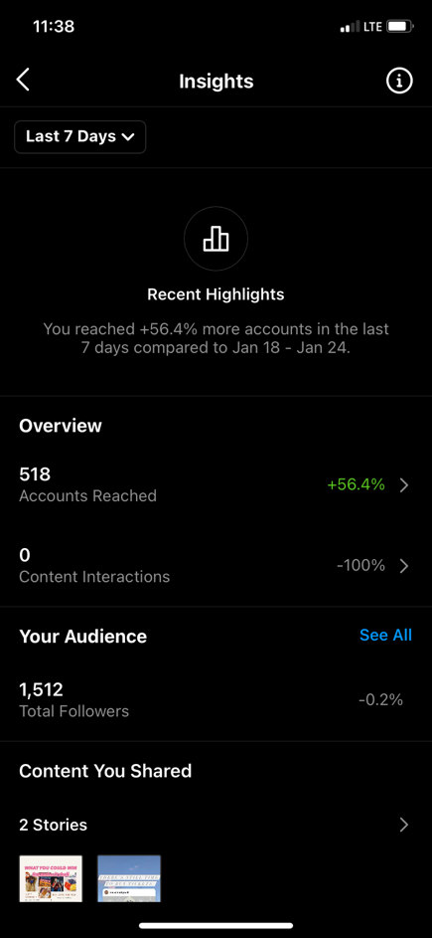

Past Events, Projects, & Activities
The give-away was very successful! We did a Burnt Tongue give-away and an Uber eats give-away! Both of giveaways were successful in increasing our followers and developing our online platform. We are currently debating to do another give-away or combine the give-away with a Spirit event/contest of some sort.

We collaborated with charity ball and helped run their event rooms! There were no difficulties or technical issues experienced by the reps in their rooms.

Furthermore, we just completed the hiring process for the new Maroons Coordinator! The hiring process was very different than what I was used to from previous hiring processes, but I think it went really well and had a great new structure! This transition is going to be very unique and I will have a lot to share with the new PTM, especially the amount of online resources I have accumulated over this year.

Upcoming Events, Projects & Activities
Wellness Week
- We are working with a few services and clubs to plan a Wellness Week. The idea is to run live-programming on the Monday, Wednesday, and Friday of the 2nd week of March.
- Throughout the week we would run other asynchronous programming such as posting wellness tips on our Instagram, or self-care videos, or account take-overs! I understand that this is a busy time for students, and so I am trying to plan this week in a way where reps do not feel overwhelmed by their commitment to these events.
- Currently we have FYC, FCC, Spark, COPE, Macademics and Mac Moves collaborating with us
- The objective of this event is to provide students with an opportunity to destress, learn about ways to develop/maintain wellness during these unique times, and to provide a safe(r) space for students to interact with other services and clubs at McMaster

Transition and Hiring of the Leadership team (LT)
- With the hiring of our new PTM, I am really excited to start this transition process early and get them onboard and understanding the various aspects of the role that is not seen by the reps or the LT.
- Furthermore, we want to review our hiring processes and work with VP admin and others to see how we can make opportunities to get involved with the Maroons more accessible and equitable.

Currently Working On
- We are currently working on our Outreach event for February and in the initial planning processes for our Wellness Week event
- For Wellness Week, we are confirming our collaborators and what our collaborations would look like (asynchronous events, trivia nights, discussion panels, etc…)
  - Currently, we have planned for Spark and FYC to be running a Trivia Night on the Wednesday of Wellness Week.
  - COPE is planning on a asynchronous, educational campaign on mental health and wellness, and then hosting a discussion panel at the end of the week
  - Mac Moves is planning on hosting a movement-wellness workshop
  - FCC has a few options such as recipe tutorials, or tips on budget friendly foods!
- For our outreach event in February, the events Coordinators are currently exploring potential organizations/businesses we could collaborate and promote through this event. A few options include the black owned businesses we presented at our auction during WW or Empowerment Squared.
- We have received the jerseys and the complimentary T-shirts that came with them! We have finalized that we would be distributing the jerseys via shipping because the current restrictions. I am just in the process of finalizing mailing addresses!

Budget
ACCOUNT CODE | ITEM | BUDGET / COST
5003-0120 | MAROONS - OFFICE SUPPLIES | $50.00
 | TOTAL SPENT IN LINE | $0.00
 | REMAINING IN LINE | $50.00
6102-0120 | MAROONS - ANNUAL CAMPAIGNS | $450.00
 | TOTAL SPENT IN LINE | $0.00
 | REMAINING IN LINE | $450.00
6415-0120 | MAROONS - VOLUNTEER APPRICIATION | $750.00
 | TOTAL SPENT IN LINE | $0.00
 | REMAINING IN LINE | $750.00
6501-0120 | MAROONS - ADVERTISING & PROMOTIONS | $1,000.00
 | TOTAL SPENT IN LINE | $0.00
 | REMAINING IN LINE | $1,000.00
6603-0120 | MAROONS - SPECIAL PROJECTS | $750.00
 | Uber Eats Gift Card | $50.00
 | Burnt Tongue Gift Card | $25.00
 | TOTAL SPENT IN LINE | $75.00
 | REMAINING IN LINE | $675.00
6633-0120 | MAROONS - UNIFORMS | $7,000.00
 | Westend Sports | $1,600.00
 | TOTAL SPENT IN LINE | $1,600.00
 | REMAINING IN LINE | $5,400.00
6804-0120 | MAROONS - MEMBER TRAINING | $500.00
 | SACHA | $450.00
 | TOTAL SPENT IN LINE | $450.00
 | REMAINING IN LINE | $50.00
TOTAL BUDGETED DISCRETIONARY SPENDING | $10,500.00
TOTAL ACTUAL DISCRETIONARY SPENDING | $2,125.00
REMAINING DISCRETIONARY SPENDING | $8,375.00

Volunteers
We have had 2 really great socials since the last reporting cycle. It is a great way to keep reps engaged, improve team dynamic, and an avenue for me to talk to the entire team, give them updates and show my appreciation for their efforts and hard work throughout this year! I am really grateful for this team and all the effort they put in for our events. I know this is a unique year, and this was not what they were expecting when they signed up for the position. Nonetheless, I am grateful for the unwavering enthusiasm and commitment this team brings to our events. The socials are a great place for me to express this to my team.

Current Challenges
I am trying my best to create the most helpful transition possible for the new PTM. However, it is clear that it is unknown how the service will be functioning in the next year due to COVID regulations. I unfortunately did not get to experience in-person programming as the PTM. To combat this, I am going to connect our previous PTM with our new upcoming PTM. This way if the new PTM can draw from both an in-person and completely virtual experiences for their term.

Successes
Our Instagram give-away was very successful! I am excited to now run/post asynchronous programming onto our social media platforms because we have a larger audience, which will hopefully boost our student engagement during upcoming events.

