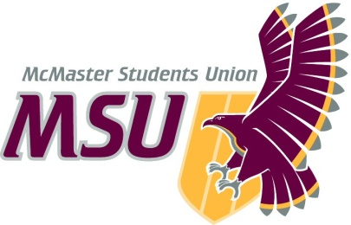**Report**

**From the office of the…**

Associate Vice-President (Services)

To: Members of the Executive Board

From: Martino Salciccioli, Associate Vice-President (Services)

Graeme Noble, Vice-President (Administration)

Subject: MSU Macademics Service Review, Final Report & Recommendations

Date: February 9, 2021

#### Introduction

Dear Members of the Executive Board (EB),

The following report is a review of the MSU Macademics service conducted by the Associate Vice-President (Services). This report will critically examine MSU Macademics by looking at the service’s mission, history, structure, and engagement. The report also takes a look at similar initiatives within the McMaster community and at other post-secondary institutions to compare and contrast MSU Macademics to provide context for its evaluation. After displaying all the aforementioned information, the report is concluded with recommendations made by myself, the committee, and the Vice-President (Administration) with regards to the future direction of the service.

**Service Overview**

##### Mandate & History

##### MSU Macademics is service which strives to bridge the gap between the MSU and academic initiatives at McMaster by providing access to educational resources and to recognize excellence in teaching at the school. As stated in Operating Policy – MSU Macademics, the purpose of MSU Macademics is:

*“To recognize, promote, and encourage excellence in teaching and learning at McMaster University (Section 1.1).”*

To achieve its purpose, MSU Macademics must aim to maintain the following operating parameters:

*“MSU Macademics shall:*

*Recognize excellence in teaching at McMaster University by awarding MSU Teaching Awards on behalf of MSU members (Section 2.1);*

*Maintain and moderate an editable database of courses known as the MSU Course Wiki (2.2);*

*Work in partnership with Faculty Societies and McMaster University to promote student evaluation of teaching via the Course Evaluations period (2.3);*

*Collect and disseminate information on quality of education at McMaster University not limited to (2.4); and*

*Collect and promote online resources to students to aid in academic success (2.5).”*

MSU Macademics has done excellent work for students across McMaster. There is a notably high engagement with Teaching Awards each year and a considerable rise in collaborations with other services since the service’s creation. MSU Macademics also does great work sharing resources on their Facebook page throughout the semester, whether they cover study tips, strategies for note taking, or general techniques for improving the quality of learning. That said, the majority of the promotional material for this service only covers Teaching Awards. In fact, the MSU Macademics Instagram account has only been used to promote this initiative (aside from hiring). It is great to see this amount of promotion for Teaching Awards. since it is such a well-known and well-received aspect of the service. Overall, the service is clearly meeting the requirements to achieve its purpose, however the operating parameters do not seem to accurately line up with the purpose. When examining the purpose in Section 1.1, it appears that this service’s only mission is to promote and run Teaching Awards, however the Operating Parameters indicate something much different. There seems to be some other work that the service should be doing that is not well-reflected in the purpose listed in **Operating Policy – MSU Macademics**.

##### Service Structure

As outlined in the Operating Policy, this service is entirely run by students. Currently, MSU Macademics is overseen by one Part-Time Manager (PTM), the MSU Macademics Coordinator, who is assisted with service planning and facilitation by five (5) executives. These executive roles include: one (1) Volunteer & Logistics Coordinator, one (1) Research & Resources Coordinator, one (1) CourseWiki Coordinator, one (1) Promotions Coordinator, and one (1) Teaching Awards Coordinator. The PTM and five (5) executives make up the Executive Team. Together, the team hires the MSU Macademics volunteer team. Each position on the Executive Team has a different job to be achieved throughout the school year. The Teaching Award Committee Coordinator chairs the Teaching Awards Committee and plans the Teaching Awards ceremonies. The Course Wiki Coordinator moderates and oversees all the functions of the MSU Course Wiki (when operational). The Research & Resources Coordinator is responsible for the online library of academic resources and works with the MacPherson Institute for Innovation & Excellence in Teaching & Learning, Faculty Societies, the Student Success Centre, and other groups on campus to provide the best academic support to students. The Promotions Coordinator shall create and share promotional material for all MSU Macademics events, programs and campaigns and be responsible for the promotion of the Course Evaluation period. The Volunteer & Logistics Coordinator is responsible for outreach, engagement, scheduling and coordination of volunteers and the day-to-day activities of the service. The general volunteers must support the service in completing their mandated duties and are selected by the MSU Macademics Coordinator.

#### Internal Research

##### Student Engagement

A total of 42 responses were received for the MSU Macademics survey. When analyzing the following data, please recognize that this is not a holistic view of the service from the perspective of MSU members, considering 42 individuals only comprise about 0.1% of all undergraduate students. The following figures represent data which were accumulated through survey responses:

*(it should be noted that over 50% of survey responses came from students in Year III and above)*

**Figure 1** asked for opinions on whether students agree that MSU Macademics advocates for the improvement of education and resource accessibility at McMaster, while **Figure 2** asks if they agree or disagree with the fact that MSU Macademics collaborates with their respective Faculty Societies to achieve educational improvement and resource accessibility. A large majority of students in **Figure’s 1 & 2** have responded neutral. While this does not necessarily mean that MSU Macademics is not fulfilling this responsibility, it does indicate that students are either unaware that this is within the scope of MSU Macademics’ operation or happening at all. Considering that the majority of survey responders are in third year or above, these students have had the opportunity to interact with the service for numerous years and in various different capacities (both in person and online). While there are some responses which indicate strong agreement/disagreement, it is alarming that such a large number of responders have no opinion after being students for several years. This raises questions about the current scope and operations of MSU Macademics:

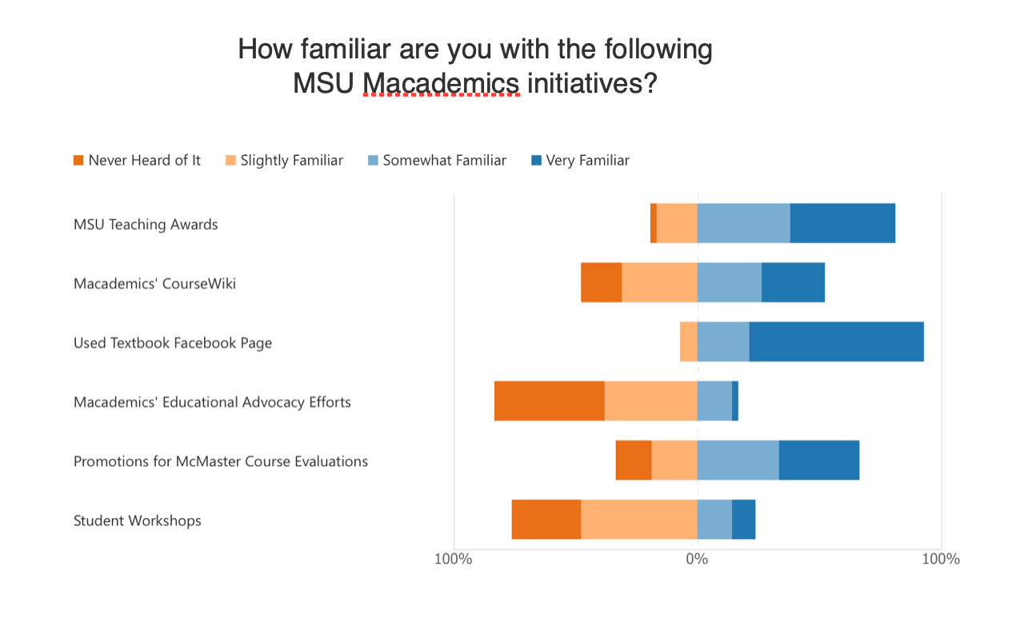

**Figure 5:**

How familiar are you with the following MSU Macademics initiatives?

* Is this service fulfilling what is set out within its mandate?
* Is this service accessible to students?
* Has the service effectively completed what it has set out to do in terms of improving education and access to resources?
* Or has the service put more energy into different initiatives?

**Figure 3 & 4** ask students about their opinions on the MSU Macademics’ Teaching Awards/Teaching Awards Committee (TAC). **Figure 3** asks students if they feel that teaching awards effectively promotes standards for teaching and learning at McMaster. There seems to be an overwhelming number of responders who agree with this sentiment, and, connecting this to **Figure 4**, it is evident that many responders have nominated Professors and/or TAs on numerous occasions. It is so great to see that this aspect of MSU Macademics is so well received and interacted with. The other survey questions related to the TAC seem to have similar responses in that students seem familiar with the initiative and enjoy its place within the school community.

**Figure 5** asks students to rate their familiarity with various MSU Macademics initiatives. It is clear that Teaching Awards and the Used Textbook Page on Facebook are the most familiar initiatives among students. These initiatives are well-received and interacted with and the survey indicates positive engagement with these two assets of MSU Macademics. While students have indicated familiarly with Promotions for McMaster Course Evaluations, when analyzing MSU Macademics’ social media pages there seems to be an absence of promotions for these course evaluations. Considering this is an initiative listed as an Operating Parameter in **Operating Policy – MSU Macademics, Section 2.3**, it is interesting to see a lack of promotion for these evaluations across numerous years and academic terms. Furthermore, there is also a lot of grey area surrounding the CourseWiki, but it is worth discussing that something listed as an Operating Parameter **(Operating Policy – MSU Macademics, Sections 2.2)** is, for one, no longer active, as well as being unfamiliar among students. Figure 5 also address that students were unfamiliar with student workshops and educational advocacy efforts that MSU Macademics should be running **(Operating Policy – MSU Macademics, Sections 2.4.2 & 2.5).**

One responder left a comment at the end of the survey which states, “MSU Macademics sounds great on paper, but needs more advertisement, or other means to be easier to access/use in order to be more popular as a campus resource.” In general, this survey indicates a lack of engagement amongst students with MSU Macademics’ events, contests, and ceremonies. It is interesting to see students addressing the lack of engagement due to a lack of promotions/advertisement and barriers to accessing the service.

***Key Takeaways***

* High student engagement with MSU Macademics’ Teaching Awards
* Low student engagement with other aspects of the service

##### Volunteer Engagement & Retention

A total of 10 responses were received for the MSU Macademics Volunteer survey. When analyzing the following data please recognize that this is not a holistic view of the service from the perspective of MSU Macademics Volunteers, this survey was open for numerous weeks and was available to all current and former MSU Macademics volunteers. While these responses will be useful, it is worth noting that it only comprises the opinions of 10 volunteers. It is also worth keeping in mind that these responses are from volunteers which may present a specific bias in the way they respond to specific questions regarding the service. The following figures represent data which was accumulated through survey responses:

In **Figure 6**, volunteers were asked if they felt that MSU Macademics could operate as an independent initiative. As demonstrated in the graph, most responders indicated that they did not think the initiative could operate independently. **Figure 7** measures whether volunteers feel that Teaching Awards effectively promote standards for teaching and learning at McMaster, where the majority of responders agreed with the statement. These data clearly indicate a high and positive retention for Teaching Awards and the TAC among volunteers. It is clear that volunteers agree that the awards promote academic standards at McMaster and want to see this committee continue on through the service. While there is a clear understanding and appreciation for the TAC amongst volunteers, **Figures 8, 9, & 10** draw upon some areas where it appears that volunteers do not have as much of an understanding towards other aspects of the service. These figures ask if volunteers feel MSU Macademics effectively collaborates with the MacPherson Institute, the MSU Education department, and McMaster’s AVP (Faculty), respectively. While some responders agreed with these statements, majority answered “neutral”. The reasoning behind this selection is unclear, however it indicates that volunteers are unaware of these various relationships MSU Macademics is responsible for upholding. Including an “unsure” response option may have helped to draw on more conclusive answers. Regardless, the absence of a definitive agree/disagree response raises some questions about how much volunteers know about MSU Macademics’ collaborative efforts.

#### External Research

##### Community Landscape

Looking within the McMaster community for groups/services that have similar functions to MSU Macademics, aside from the obvious Student Success Centre (SSC) and MacPherson Institute, we can look to the McMaster University Faculty Association (MUFA). MUFA—which represents and protects the interests of all members of McMaster Faculty—has its own annual teaching awards initiative similar to MSU Macademics’ TAC. The award is called the MUFA Faculty/Librarian Awards for Outstanding Service and recognizes the achievements of Faculty and librarians who are MUFA members. Traditionally, a student member will sit alongside University staff on the selection committee for the award. This is something worth discussing as an already existing initiative within McMaster, though the MSU Macademics TAC functions quite differently. While students still nominate Faculty members for the award, the MSU TAC recognizes both Professors and TAs, while not limiting who is eligible for receiving the award due to a membership to MUFA members. What makes the MSU Macademics Teaching Awards unique from MUFAs award is that it is directly awarded through the MSU, not a university association, which can help to bridge gaps between advocacy for academic excellence and the student body. Additionally, there is a positive reception amongst students with MSU Macademics’ Teaching Awards, with that an added uniqueness not seen elsewhere within the McMaster community. While there may be multiple academic recognition awards for Faculty at McMaster, there are features that differentiate these initiatives which support its continued worth as an MSU annual tradition.

##### External Institutions

To continue the research for the MSU Macademics review, other post-secondary institutions were researched to explore similar initiatives. Notably, many post-secondary institutions do not have a student-union-led academic advocacy service, as those responsibilities often fall on the universities themselves. The two institutions that were studied closely were Queen's University and Nipissing University. To start with, at **Queen's University** it was discovered that most of their academic aid was found within the university through a program called the Student Academic Success Services (SASS). SASS offers academic support to students who wish to develop their skills in critical thinking, reading, learning, studying, writing, and self-management. This initiative holds workshops, has a high presence on social media with tips on student academic success as well as peer support (Peer Learning Assistants). One interesting part of this service is its dedication to weekly blog posts written by staff and students on how to survive Queens academically. Upon further investigation of these blog posts, many are candid and witty, giving students a laid back and authentic look into different academic tips and tricks. It is important to note that this group focuses more closely on writing help and, since the switch to online content, uses their Instagram platform to reach their audience. From **Nipissing University**,different academic support initiatives were found. Most online resources are distributed through two emails, [counselling@nipissingu.ca](mailto:counselling@nipissingu.ca) and [academicdon@nipissingu.ca](mailto:academicdon@nipissingu.ca). These two emails are taken care of by staff on campus who can redirect students to academic support. There are also many student-run clubs specific to different types of programs offered at Nipissing and many of them hold academic based events to support students. Although both institutions run different types of initiatives for their students, the goal to support students academically is at main priority similar to MSU Macademics. It is clear that these external initiatives do not function the exact same as MSU Macademics, but they have features that could be incorporated to ensure academic support and resource accessibility is maintained for students.

#### Final Thoughts

##### Concluding Remarks

When considering the research and data collected it is time to consider a serious remodeling of MSU Macademics and its initiatives. While the service strives to do great work, there are numerous responsibilities and operating parameters listed directly in the Operating Policy that have not been acted upon for numerous years, this includes:

* Collaborating with Faculty Societies.
* Moderating an accessible and editable course database for students called the MSU CourseWiki.
* Establishing formal collaboration and communication with the MacPherson Institute for Innovation & Excellence in Teaching & Learning.
* Promoting undergraduate course evaluations at the end of each academic term.

Although some aspects are no longer the responsibility of MSU Macademics (e.g., the CourseWiki), they are still listed as parameters in the Operating Policy and should be removed. It is evident that given its numerous years as a service, MSU Macademics has appeared to take on a much different direction than originally set out upon its creation. Students are unaware of what the service is doing and have trouble accessing numerous initiatives. Moreover, with the overwhelmingly positive responses related to TAC, from both students and volunteers, it is worth investing more into this initiative as a way to recognize educational excellence at McMaster that still performed through the MSU and separate from the university. Currently, it is the responsibility of the MSU Speaker to act as a non-partisan staff member to chair numerous awards committees. Considering the following three recommendations listed in the next section, it may be most effective for the MSU to hire an awards committee chair as a part-time staff role who is focused on chairing awards committees that the MSU is responsible for. This would give the opportunity for a designated individual to have more time for planning and strategizing for MSU Teaching Awards, and other awards, with a designated volunteer team. This will also allow the MSU Speaker to focus more on their own responsibilities relating to the operations of the SRA. While most volunteers who responded to the survey indicated that they felt the TAC could not operate independently, there are numerous awards committees that are effectively functioning within the student union currently. Prior to the formation of MSU Macademics, TAC used to operate independently as its own awards committee with a paid part-time staff to handle all logistics for the award. Operating independently would allow for more focus and attention to be put on the awards, a formalization of the process, and would ensure that there are even more promotions for something that already has such a positive response already. For these reasons, it is recommended that the MSU Executive Board move to rescind the Operating Policy for MSU Macademics, work towards creating a job description for a part-time awards committee chairperson, and make a commitment to continuing its advocacy for accessible educational resources at McMaster.

##### Recommendations

1. **A)** The MSU should rescind **Operating Policy - MSU Macademics.**

**B**) The MSU should create an Operating Policy through **Operating Policy: MSU Macademics, Appendix A – Teaching Awards Parameters.**

1. The MSU should create a new Job Description for, and hire a new, part-time staff position responsible for chairing committees related to award distribution (e.g., Teaching Awards, Student Recognition Night Awards, etc.) to centralize the awards process. This would replace many awards tasks that currently belong to the Speaker and Vice-President (Administration).
2. TheMSU should be committed to collaborating with Faculty Societies and university services to continue advocating for accessible education for students and continuing the connection between the MSU and academic study.

Warm Regards,

Martino Salciccioli *(AVP [Services]),* Graeme Noble *(VP [Administration])*, Haley Birch *(SRA Committee Member),* Simran Dhindsa *(SRA Committee Member*), Adit Dixit *(SRA Committee Member)*, & Simranjeet Singh *(SRA Committee Member)*



Martino Salciccioli

Associate Vice-President (Services)

McMaster Students Union

[avpservices@msu.mcmaster.ca](mailto:avpservices@msu.mcmaster.ca)



Graeme Noble

Vice-President (Administration)

McMaster Students Union

[vpadmin@msu.mcmaster.ca](mailto:vpadmin@msu.mcmaster.ca)