. | MEMO  From the office of the…  Vice-President (Finance) & CFO
TO: | Executive Board
FROM: | The Wage Review Committee (Jess Anderson, Maddison Hampel, Giancarlo Da-Ré)
SUBJECT: | Service Updated Wages
DATE: | February 9, 2021

Dear Executive Board,

The Wage Review Committee has met and assigned a wage for the following positions: PCC Director, SHEC Director, Diversity Services Director, WGEN Director, Maccess Director and Spark Director. After scoring these positions, the roles have all been graded as C5 ($15.40 per hour, 12-14 hours per week).
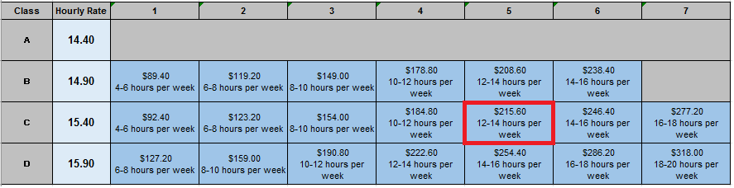

These gradings were determined using the newly updated Director job descriptions. Working with the current coordinators/directors, Graeme Noble, VP-Admin, worked to update the job descriptions. The review was done based on the newly updated descriptions, as responsibilities have been more clearly outlined and indicated for these jobs, as well as how they will end up working in tangent with the new Assistant Director Roles.

Please see an outline of the changes below:
- Pride Director:
  - Formally D3 ($15.90/Hour, 10-12Hours/Week, $190.60/Week)
  - Updated to C5 ($15.40/Hour, 12-14Hours/Week, $215.60/Week)
- SHEC Director:
  - Formally D3 ($15.90/Hour, 10-12Hours/Week, $190.60/Week)
  - Updated to C5 ($15.40/Hour, 12-14Hours/Week, $215.60/Week)
- Diversity Services Director:
  - Formally D4 ($15.90/Hour, 12-14Hours/Week, $222.60/Week)
  - Updated to C5 ($15.40/Hour, 12-14Hours/Week, $215.60/Week)
- WGEN Director:
  - Formally D5 ($15.90/Hour, 14-16Hours/Week, $254.40/Week)
  - Updated to C5 ($15.40/Hour, 12-14Hours/Week, $215.60/Week)
- Maccess Director:
  - Formally D4 ($15.90/Hour, 12-14Hours/Week, $222.60/Week)
  - Updated to C5 ($15.40/Hour, 12-14Hours/Week, $215.60/Week)
- Spark Director:
  - Formally D3 ($15.90/Hour, 10-12Hours/Week, $190.60/Week)
  - Updated to C5 ($15.40/Hour, 12-14Hours/Week, $215.60/Week)

Should there be any questions or concerns please do not hesitate to contact any member of the Wage Review Committee.

Jess Anderson
Vice-President (Finance) & CFO
vpfinance@msu.mcmaster.ca

Maddison Hampel
Human Resources Generalist & Clubs Support
hr@msu.mcmaster.ca

Giancarlo Da-Ré
MSU President & CEO
president@msu.mcmaster.ca

