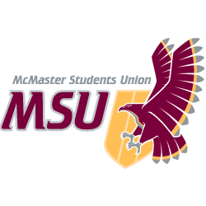. | REPORT  From the office of the…  Kinesiology Caucus
TO: | Members of the Student Representative Assembly
FROM: | Charlie Violin, Manpreet Chopra
SUBJECT: | SRA 20J Report
DATE: | January 19, 2021

Progress on Year Plan

- Helped to Advocate for a safe reopening of the Pulse and DBAC through a survey on our social media.
  - the results of the survey were generally to open the Ath & Rec (76%), with 35% of students wanting a reduced fee and the remaining 41% said they would pay full price for a safe reopening of the pulse.
- Although 76% of students said they wanted Ath & Rec facilities to open in the Winter semester we must acknowledge that almost 72% of respondents were from the Kinesiology program, which may heavily skew the data.
  - Shoutout to Ryan, the VP of Education, for accepting the results of our survey and keeping the needs of our constituents in mind throughout this challenging time.
- The full results of the survey as they were sent to the VP of Education are listed at the bottom of this memo for those interested.

Past Events, Projects, & Activities

- FROST Week w/ Kin Society
  - Speed Friendships using an Icebreaker website, where students would randomly be paired with another or group of students for a few minutes talking about themselves using prompts. Had a great turnout of about 40 students and many students are looking forward to participating in a similar event in the future.
  - In Family Feud, students registered in teams of 5 or were put into a group. Groups had 15 mins to answer questions on a google form, all groups then voted for the best answers to the questions. A great turnout of about 60 students.
  - Virtual Escape Rooms also had a great turnout
- Promoted ‘Tukes from the Heart’, a non-profit organization founded by a mac alumni, that makes tukes out of old hockey socks and donates one tuke for every one sold.

Upcoming Events, Projects, & Activities

- Met with the Diversity & Inclusion rep on Kin Society and discussed the great A2L page that Graeme has put together for MSU Exec. training.
  - D&I rep will now share information from that page at weekly meetings on KS
  - looking into starting an IGTV series featuring members of KS talking about struggles and challenges we have faced and how we have overcome them, A Struggling Kinmmunity.

Current Challenges

- Kin Society has moved away from office hours due to a lack of engagement
  - Kin SRA working with KS to bring back some form of office hours to let students know what we are working on and to help answer any concerns they have about events and their academic challenges
- We have noticed that many course instructors have forgotten to acknowledge the indigenous lands that we are learning and living on and have asked the Kin VP Academic to remind the faculty of this important acknowledgment and hope those other SRA members do the same if they have noticed this as well.

Successes

- Ath & Rec survey had 165+ responses in just 2 days, and it was great to see it be shared by the Kin Society Instagram as well as from our constituents
- Great turnout for FROST week events
- Kin Academic Affairs Council has put together a google calendar for every Kin course to help alleviate the stress of students having to create their own course schedules

Best,

Manpreet Chopra
SRA Kinesiology Caucus Leader
McMaster Students Union
srakin@msu.mcmaster.ca

. | REPORT  From the office of the…  Kinesiology Caucus
TO: | Athletic & Recreation
FROM: | Charlie Violin, Manpreet Chopra
SUBJECT: | Survey, Ath & Rec Facilities Opening
DATE: | December 21, 2020

The following report presents the results of a survey; sent mainly to Kinesiology Undergraduate Students through various Facebook group chats, shared on Snapchat, as well as posted to the @SRA.Kinesiology Instagram and Facebook pages. The survey was composed of five questions; two were demographic questions, and three questions asked students to share their opinions on whether or not, and how Athletic & Recreation facilities should open.

The survey received 165 responses from individual students of all years and almost all faculties, between December 16 and December 19, 2020. 119 students were from Kinesiology, 19 from Science, 9 from Business, 5 from Engineering, 5 from Health Science, 3 from Humanities, 3 from Nursing, and 2 from Social Science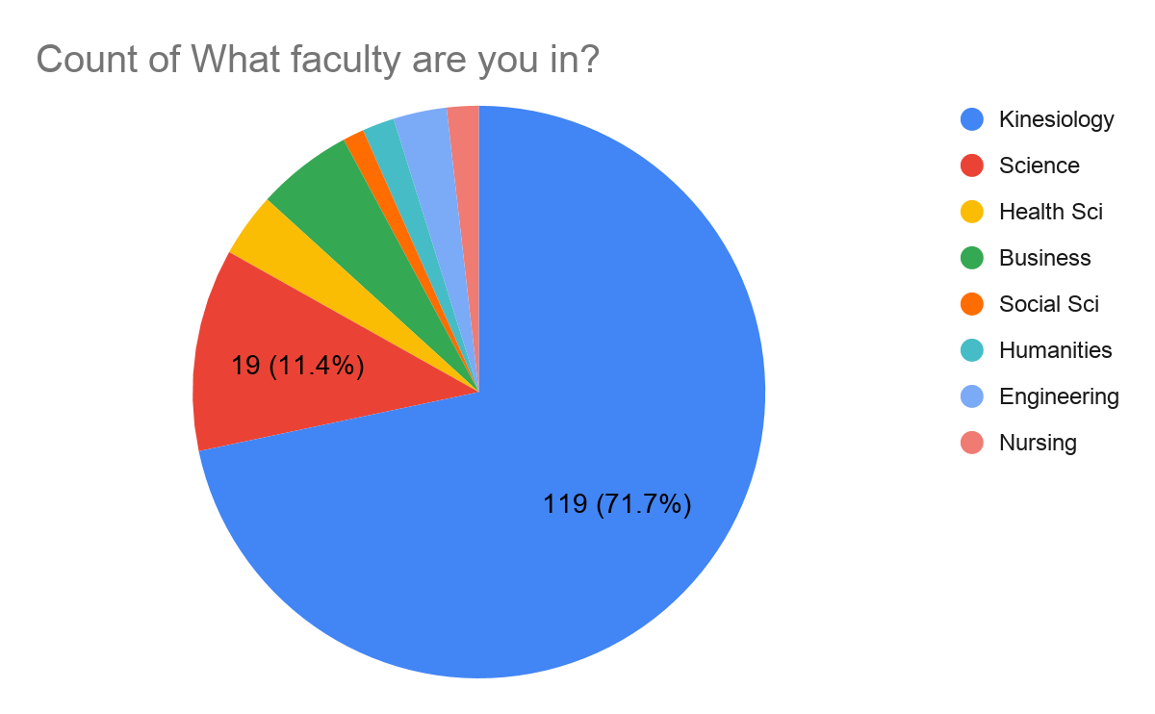
Almost 41% of respondents were in Level II, 33% in Level III, 15% in Level IV, and a small number in both Level I and level V+.
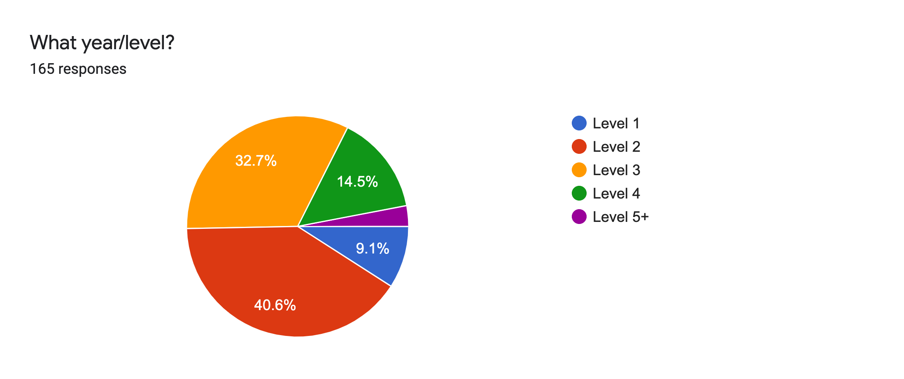
The first opinionated question asked to students was the following: If the university decides to open athletic facilities, students would likely pay close to the full Ath&Rec fee for the second semester. While if the facilities remain closed, we expect the university to continue with a 75% Ath&Rec fee reduction for the second semester (same as the fall semester). Over 76% of students are in favour of Ath&Rech facilities (including the Pulse) opening, and of that, almost 54% are okay with paying close to/or full price, while 46% want a reduced price. The last 39 students would have opted for Ath & Rec facilities (including the Pulse) to remain closed.
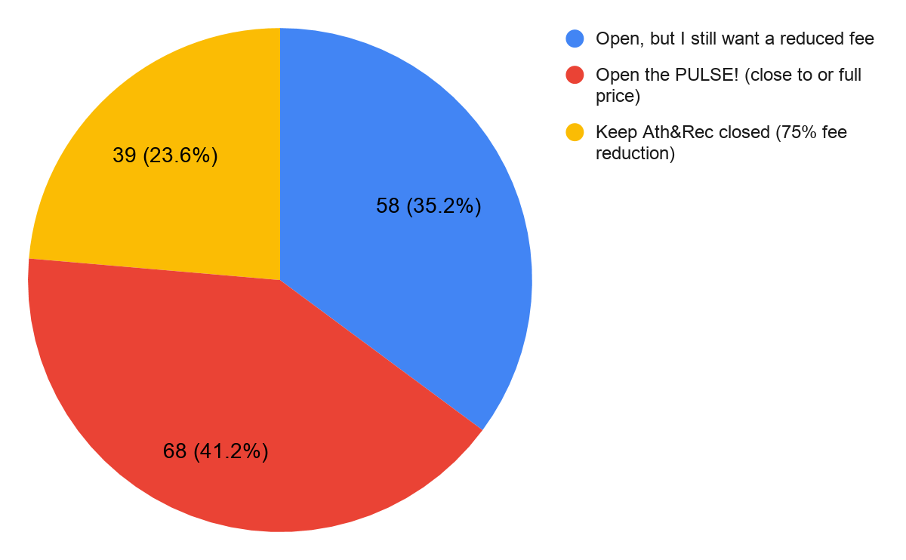
The second opinion based question was: If Hamilton goes into lockdown…, they would a) want a refund for the time Ath&Rec facilities are closed, b) fine with paying the full fee, even if they only got to use the facilities for a brief time. 81% of students would want a) a refund for the time Ath&Rec facilities are closed. The remaining 19% opted for option b) fine with paying the full price, even if they only got to use the facilities for a brief time.
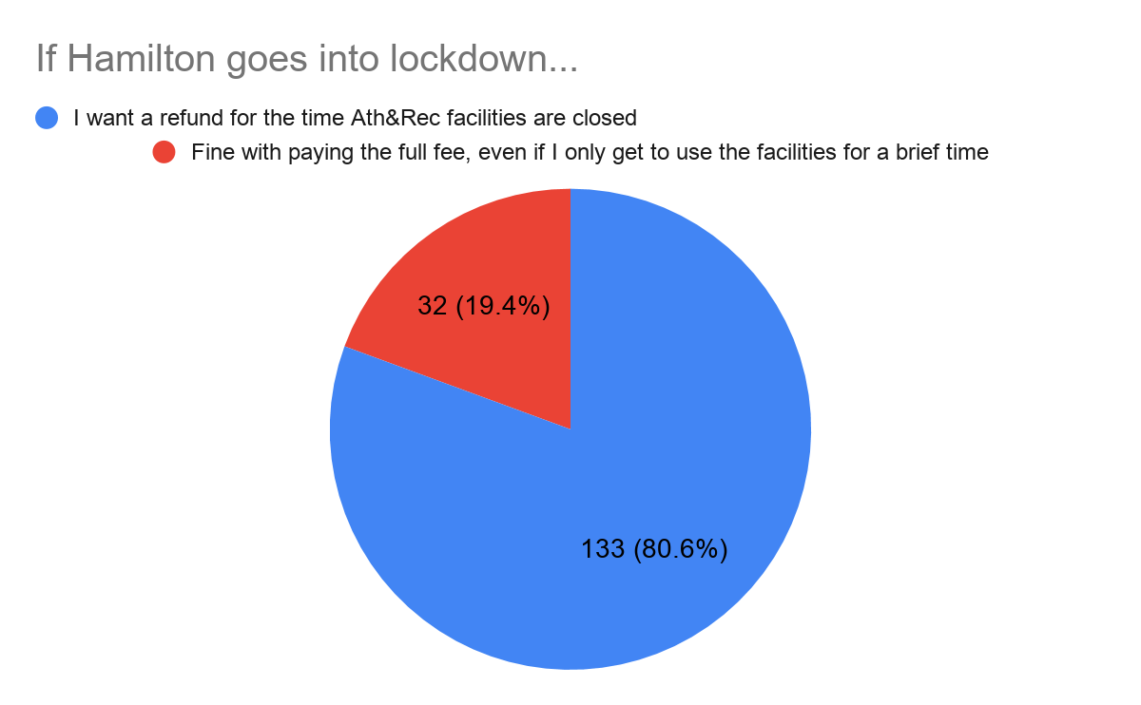

The last question on the survey asked students to Select which applies to them and were reminded that students will have HSR Bus Passes for the Winter. 73% of the students said they were located in Hamilton or close enough to make use of the facilities, 31% were concerned about COVID-19 protocols if open, 27% said if Ath&Rec is open that they want access to more buildings to study, and 32 students said they would not be able to access the facilities and didn’t want to pay for something they can’t even access.

The preceding survey - as mentioned, primarily asked Kinesiology undergraduate students. This lays a heavy bias against the argument of wanting Ath & Rec facilities (including the Pulse) to open. We also acknowledge that those inclined to vote in favour of Ath & Rec opening are also more likely to fill out this survey in the first place, this is also another bias in the results of our survey.

I and Manpreet Chopra, SRA Kinesiology Cacuase Leader, have agreed that in line with students wishes, we would like the MSU Executive Board:
- to advocate for an Athletic & Recreation facilities opening that includes access for students to the: basketball courts, meditation studio, squash courts, the pop-up, and the pulse, as well as the old squash courts and auxiliary gym.
- that the Winter 2021 Ath&Rec fee be reduced 40% from the intended regular price to allow for fairness among those students that are and are not able to access, and those that simply won’t and will use it, throughout this time with COVID-19. The 40% fee reduction would also reflect the decreased capacity of the Pulse.
- that all COVID-19 health protocols are in place if A&R opens
- the University create a fair pre-booking system for all students
- allow students more access to at least one Library on campus to study
- and that, if Hamilton enters into a Lock-Down or a state where A&R cannot be open. That the University refund any difference between the originally charged A&R fee and the time facilities are close due to COVID-19.

We hope the MSU will advocate the above to the University, and that the University strongly consider the students’ wishes.

NEW: As of Monday December 21, 2020 Hamilton Region will be placed in a lockdown, and as such, the continued 75% fee reduction would be welcomed.

All the best,

Charlie Violin
SRA Kinesiology
Caucus Member

violinc@mcmaster.ca

