REPORT
From the office of the…
Health Sciences Caucus
.

TO: Members of the Student Representative Assembly

FROM: Bethel Samson
SUBJECT: SRA 20L Report
DATE: January 18, 2021

Progress on Year Plan
We contributed to the BHSS’s to add to their mid-term report. We stated the following information which is relevant here as well.

Platform | Progress
- TA Reform - Training and Feedback forms.  - Connectivity - Improve connection with BHSc students and the wider MSU community.  - Anti-Security/Anti-HPS awareness & advocacy  - Greenery in HSL  - Restore LearnLink documents | - Still in talks with the dean and course departments about how to bring in training. Helped implement TA feedback forms in Epi (HTH SCI 2G03) with Russ. Looking to see what other courses to pilot next. Also in talks with faculty to make it more widespread.  - BHSS and SRA connectivity going strong - lots of communication with Chair and SRA x BHSS events in planning. Social media game is strong too. We widely circulate Instagram graphics about what MSU is, how to get involved with it, and the MSU Clubs updated policies that were under a lot of discussion earlier in the year.  - We did a lot of social media advocacy and awareness work using defund HPS on social media. Hopefully our followers gained some knowledge about the important change happening in our city. We also went to protests, passed a motion with the SRA in support of the protestors downtown and used the SRA special projects fund and donated money to the cause.  - Alas there was no greenery in HSL.  - Still talking to Academic and communication about this one! More to come in the new year.

Past Events, Projects, & Activities
Our most recent project was the Feedback Form. Here are the results.
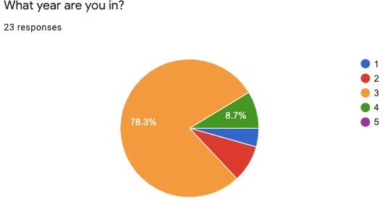
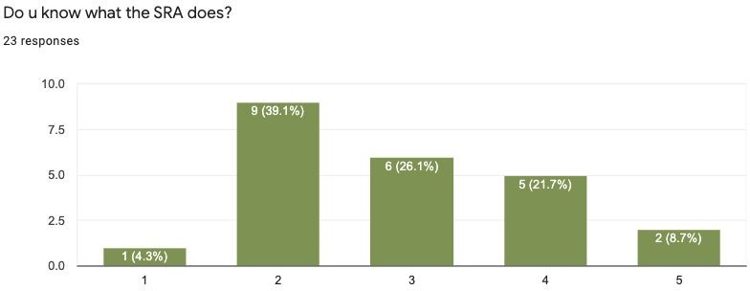

Take away - more than 50% STILL doesn’t know what the SRA does. Some common suggestions were:
- IG stories
- FB Posts
- Teams posts
- “Follow us back”
- Instagram story takeovers
- Let us see your faces

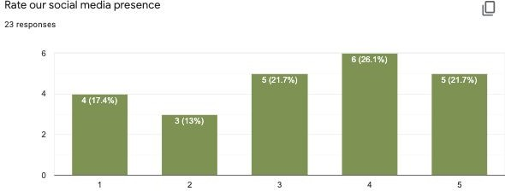

Take away - 60% of our constituents think we have good social media presence but don’t feel informed. I think this means although we have a lot of posters and posts they are probably not the most memorable.
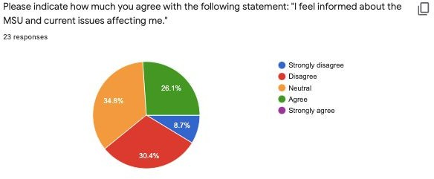
Common suggestions we received were:
- More casual posts & updates while we are just working
- Use the BHSc Teams

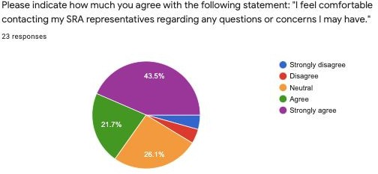

Take away - 92% of our caucus is neutral - strongly in agreement with the statement above!

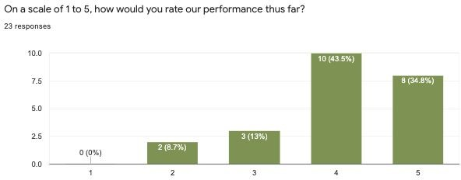

Key takeaway - Only two people said ⅖, no one said ⅕, and 80% said ⅘ or above.

Upcoming Events, Projects, & Activities
- The LearnLink revival
- The implementation of this feedback. Right now we are discussing ways on how to post me & Zoe’s faces more often because that is apparently what our caucus wants<3.
- We are also working with BHSS president on maybe making a SRA channel on the Teams

Current Challenges
- Engagement and awareness: we truly thought we were doing enough to engage with BHSc but turns out a lot of people don’t know exactly what the SRA is and what MSU issues we talk about every other week that affect their school
  - We thought that the stuff we were currently doing was enough through INstagram promotion but some of the feedback that we got was to post on Teams or send messages in the FB year group chats. I think we will consider moving some of our promotions to Teams for the people who don’t have INstagram/don’t want to follow us??
- Reviving LL seems very challenging. We may need funding to buy GB of storage to add to our Program’s website and upload all the academic documents but we’ll see about that!

Volunteers (Standing Committees only)
- Zoe’s updates: SCI report is going thru final editing stages
- Bethel’s updates: simply chugging along on the Mental health paper, the MA paper.
Just lots of writing.

Successes
- Our collaboration with the BHSS has been great. We fluidly partner up on a bunch of different projects. Seamless teamwork & we are always at their weekly meetings.
- The feedback form got a surprising amount of responses. I thought it was going to be like 9 but it was 25 so the results are probably accurate and generalizable
  - A nice take away - 92% of our caucus is neutral - strongly in agreement with the statement above “i feel comfortable reaching out to ask

questions/suggestions”

Other
N/A

Best,
Bethel Samson
SRA Health Sciences Caucus Leader McMaster Students Union srahealth@msu.mcmaster.ca

