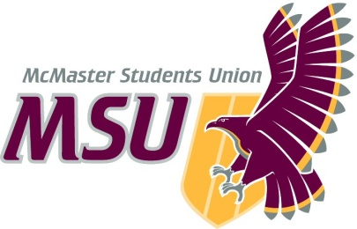. | Report  From the office of the…  Executive Board
To: | Members of the Student Representative Assembly
From: | Graeme Noble, Vice-President (Administration)
Subject: | Executive Board
Date: | January 25, 2020

Introduction
Dear Members of the Assembly & Committee Chairs,

Here are the major points to hit on from the first and only meeting of the Executive Board (EB) in 2021:

Sponsorship & Donations Request
The following Sponsorships were approved by EB, as proposed by Sponsorship & Donations Committee:
- Sponsorship – Relay for Life for $250
- Sponsorship – McMaster Artificial Intelligence Society for $400
- Sponsorship – United Nations Association of Canada for $100
No comments or questions came up.

Peer-Support Service Changes
Tons of changes came up for Peer-Support Services, but here are the main points are as follows:
- Diversity Services is now a Peer-Support Service.
- Peer-Support Service Coordinators have now been retitled to Directors.
- Volunteer Coordinators have been retitled as Assistant Directors and will now be given monetary compensation for their work.

Organizational Chart Comparisons
Before (Left) & After (Right)
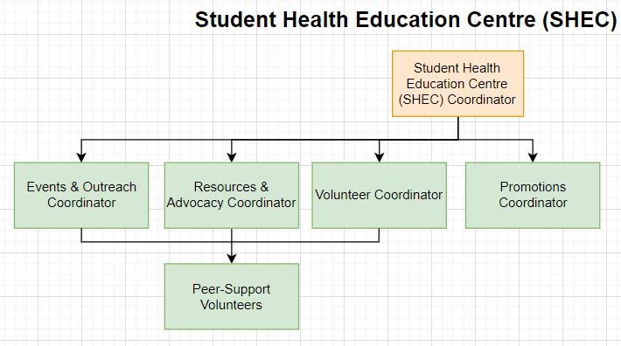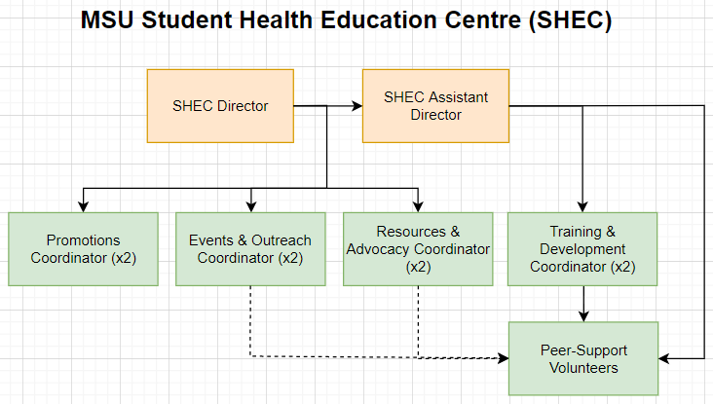
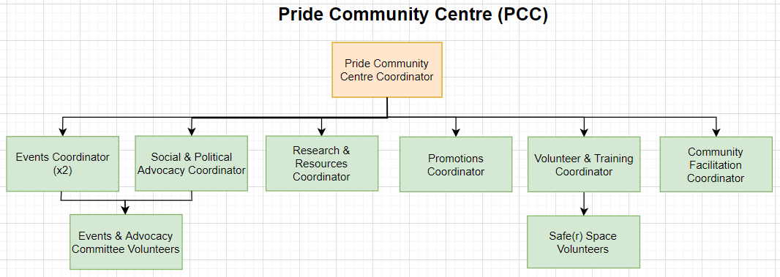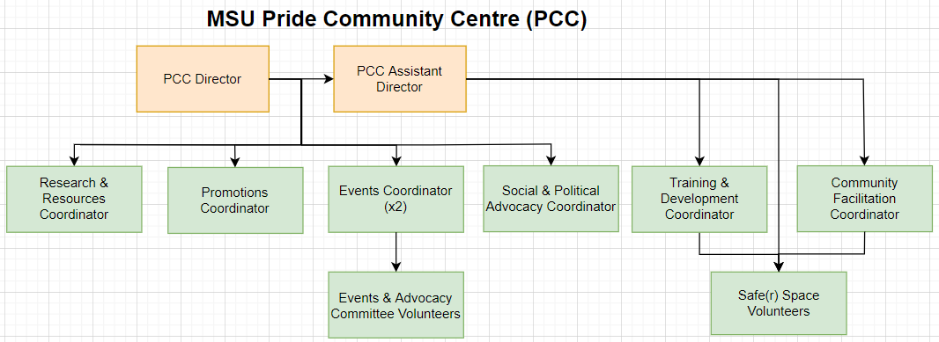
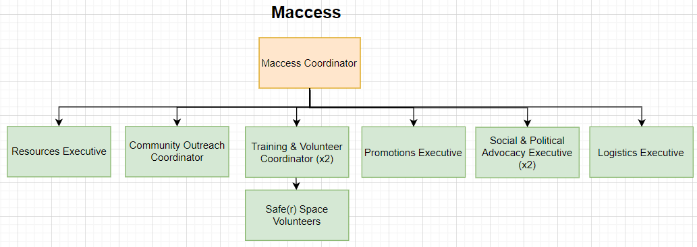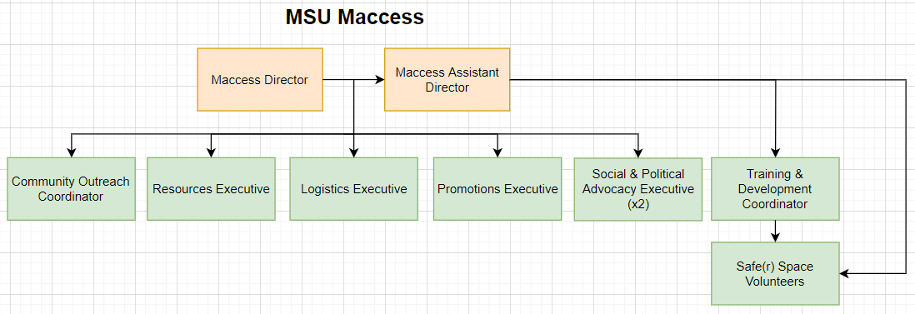
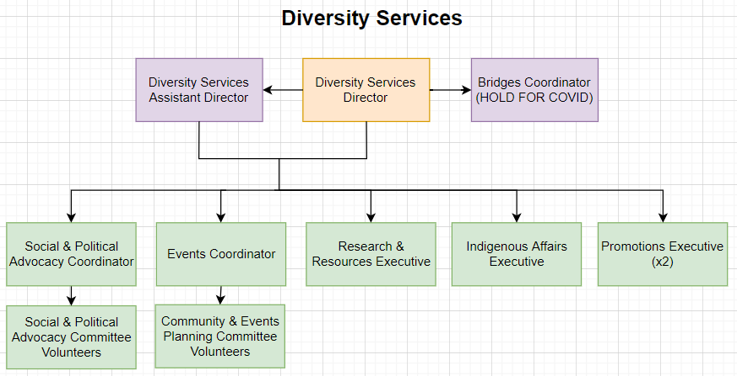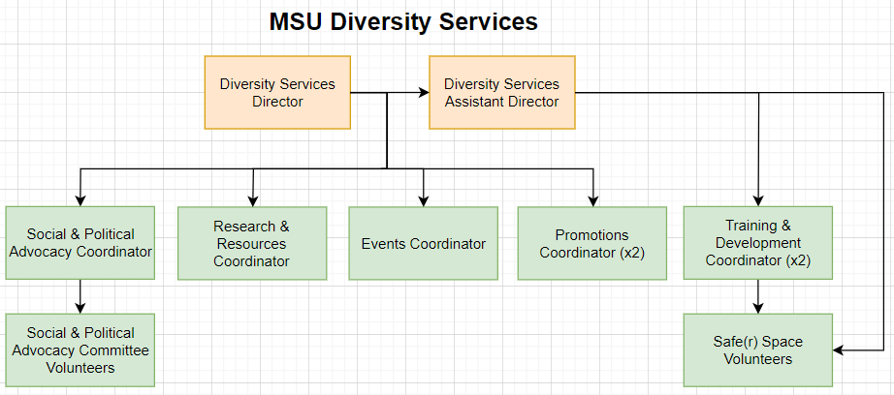
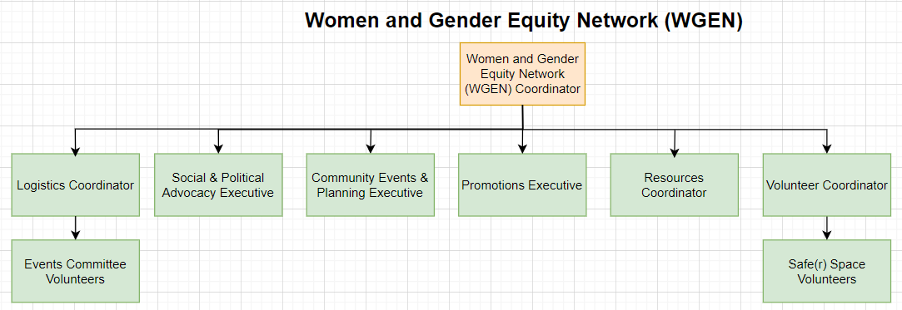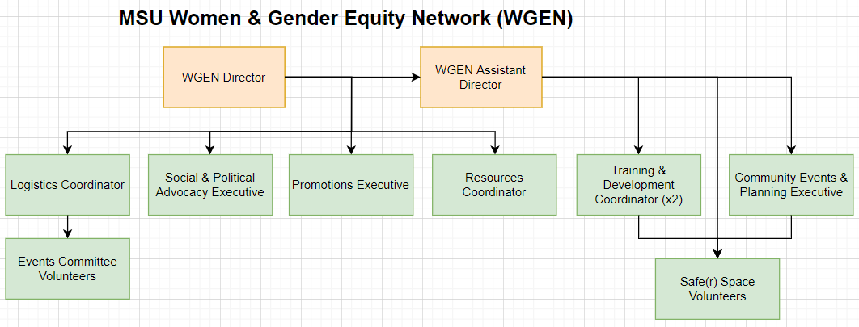

MSU Spark Changes
As a result of the Service merger, here are the notable changes to MSU Spark:
- Spark Coordinator has now been retitled to the Spark Director.
- The Volunteer Coordinator has been retitled as Assistant Director and will now be given monetary compensation for their work.

Organizational Chart Comparison
Before (Left) & After (Right)

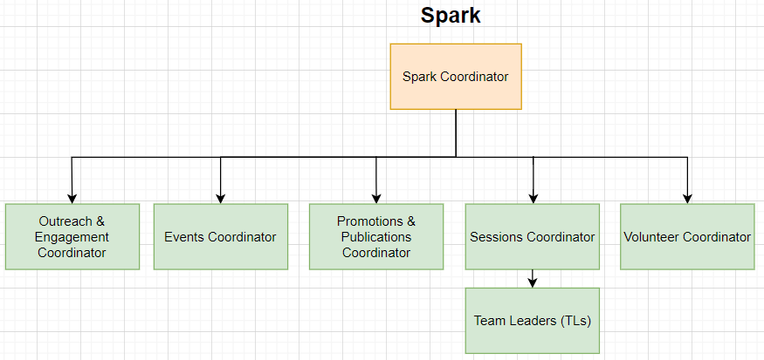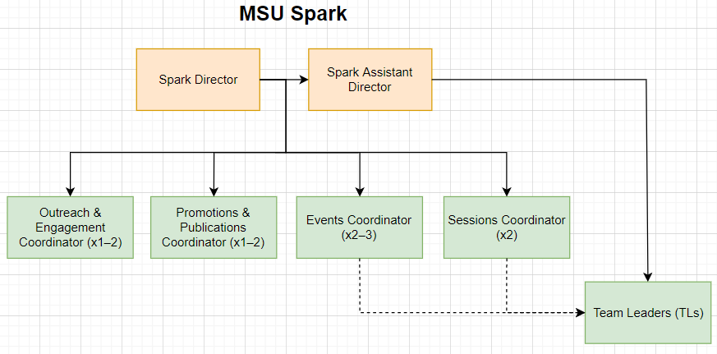

Please let me know if you have any questions or concerns prior to/during the meetings.

Kind regards,

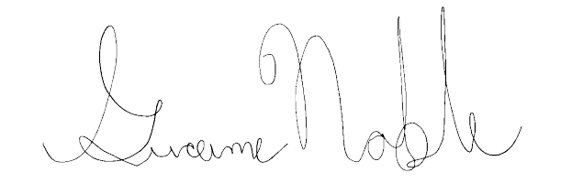
Graeme Noble
Vice-President (Administration) & Chief Administrative Officer
McMaster Students Union
vpadmin@msu.mcmaster.ca

