Yearplan Update:
. 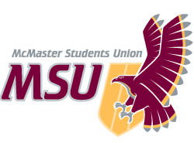 | REPORT  From the office of the…  MSU Pride Community Centre Coordinator
TO: | Members of the Executive Board
FROM: | Christian Barborini
SUBJECT: | Pride Community Centre Report #6
DATE: | 2021-01-28

In accordance with our year plan, we have held a brief training refresher session with our safe(r) space volunteers. This allowed us to re-open our discord safe(r) space as well as peer support line offered via tawk.to on January 18th. Community engagement groups also started up again the week of January 25th. In addition, we have been in the midst of planning our largest annual campaign, Mac Pride Week which will feature 8 different events throughout the week of February 8th.

Service Usage:
Since my last report, we closed our safe(r) space on December 9th for the holidays and re-opened on January 18th. As such, our safe(r) space usage is reported from last term in full along with the week of January 18th. We also offered an Exam Destressor event at the beginning of December as well as a Holiday Event on December 22nd.

Community Groups:
Community Groups were started up again this week (January 25th) and as such, group turnout from the Fall 2020 academic term is reported below. We have yet to start our Disabled Queer and Trans Group with Maccess. We have been experiencing no attendance to our Black, BIPoC 2STLGBQIA+ and Trans & Non-Binary Groups. Attendance numbers will be reported for Winter 2021 in our next EB report.

Fall 2020 PCC Community Group Attendance:
Date | Community Group | Attendance | Sessions | Average
Mondays | Asexual and Aromantic Group | 15 | 5 | 3
Mondays | Bi-Pan-Poly Hour | 3 | 5 | 1
Mondays | Newcomers 2STLGBQIA+ Group | 11 | 5 | 3
Tuesdays | Where We Come From | 1 | 5 | 1
Tuesdays | Black 2STLGBQIA+ Group | 0 | 5 | 0
Wednesdays | Men Loving Men | 4 | 5 | 1
Wednesdays | Women Loving Men | 8 | 5 | 2
Wednesdays | Trans & Non-Binary Group | 0 | 5 | 0
Thursdays | BIPoC 2STLGBQIA+ Group | 0 | 5 | 0

Events:
Since my last report, we have run 2 events (see below).

Date | Event | Attendance | Collabs
2020-12-09 | Exam Destressor | 9 | NA
2020-12-22 | Non-Denominational Holiday Shebang | 6 | NA

PCC Safe(r) Space Usage:
Since my last report, we have had no new members join our Discord Space with a grand total of 109 members currently occupying our Discord. Space usage between the dates 2020-11-20 and 2021-01-22 are shown below (excluding PCC execs and volunteers). In the Fall, our space was open Monday-Friday from 10AM to 4PM. This semester, we have decided to modify our hours of operation so that we also offer an evening support option. As such, we are now open Monday-Friday from 12-3PM and 6-9PM. Note that our safe(r) space was closed for the holidays from December 9th, 2020 until January 18th, 2021.

Dates | Platform | Space Usage
September 30th – October 3rd | Discord | ~21
October 3rd – October 30th | Discord | ~23
October 30th – November 20th | Discord | ~8
November 2nd – 20th | Tawk.to | 1
November 20th – January 22nd | Discord | ~16
November 20th – January 22nd | Tawk.to | 1
November 20th – January 22nd | Zoom (Video Support) | 1

Social Media:
The following numbers for our three social media platforms are shown below:

Platform | 2020-11-20 | 2021-01-22
Facebook | 1211 followers | 1210 followers
Instagram | 857 followers | 870 followers
Twitter | 1032 followers | 1032 followers

Past Events, Projects, & Activities:

Community Engagement Groups:
We restarted our community groups the week of January 25th. All groups are once again being run through Zoom with live captioning offered via Otter.ai. The same groups are offered as last semester, though the groups are offered at different times. We have also created private community group discord channels for each group on our server. This has created an alternative medium for folks to participate in our groups and stay connected.
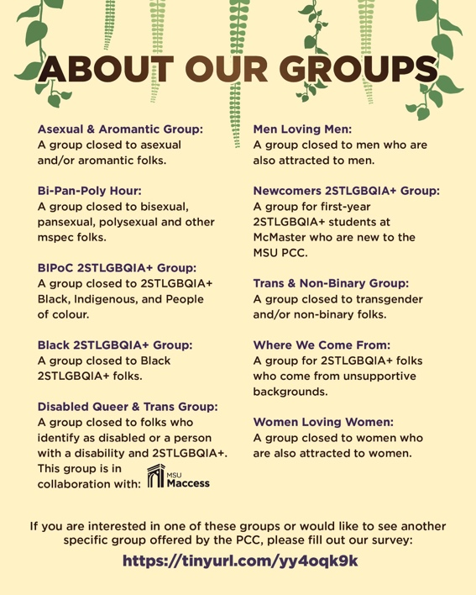
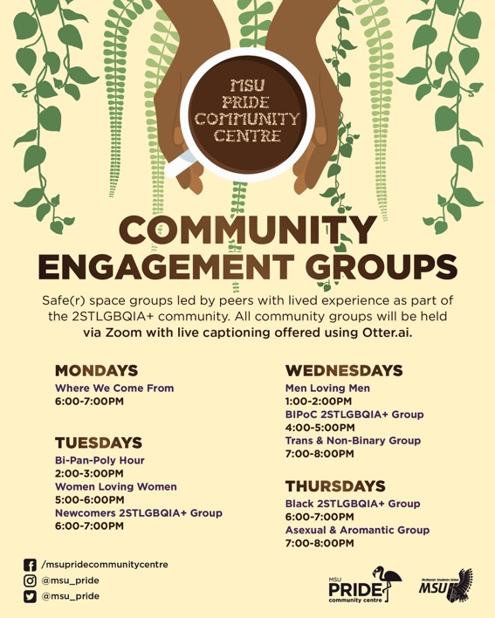
Exam Destressor Event:
To kick off the end of the fall semester, we ran a space for 2STLGBQIA+ students to destress before entering exams. The event took place on December 9th, was very successful, and received good attendance.

Non-Denominational Holiday Shebang:
December can be a hard time for many 2STLGBQIA+ students especially those who are not out to their families and have to conceal their identity during the holidays while back at home. As such, we offered this space (closed to 2STLGBQIA+) to celebrate the holidays with chosen family on December 22nd. The online nature of events has offered this opportunity which we historically have not been able to run in previous years.

Upcoming Events, Projects & Activities:
We have been focusing much of our attention on re-opening our space and getting our community groups back up and running. In addition, our events team has been working hard to put together Mac Pride Week which is our largest annual campaign. Now that our safe(r) space is open and running, Mac Pride Week will be the main focus of our exec team in the coming weeks.

Currently Working On:

Mac Pride Week:
PCC’s largest annual campaign week which celebrates queer existence and the diverse identities that make up our community. We will be running this campaign week from February 8th-12th. The theme for Mac Pride Week this year will be Joy in Queerness. We have a series of eight events planned for the week which are listed below:

- Self-Love, Self-Touch: Trusting Your Body Again Through Dance (closed to BIPoC 2STLGBQIA+ folks)

- Each/Other: A Coffeehouse Celebrating BIPoC and Our Relationships (Performances closed to BIPoC 2STLGBQIA+ folks, Coffeehouse open to everyone) in collaboration with Queer and Trans Colour Club

- Fully PrEP'd in collaboration with MSU SHEC

- 2STLGBQIA+ Indigenous Sharing Circle
(closed to indigenous 2STLGBQIA+ folks) with De dwa da dehs nye>s

- Breaking the Model Minority Mould
(closed to BIPoC 2STLGBQIA+ folks) in collaboration with Queer and Trans Colour Club

- We Are Here! We Are Queer!
(closed to 2STLGBQIA+ folks)

- We Will Get Through This: Positive Affirmations Through Art
(closed to 2STLGBQIA+ folks)

- Spreading Queer Joy: Pride Book Club Kick-Off
(closed to 2STLGBQIA+ folks)

2STLGBQIA+ in STEM Panel Event:
PCC along with the Bachelor of Health Science Student Society (BHSS) and McMaster Science Society (MSS) will be hosting a panel of scientists, engineers, and medical professionals who are also 2STLGBQIA+ and willing to share their experiences. The purpose of this event will not only raise awareness to allies about the unique barriers faced by 2STLGBQIA+ folks in STEM but will also empower 2STLGBQIA+ students who may share similar experiences. As such, the hope is that this event will create a united community of 2STLGBQIA+ scientists, and engineers alike. Although an exact date and time for the event has yet to be decided, it will most likely be taking place the week of March 1st.

Transcendence:
Our final campaign week of the year which is dedicated to the McMaster transgender community. We are in the early stages of planning this campaign week, but we are anticipating that this will take place the week of March 15th and involve 4-5 separate events.

Resources:
The content for our 2STLGBQIA+ Handbook is at completion and we are now working with Wooder and the MSU Underground to get it published. The handbook contains three sections including general terminology, pronouns and use of transgender inclusive language, as well as resources. We also have incorporated an appendix with detailed descriptions and information on gender-affirming procedures and surgeries. In addition, we are seeking the possibility of increasing our library of gender-affirming gear accessible to students. We hope to connect with WGEN about this in the coming weeks to see how our services can work together on offering a wider range of gender-affirming gear. Lastly, before the end of the year, our Resource Coordinator is hoping to put together a resource delineating queer friendly businesses, shops, and services in the Hamilton and GTA area (ie. hairdressers, coffee shops, etc).

PCC Service Rebrand:
Myself and my executive team are making it a priority to work alongside Wooder and Elisabetta to complete the PCC service rebrand before the end of my term as PTM.

Budget:
Our most recent payments have come from Mac Pride Week.

ACCOUNT CODE | ITEM | BUDGET / COST
5003-0119
Office | TOTAL SPENT IN LINE | $0.00
 | REMAINING IN LINE | $100.00
5202-0119 | 1.) Disabled & Queer Community Art Circle  2.) Donation to Speqtrum Hamilton
Outreach | TOTAL SPENT IN LINE | $250.00
 | REMAINING IN LINE | $0.00
6102-0119 | 1.) Self-Care and Queer Resilience Event  2.) From Monocles to Manbuns: Drag Show  3.) Self-Love, Self-Touch: Trusting Your Body Again Through Dance  4.) We Will Get Through This: Positive Affirmations Through Art
Campaigns | TOTAL SPENT IN LINE | $1400.00
 | REMAINING IN LINE | $1600.00
6494-0119
Volunteer | TOTAL SPENT IN LINE | $0.00
 | REMAINING IN LINE | $750.00
6501-0119 | 1.) Pride Myth Busters Campaign  2.) Pride Student Network Promo  3.) Community Engagement Group Promo  4.) 2STLGBQIA+ History Week Promo  5.) Queer History Trivia Starbucks Gift card  6.) 2STLGBQIA+ History Week Raffle Prize  7.) Mac Pride Week Promo
Promo | TOTAL SPENT IN LINE | $1150.00
 | REMAINING IN LINE | $550.00
6604-0119
Resources | TOTAL SPENT IN LINE | $0.00
 | REMAINING IN LINE | $300.00
6804-0119 | 1.) Fully PrEP’d Workshop
Training | TOTAL SPENT IN LINE | $150.00
 | REMAINING IN LINE | $350.00
TOTALS
TOTAL BUDGETED DISCRETIONARY SPENDING |  |  | $6600.00
TOTAL ACTUAL DISCRETIONARY SPENDING |  |  | $2950.00
REMAINING DISCRETIONARY SPENDING |  |  | $3650.00

Volunteers:
We have had full retention of our safe(r) space volunteers with all 29 volunteers interested in continuing with the PCC for the Winter 2021 term. As such, we decided not to re-open volunteer hiring. Safe(r) space volunteers have signed up for peer support shifts (minimum of 2 shifts per volunteer). Volunteers who are also running community groups have been given the option to take on less peer support shifts during the week. We also ran a volunteer appreciation event over the holidays and intend to hold 1-2 more volunteer appreciation events before the end of the term.

Events and Advocacy Committee Meetings have started up again for the Winter 2021 term every Thursday evening. We unfortunately have had one Events and Advocacy Volunteer drop their position with the PCC. We now have a total of 5 Events and Advocacy Committee Volunteers for the remainder of the term.

Current Challenges:
One of the main challenges we noticed as our space opened this past week is volunteers not showing up for their shifts without giving notice. We are now enforcing a three-strike policy with volunteers whereby if there is a no-show based on the attendance sheet 3 times, they will have a meeting with an exec to check-in and remind them of the commitment they have made to the PCC.

I also wanted to express my frustration regarding the lack of communication Coordinators have been receiving from the MSU specifically around incoming Coordinator hiring. Since November, we have received mixed hiring timelines leaving us unsure when we are to plan for the added weight of hiring in our schedules. For example, initially, I was told that the incoming PCC Coordinator position would open on November 30th. This later changed to January 18th with applications closing by ~February 1st in order to allow for resume review and interviews before reading week. This past Tuesday January 19th (without any indication until days later), the position was finally posted, however, the closing date was very different from the timeline which I and other PTMs had expected and planned for (February 20th). This is extremely unprofessional and imposes on the schedules of PTMs who are also full-time students. Moreover, I felt very rushed and anxious to confirm that these new hiring dates still worked with the member of EIO which will be assisting with hiring of the incoming PCC Coordinator. I would have appreciated if this was not sprung upon us, leaving Peer Support Coordinators to frantically follow-up with their respective EIO interview panel members to ensure their availability.

On the similar note of communication, I have felt very much in the dark about the PCC service review and after providing edits to the survey, I was not notified when the survey was released and rather found out from Yimeng, the WGEN Coordinator. This resulted in me not sharing the survey with our volunteers until the beginning of January since I kept off social media for the majority of December and would have had no other way of knowing that the service review for the PCC was underway. PTMs should not be expected to frequently check social media or hear from others when their service reviews are released, but rather should be communicated with directly.

On November 16th, 2020, the Queer and Trans Colour Club (QTCC) hosted a panel during the MSU’s Anti-Racism Month discussing the experiences of BIPoC 2STLGBQIA+ folks. Although the PCC was (regrettably) not involved in the panel, one of my execs partook in the panel and we work very closely with the QTCC in general. During this panel, various questions were directed at the MSU regarding support for racialized queer students as well as questions addressing the closure of the PCC in Winter 2020. QTCC has yet to hear back regarding the answers to these questions. Moreover, the panelists, all of which are racialized queer students, have yet to receive the compensation they were promised for their emotional labour. The QTCC Co-Presidents, Talia Tissera and Kriti Manuja have also not yet been compensated for moderating the panel nor have they received the recording of the panel as was initially agreed upon. If the MSU intends to hold campaigns such as Anti-Racism Month, they must truly invest in anti-racism. This requires listening to students who have been impacted by the MSU rather than shutting them out and ignoring their emails. This means working with students to see how the MSU and other institutions that uphold racism can improve to ensure the safety of their racialized students. As the PCC Coordinator, I urge the MSU to face the questions put forward by the QTCC, hold the MSU accountable, and show your students that holding such events was not merely a performative action.

Finally, I am hoping that with Mac Pride Week coming up at the beginning of February, we will have the support of the MSU social media in promoting our events and programming. I was disappointed with the lack of coverage our 2STLGBQIA+ History Week received, especially considering the PCC was shut down for a whole semester last winter and this was the first time the PCC had held a campaign in an entire year. Prior to 2STLGBQIA+ History Week, I had emailed Khaleel, the Social Media Coordinator asking that our events be circulated on the MSU socials. I did not hear a response back until midway through 2STLGBQIA+ History Week when I was told that the MSU would promote the remaining 3 events that were being held for the week (our 6 other events were never mentioned on the MSU socials). As a PTM, I have been very good at ensuring that the MSU events calendar is updated on a regular basis and have done exactly as I have been told, often going above and beyond by reaching out to the MSU to help promote our events. I hope we can rely on support from the MSU in spreading the word about Mac Pride Week which myself and my executives have worked hard to bring to the student body.

Successes:
Seeing that we are early on in the semester, we have not had a chance to fully execute many of our plans besides space opening and community groups. However, although we have been experiencing some attendance issues with shifts, I am really thrilled to have such a wonderful volunteer and executive team who have continued as volunteers into the Winter term despite lots of trouble shooting which we endured in the Fall. My executive team and I have been very grateful for our volunteers working with and bearing with us to make the PCC as accessible and effective this year as possible.

