. | Memo  From the office of the…  Vice-President (Administration)
To: | Executive Board Members
From: | Graeme Noble, Vice-President (Administration)
Subject: | Amend Job Descriptions – MSU Spark
Date: | January 14, 2021

Introduction
Dear Members of the Executive Board (EB),

As all voting members should be all too familiar with, the MSU Horizons Service has been officially rescinded, thus putting it on a minimum hiatus of 2 years before any motions may be considered for its revival. I am writing this memo today to show that all is not lost: in fact, that’s far from the truth!

This potentially temporary adaption on the part of the MSU, largely due to the limitations of pandemic-hosted conferences, serves as an excellent opportunity for the student leadership Services of the MSU to thrive during this ever-changing time. As other key campus stakeholders either translate their incoming student transition programs to a centralized format or create brand-new ones to accommodate the needs of the pandemic, this proposal seeks to leverage the MSU’s existing programs to create a unified pillar of support for incoming first-year students. Here’s what I mean:

Proposal
Now, for readers who have recently seen my memo regarding updated projections for the evolution of Peer-Support Services, this will sound a tad familiar.

General Changes

Overall, the most significant changes come from the combination of resources from both Services and the culmination in a reduced MSU Horizons service delivery plan. Due to the high human capital demands of a conference, this combination allows for additional support for MSU Spark to carry out responsibilities like those executed by MSU Horizons this past summer. This combination thus allows for sufficient resources to continue this well-received transition-oriented programming for incoming first-year students while also providing time and liberties to perform regular MSU Spark mentorship duties. It also has the positive side effect of clarifying the MSU’s role in student orientation and transition through a single Service, which will undoubtedly make it easier for confused incoming students to access the resources available to them.

This proposal does not intend to create a structure with sufficient resources necessary for hosting a full in-person conference. However, given the policy rescindment renewal period and the current state of the pandemic, this likely won’t create significant boundaries in bringing back the full Services when it’s safe to do so.

Spark/Horizons Coordinator to Spark Director

Here’s a quote from my memo on Peer-Support Services for a near-identical arrangement:

“So,” I hear you say, “if we’ve had issues with ambitious keener ADs taking over for absentee Directors in the past, what stops that from happening here on a larger scale?” If this was you asking this question, you’ve made quite an astute observation about potential woes from Unclear Occupational Expectations. Believe me, I had similar concerns. To address them, look to the proposed changes to the Diversity Services AD JD: here, you can see just how much effort has gone in to creating absolutely crystalline instructions on how to go about the job. Notice the line “Support the executive team in the ___ Director’s absence” which has been so cleanly articulated in the organizational charts below. While it’s absolutely encouraged that some responsibilities are undertaken through collaboration with the Director, under no circumstances will the Assistant Director ever assume the Director’s exclusive responsibilities. Instead, they shall offer support however possible. I’ve made this abundantly clear with [Part-Time Managers] (PTMs) in my consultations and this sentiment has been echoed throughout the proposal’s inception. As such, areas for collaboration between both roles have been explicitly identified and referenced.

While I’ve included the General Purpose & Scope for the role below, there are clear and sensible parallels between all PTM roles that make them ideal for templates. You’ll thus, notice, that much of the scope and many of the listed duties are similar for the Spark Director (and Assistant Director) relative to those of the Peer-Support Services. In general, the primary changes made in the creation of these roles relies on similar assumptions:

- Clear Occupational Expectations.
- Work-Life Balance.
- Sufficient Training & Transition.

The roles thus follow a new cycle that accommodates effective Summer planning and role transition. The Spark Director also possesses significantly greater clarity of responsibility to facilitate this Service merge without inciting any undue burden. Here’s the summary of the new role:

The Spark Director shall be responsible for the planning and implementation of MSU Spark, the MSU’s first-year transition support program. The Spark Director shall coordinate a team of like-minded students to facilitate a successful transition to university for first-year McMaster students that focuses on education, resiliency, and overall personal development throughout the course of the year. The Spark Director accomplishes this goal through supporting the executive team in the creation of first-year oriented events, sessions, and resources. The Spark Director serves to establish a vision for MSU Spark and guide its executive and volunteer teams towards the unified goals of the Service as a prime resource for McMaster students by creating a sense of community amongst the first-year population.

Spark/Horizons Volunteer Coordinator to Spark Assistant Director

Like with Peer-Support Services, the Spark Assistant Director shall function as a proxy for the Volunteer Coordinator roles. What separates this proposition from that used for Peer-Support Services involves the increased expectation for summer work when a volunteer team has yet to take form. In response to this specialized demand, the start date for this position is scheduled to take place a month prior to Assistant Directors for other Services. These changes work to counterbalance the additional workload introduced from the past work of MSU Horizons while functioning as a fairly neutral resource reallocation within our Services. The general position description is as follows:

The Spark Assistant Director will be responsible for the coordination of MSU Spark’s volunteer team in the execution of the MSU’s first-year transition support program. The Spark Assistant Director will coordinate a team of like-minded students to facilitate a successful transition to university for first-year McMaster students that focuses on education, resiliency, and overall personal development throughout the course of the year. The Spark Assistant Director will assist the Spark Director in the recruitment and hiring of all executive and volunteer members, as well as coordination, training, and recognition of all volunteers within the Service. While an assistant with the formation of summer programming for MSU Spark, the Spark Assistant Director largely serves to address the internal growth needs of the Service.

Organizational Chart Comparison*
Before (Left) & After (Right)

Here are the proposed org. charts for each Service before and after the updates. The current plan is to include each diagram in an accessible format (once I figure out how) as an appendix for all Service Operating Policies (OPs) so that it’s made clear for anyone who wishes to better understand their structure, yet still allows for simple and easy changes from the administrative side.

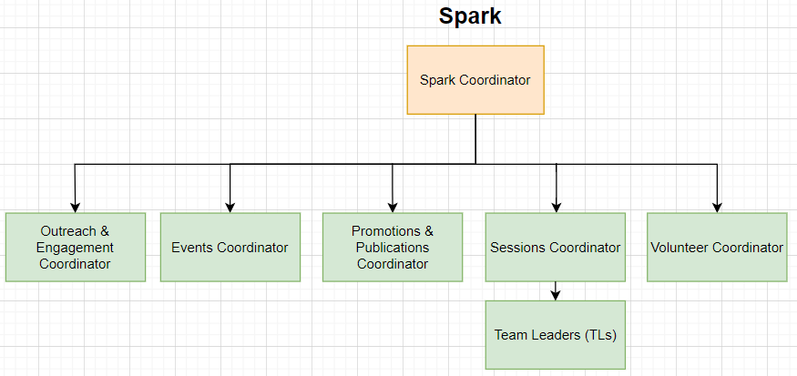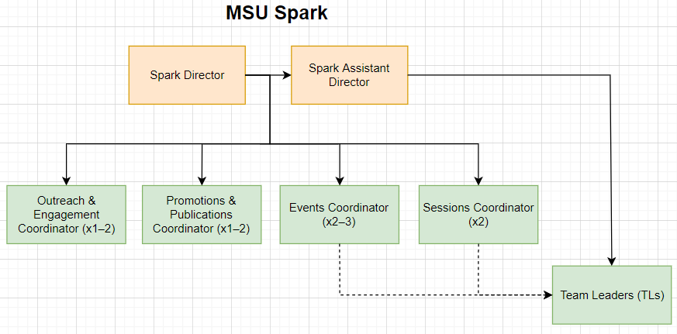

*While the names of some executive positions may change (easily, I might add, since no explicit mentions are made of their titles in any Service JDs going forward), this structure is fairly rigid. Regardless, this comparison offers a decently conclusive picture of how the Service will operate after these changes take effect.

Now that MSU Horizons has been officially rescinded, it is my hope, and that of both the Spark Coordinator and Horizons Coordinator, that the spirit of the Service may live on through this vessel for now, with room for revisit the discussion as the state of the world evolves.

Please let me know if you have any questions or concerns.

Kind regards,

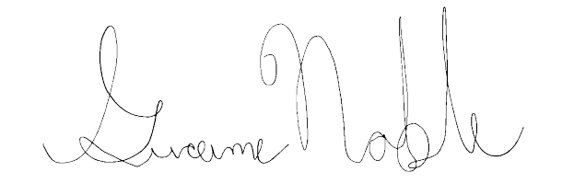
Graeme Noble
Vice-President (Administration) & Chief Administrative Officer
McMaster Students Union
vpadmin@msu.mcmaster.ca

