. | Memo  From the office of the…  Vice-President (Administration)
To: | Executive Board Members
From: | Graeme Noble, Vice-President (Administration)
Subject: | Amend Job Description – Peer-Support Services
Date: | January 14, 2020

Introduction
Dear Members of the Executive Board (EB),

With hiring just around the corner, I should start by saying that these changes that I bring forward to you today are the result of countless hours of consultation, many evenings of calculated consideration, and an inbox constantly full of complaints about the current way we do things. Needless to say, what I am proposing is not a passing thought by a Vice-President (Administration), but a comprehensive strategy to make concrete change to a series of institutionalized issues. With that in mind, here’s the background:

Anyone who has ever worked as a Part-Time Manager (PTM) in the MSU will surely begin their roles under at least one of the following conditions:
- Unbridled passion for the Service and all that it stands for;
- A selfless drive to improve the lives of students at McMaster and the broader Hamilton community; and/or
- A head full of ambitious projects and ideas to help make life that much easier for students, not unlike themselves, and give them the support they didn’t get when they were in the same situation.

Now, anyone who has ever worked as a PTM for a Peer-Support Service in the MSU will undoubtedly finish their roles under at least one of the following conditions:
- Bitterness towards the MSU administrative team and the MSU as a whole;
- An abundance of unpaid work rewarded, at best, with a pat on the back and, at worst, a sentiment of “what a great opportunity it was” to be neglected/underappreciated for their work;
- A distasteful transition for their successors, if they receive one at all;
- A brutally cold departure from their jobs, complete with excessive burnout; and/or
- Feelings of guilt that they could/should have done more for their communities.

For many years, the MSU’s many student-led Services have operated under chaotic mismanagement: an issue that inevitably contributed to what we now know as an unhealthy work culture where PTMs (1) frequently go over their allotted hours which they’re told will balance out (even though the only cases where it’s been tracked say this isn’t even close to true), (2) take on projects and expectations under vague or unwritten pretenses (often due to ambiguous documents or unclear supervisorship), and (3) consistently receive inadequate support from the MSU to fulfill their ambitious yet unobtainable mandates. I can’t imagine what it’s like for the full-time staff at EB meetings to see these problems recur every single year, often with the same issues arising from the exact same Services, yet not a single significant change has been made to prevent it. Sure, a pandemic is certain to create issues for Services, but every consultation I’ve had with staff proves that many of the same problems have been repeated for decades. While these issues most often compound within Peer-Support Services due to the additional emotional burden of the roles, many of these statements apply to other Services as well, only with somewhat less urgency.

But of course: complaining about a problem is one thing, actually fixing it is another entirely. Here are the key problems that have been identified throughout the consultation process that I hope to address promptly and with an empirical approach:

- Unclear Occupational Expectations.
- Work-Life Imbalance.
- Insufficient Training & Transition.

Now let’s get to the how:

Proposal
Circulated, you will find ten (10) job descriptions for five (5) Peer-Support Services (including the addition of MSU Diversity Services), each of which prepared in a new and improved document format to comply with accessibility best practices and act complementary to our current wage review system. As such, track changes would not have been appropriate nor useful. Instead, I’ve circulated the old positions (Service Coordinators and Volunteer Coordinators) as well as the new ones [Service Directors and Assistant Directors (ADs)] to allow you the opportunity to check through anything that might be a cause for concern. Here are the notable changes for each Service under this proposed model:

Service Coordinator to Director

In essence, this change isn’t all that significant. Prior to any changes, the Coordinator Job Descriptions (JDs) reflected a highly individualized take on what it means to be involved in every facet of a Service’s operations. While the new Director JDs are undeniably longer, their specificity also allows for increased accountability, clarity of expectations, and definitive separations from the front lines of volunteer/executive duties where they ought not to be directly involved. Instead:

The ___ Director shall oversee the operations of MSU ___, its executive, and the overall vision of/for the Service as it relates to the pursuit of its core mandates. The ___ Director shall ensure that MSU ___ operates within its budgetary resources, its Operating Policy, and all other policies of the MSU that pertain to its overall purpose and procedures. The ___ Director, alongside the Directors of other Peer-Support Services, shall serve as pillars for student support throughout the McMaster community. As well, the ___ Director functions as a critical source of insight on XXX and relevant resources for MSU students through the creation and delivery of programming, events, and campaigns. The ___ Director shall strive to create a welcoming, inclusive, and safe(r) environment for Service users, volunteers, and executives within an Anti-Racist and Anti-Oppressive Framework. The ___ Director’s primary responsibilities shall address the executive-level functioning of the Service, any collaborative efforts with community/university/MSU partners, and the operational direction for MSU ___.

This template above not only explains the gravity of the role and its purpose for the MSU, it also concludes with a clear description of the primary responsibilities of the Director: ideal for its clear contrast to a similar statement made in the AD JD.

Volunteer Coordinator to Assistant Director

As you may have rightly assumed, this position was chosen quite purposefully as the target for true reform. Volunteer Coordinators are well-known to be the most demanding roles within the executive teams of Peer-Support Services, as well as many others (e.g., MSU CLAY, MSU Horizons, MSU Spark, etc.). As such, they frequently go above and beyond to assist volunteers and ensure their needs are met for the good of the Service. While this may seem like the most financially precarious option, far from it! By treating this individual as a Director, but exclusively for volunteers, the MSU can provide additional support and compensation (yes, that means money) for the roles to better hold them accountable to a reasonable workload. Their JD template goes a little something like this:

The ___ Assistant Director shall be responsible for the coordination of MSU ___’s volunteer team in the execution of one of the MSU’s Peer-Support Service’s programs. The ___ Assistant Director, alongside the ___ Director, shall serve as a pillar for student aid throughout the McMaster community that focuses on XXX and relevant resources for MSU students through the creation and delivery of programming, events, and campaigns. The ___ Assistant Director will assist the ___ Director in the hiring of all executive and volunteer members, as well as the coordination, training, and recognition of all volunteers within the Service. The ___ Assistant Director shall strive to create a welcoming, inclusive, and safe(r) environment for Service users and volunteers within an Anti-Racist and Anti-Oppressive Framework. The ___ Assistant Director’s primary responsibilities shall involve regular reflection and intervention in addressing the internal growth needs of the Service.

Now, while this also has the added benefit of taking the volunteer burden clearly off the shoulders of Directors, who may now refocus their work towards the feasibility of projects, the support of executives, and the operations of the Service as a part of the MSU (i.e., financial obligations, administrative duties, etc.), it also gives a huge boost to our severely damaged PTM succession planning cycle. Though the Director would never be restricted to previous ADs, it at least offers the opportunity for an individual to take that sensical step if they wish to do so. Also, from an administrative perspective, all ADs will report hours and accommodation requests to the Vice-President (Administration), while also attending all PTM training sessions, group meetings, and receiving all Service-geared internal emails.

Also, due to the high volume of products supplied through MSU SHEC, a small change has been made to allow for the SHEC Director to receive a modicum of additional financial/material management support from the SHEC Assistant Director, where time and capacity permit.

Assistant Director to Assistant Director – Diversity Services

“So,” I hear you say, “if we’ve had issues with ambitious keener ADs taking over for absentee Directors in the past, what stops that from happening here on a larger scale?” If this was you asking this question, you’ve made quite an astute observation about potential woes from Unclear Occupational Expectations. Believe me, I had similar concerns. To address them, look to the proposed changes to the Diversity Services AD JD: here, you can see just how much effort has gone in to creating absolutely crystalline instructions on how to go about the job. Notice the line “Support the executive team in the ___ Director’s absence” which has been so cleanly articulated in the organizational charts below. While it’s absolutely encouraged that some responsibilities are undertaken through collaboration with the Director, under no circumstances will the Assistant Director ever assume the Director’s exclusive responsibilities. Instead, they shall offer support however possible. I’ve made this abundantly clear with PTMs in my consultations and this sentiment has been echoed throughout the proposal’s inception. As such, areas for collaboration between both roles have been explicitly identified and referenced.

Organizational Chart Comparisons*
Before (Left) & After (Right)

Here are the proposed org. charts for each Service before and after the updates. The current plan is to include each diagram in an accessible format (once I figure out how) as an appendix for the Service’s Operating Policy (OP) so that it’s made clear for anyone who wishes to better understand their structure, yet still allows for simple and easy changes from the administrative side.

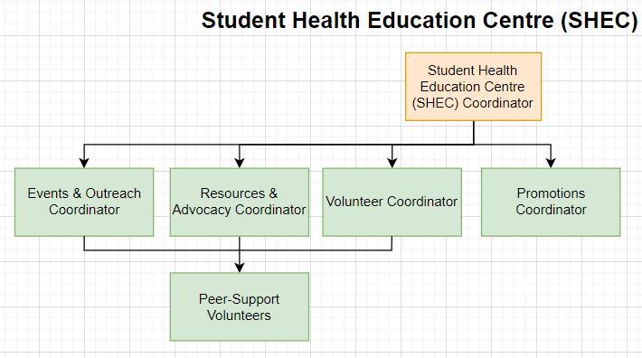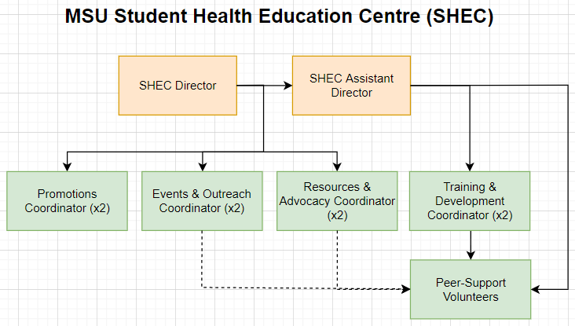
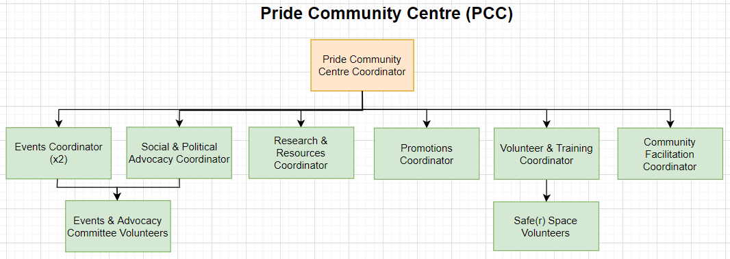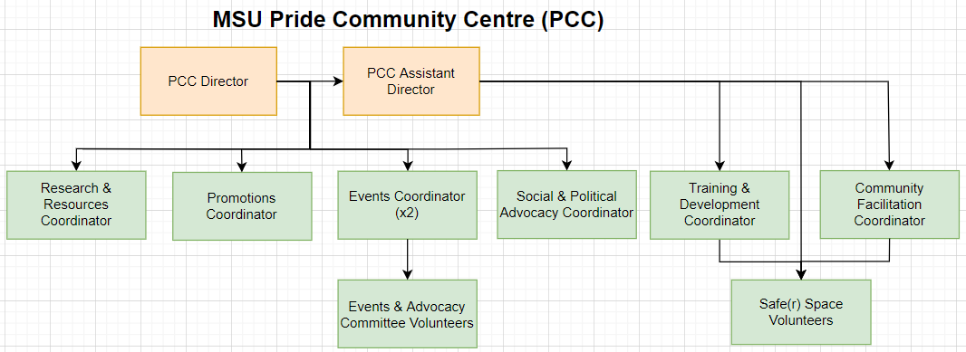
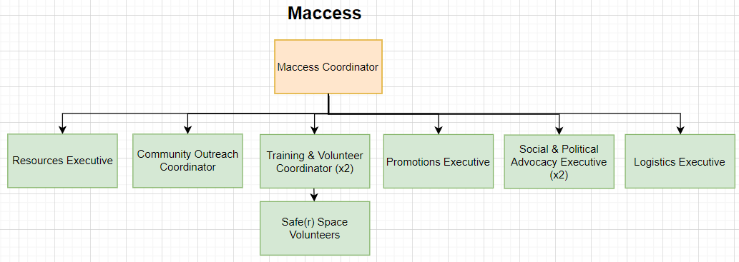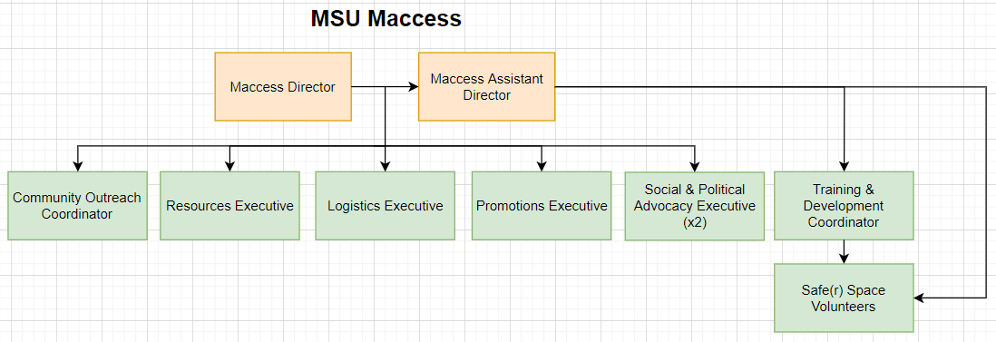
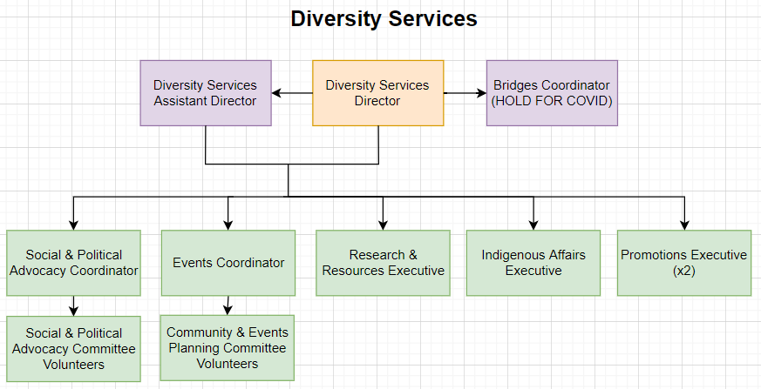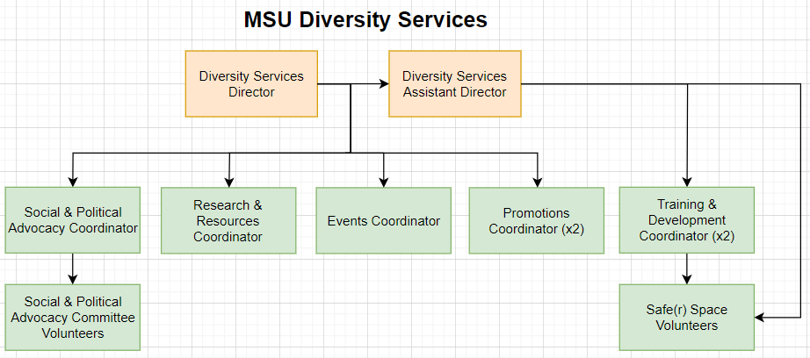
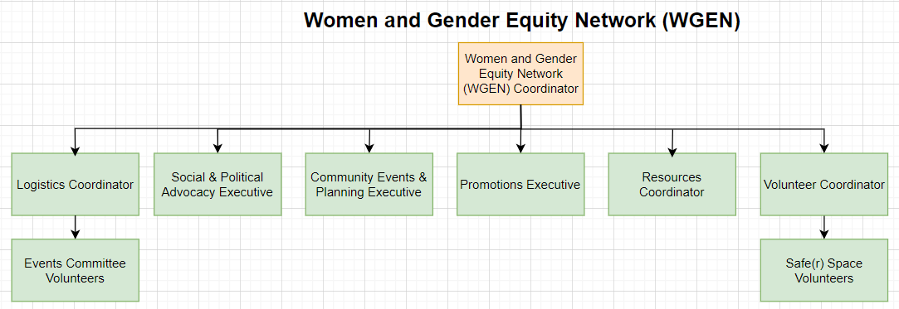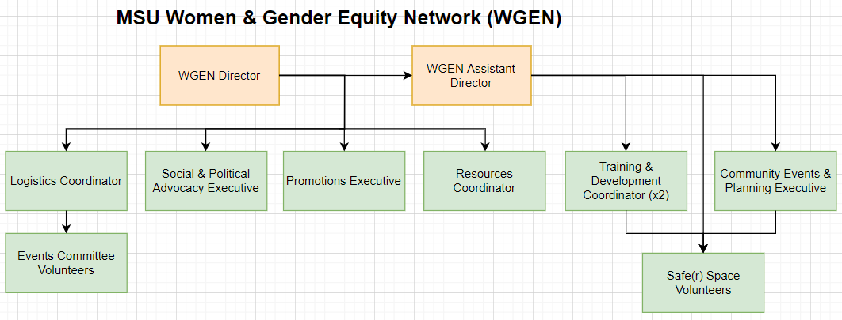

*While the names of some executive positions may change (easily, I might add, since no explicit mentions are made of their titles in any Service JDs going forward), these structures are fairly rigid. MSU Diversity Services might make small changes with their executive to accommodate these changes while others may slightly alter the number of people who fill each role. Regardless, these comparisons offer a decently conclusive picture of how Services will operate after these changes take effect.

FAQs
Why are you approving the JDs before the OPs?
Truly, with the schedule we’re on, there isn’t enough time. Besides, the OP changes would only take effect on April 1st, when I intend to have the OP changes ready for. Meanwhile, hiring for these roles requires the updated JDs and the positions must be posted for January 18th if we are to make these changes within the next ~15 months before the incoming PTMs have started transitioning their successors. Needless to say, there’s no rationale for doing the OP first so long as I intend to adjust it before the changes actually occur, which—as the ex-Associate Vice-President (Internal Governance) and an avid policy fanatic—I clearly do intend.

Why is MSU Diversity Services listed as a Peer-Support Service now and who decided this was the best direction for the Service? Shouldn’t this be an SRA decision?
Well, clearly this is a multi-part question, so let me address each individually to make things clear:
- From a historical perspective, MSU Diversity Services has—for as long as I’m aware—operated as a community pillar for the celebration and congregation of diverse populations of students on McMaster’s campus. Well, over the years, the Service has fragmented into what we now know as the substance of our Peer-Support Services. What’s left of the Service represents a group of students with an audience focussed on spirituality, race, and ethnicity that:
  - Supports their peers, but not through peer support;
  - Advocates to the university, but separately from the Education and Advocacy Department; and
  - Plans events for students, but rarely interacts with MSU Campus Events.
Besides, the current Service staff and executive have already devised a plan for rolling out the internal structure of the Service to accommodate this change by April. I will see to it that this happens within this timeline and with sufficient support to get it off the ground.
- “The committee suggests piloting race-based peer support in 2019 through Diversity Services” is a direct quote from the 2018 Services Standing Committee as a conclusion of their review. The details will come forward to the SRA with the OP changes, though, with the abundance of evidence in support of this change, I sincerely doubt there will be much (if any) resistance.

Who have you consulted with to get to this product?
Due to the frequent changes in this proposal throughout the process, I’ve been speaking with various PTMs and full-time staff, as well as consulting various email, report, and Service review records to get to were things are now. Because this proposal was formed through a cross-functional approach, I’m 100% confident that the evidence gathered in support of this system will be proven as an effective improvement over our current approach, particularly within the 3 problem areas I identified earlier in this memo. While it may not be the perfect system, no such thing exists. At least with these amendments in place, our holistic administrative stagnation can and will no longer contribute to the operational degradation of MSU Services.

Why are the JDs so long? Isn’t it a bit much?
For too long, the MSU has left hour overages up to chance or individual divergences in work ethic. This system, as has been proven for decades, sucks. By providing a comprehensive JD, hour approval can be then moved towards an as-needed basis where certain things require EB approval, all hour overages require supervisory approval, and approval may only ever be given to tasks clearly outlined in the JD. The old system doesn’t work and should be abolished. It leaves way too much room for interpretation and in contexts where identity-based oppression intersectionality plays such a significant role, you should never have even the opportunity for a cisgender white man to decide whether or not an identity is worth extra time and support.

Please let me know if you have any questions or concerns.

Kind regards,

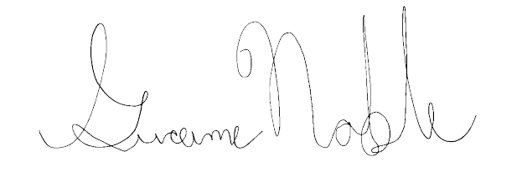
Graeme Noble
Vice-President (Administration) & Chief Administrative Officer
McMaster Students Union
vpadmin@msu.mcmaster.ca

