Yearplan Update
. 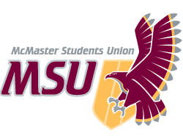 | REPORT  From the office of the…  Food Collective Centre Director
TO: | Members of the Executive Board
FROM: | Hannan Minhas
SUBJECT: | Food Collective Centre Report [7]
DATE: | January 28th, 2021

Reflecting back on last year, the Food Collective Centre has started some new and exciting programming in place of the traditional programming that FCC has organized in the past. During the winter term, FCC plans on continuing these initiatives such as Quarantine Cooking Challenge, Foodie Fridays, Good Food Box Program and Community Cooking Workshops.

In terms of the year plan, we have started the hiring process for an incoming director and are in the interviewing stage. We received 10 applicants and narrowed it down to 3 promising candidates for the interview phase. During this month, we were originally planning to hold a volunteer training in hopes of an “in person” semester, however since this term is still online and we did not have new additions to the volunteer team, we decided to have a volunteer social instead to start off the new term.

FCC also planned to create some recipe videos in the summer to post on Facebook in order to add to our existing collection of easy and healthy recipe videos. However, that project was somewhat forgotten until earlier this month, when I contacted Chef Stu to continue on the recipe video which we plan on releasing next month.

Another collaboration that is in the works is with the McMaster Library Sustainable Committee to help promote plant based cooking through a Foodie Friday Cooking Demo to promote plant based cookbooks and sustainability.

Service Usage
- Good Food Box Program
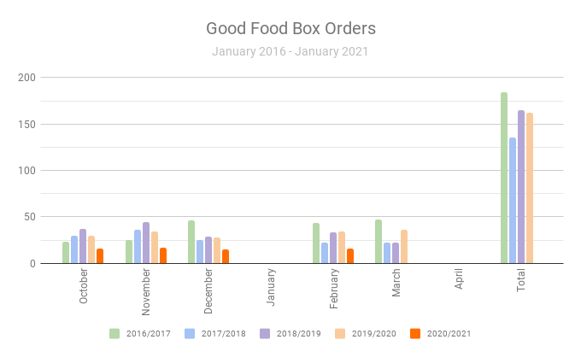

2019/2020 Average Orders/Month: 32.6
2020/2021 Average Orders/Month: 16

- Lockers of Love

November: 8 orders
December:10 orders

- Quarantine Cooking Challenge

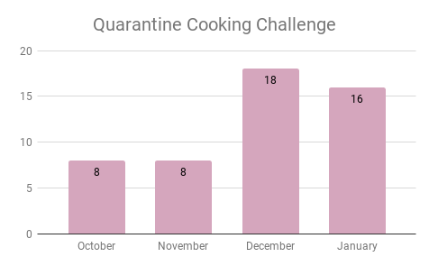

Past Events, Projects, & Activities

- Study Snack Pack
  - This event was planned for the last day of school in the fall term which students in the Hamilton community ordered a small snack packaged with some nutritious snacks to eat during exam studying.
  - Students were able to order in the last week of November, and would receive their snack pack on the last day of the term.
  - The FCC received 75 orders

- Volunteer Appreciation Event / Check in
  - This event took place on November 19th and it was an event in which volunteers will update us on their projects and more importantly, play virtual games with us in order to connect with the exec team and other volunteers.
- Volunteer Social Event
  - This event was on January 15th and it served as an event for FCC volunteers to regroup and socialize in order to get the semester started.
  - Also used to check in on FCC volunteer projects.

Upcoming Events, Projects & Activities

- Community Kitchen Workshop
  - This event will take place on February 8th. Community members will register to learn how to make fried rice through Zoom in order to teach students cooking strategies in which they become more confident in their own cooking skills.

- Documentary & Discussion (February 22nd)
  - Students and FCC Volunteers will watch “The biggest little farm” which discusses topics about agriculture and food supply as well as building sustainable farming ecosystem
  - Will use breakout rooms and volunteers to lead discussions of sustainability

- Food Security & Health Campaign (March 22nd – 26th)
  - Week long campaign discussing food security in terms of health.
  - There will be one event about budget friendly and healthy eating involving a guest speaker.

- Foodie Fridays:
  - Recipe Instagram takeovers will become regular programing and we hope to continue until the end of the term.

- Valentine’s Day Giveaway
  - Annually FCC does a Good Food Box giveaway on Valentine’s Day to promote the service and increase engagement on social media.

Currently Working On

- Recipe Video with Chef Stu
  - Chef Stu recorded a video for a oats bread recipe which is in the editing process.
- Okanagan Special Project Fund
  - Putting together ideas and proposal for the project fund
- Planning event for wellness week with Maroons
  - Brainstorming ideas to collaborate with Maroons event.
- Budget friendly and healthy eating event
  - Planning a Budget friendly and healthy eating event as part of our health campaign with a guest speaker. This will expose students to eating on a budget and choosing nutritious foods to cook at home.

Budget

ACCOUNT CODE | ITEM |  | BUDGET / COST
5003-0318 |  | FCC - OFFICE SUPPLIES
 |  | Cleaning Supplies for Space | 24.59
SUPPLIES | TOTAL SPENT IN LINE |  | 24.59
 | REMAINING IN LINE |  | 75.41
6102-0318 |  | FCC - ANNUAL CAMPAIGNS
 |  | QCC Gift cards | $75
 |  | Study Snack Support | $209.64
 | TOTAL SPENT IN LINE |  | $284.64
 | REMAINING IN LINE |  | $1431.36
6603-0318 | FCC - RESERVE
 | Stocking up space |  | $92.49
 | TOTAL SPENT IN LINE |  | $92.49
 | REMAINING IN LINE |  | $907.51
TOTALS
TOTAL BUDGETED DISCRETIONARY SPENDING
TOTAL ACTUAL DISCRETIONARY SPENDING
REMAINING DISCRETIONARY SPENDING

Volunteers
As stated in the past events sections, FCC held a volunteer social event this month to allow volunteers to get to know each other better. This was also used as a check-in to gauge how the volunteer projects are going and what needs to be accomplished this term to complete them.

During this term, FCC volunteers are still working on volunteer projects such as City Spotlights, Grocery Guide, FCC Cookbook as well as engaging in the advocacy events such as the documentary event and the Food Security & Health campaign. The focus on these projects are to finalize existing work and put the information into a presentable graphic which will be posted on our social media. The volunteers working on the campaigns will be a part of a research subcommittee and work with the social and political advocacy coordinators.

There are three grocery guides on how to shop on a budget, shop as a vegan/vegetarian, and shop sustainably. Additionally, there are six city spotlights infographics on food (in)security in six different regions of southern Ontario. We hope to start posting the projects in March.

FCC cookbook website: https://msufcccookbook.carrd.co/

In terms of volunteer appreciation, we hope to email the volunteers $10 gift cards for their hard work over the semester.

Current Challenges
With the transition to the new MSU website, FCC did not have a running payment portal to collect orders for the Good Food Box Program. For the February GFB orders we opted to use Eventbrite to process the payments and fortunately, we were able to get the same amount of monthly orders!

Successes
In terms of success, the Study Snack Support event was amazing because of the engagement from the community. We about 75 orders in total and received a lot of appreciation from the community for having this event! We hope to continue the event this term as we loved the higher community engagement.

