Appendix A: Social Media Guidelines

Guide for Candidates and their Campaign Representatives. Reference to Election Rules
- Candidates may not distribute unsolicited electronic communication.

- Electronic media (excluding Twitter posts) must provide a link/tag to the main Elections Department website (msumcmaster.ca/elections), Facebook Page (@MSUElections), or @MSU_Elections handle. See Appendix A for clarification on how to follow this rule.
  - Candidates are encouraged to use msumcmaster,ca/vote on campaign material including social media posts during polling days.
- Campaigning may not take place on Facebook groups, pages, events or group chats, except those expressly created to advertise a candidate’s campaign.

  - Posts made by the Elections Department may be shared on public Facebook groups or pages to advertise the election without additional commentary.

- Personal social media accounts converted for the purposes of campaigning should comply with all election rules.

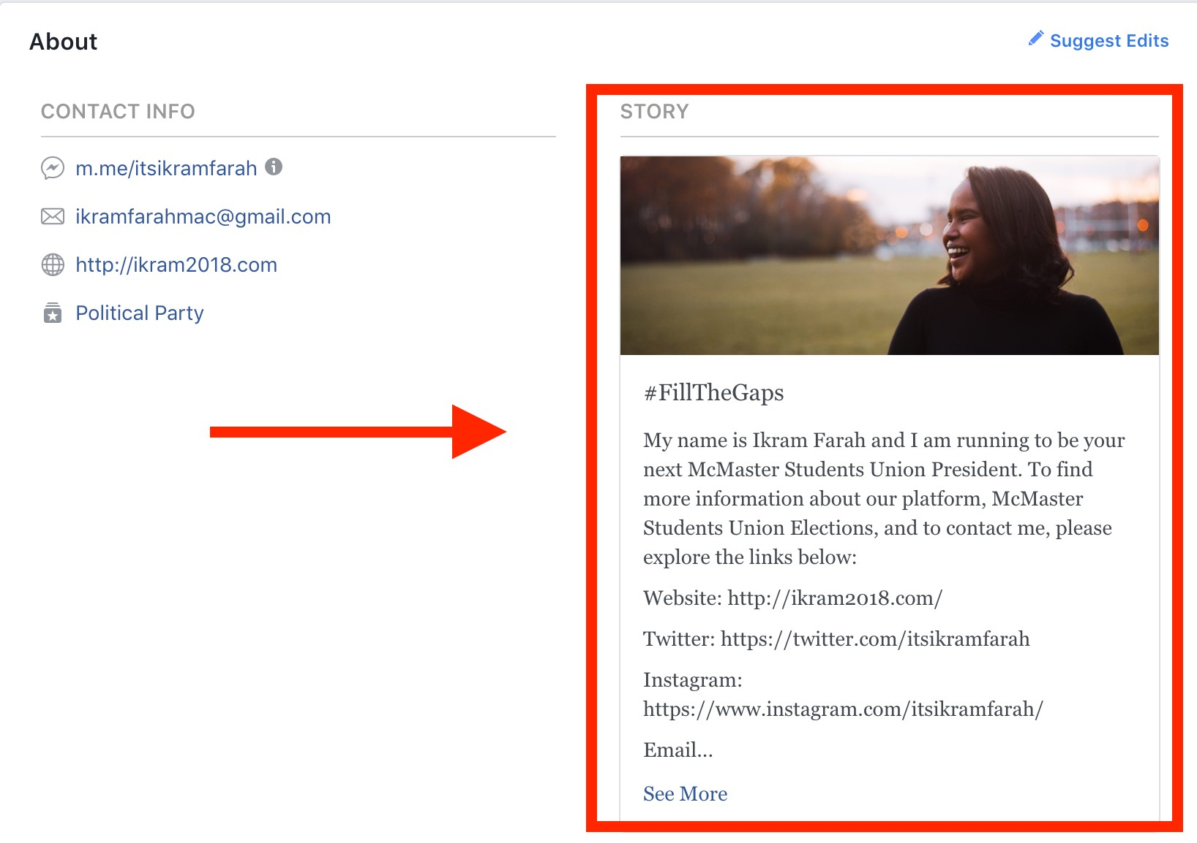
Facebook Page Guidelines

The msumcmaster.ca/elections link or tag should appear somewhere on your Facebook page. A recommended place could be the “About” section under STORY.

Page 1 of 7

Facebook Posts Guidelines

Posts on Facebook including profile pictures, cover photos, and status updates should include
the msumcmaster.ca/elections link or tag. What is included below are examples of how you can go about including the required link or tag, however, the blurb before is up to you.

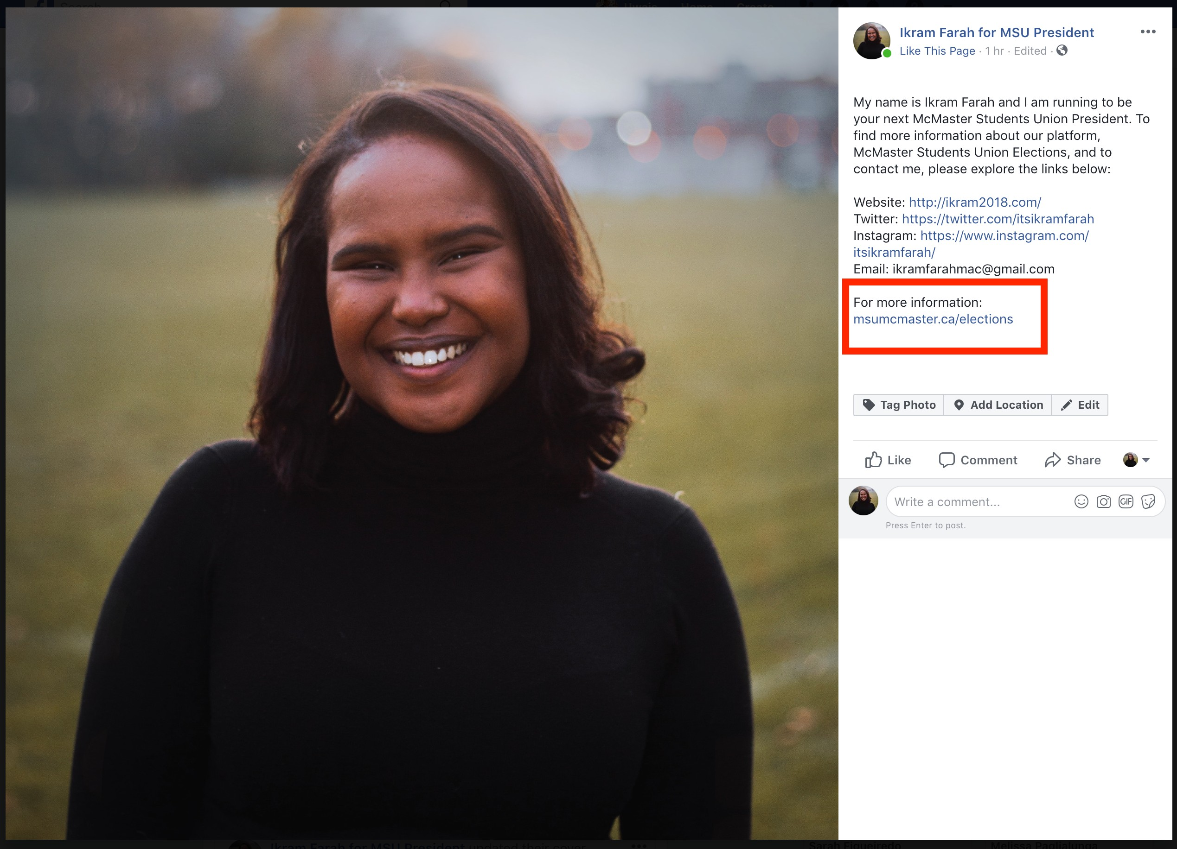
Profile Picture Example:

Example blurb: “For more information on the MSU Elections Department, visit msumcmaster.ca/ elections"

Feel free to be as creative as you’d like.

Page 2 of 7

Below is an example of how you can include the link on a status update.

lkram Farah for MSU President
Just now·0
My name is lkram Farah and I am running to be your next McMaster Students Union Pres ident.
To find more information about our platform, the Elections Department, and to contact me, please explore the links below:
Website: htt p://ik ram2018.com/
Twitter: htt ps://twi tt er.com/it sikramfarah
lnstagram: htt ps://www.instagram.com /i tsikram farah/ Email: ikram farahmac@gmai l.com
MSU Elections msumcmaster.ca/e lect ions
•••

MSU
ELECTIONS
DEPARTMENT
Facebook Posts Guidelines

Status Update
Page 3 of 7

Boost Post

rfJ Like CJ Comment Share
Press Enter to post.

Instagram Landing Page Guidelines

Your landing page on Instagram doesn’t have to include the link to the MSU Elections Department if you
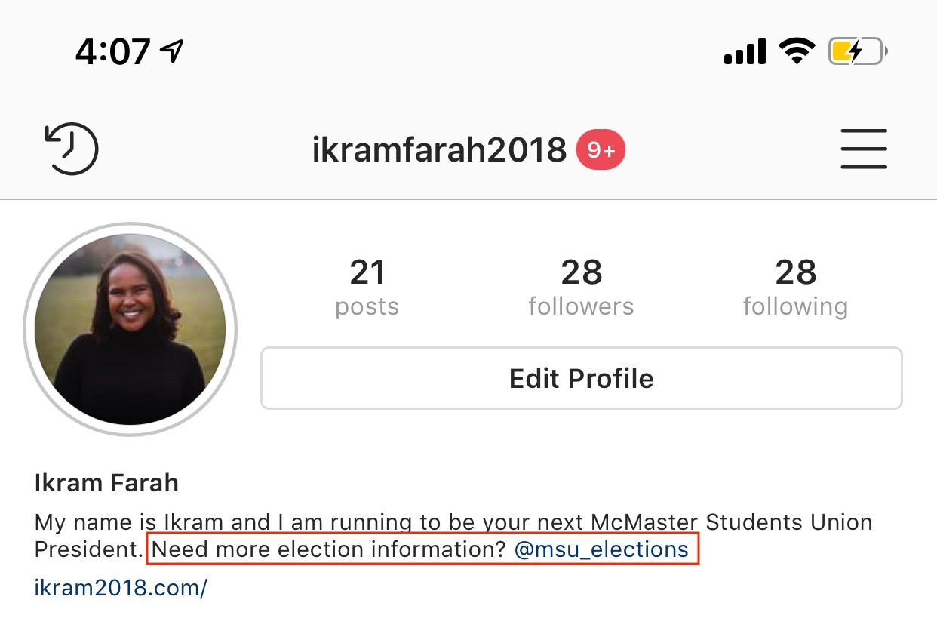

will be including your own link. To substitute, you can tag @MSU_Elections in your bio.

Instagram Posts Guidelines

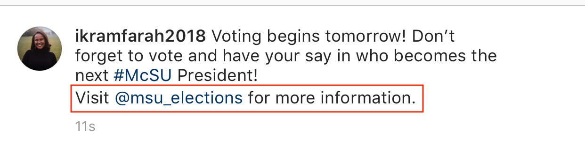

Page 4 of 7

Your instagram posts should tag the @MSU_Elections page. A link is not required as links are not clickable on instagram posts.

Instagram Story Guidelines

Similar to what was mentioned before, you should tag the @MSU_Elections page when you post an instagram stories. Either of the two options seen below work.
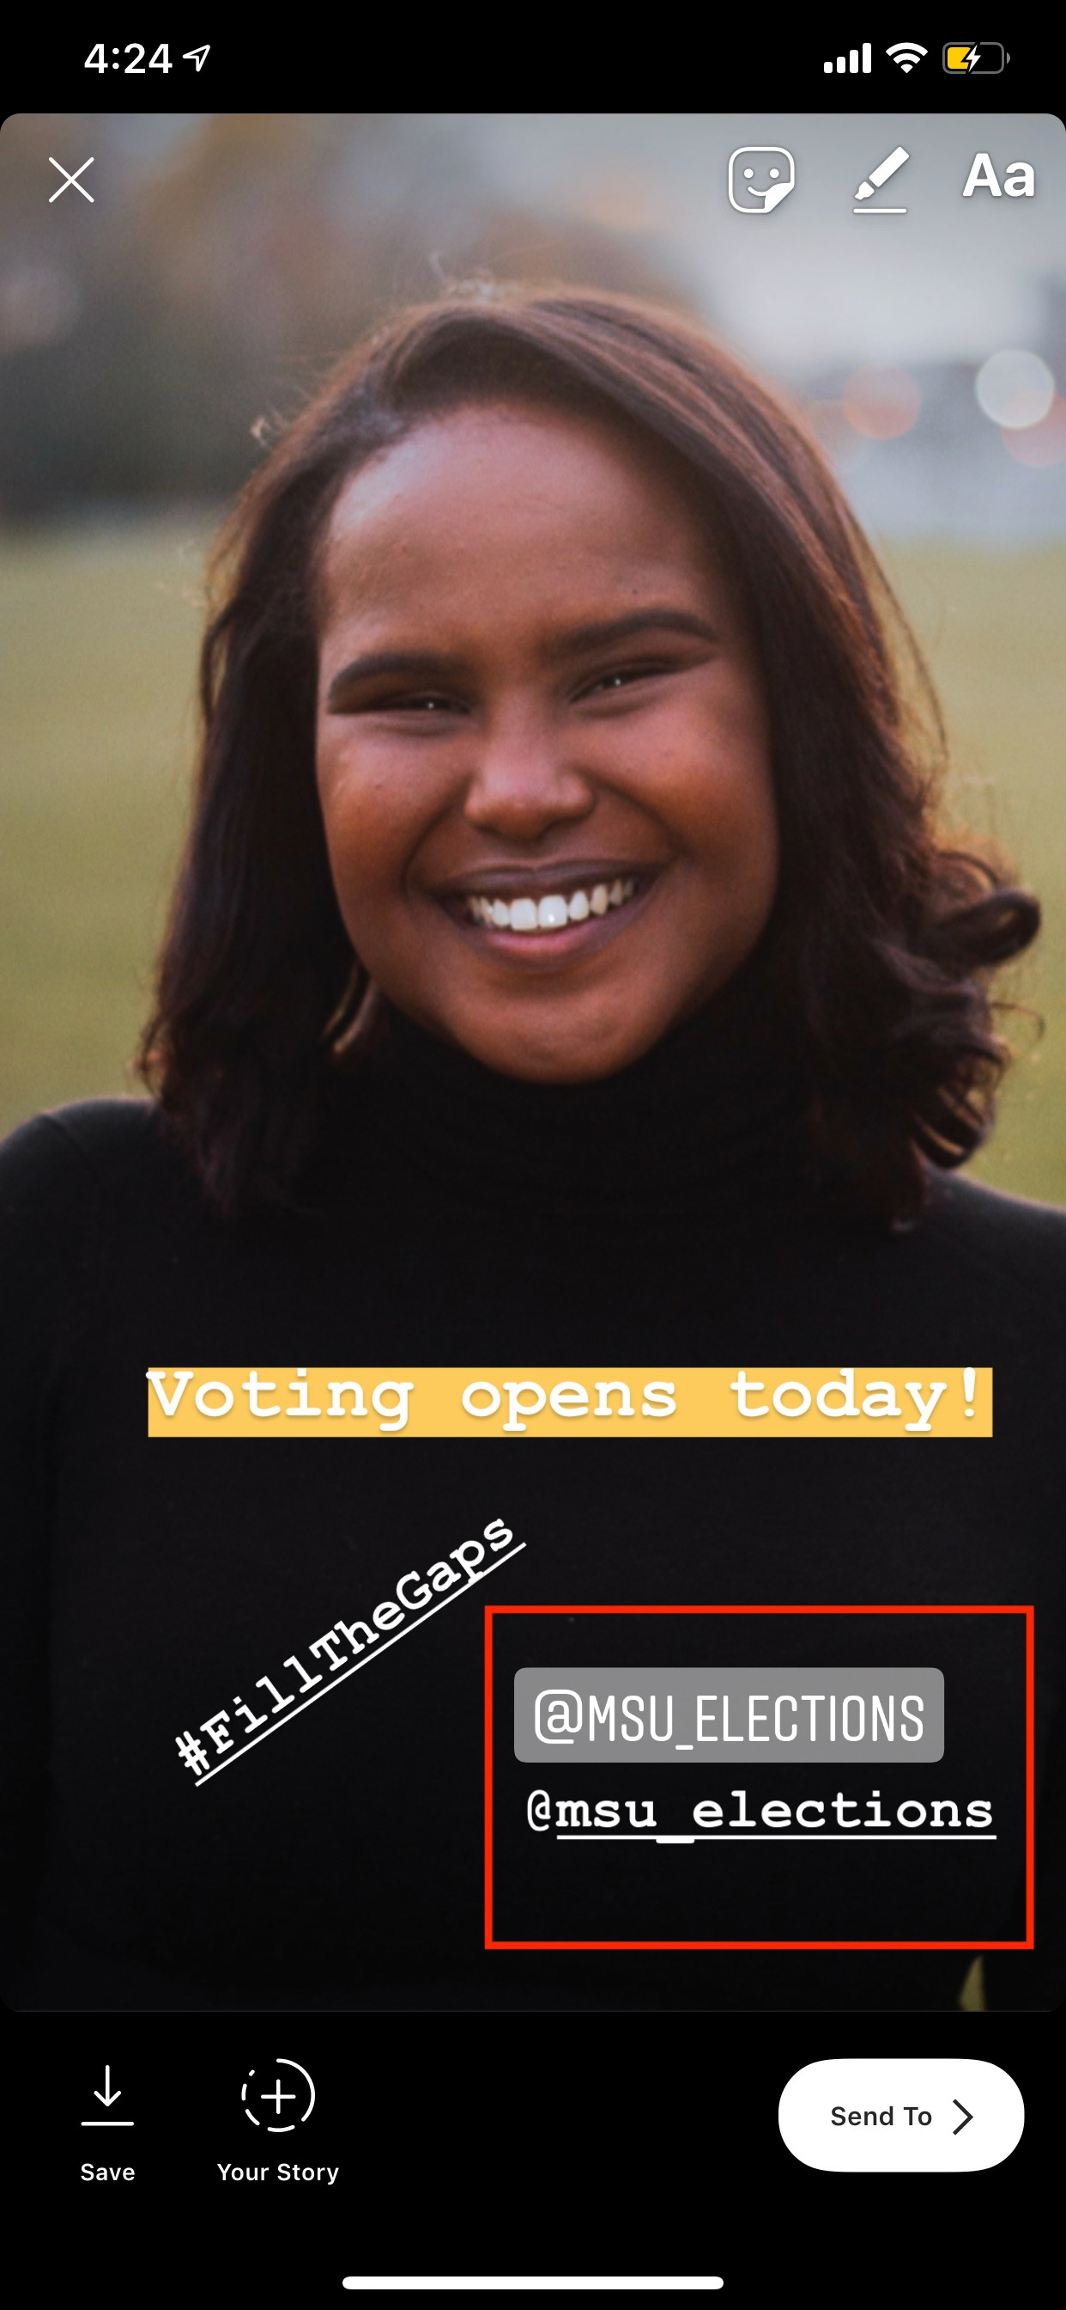

Page 5 of 7

Twitter Landing Page Guidelines

@MSU_Elections should be mentioned in your Twitter landing page similar to what is shown below.
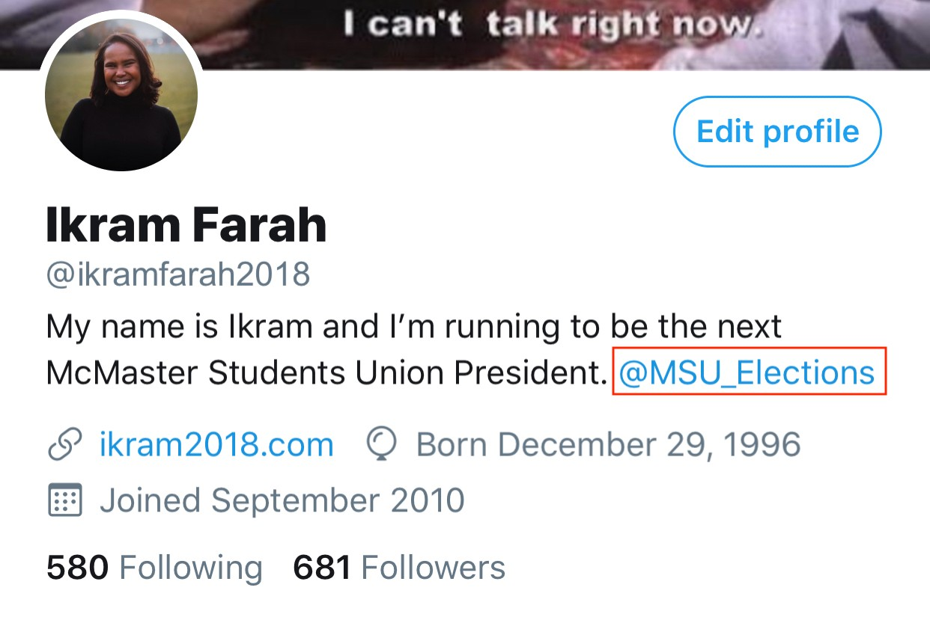

Twitter Posts Guidelines

Posts on twitter do not have to include the @MSU_Elections handle or the msumcmaster.ca/elections link.

Other Guidelines

Where possible, please use the msumcmaster.ca/elections link or tag. In some instances, using the @MSU_Elections handle or @MSUElections is also acceptable.

Please don’t hesitate to contact elections@msu.mcmaster.ca for more information.

Page 6 of 7

Snapchat Guidelines

- A campaign Snapchat account may not send unsolicited personal snapchats to other snapchat accounts

- Similar to what is required for Instagram stories, Snapchat stories must also include a tag to the MSU Elections Snapchat account (@msu_elections). The tag must be displayed somewhere on the story, as shown in the example below.
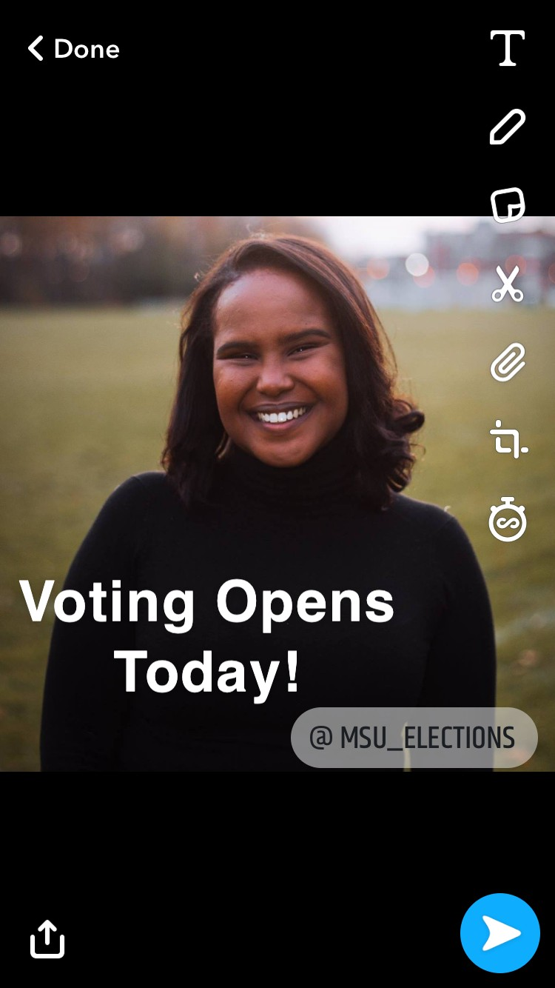

Page 7 of 7

