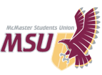REPORT
From the office of the...
Associate Vice-President: Services

.
TO: Members of the SRA
FROM: Martino Salciccioli, AVP Services
SUBJECT: SRA 20L Report
DATE: January 10, 2021
PROGRESS ON YEAR PLAN
While this year has taken many unexpected turns and many of my plans for this year have not been able to happen, I am still happy with the progress myself, the services committee, and Graeme have made in terms of services reviews (especially surveys!!!!). All of the surveys (10 in total) for each of the 5 planned service reviews have been completed and are either available now or have been closed. The new format this year of completing all of the surveys first rather than one at time as each review is being completed has proven to be much more effective. Rather than halting the review process while waiting for survey results, we have been able to work on getting all of the surveys done in first semester so that second semester can be focused more on writing the reviews. What makes this process more effective is that all of our data will be ready to go for when it is time to write the reports, this gives myself and the committee more time to critically analyze the data and make necessary recommendations.
PAST EVENTS, PROJECTS & ACTIVITIES
Since the last time I reported, the biggest activities/projects have been the opening of our WGEN, SHEC, and PCC surveys. I had mentioned in my last report that I would be looking into reviewing a different service aside from Horizons or SWHAT due to the drastic change in service delivery due to the pandemic. I have since decided that I will work on completing 5 reviews instead of 6, and making the PCC the fifth and final review of this year. In addition to deciding on reviewing the PCC, Graeme and I spent countless hours constructing and editing the questions for the last 3 surveys, we received a great amount of feedback from respective service PTMs and ensured we incorporated and reflected their thoughts within the survey questions.
UPCOMING EVENTS, PROJECTS & ACTIVITIES
Coming up in the world of AVP Services will be all 5 of the service reviews!!!!! So far the rough plan for the order of review completion will be EFRT, Macademics, WGEN, SHEC, then PCC. I am hopeful that with the help of the services committee these 5 reviews can all be completed before my time as AVP comes to an end. In terms of other upcoming things, when the reviews are done I hope to help Graeme in any area he may need help in. Additionally, I am hoping to look into all the past service reviews and constructing a document that discusses when the reviews were completed, what the recommendations were, and when the service should go back up for review.
CURRENT CHALLENGES
With the start of a new semester I haven’t been faced with many challenges so far. I think one of the biggest challenges that may come up in the future will be balancing review completion with a full course load and my other job. I am typically good with time management but with these unprecedented times I never know what may come up and how it will impact my day-to-day schedule. I am hoping that when things arise I can rework my schedule so that I don’t get overwhelmed and I am still able to complete everything on time and as efficiently as possible.

SUCCESSES
I would have to say the biggest success thus far has been how fast surveys were completed and published this year. I feel like this will be a much more effective structure for the service review process and something that should continue to be used in the future.

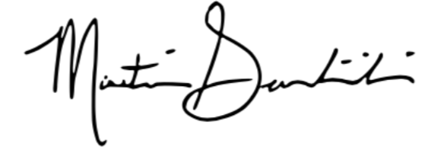
Best wishes,

Martino Salciccioli
Associate Vice-President: Services
McMaster Students Union
avpservices@msu.mcmaster.ca

