. 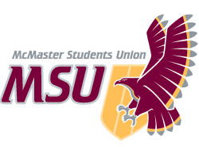 | REPORT  From the office of the…  Spark Coordinator
TO: | Members of the Executive Board
FROM: | Baila Lovejoy
SUBJECT: | Spark Report 5
DATE: | December 3rd, 2020

Year Plan Update
Since my last report less than a month ago, we haven’t had a ton of year plan updates! Sessions have wrapped up for the term and we’ve completed 2 events. We’re working on a promo plan for the second semester registration of sessions. The biggest change from my year plan is that I originally planned to open ticket sales for formal in December. The formal replacement this year will be a free event for students so we will not have to sell tickets and will be thinking about registration for the event closer to the middle of the term. Overall, the semester has been really rewarding and I feel like the team has accomplished a lot considering the challenges everyone has faced!

Service Usage
Sessions have been getting a ton of traction! Again, a lot of the groups have had 3-5 students coming to their sessions consistently. Additionally, our events have had decent attendance! Our yoga event had roughly 15 students attend and our exam review sessions and destressing event with the Maroons had approximately 25 students come! For being such a busy time of year for students, the team is pretty impressed that students have remained engaged in programming. In terms of Instagram following, I have outlined it in the chart below:
Report 1 | Report 2 | Report 3 | Report 4 | Report 5
4275 | 4531 | 4625 | 4572 | 4543

Past Events, Projects, & Activities
Our biggest project that we’ve finished up is sessions ending for the semester! It feels like this semester flew by and all 9 sessions for the term have been completed. Planning and completing sessions for a term is a huge task when it’s in person, and an even bigger task when online so I’m really proud of how the team approached the challenge and were so successful!

We also have had two events since my last report. On the 12th, we had our yoga class that was open to all first years. Jenn, a yoga instructor from the pulse ran a very relaxed and beginner level yoga class that was focusing on areas that would be affected by spending so much time sitting at a computer. Around 15 students came and we had around 7 volunteers come and join the event as well! It was a really great class and Jenn was really great to work with! On the 27th, we collaborated with the Maroons on an exam review/de-stressing event. We ran 4 exam review sessions: CHEM 1A03, PSYCH 1X03, MATH 1ZA3 and anatomy, and had volunteers available to run online games etc. Student turn out was lower than the amount that signed up, which is to be expected but the students that came seemed super engaged and appreciative of all the advice TLs and Maroons had to offer! I actually think having the smaller groups was beneficial because students could ask specific questions they had and volunteers could have more lengthy conversations with students.

Upcoming Events, Projects & Activities
We will be having our end of term social with the team on Saturday December 5th! Usually, this event is a potluck where we give out gifts to TLs and play yankee swap all together. It's been tricky to try and come up with a way to recreate this online but we’ll be having a few different options for TLs: online games, baking cookies, jackbox etc. This social is always one of my favourite parts of the year, getting to see the team come together so I’m really excited for this! In terms of gifts, we’ll be sending Starbucks gift cards to the team as an appreciation for all the hard work they’ve put into the service this year! We will also be having closing ceremonies before the end of the semester! The events committee has been taking lead on planning this and will be a games night! It’s generally a really good way for students in session and TLs to hang out/meet others in session to end off the semester.

Currently Working On
As the semester is wrapping up, we’re trying to plan the beginning of next semester! Retention etc is always lower in the second semester so I’m hoping that planning in advance will give us a strong foundation for the semester. I’m hoping to have registration for sessions open over the holiday break, with doing heavy promo in the first two weeks of classes before sessions start on the week of the 25th. We will also be having a re-training session/social for a few hours on either the 16th or 17th (TBD). I’m hoping to review some stuff from our fall training weekend, and revisit expectations with the team. They’ve all been fully meeting our expectations but I want to make sure that we’re meeting their expectations or if there’s anything else they expect from us. We’ll also have part of the training as a social with co reveals and an opportunity to meet and connect with more of the team. I’m also currently working on having 1 on 1 meetings with each exec member to gain feedback from them, see what their goals in their role are for the rest of the school year, and see how I can better support them in their roles as well as personally.

Budget
In terms of budget, we haven’t spent anything since the last report. I’m also going to be asking for the General Ledger in the next week or so so I can reconcile and double check my budget tracker.
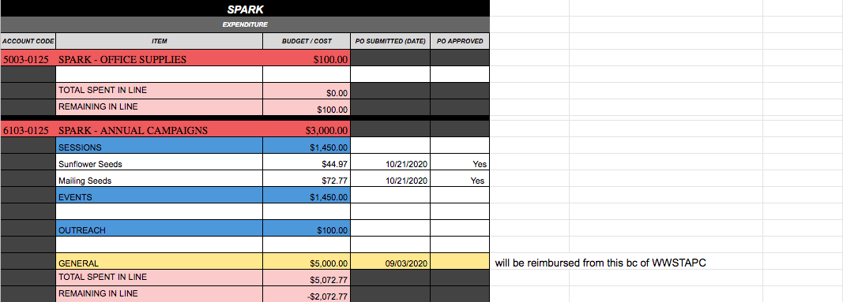
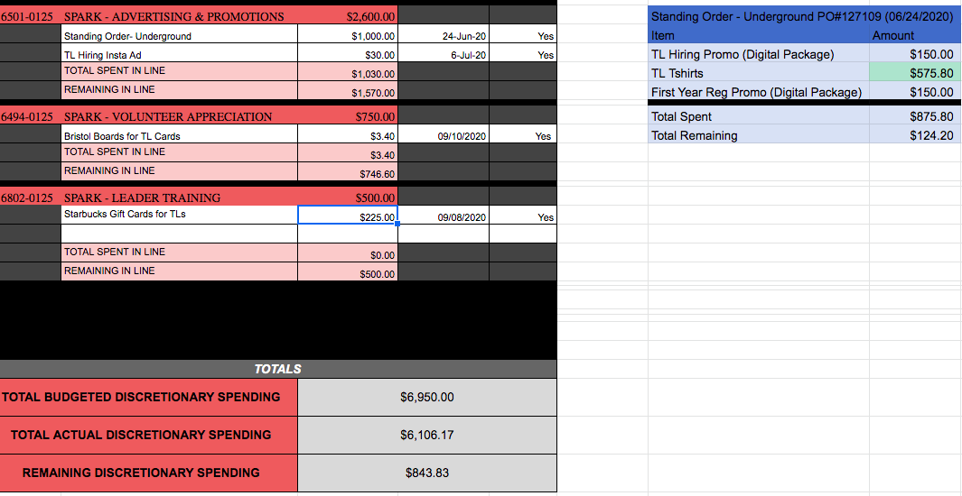

Volunteers
Volunteers have been absolutely incredible! Recently, I’ve had a few TLs message me to explain how much they’re enjoying Spark and that’s been incredibly rewarding. Being a TL is one of my favourite experiences of undergrad so it’s been really rewarding to be able to have a part in creating such a great experience for the team this year. I’m excited to find ways to connect with the team more second semester as well!

Current Challenges
We really haven’t had any major challenges lately! The one thing that I’m very aware of is how little balance I had at the beginning of this semester and was pretty overwhelmed with organizing sessions, training etc. and I fell behind in school really early on because of this. I’m more aware of that fact now and am trying to work proactively now on planning for the beginning of next semester so I don’t become overwhelmed at the beginning of next term.

Successes
I’m genuinely super proud of the team and everything we’ve accomplished up until this point! Something that’s been really rewarding is to see student feedback from sessions. A ton of students have taken the time to write so much thoughtful and positive feedback on the impact sessions have had on them this term. Making online sessions is not easy by any means and I’m extremely proud of Mitch and Guneet and the work they’ve put in to creating such impactful sessions this term.

Student engagement as a whole has been a highlight for me lately. Even at the exam review event, I got to pop in to different exam reviews and see how they were going. Every time, I saw students so engaged, asking questions on volunteers’ experiences with different courses and genuinely participating and taking things away from the reviews. It was really really nice to see students so engaged and the service having a tangible impact on first years. Overall, things have been going really well and I can’t imagine what I would do without the incredible exec and TL team!

