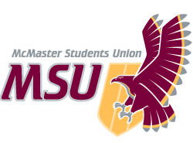. | MEMO  From the office of the…  AVP Finance
TO: | Student Representative Assembly
FROM: | Chen Liu, AVP Finance
SUBJECT: | Bylaw 5; Non-MSU Groups – Incite Magazine
DATE: | October 8, 2020

Dear SRA,

The Finance Committee would like to provide an update on our recommendation of approval for Incite Magazine’s budget. The organization has agreed to refund roughly $54K to students at the end of the 2020-2021 school year. As a result of this, the Finance Committee recommends approval of their 2020-2021 budget.

Thank you,
Chen Liu

Associate Vice-President Finance
avpfinance@msu.mcmaster.ca

