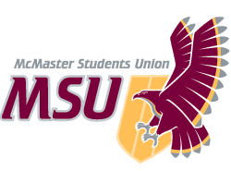. | REPORT  From the office of the…  Internal Governance Committee
TO: | Members of the Student Representative Assembly
FROM: | Michelle Brown – Associate Vice-President (Internal Governance)
SUBJECT: | SRA 20I Report
DATE: | November 1st, 2020

Progress On Year Plan
Objective # 1 – Review 25 Policies
- Reviewing 1 policy every week
- First policy reviewed on Sept 4th
- Have reviewed 6 policies
- Did not meet on the week of Oct 8th, or Reading Week (Oct 12th)
- Reviewed Bylaw 11/F, Bereavement OP, Services OP, Disciplinary Procedures OP, Ancillary Operations OP, and Retail Services OP

Past Events, Projects & Activities
Objective #1 – Review 25 Policies
- Reviewed 6 Policies
- Finished changes, wrote up memo, and submitted Bereavement OP

Long-term Planning – Increase Transparency and Accessibility within MSU
- Reorganized policy structure
- Approved policy reorganization

Upcoming Events, Projects & Activities
Objective #1: - Review 25 Policies
- Another 19 policies are still to be reviewed
- 1 policy/weekly meeting
- Potentially combining Retail Services OP and Food & Beverage Services OP
  - More effective and consistent with other services’ organization
- Pass changes for Ancillary Operations Operating Policy
  - Memo written, changes to be passed by SRA
- Restructure and define MSU Services
  - Complete overhaul of Services Operating Policy
  - Very out of date and inconsistent

Role Delegation:
- Each committee member is responsible for leading the review of 4 policies for the year; 2 per semester.

Current Challenges
Objective #2 – Non-Functional Changes Overhaul
- Passing these changes quickly and successfully is incredibly difficult
- Memo has to be written for each policy changed

Other Challenges: - Many projects on the go
- Committee gets through many policies, but does not necessarily have time to write up all the changes for the more complicated ones
  - Those are completed by AVP IG who is currently balancing many other projects

COVID-19 Challenges: - New online world and challenges
- Switching to all online learning brings a long adjustment period where students and staff are working more than usually to accommodate
- Technical issues are prevalent especially during meetings where there can be major connectivity issues

Volunteers
Committee – The best committee to ever exist on Earth
- All members are incredibly insightful and passionate
- Full commitment and great communication from members
- Finally have full committee as all 4 SRA and 2 Non-SRA MSU member positions are filled

Interests:
- Some members demonstrate interests in specific categories, others show broader range of interests
- Members use their passions to further their committee work

Successes
Committee: Committee as a whole is a huge success, as members are so excellent
Innovation: Set up great communication and documentation strategies for future successes of the MSU

Kind regards,

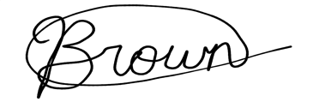

Michelle Brown
AVP Internal Governance
McMaster Students Union
avpinternal@msu.mcmaster.ca

